Tax Year 2021 ProConnect Tax Preparation Guide, Whittenburg, Gill
Chapter 1
You will be using Intuit’s ProConnect Tax online software to prepare federal income tax returns. You will not be e-filing the tax returns though! To create an Intuit ProConnect Tax account, go to:
https://taxeducation.intuit.com
Note: do not use the typical ProConnect commercial site (proconnect.intuit.com) as that site will require payment to print or download the returns.
Google Chrome and Mozilla Firefox browsers best support ProConnect Tax. At the bottom of the educational site, click on Create an account. Enter your email address and create a password. Enter your first and last names, your phone number, and for Firm name, enter a company name of your choosing. Each time you log into the software, you will receive a Welcome screen with various information that you may browse to learn more about ProConnect Tax. When you are ready to begin completing the federal tax returns for the Group 4 and 5 comprehensive problems in the textbook, select Tax Returns in the left margin. Please note that the information you enter into the ProConnect Tax software is saved automatically as you go but is also easily edited as needed.

Group 4, Problem 1A: Tallchief, Maria
Sign into your ProConnect Tax account and from the Welcome screen, select Tax Returns in the left margin. You will land on the Tax Returns 2021 page. Select Create tax return in the upper right corner.
From the Create tax return screen, click the [+] for Add new and select the Individual (1040,709) button (it is selected as the default). Fill out the information for Maria. Email and phone numbers are not required but you may enter assumed data if you wish. Click on Save at the lower right. On the next screen Client, you may review the information you input, make any corrections necessary through the Edit button on the upper right, and once satisfied, click on Save at the lower right.

You have now landed on Maria’s 1040 Profile page. You may unselect Select for E-file for the Federal line under General since you will not actually be filing the tax return, but it is not required to do so. From the tabs near the top, select Input Return.
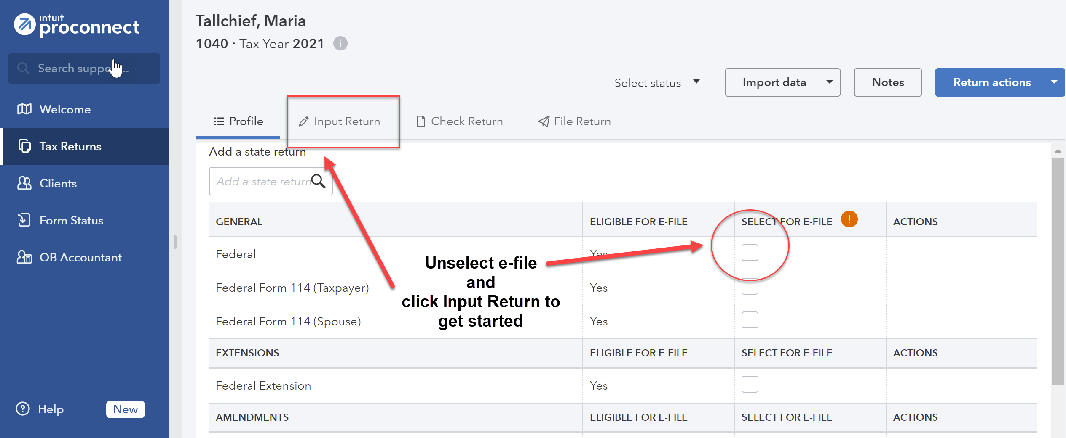
Under Views from the top left, click on All. You will now see Details: Client Information. Scroll down this page and enter the Occupation for Maria.
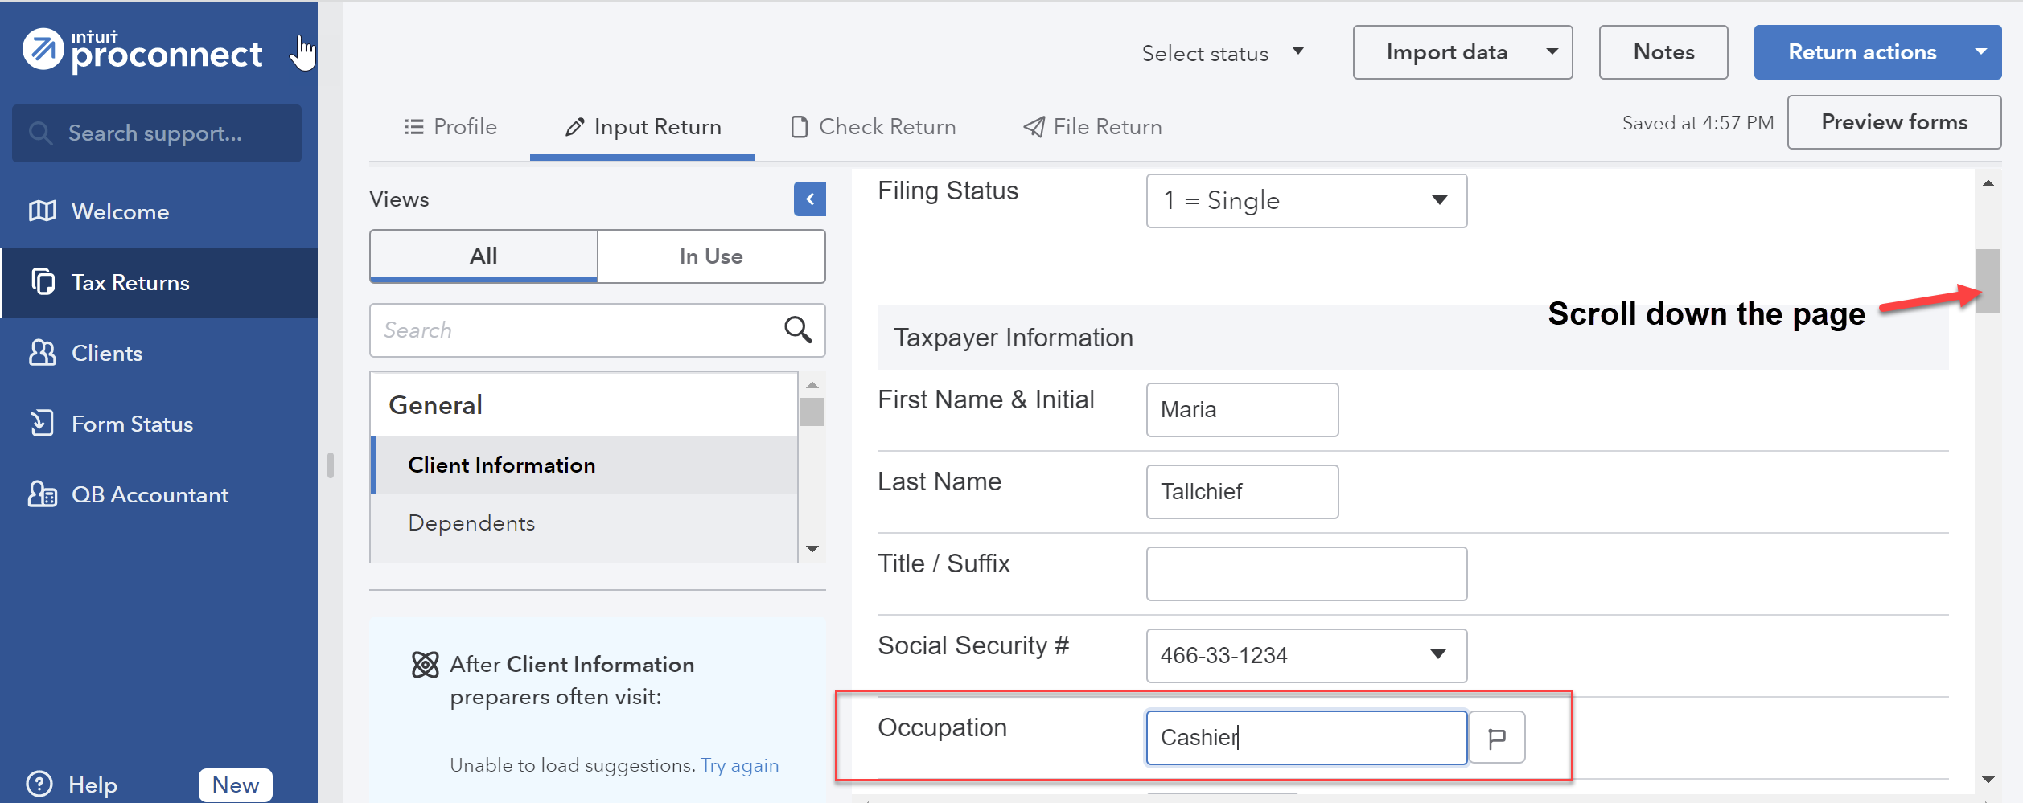

Continue to scroll down this page and toward the bottom, under Miscellaneous Info, find Prepared by and select 3 = Self-Prepared.
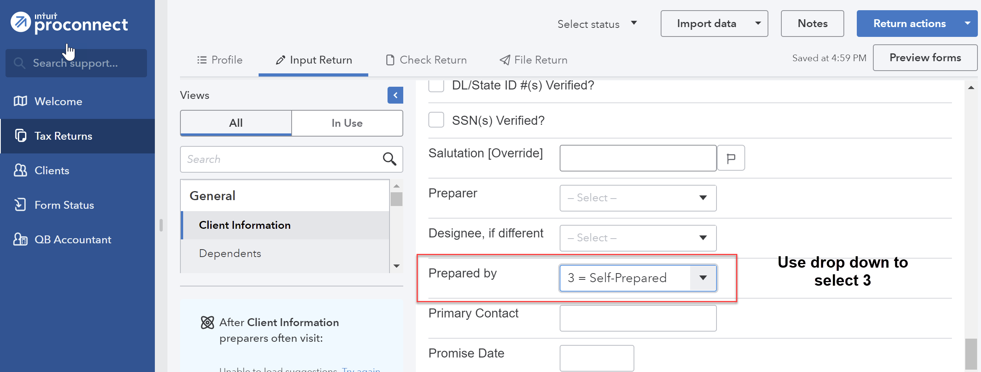
From the menu at the left, scroll down to select Income and then Wages, Salaries, Tips (W-2). At the top of the entry form tabs will be presented (W-2 and Less Common Scenarios). Be certain you are on the W-2 tab (the default). Enter the Employee identification number (EIN) of Maria’s employer.
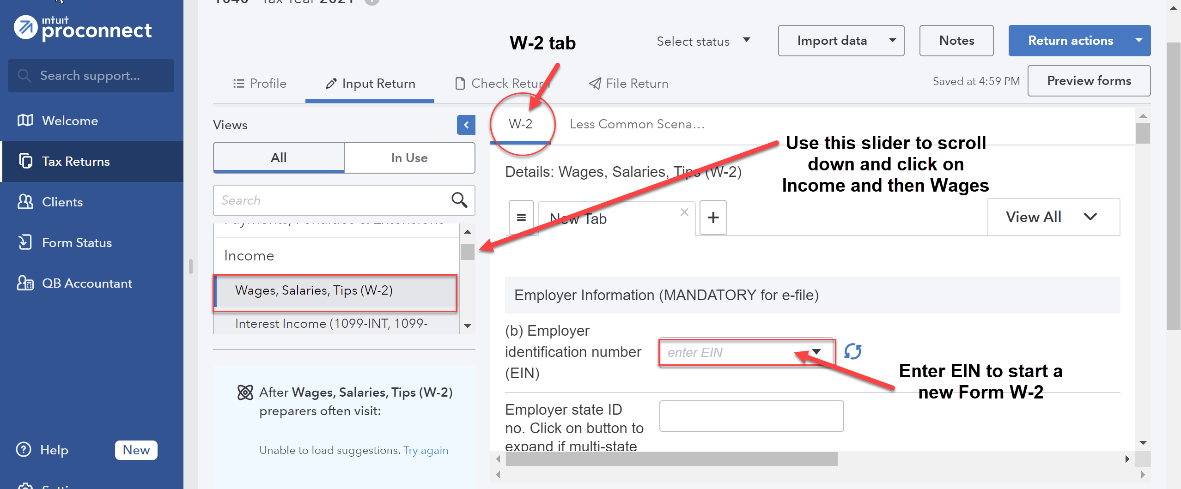
Because all of the employers in ITF are fictional, Intuit ProConnect will not be able to automatically download Form W-2 information. Scrolling down the page, enter the remaining details from Maria’s Form W-2 included in the problem. Be sure to input the amounts of Maria’s wages and federal income tax withheld. Note that ProConnect Tax automatically rounds amounts to the nearest $1, which is permitted by the IRS. The information entered is saved automatically. You can click on the menu items to return to detailed entry at any time.
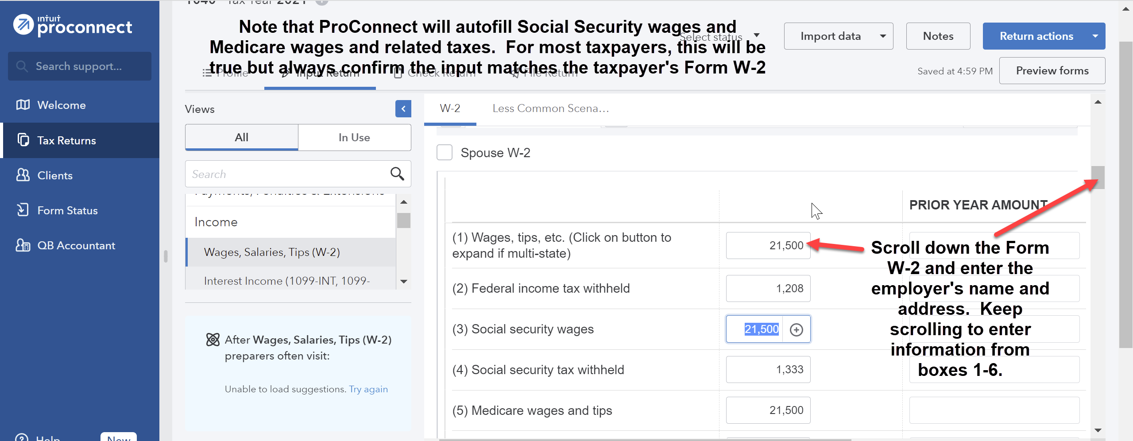
Under the Credits menu at the left, scroll down to Recovery Rebate, EIC, Residential Energy, Oth Credits. The tabs across the top are used to input the different types of credits. Select the Recovery Rebate Credit tab (the first tab and the default) and enter the appropriate amount of the Economic Impact Payment (EIP) received by the taxpayer in the Economic impact payment 3 box under the Taxpayer column.
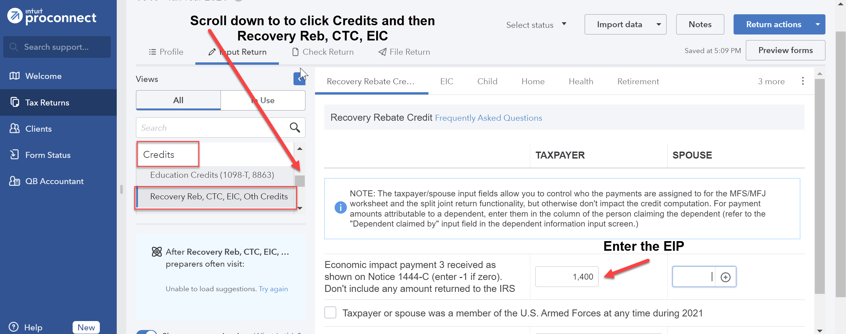

From the menu at the top, select File Return. From the menu at the left, under Print, select View/Print Return PDF. Click the blue Create PDF button which will result in a Download Return PDF blue button that you should click on. The return should open in a new tab. Review the return and if corrections are needed, close out of the tab and you can go back into the return and make the necessary corrections. Once complete, follow the File Return instructions again and then download the return by clicking on the download icon in the upper right corner, to the left of the print icon. Remember where you save the tax return. Close the PDF.
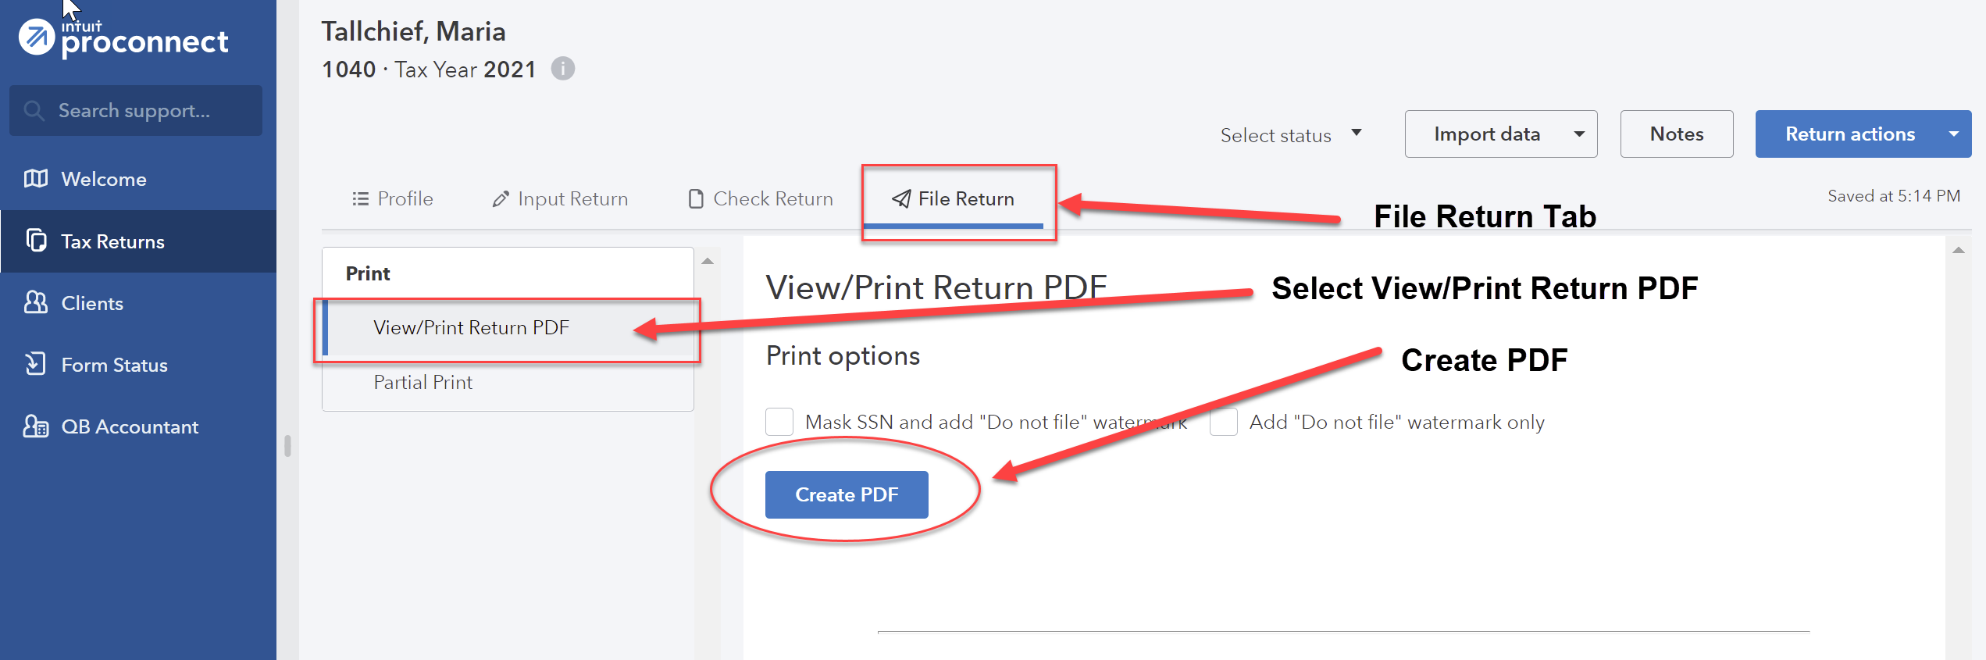
Don't be afraid to explore the ProConnect Tax software - you cannot hurt anything!
Group 4, Problem 1B: Tallchief, Maria
This guide assumes you have completed Group 4 Problem 1A and if so, you do not need to add a new client. If you have not completed Problem 1A, follow the instructions for Problem 1A above except use the revised birthdate provided in Group 4, Problem 1B.
Sign into your ProConnect Tax account and from the Welcome screen, select Tax Returns in the left margin. You will land on the Tax Returns 2021 page. Find Maria Tallchief (the tax return prepared in Problem 1A) and use the View return dropdown arrow under the Actions column to select Copy return from the dropdown box. This will create a copy of the return with a new name (the default is the previous name with COPY attached). You may now select the copied tax return and use its View return dropdown box under the Actions column to Rename return (e.g., “Maria Tallchief Old”).
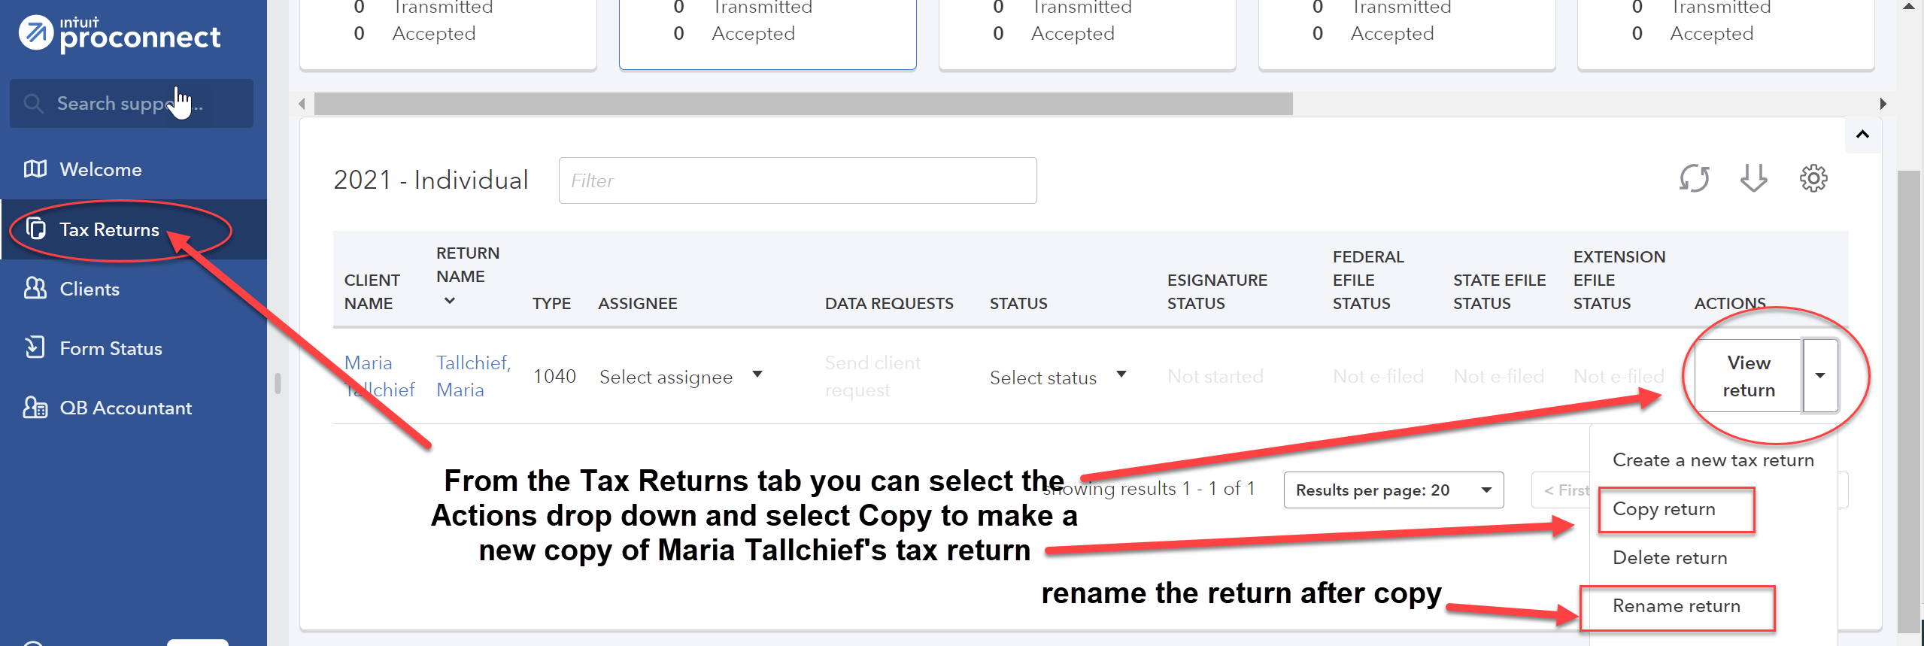
You can click on the renamed tax return for Maria Tallchief and the copy of the tax return will open. Birthdates are entered under the General; Client Information shown in the left margin. Change Maria’s birthdate to the revised date.
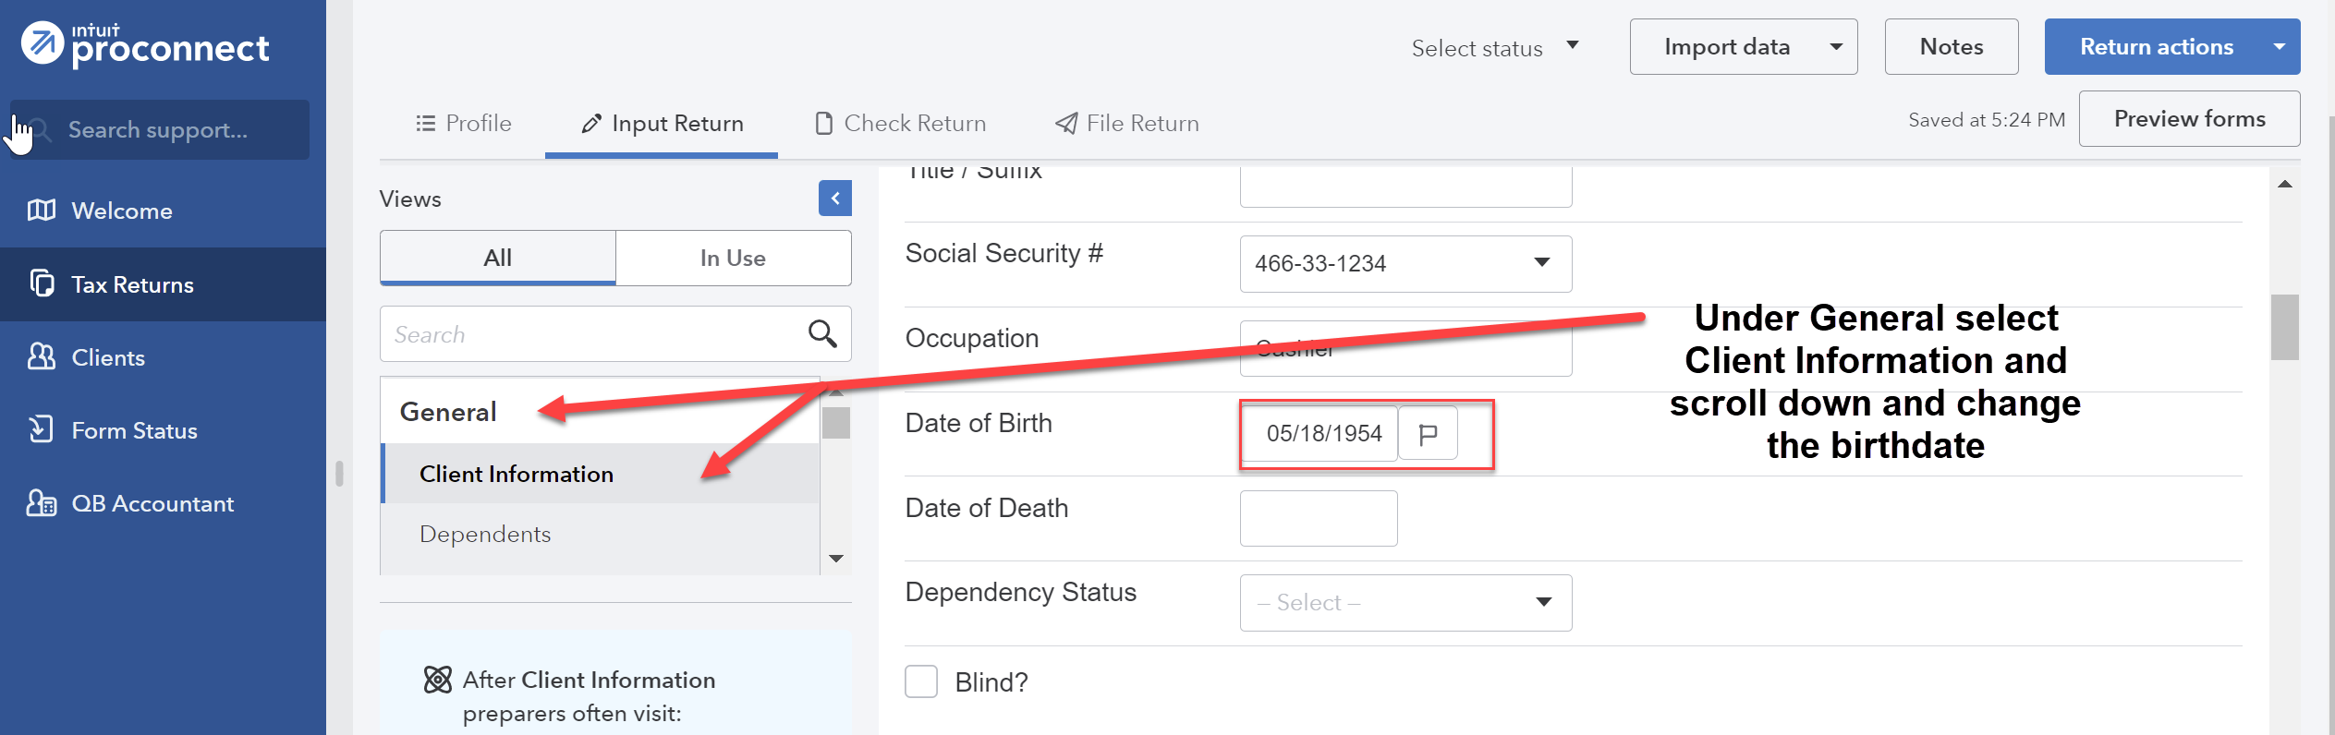
From the menu at the top, select File Return. From the menu at the left, under Print, select View/Print Return PDF. Click the blue Create PDF button which will result in a Download Return PDF blue button that you should click on. The return should open in a new tab. Review the return and if corrections are needed, close out of the tab and you can go back into the return and make the necessary corrections. Once complete, follow the File Return instructions again and then download the return by clicking on the download icon in the upper right corner, to the left of the print icon. Remember where you save the tax return. Close the PDF.
Group 4, Problem 2A: Knox, Dora and Hardy
Sign into your ProConnect Tax account and from the Welcome screen, select Tax Returns in the left margin. You will land on the Tax Returns 2021 page. Select Create tax return in the upper right corner.
From the Create tax return screen, click the [+] for Add new and select the Individual (1040,709) button (it is selected as the default). Fill out the information for Dora. Note that ProConnect Tax tracks a married filing jointly client by one taxpayer and so often the primary income-earning taxpayer is entered as the default, since many of the input fields will default to that taxpayer. Email and phone numbers are not required but you may enter assumed data if you wish. Click on Save at the lower right. On the next screen Client, you may review the information you input, make any corrections necessary through the Edit button on the upper right, and once satisfied, click on Save at the lower right.
You have now landed on Dora’s 1040 Profile page. You may unselect Select for E-file for the Federal line under General since you will not actually be filing the tax return, but it is not required to do so. From the tabs near the top, select Input Return. Under Views from the top left, click on All. You will now see Details: Client Information. The Filing Status will appear in the main window. Change filing status to 2 = Married filing jointly.
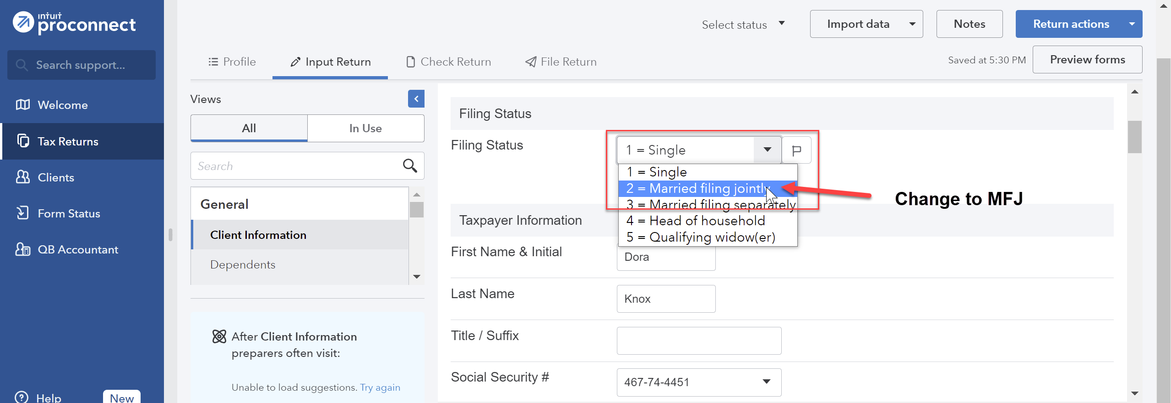
Check the Live With Spouse? Box that appears after you change the filing status. Scroll down this page and enter the Occupation for Dora and the Spouse Information for Hardy (first name, Social Security number, occupation, and birthdate). Continue to scroll down this page and toward the bottom, under Miscellaneous Info, find Prepared by and select 3=Self-Prepared.
Note: Fort Knox should not have been entered into the ProConnect Tax as a dependent. Fort is not a dependent as he does not qualify as a qualified child (age and not a full-time student) or qualified relative (fails gross income test). If you incorrectly entered Fort’s information, the easiest way to delete him from the return is to select General; Client Information; Dependents and delete (use the small “x” on the tab) the Fort tab near the top of the screen.
From the menu at the left, select Income; Wages, Salaries, Tips (W-2). See the New Tab above and click on the icon that looks like a sheet of paper, to the left of New Tab. This action takes you to the Quick Entry: Wages, Salaries, Tips screen.
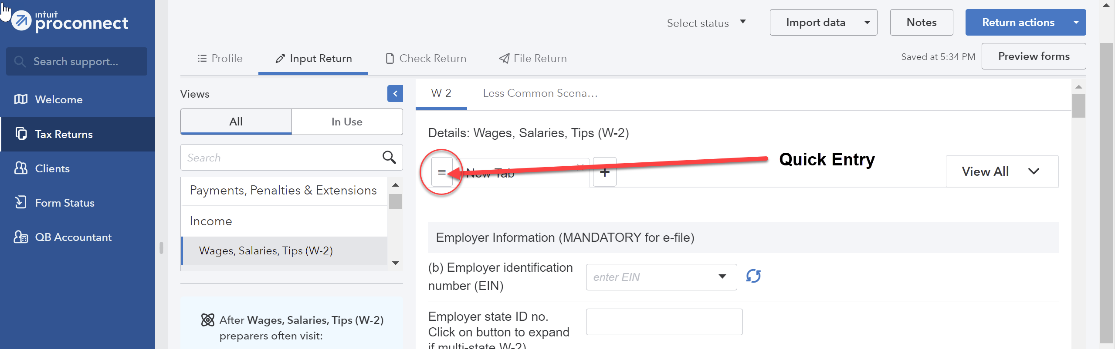
Enter the amounts for Dora’s wages and federal income tax withheld. The information entered is saved automatically.
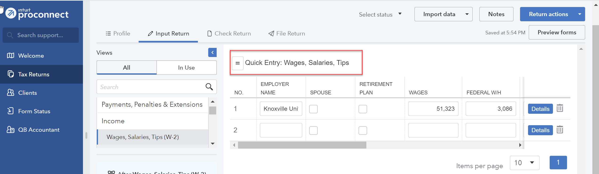
Under the Credits menu at the left, scroll down to Recovery Rebate, EIC, Residential Energy, Oth Credits. The tabs across the top are used to input the different types of credits. Select the Recovery Rebate Credit tab (the first tab and the default) and enter the appropriate amount of the Economic Impact Payment (EIP) received by the taxpayer in the Economic impact payment 3 box under the Taxpayer column and the appropriate amount of the EIP received by the spouse under the Spouse column.
From the menu at the top, select File Return. From the menu at the left, under Print, select View/Print Return PDF. Click the blue Create PDF button which will result in a Download Return PDF blue button that you should click on. The return should open in a new tab. Review the return and if corrections are needed, close out of the tab and you can go back into the return and make the necessary corrections. Once complete, follow the File Return instructions again and then download the return by clicking on the download icon in the upper right corner, to the left of the print icon. Remember where you save the tax return. Close the PDF.
Group 4, Problem 2B: Boxer, Abigail
Sign into your ProConnect Tax account and from the Welcome screen, select Tax Returns in the left margin. You will land on the Tax Returns 2021 page. Select Create tax return in the upper right corner.
From the Create tax return screen, click the [+] for Add new and select the Individual (1040,709) button (it is selected as the default). Fill out the information for Abigail. Email and phone numbers are not required but you may enter assumed data if you wish. Click on Save at the lower right. On the next screen Client, you may review the information you input, make any corrections necessary through the Edit button on the upper right, and once satisfied, click on Save at the lower right.
You have now landed on Abigail’s 1040 Profile page. You may unselect Select for E-file for the Federal line under General since you will not actually be filing the tax return, but it is not required. From the tabs near the top, select Input Return. You will now see Details: Client Information. The Filing Status will appear on the in the main window. Change filing status to 4=Head of household. Scroll down this page and enter the Occupation for Abigail. Continue to scroll down through this page and toward the bottom, under Miscellaneous Info, find Prepared by and select 3 for Self-Prepared.
From the menu at the left, select General; Dependents. You will now see the General Information tab on the right. Enter the information you have for Helen (name, Social Security number, relationship).
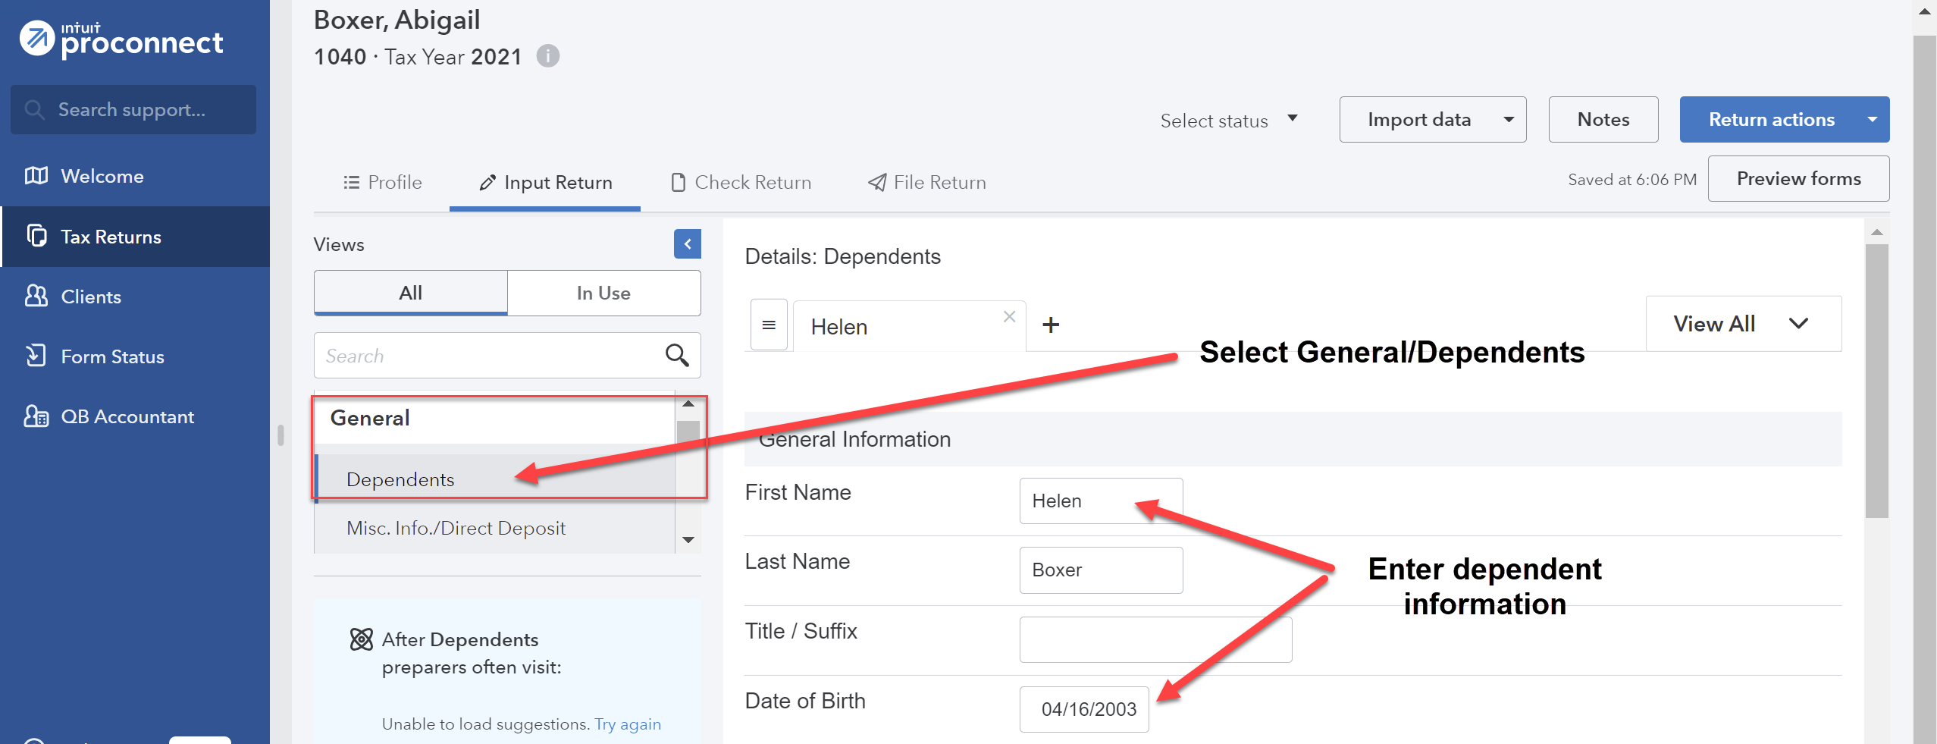

You may leave Earned Income Credit and Child Tax Credit at 1=When applicable. The software will automatically determine the proper credit for the dependent (see ProConnect Tip on p. 1-19 of the textbook).
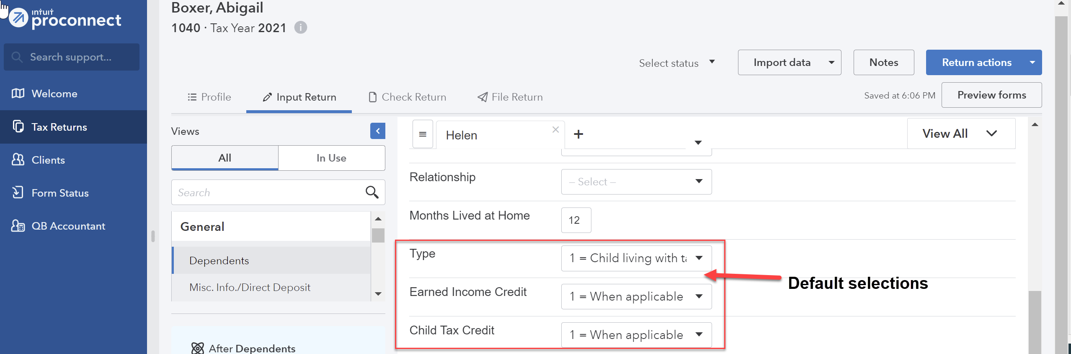
From the menu at the left, select Income; Wages, Salaries, Tips (W-2). See the New Tab above and click on the icon that looks like a sheet of paper, to the left of New Tab. This action takes you to the Quick Entry: Wages, Salaries, Tips screen. Enter the amounts for Abigail’s wages and federal income tax withheld.
To enter the interest income, from the menu at the left, select Income; Interest Income (1099-INT, 1099-OID).
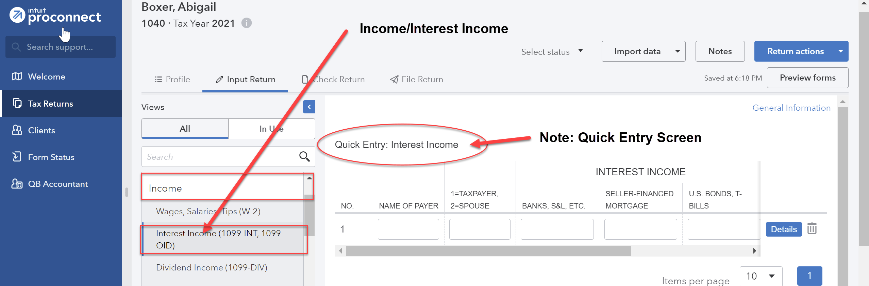

For the taxable interest, enter the name of the payer and enter the amount for Banks, S&L, etc. For the tax-exempt interest, scroll down to No. 2 on the same screen, enter the name of the payer and enter the amount for Total Municipal Bonds (you may enter the information for in-state municipal bonds but it will have no effect since South Dakota does not have a state income tax).
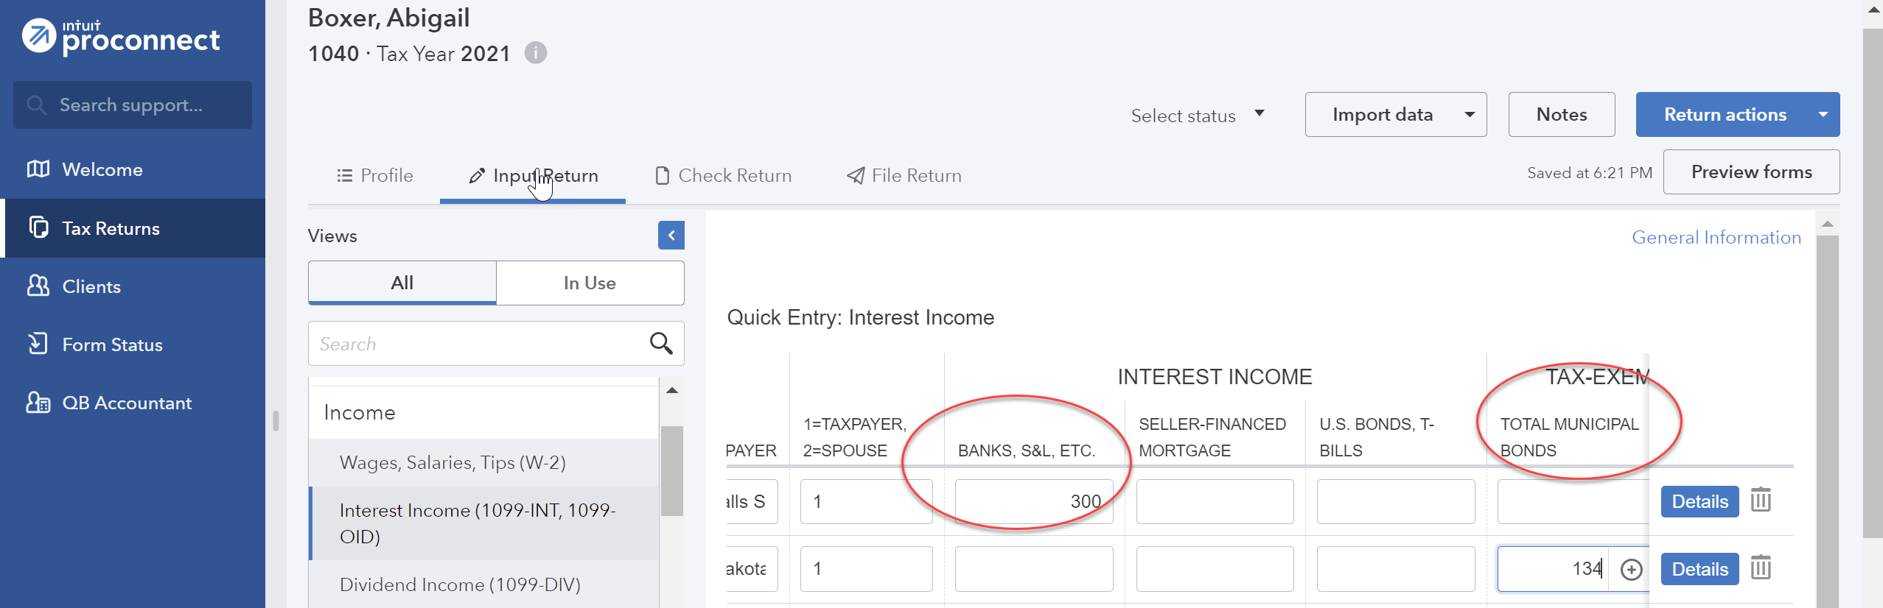
Under the Credits menu at the left, scroll down to Recovery Rebate, EIC, Residential Energy, Oth Credits. The tabs across the top are used to input the different types of credits. Select the Recovery Rebate Credit tab (the first tab and the default) and enter the appropriate amount of the Economic Impact Payment (EIP) received by the taxpayer in the Economic impact payment 3 box under the Taxpayer column.
From the menu at the top, select File Return. From the menu at the left, under Print, select View/Print Return PDF. Click the blue Create PDF button which will result in a Download Return PDF blue button that you should click on. The return should open in a new tab. Review the return and if corrections are needed, close out of the tab and you can go back into the return and make the necessary corrections. Once complete, follow the File Return instructions again and then download the return by clicking on the download icon in the upper right corner, to the left of the print icon. Remember where you save the tax return. Close the PDF.

