Tax Year 2021 ProConnect Tax Preparation Guide, Whittenburg, Gill
Chapter 2
You will be using Intuit’s ProConnect Tax online software to prepare federal income tax returns. You will not be e-filing the tax returns though! To create an Intuit ProConnect Tax account, go to:
https://taxeducation.intuit.com
Note: do not use the typical ProConnect commercial site (proconnect.intuit.com) as that site will require payment to print or download the returns.
Google Chrome and Mozilla Firefox browsers best support ProConnect Tax. At the bottom of the educational site, click on Create an account. Enter your email address and create a password. Enter your first and last names, your phone number, and for Firm name, enter a company name of your choosing. Each time you log into the software, you will receive a Welcome screen with various information that you may browse to learn more about ProConnect Tax. When you are ready to begin completing the federal tax returns for the Group 4 and 5 comprehensive problems in the textbook, select Tax Returns in the left margin. Please note that the information you enter into the ProConnect Tax software is saved automatically as you go but is also easily edited as needed.
Group 4, Problem 1: Hoser, Donna and Chris
Sign into your ProConnect Tax account and from the Welcome screen, select Tax Returns in the left margin. You will land on the Tax Returns 2021 page. Select Create tax return in the upper right corner.
From the Create tax return screen, click the [+] for Add new and select the Individual (1040,709) button (it is selected as the default). Fill out the information for Donna. Note that ProConnect Tax software tracks a married filing jointly client by one taxpayer and so often the primary income earning taxpayer is entered as the default, since many of the input fields will default to that spouse. Email and phone numbers are not required but you may enter assumed data if you wish. Click on Save at the lower right. On the next screen Client, you may review the information you input, make any corrections necessary through the Edit button on the upper right, and once satisfied, click on Save at the lower right.
You have now landed on Donna’s 1040 Profile page. You may unselect Select for E-file for the Federal line under General since you will not actually be filing the tax return, but it is not required to do so. From the tabs near the top, select Input Return. You will now see Details: Client Information. The Filing Status will appear in the main window. Change filing status to the 2 = Married filing jointly. Check the Live With Spouse? box. Scroll down this page and enter the Occupation for Donna and the Spouse Information for Chris (first name, Social Security number, occupation and birthdate). Continue to scroll down this page and toward the bottom, under Miscellaneous Info, find Prepared by and select 3 = Self-Prepared.
From the menu at the left, select Income; Wages, Salaries, Tips (W-2). See the New Tab above and click on the icon that looks like a sheet of paper, to the left of New Tab. This action takes you to the Quick Entry: Wages, Salaries, Tips screen. Enter the amounts for Donna’s wages and federal income tax withheld. Do not forget to enter the state withholding also. In the second line of the Quick Entry screen for Income; Wages, Salaries, Tips (W-2), enter Chris’ wages and federal income tax withheld. Be sure and check the Spouse box for Chris on the Quick Entry screen.
To enter the interest income, from the menu at the left, select Income; Interest Income (1099-INT, 1099-OID). From the Quick Entry: Interest Income screen, enter the name of the payer and enter the amount for Banks, S&L, etc. For the tax-exempt interest, scroll down to line No. 2 on the same screen, enter the name of the payer and enter the amount for Total Municipal Bonds (you may enter the information for in-state municipal bonds but it will have no effect since you are not filing a state income tax return).
To enter the dividend income, from the menu at the left, select Income (1099-DIV). Enter the name of the payer and enter the same amount under Dividend Income/Total Ordinary Dividends and also under Dividend Income/Qualified Dividends.
To enter Donna’s unemployment compensation, from the menu at the left, select Income; Tax Refund, Unempl. Comp./1099-G. See the New Tab above and click on the icon that looks like a sheet of paper, to the left of New Tab. This action takes you to the Quick Entry: State Refunds & Unemployment Comp., etc. screen.
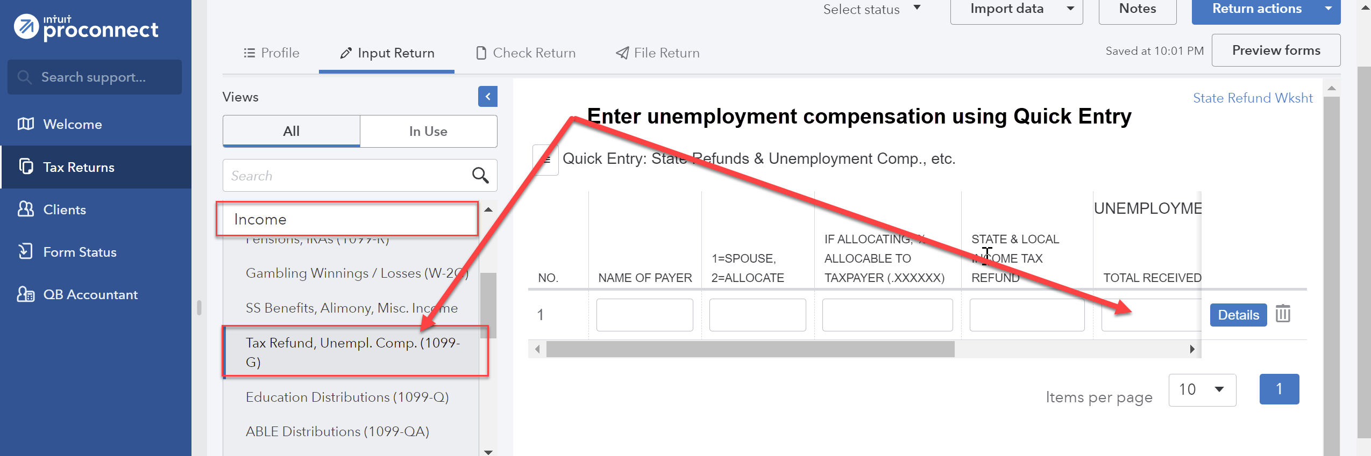
Enter the Name of Payer and indicate which taxpayer is receiving the unemployment compensation by entering a 1=Spouse, if applicable. If it is the taxpayer receiving the unemployment compensation, leave the box blank. Continue by entering the Total received and Federal Withholding.
Under the Credits menu at the left, scroll down to Recovery Rebate, EIC, Residential Energy, Oth Credits. The tabs across the top are used to input the different types of credits. Select the Recovery Rebate Credit tab (the first tab and the default) and enter the appropriate amount of the Economic Impact Payment (EIP) received by the taxpayer in the Economic impact payment 3 box under the Taxpayer column and the appropriate amount of the EIP received by the spouse under the Spouse column.
From the menu at the top, select File Return. From the menu at the left, under Print, select View/Print Return PDF. Click the blue Create PDF button which will result in a Download Return PDF blue button that you should click on. The return should open in a new tab. Review the return and if corrections are needed, close out of the tab and you can go back into the return and make the necessary corrections. Once complete, follow the File Return instructions again and then download the return by clicking on the download icon in the upper right corner, to the left of the print icon. Remember where you save the tax return. Close the PDF.
Group 4, Problem 2A: Gomez, Ray and Maria
Sign into your ProConnect Tax account and from the Welcome screen, select Tax Returns in the left margin. You will land on the Tax Returns 2021 page. Select Create tax return in the upper right corner.
From the Create tax return screen, click the [+] for Add new and select the Individual (1040,709) button (it is selected as the default). Fill out the information for Ray. Note that ProConnect Tax tracks a married filing jointly client by one taxpayer and so often the primary income earning taxpayer is entered as the default since many of the input fields will default to that taxpayer. Email and phone numbers are not required but you may enter assumed data if you wish. Click on Save at the lower right. On the next screen Client, you may review the information you input, make any corrections necessary through the Edit button on the upper right, and once satisfied, click on Save at the lower right.
You have now landed on Ray’s 1040 Profile page. You may unselect Select for E-file for the Federal line under General since you will not actually be filing the tax return, but it is not required to do so. From the tabs near the top, select Input Return. Under Views from the top left, click on All. You will now see Details: Client Information. The Filing Status will appear on the in the main window. Change filing status to the 2=Married filing jointly. Check the Live With Spouse? box. Scroll down this page and enter the Occupation for Ray and the Spouse Information for Maria (first name, Social Security number, occupation and birthdate). Continue to scroll down this page and toward the bottom, under Miscellaneous Info, find Prepared by and select 3=Self-Prepared.
From the menu at the left, select Income; Wages, Salaries, Tips (W-2). See the New Tab above and click on the icon that looks like a sheet of paper, to the left of New Tab. This action takes you to the Quick Entry: Wages, Salaries, Tips screen. Enter the amounts for Ray’s wages and federal income tax withheld. On the next line, enter the amounts for Maria’s wages and federal income tax withheld. Also check box in the Spouse column for Maria.
To enter the interest income, from the menu at the left, select Income; Interest Income (1099-INT, 1099-OID). From the Quick Entry: Interest Income screen, enter the name of payer and enter the amount for Banks, S&L, etc.
To enter the alimony, from the menu at the left, select Deductions, Adjustments to Income. Then select the Less Common Scena…tab near the top right. Click on the Alimony Paid box under Taxpayer and in the popup box that appears enter the ex-spouse’s information and amount paid for the year.
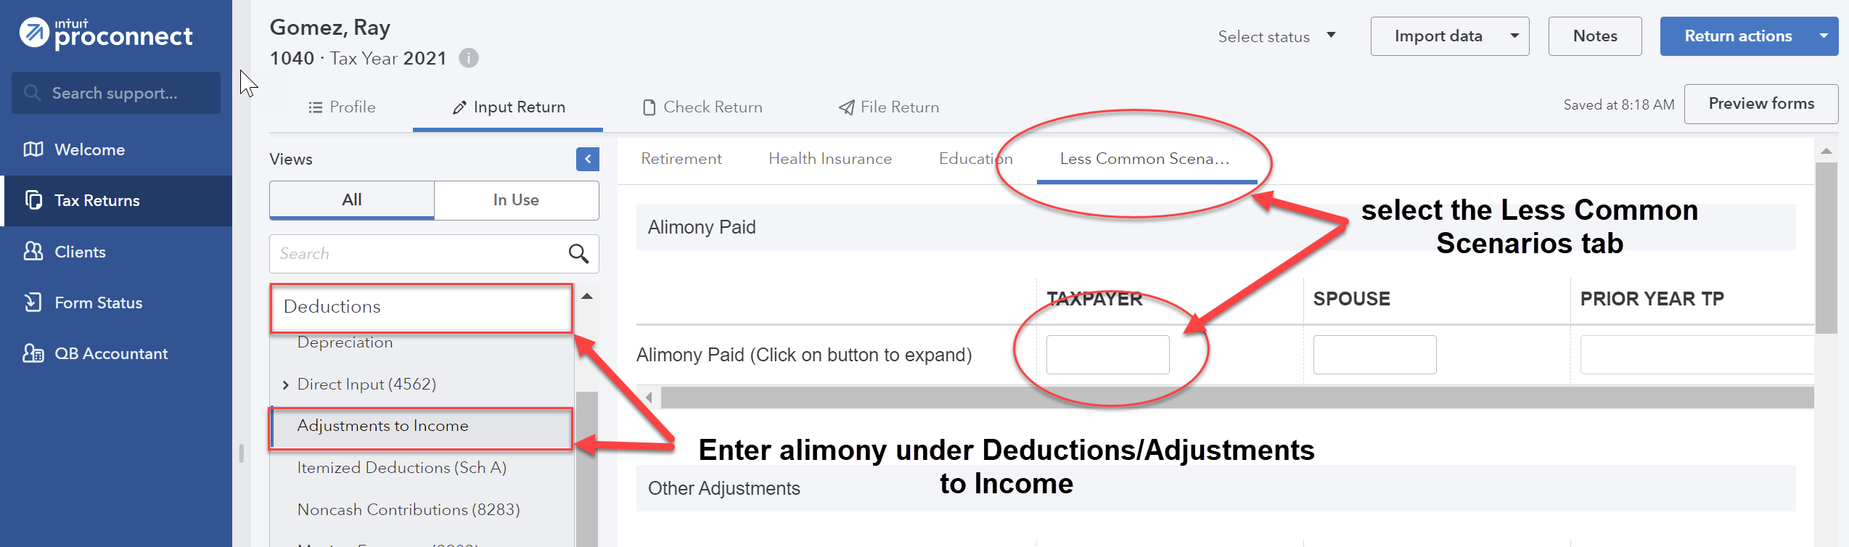
To enter Maria’s lottery winnings, from the menu at the left, select Income; Gambling Winnings/Losses (W-2G). The default screen that pops up is typically the Quick Entry screen. Click Losses/Misc Winnings in the upper right corner. Enter the amount for Winnings not reported on Form W-2G.
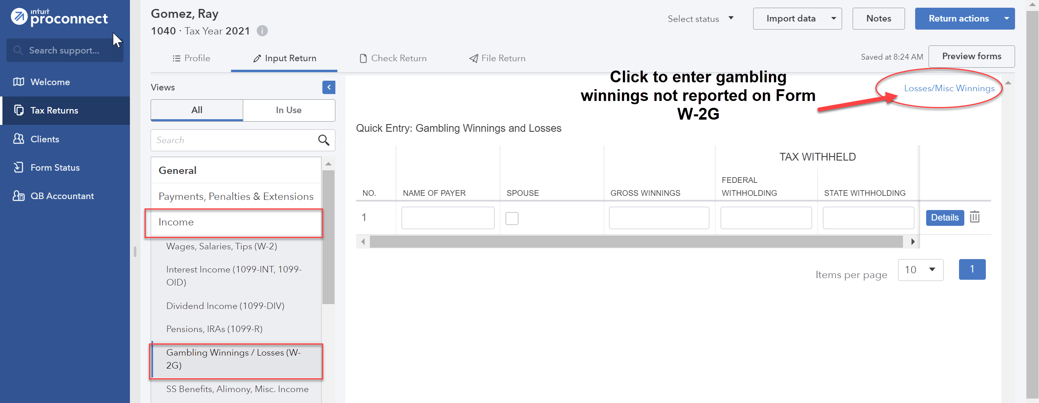
Under the Credits menu at the left, scroll down to Recovery Rebate, EIC, Residential Energy, Oth Credits. The tabs across the top are used to input the different types of credits. Select the Recovery Rebate Credit tab (the first tab and the default) and enter the appropriate amount of the Economic Impact Payment (EIP) received by the taxpayer in the Economic impact payment 3 box under the Taxpayer column and the appropriate amount of the EIP received by the spouse under the Spouse column.
From the menu at the top, select File Return. From the menu at the left, under Print, select View/Print Return PDF. Click the blue Create PDF button which will result in a Download Return PDF blue button that you should click on. The return should open in a new tab. Review the return and if corrections are needed, close out of the tab and you can go back into the return and make the necessary corrections. Once complete, follow the File Return instructions again and then download the return by clicking on the download icon in the upper right corner, to the left of the print icon. Remember where you save the tax return. Close the PDF.
Group 4, Problem 2b: Conch, Carl and Mary Duval
Sign into your ProConnect Tax account and from the Welcome screen, select Tax Returns in the left margin. You will land on the Tax Returns 2021 page. Select Create tax return in the upper right corner.
From the Create tax return screen, click the [+] for Add new and select the Individual (1040,709) button (it is selected as the default). Fill out the information for Carl. Note that ProConnect Tax tracks a married filing jointly client by one taxpayer and so often the primary income-earning taxpayer is entered as the default, since many of the input fields will default to that taxpayer. Email and phone numbers are not required but you may enter assumed data if you wish. Click on Save at the lower right. On the next screen Client, you may review the information you input, make any corrections necessary through the Edit button on the upper right, and once satisfied, click on Save at the lower right.
You have now landed on Carl’s 1040 Profile page. You may unselect Select for E-file for the Federal line under General since you will not actually be filing the tax return, but it is not required. From the tabs near the top, select Input Return. Under Views from the top left, click on All. You will now see Details: Client Information. The Filing Status will appear on the in the main window. Change filing status to 2=Married filing jointly. Check the Live With Spouse? box. Scroll down this page and enter the Occupation for Carl and the Spouse Information for Mary (first name, Social Security number, occupation and birthdate). Continue to scroll down this page and toward the bottom, under Miscellaneous Info, find Prepared by and select 3=Self-Prepared.
From the menu at the left, select Income; Wages, Salaries, Tips (W-2). See the New Tab above and click on the icon that looks like a sheet of paper, to the left of New Tab. This action takes you to the Quick Entry: Wages, Salaries, Tips screen. Enter the amounts for Carl’s wages and federal income tax withheld.
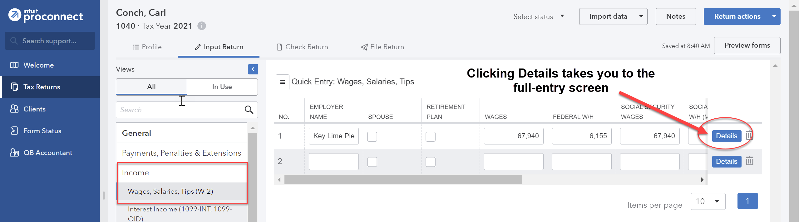
To enter the detail from Boxes 12 and 14 of the Form W-2, click the blue Details button on the right hand side and scroll down the page to enter the amount in Box 12a by using the dropdown box to select Code C. Enter the parking amount in Other under Box 14.
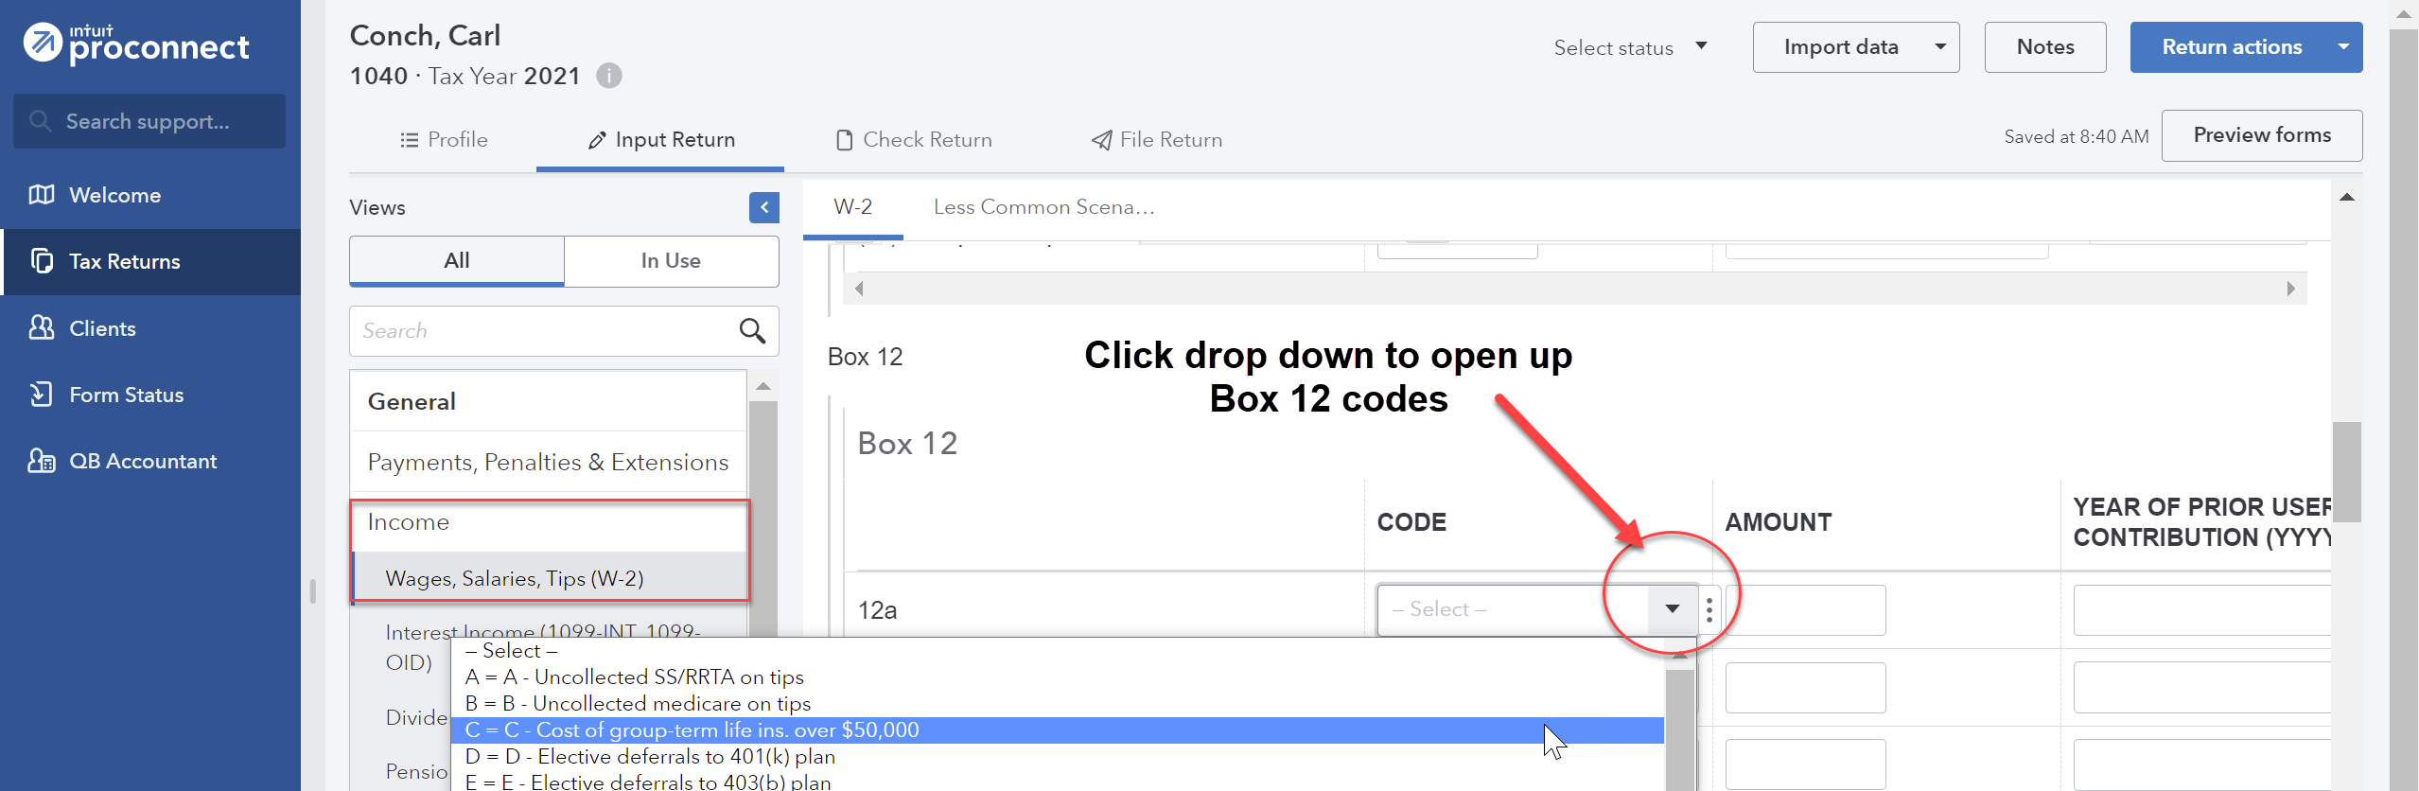
To enter the interest income, from the menu at the left, select Income; Interest Income (1099-INT, 1099-OID). For the taxable interest, enter the name of the payer and enter the amount for Banks, S&L, etc.
To enter Mary’s unemployment compensation, from the menu at the left, select Income; Tax Refund, Unempl. Comp./1099-G. See the New Tab above and click on the icon that looks like a sheet of paper, to the left of New Tab. This action takes you to the Quick Entry: State Refunds & Unemployment Comp., etc. screen. Enter the Name of Payer and indicate which taxpayer is receiving the unemployment compensation by entering a 1=Spouse, if applicable. If it is the taxpayer receiving the unemployment compensation, leave the box blank. Continue by entering the Total received and Federal Withholding.
To enter Mary’s raffle winnings, from the menu at the left, select Income; Gambling Winnings/Losses (W-2G). The default screen that pops up is typically the Quick Entry:Gambling Winnings and Losses screen. Click Losses/Misc Winnings in the upper right corner. Enter the amount for Winnings not reported on Form W-2G.
Under the Credits menu at the left, scroll down to Recovery Rebate, EIC, Residential Energy, Oth Credits. The tabs across the top are used to input the different types of credits. Select the Recovery Rebate Credit tab (the first tab and the default) and enter the appropriate amount of the Economic Impact Payment (EIP) received by the taxpayer in the Economic impact payment 3 box under the Taxpayer column and the appropriate amount of the EIP received by the spouse under the Spouse column.
From the menu at the top, select File Return. From the menu at the left, under Print, select View/Print Return PDF. Click the blue Create PDF button which will result in a Download Return PDF blue button that you should click on. The return should open in a new tab. Review the return and if corrections are needed, close out of the tab and you can go back into the return and make the necessary corrections. Once complete, follow the File Return instructions again and then download the return by clicking on the download icon in the upper right corner, to the left of the print icon. Remember where you save the tax return. Close the PDF.

