Tax Year 2021 ProConnect Tax Preparation Guide, Whittenburg, Gill
Chapter 3
You will be using Intuit’s ProConnect Tax online software to prepare federal income tax returns. You will not be e-filing the tax returns though! To create an Intuit ProConnect Tax account, go to:
https://taxeducation.intuit.com
Note: do not use the typical ProConnect commercial site (proconnect.intuit.com) as that site will require payment to print or download the returns.
Google Chrome and Mozilla Firefox browsers best support ProConnect Tax. At the bottom of the educational site, click on Create an account. Enter your email address and create a password. Enter your first and last names, your phone number, and for Firm name, enter a company name of your choosing. Each time you log into the software, you will receive a Welcome screen with various information that you may browse to learn more about ProConnect Tax. When you are ready to begin completing the federal tax returns for the Group 4 and 5 comprehensive problems in the textbook, select Tax Returns in the left margin. Please note that the information you enter into the ProConnect Tax software is saved automatically as you go but is also easily edited as needed.
Group 4, Problem 1: Booth, Ken and Amy
Sign into your ProConnect Tax account and from the Welcome screen, select Tax Returns in the left margin. You will land on the Tax Returns 2021 page. Select Create tax return in the upper right corner.
From the Create tax return screen, click the [+] for Add new and select the Individual (1040, 709) button (it is selected as the default). Fill out the information for Ken. Note that ProConnect Tax tracks a married filing jointly client by one taxpayer and so often the primary income earning taxpayer is entered as the default since many of the input fields will default to that taxpayer. Email and phone numbers are not required but you may enter assumed data if you wish. Click on Save at the lower right. On the next screen Client, you may review the information you input, make any corrections necessary through the Edit button in the upper right, and once satisfied, click on Save at the lower right.
You have now landed on Ken’s 1040 Profile page. You may unselect the Select for E-file for the Federal line and the Wisconsin line under General since you will not actually be filing the tax return, but it is not required to do so. To avoid confusion related to the state income tax return, you may delete the Wisconsin state income tax return by clicking the garbage can icon under the Actions column and selecting continue to confirm the deletion.
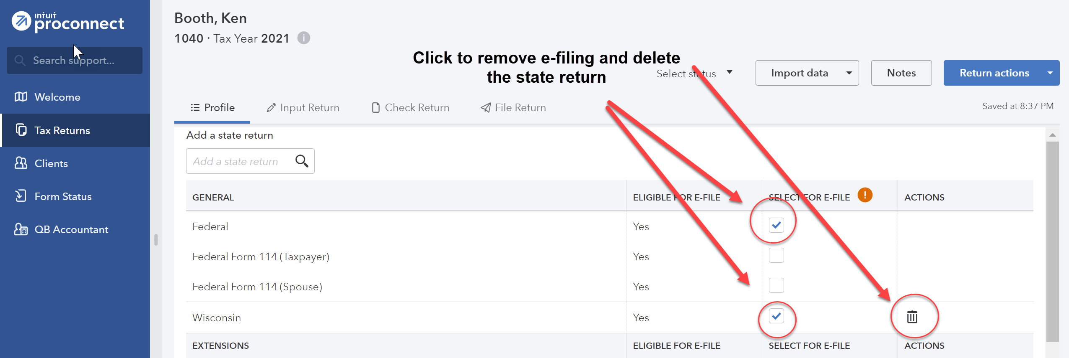
From the tabs near the top, select Input Return. Under Views from the top left, click on All. You will now see Details: Client Information. The Filing Status will appear in the main window. Change filing status to 2 = Married filing jointly. Check the Live With Spouse? box. Scroll down this page and enter the Occupation for Ken and the Spouse Information for Amy (first name, Social Security number, occupation, and birthdate). Continue to scroll down this page and toward the bottom, under Miscellaneous Info, find Prepared by and select 3 = Self-Prepared.
From the menu at the left, select General; Dependents. You will now see the General Information tab on the right. Enter the information you have for Rod. Enter a birth date appropriate for Ken’s father. Select 3 = Dependent other than child for Type. You may leave Earned Income Credit and Child Tax Credit at 1 = When applicable.
To add Mary as an additional dependent, click the [+] tab next to Rod near the top of the page. Enter Mary’s information similarly to Rod.
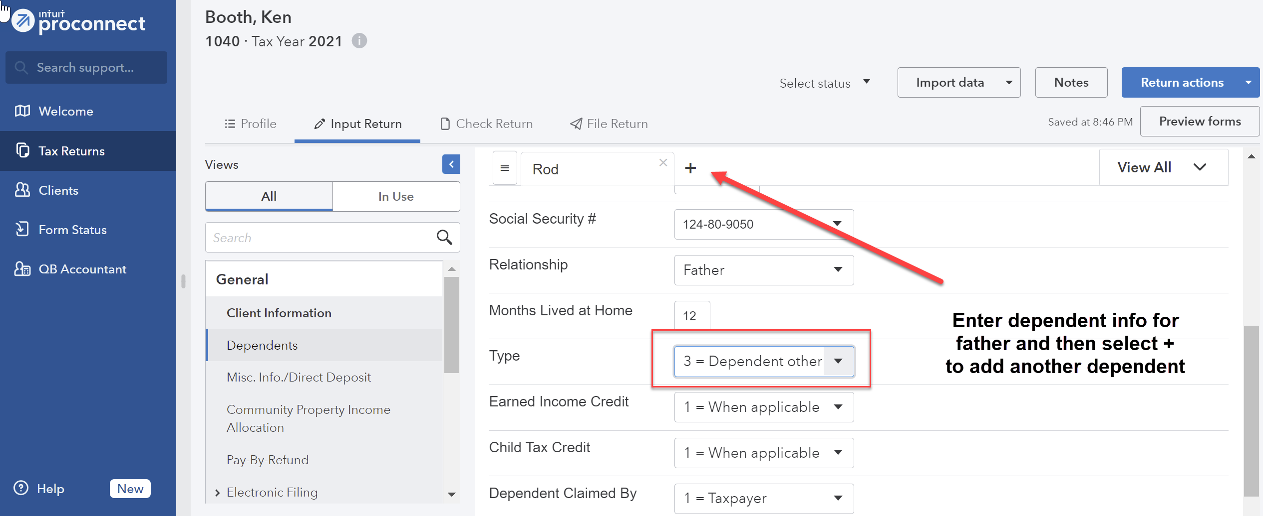
From the menu at the left, select Income; Wages, Salaries, Tips (W-2). See the New Tab to the right and click on the icon that looks like a sheet of paper, to the left of New Tab. This action takes you to the Quick Entry: Wages, Salaries, Tips screen. Enter the amounts for Ken’s wages and federal income tax withheld. On the next line, enter the amounts for Amy’s wages and federal income tax withheld. Also check box in the Spouse column for Amy. You will need to create fake company names (and addresses too if not using the Quick Entry screen) for Ken and Amy since the problem does not include copies of the Booths’ Forms W-2.
To enter the interest income, from the menu at the left, select Income; Interest Income (1099-INT, 1099-OID). From the Quick Entry: Interest Income screen, enter the name of payer and enter the amount for Banks, S&L, etc.
To enter the financial information for Amy’s bookstore, from the menu at the left, select Income; Business Income (Sch C), which will land you on the Details: Business Income (Sch C) screen. Enter the information provided. Enter the Business name, Business address, city, State and Zip. Scroll down to General Information and for Accounting method, enter 1 for cash. For Inventory method, enter 1 for cost. Click on the radio button for Spouse.
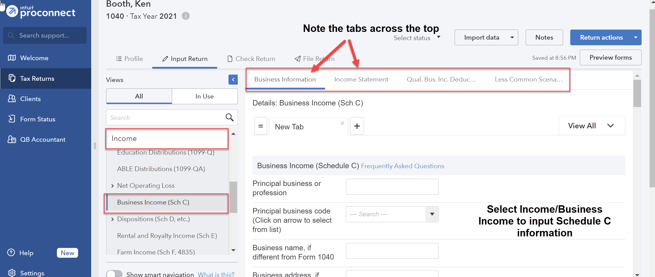
From the tabs at the top select Income Statement and enter the sales amount as Gross receipts or sales in the Federal column. Enter other deductions in the Federal column as you scroll down the page (expenses are listed in alphabetical order). To enter the Other expenses, click in the Federal column for Other expenses and enter a Description and the Amount for each. Select OK.
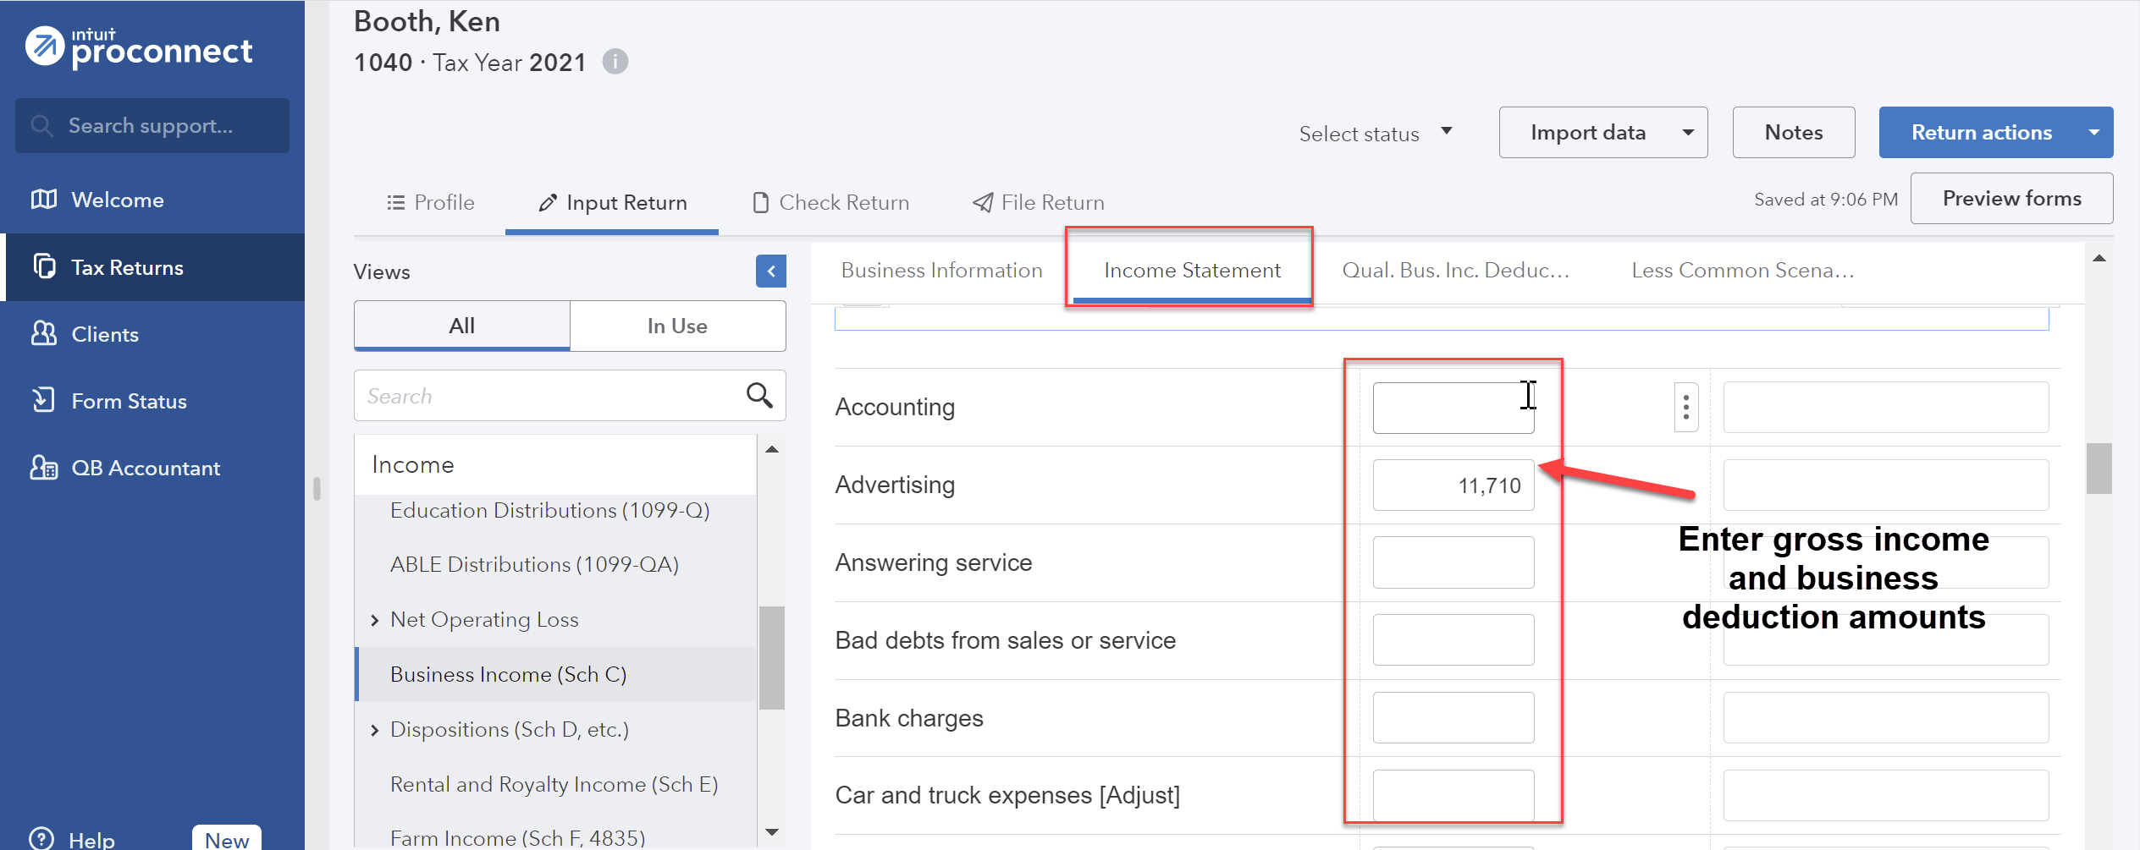
For Amy’s bad debt, from the menu at the left, select Income; Dispositions (Schedule D, etc.) Schedule D/4797/etc. From the Quick Entry: Dispositions (Schedule D, 4797 etc.) screen, on line No. 1, enter Non-Business Bad Debt for the Description of Property. For the Date Acquired enter 01/01/2021 and for the Date Sold enter 12/31/2021. For Sales Price enter 0 and for Cost or Basis enter the amount of the loan. For Basis Rptd: Blank=To IRS, 1=Not To IRS, 2=Not On 1099-B, enter 2 to indicate basis not reported on Form 1099-B.
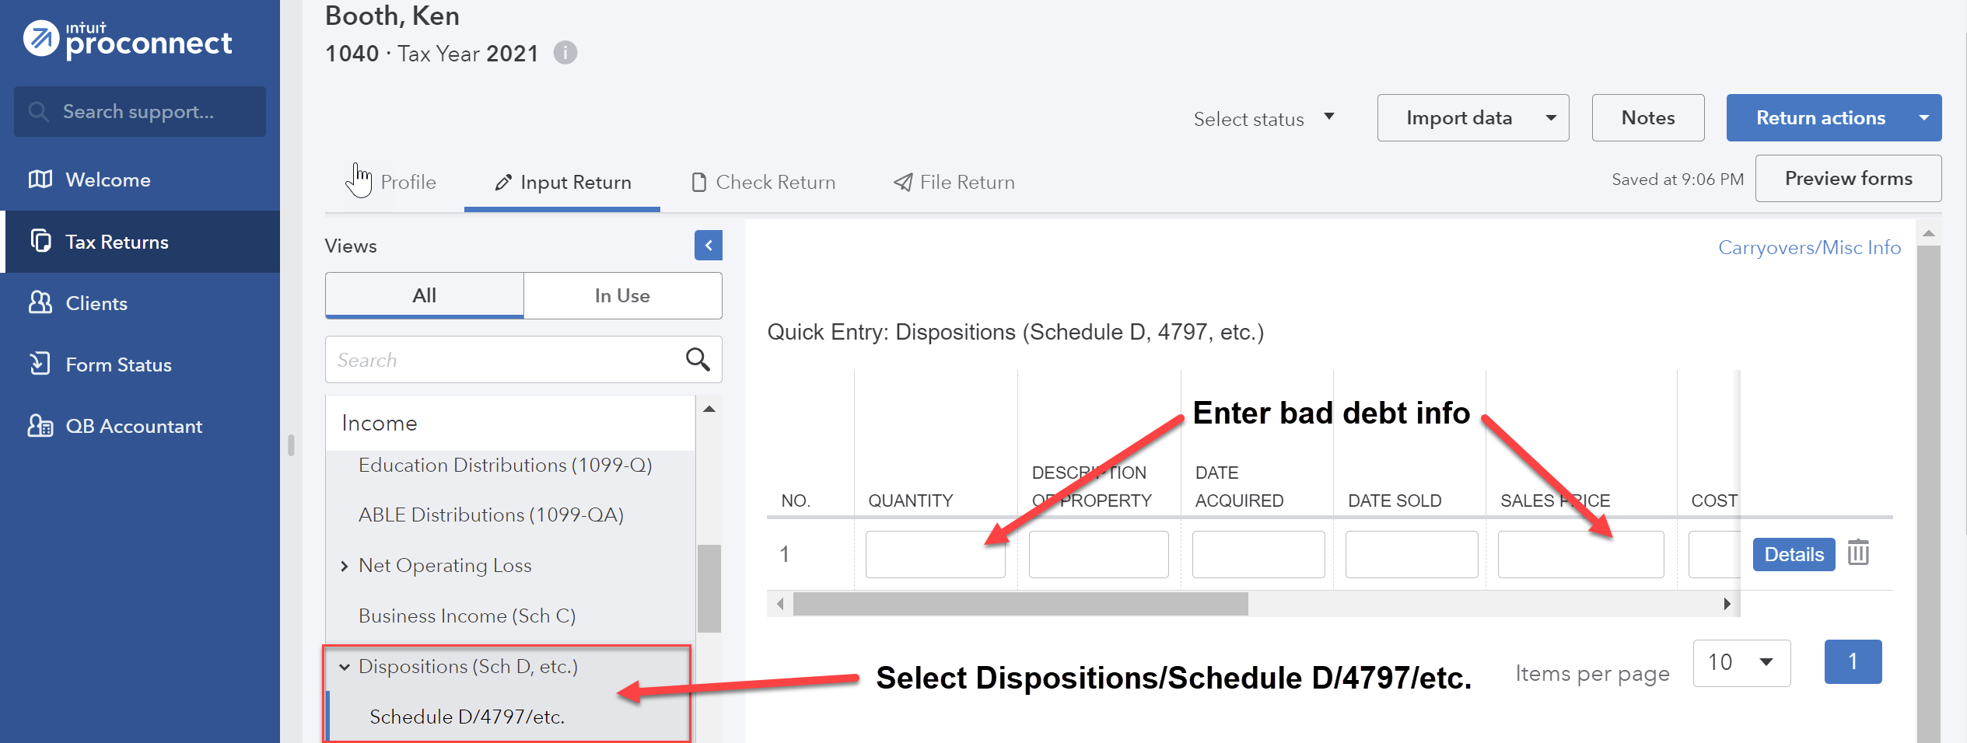
To more fully report the nonbusiness bad debt, click the blue Details button at the right of the Quick Entry line. Select the Schedule D tab at the top and scroll down to select Nonbusiness bad debt and provide a brief explanation.
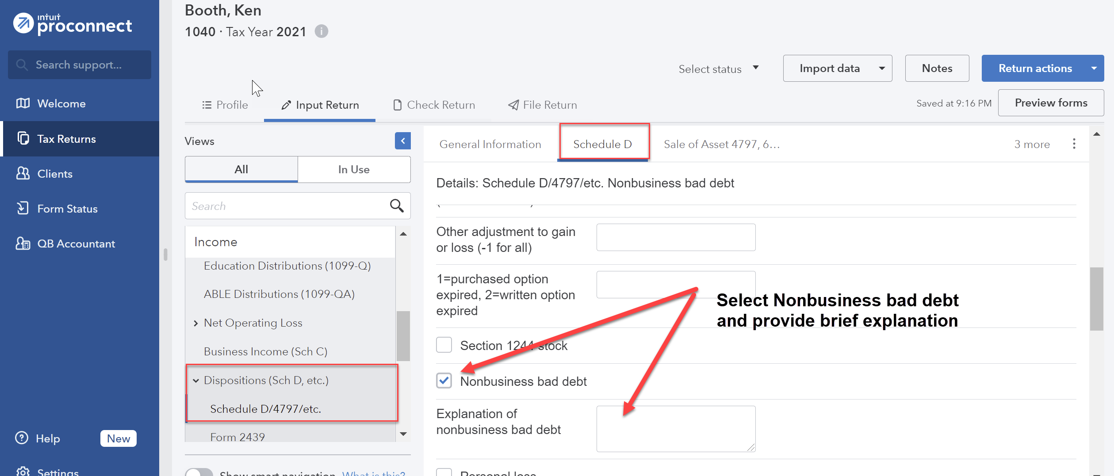
To report Ken’s casino winnings, from the menu at the left, select Income; Gambling Winnings/Losses (W-2G). The default screen that pops up is typically the Quick Entry screen. Click Losses/Misc Winnings in the upper right corner. Enter the amount for Winnings not reported on Form W-2G.
Under the Credits menu at the left, scroll down to Recovery Rebate, EIC, Residential Energy, Oth Credits. The tabs across the top are used to input the different types of credits. Select the Recovery Rebate Credit tab (the first tab and the default) and enter the appropriate amount of the Economic Impact Payment (EIP) received by the taxpayer in the Economic impact payment 1 box under the Taxpayer column and the appropriate amount of the EIP received by the spouse under the Spouse column.
From the menu at the top, select File Return. From the menu at the left, under Print, select View/Print Return PDF. Click the blue Create PDF button which will result in a Download Return PDF blue button that you should click on. The return should open in a new tab. Review the return and if corrections are needed, close out of the tab and you can go back into the return and make the necessary corrections. Once complete, follow the File Return instructions again and then download the return by clicking on the download icon in the upper right corner, to the left of the print icon. Remember where you save the tax return. Close the PDF.
Group 4, Problem 2A: Long, Russell and Linda
Sign into your ProConnect Tax account and from the Welcome screen, select Tax Returns in the left margin. You will land on the Tax Returns 2021 page. Select Create tax return in the upper right corner.
From the Create tax return screen, click the [+] for Add new and select the Individual (1040, 709) button (it is selected as the default). Fill out the information for Russell. Note that ProConnect Tax tracks a married filing jointly client by one taxpayer and so often the primary income-earning taxpayer is entered as the default, since many of the input fields will default to that taxpayer. Email and phone numbers are not required but you may enter assumed data if you wish. Click on Save at the lower right. On the next screen Client, you may review the information you input, make any corrections necessary through the Edit button in the upper right, and once satisfied, click on Save at the lower right.
You have now landed on Russell’s 1040 Profile page. You may unselect the Select for E-file for the Federal line and the Idaho line under General since you will not actually be filing the tax return, but it is not required to do so. To avoid confusion related to the state income tax return, you may delete the Idaho state income tax return by clicking the garbage can icon under the Actions column and selecting continue to confirm the deletion. From the tabs near the top, select Input Return. You will now see Details: Client Information. The Filing Status will appear in the main window. Change filing status to 2 = Married filing jointly. Check the Live With Spouse? box. Scroll down this page and enter the Occupation for Russell and the Spouse Information for Linda (first name, Social Security number, occupation and birthdate). Continue to scroll down through this page and toward the bottom, under Miscellaneous Info, find Prepared by and select 3 = Self-Prepared.
From the menu at the left, select General; Dependents. You will now see the General Information tab on the right. Enter the information you have for Bill. Enter a birth date appropriate for Bill (18 years old). You may leave Earned Income Credit and Child Tax Credit at 1=When applicable.
To add Martha as an additional dependent, click the [+] tab next to Bill near the top of the page. Enter Martha’s information similarly to Bill (Martha is 19 years old).
From the Menu at the left, select Payments, Penalties & Extensions; 2021 Estimated Payments. In the 4th Quarter (due 1/15/22) payment area, enter the estimated amount paid and date the payment was made.
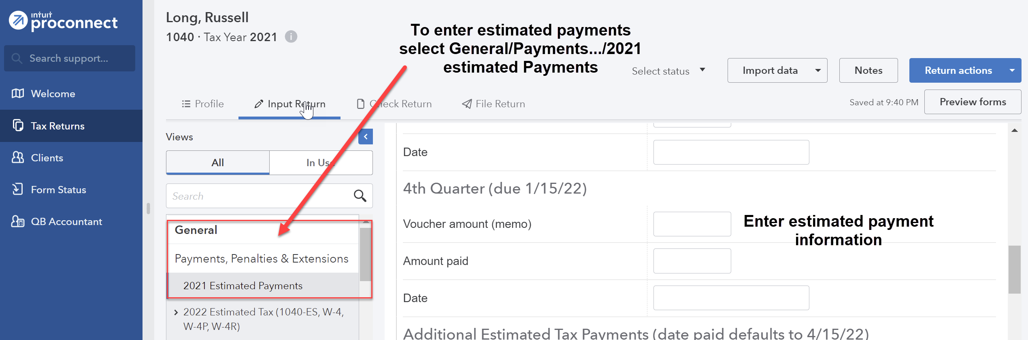
To enter the financial information for Russell’s business, from the menu at the left, select Income; Business Income (Sch C), which will land you on the Details: Business Income (Sch C) screen. Enter the information provided. There is no need to enter the business address because it is the same as their home address. Scroll down to General Information and for Accounting method, enter 1 for cash. Select the Taxpayer radio button. In the If required to file Form(s) 1099, did you or will you file all required Form(s) 1099 enter 1 for yes.
From the tabs at the top select Income Statement and enter the 2021 total revenues amount as Gross receipts or sales in the Federal column. Enter other deductions in the Federal column as you scroll down the page (expenses are listed in alphabetical order). To enter the Other expenses, click in the Federal column for Other expenses and enter a Description and the Amount for each. Select OK.
For the home office, from the menu at the left, select Deductions; Business Use of Home (8829, which will land you on the Details: Business Use of Home (8829) screen. For Form, under General Information, select 3 = Schedule C and for Activity name, use the dropdown arrow to select what you previously entered for the Principal business or profession for Schedule C.
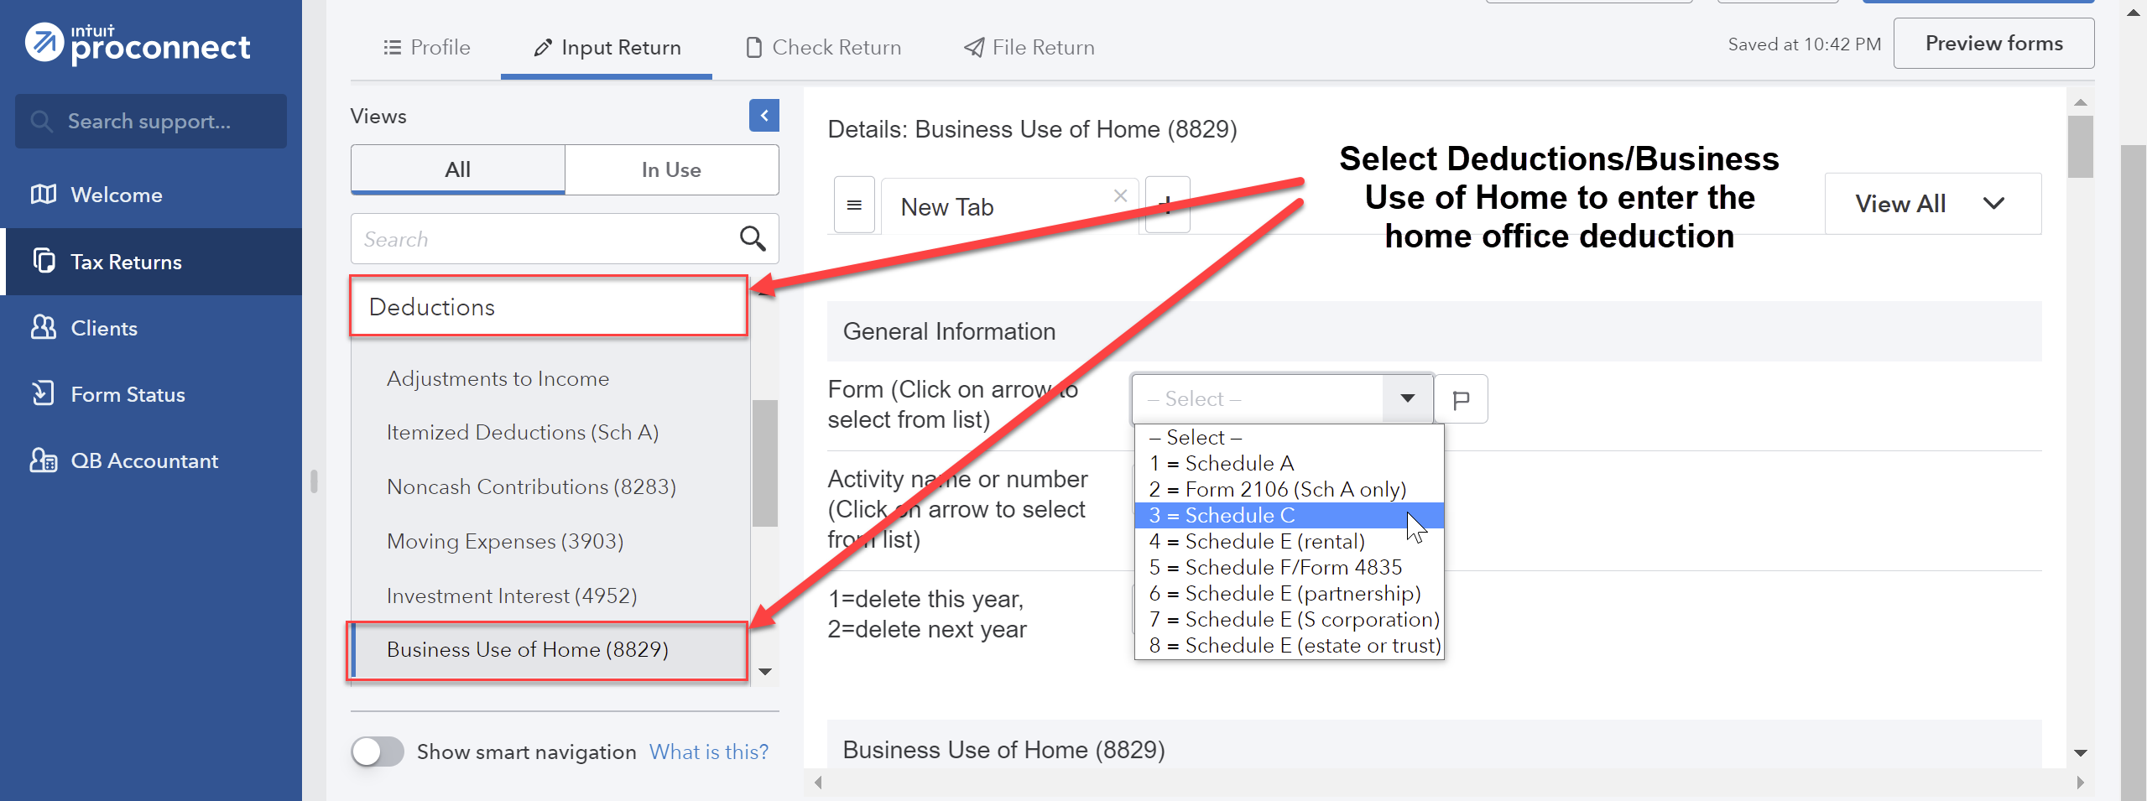
Scroll down to Business Use of Home (8829) and enter the amount of the Business use area (sq. ft.) in the Federal column. Enter the amount of the Total area of home (sq. ft.) in the Federal column. Scroll down the page and under Indirect Expenses enter the rent and utilities amounts.
To enter the qualified dividend income, from the menu at the left, select Income; Dividend Income (1099-DIV), landing you on the Quick Entry: Dividend Income screen. Enter the name of the payer and enter the same amount for Total Ordinary Dividends and Qualified Dividends.
Under the Credits menu at the left, scroll down to Recovery Rebate, EIC, Residential Energy, Oth Credits. The tabs across the top are used to input the different types of credits. Select the Recovery Rebate Credit tab (the first tab and the default) and enter the appropriate amount of the EIP received by the taxpayer in the Economic impact payment 3 box under the Taxpayer column and the appropriate amount of the EIP received by the spouse under the Spouse column.
From the menu at the top, select File Return. From the menu at the left, under Print, select View/Print Return PDF. Click the blue Create PDF button which will result in a Download Return PDF blue button that you should click on. The return should open in a new tab. Review the return and if corrections are needed, close out of the tab and you can go back into the return and make the necessary corrections. Once complete, follow the File Return instructions again and then download the return by clicking on the download icon in the upper right corner, to the left of the print icon. Remember where you save the tax return. Close the PDF.
Group 4, Problem 2B: Crosphit, Christopher
Sign into your ProConnect Tax account and from the Welcome screen, select Tax Returns in the left margin. You will land on the Tax Returns 2021 page. Select Create tax return in the upper right corner.
From the Create tax return screen, click the [+] for Add new and select the Individual (1040, 709) button (it is selected as the default). Fill out the information for Christopher. Email and phone numbers are not required but you may enter assumed data if you wish. Click on Save at the lower right. On the next screen Client, you may review the information you input, make any corrections necessary through the Edit button on the upper right, and once satisfied, click on Save at the lower right.
You have now landed on Christopher’s 1040 Profile page. You may unselect the Select for E-file for the Federal line and the South Carolina line under General since you will not actually be filing the tax return, but it is not required to do so. To avoid confusion on the state income tax return, you may delete the South Carolina state income tax return by clicking the garbage can icon under the Actions column and selecting continue to confirm the deletion. From the tabs near the top, select Input Return. You will now see Details: Client Information. The Filing Status will appear in the main window. Change filing status to 4 = Head of household. Scroll down this page and enter the Occupation for Chris. Continue to scroll down through this page and toward the bottom, under Miscellaneous Info, find Prepared by and select 3 = Self-Prepared.
From the menu at the left, select General; Dependents. You will now see the General Information tab on the right. Enter the information you have for Arnold. You may leave Earned Income Credit and Child Tax Credit at 1=When applicable.
To enter the financial information for Christopher’s business, from the menu at the left, select Income; Business Income (Sch C), which will land you on the Details: Business Income (Sch C) screen. Enter the information provided. The business address is not the same as the home address. Scroll down and under General Information; Accounting method, enter 1 for cash. Select the Taxpayer radio button. In the If required to file Form(s) 1099, did you or will you file all required Form(s) 1099 enter 1 for yes.
From the tabs at the top, select Income Statement and enter the 2021 total income amount as Gross receipts or sales in the Federal column. Continue down the page and enter the expenses in the Federal column. To enter the Other expenses, click in the Federal column for Other expenses and enter a Description and the Amount for each. Select OK.
For the home office, from the menu at the left, select Deductions; Business Use of Home (8829), which will land you on the Details: Business Use of Home (8829) screen. For Form, under General Information, select 3 = Schedule C and for Activity name, use the dropdown arrow to select what you previously entered for the Principal business or profession for Schedule C. Scroll down to Business Use of Home (8829) and enter the amount of the Business use area (sq. ft.) in the Federal column. Enter the amount of the Total area of home (sq. ft.) in the Federal column. Scroll down the page and under Indirect Expenses enter the rent and utilities amounts.
To enter the interest income, from the menu at the left, select Income; Interest Income (1099-INT, 1099-OID). From the Quick Entry: Interest Income screen, enter the name of payer and enter the amounts for Banks, S&L, etc.
Christopher’s hobby generates income of $500 (the sales less then cost of goods sold). Hobby expenses other than cost of goods sold are generally no longer deductible due to the suspension of the miscellaneous expenses subject to 2% deduction. To enter the hobby income, from the menu at the left, select Income; SS Benefits, Alimony, Misc. Income. You will land on the Social Security Benefits page. Scroll down to Alimony and Other Income. Scroll down to Other income, enter the amount and click on the button to expand. Enter Hobby Income for Description and the Amount earned.
From the Menu at the left, select Payments, Penalties & Extensions; 2021 Estimated Payments. In the 1st Quarter (due 4/15/21) payment area, enter the estimated amount paid and date the payment was made.
Under the Credits menu at the left, scroll down to Recovery Rebate, EIC, Residential Energy, Oth Credits. The tabs across the top are used to input the different types of credits. Select the Recovery Rebate Credit tab (the first tab and the default) and enter the appropriate amount of the Economic Impact Payment (EIP) received by the taxpayer in the Economic impact payment 3 box under the Taxpayer column.
From the menu at the top, select File Return. From the menu at the left, under Print, select View/Print Return PDF. Click the blue Create PDF button which will result in a Download Return PDF blue button that you should click on. The return should open in a new tab. Review the return and if corrections are needed, close out of the tab and you can go back into the return and make the necessary corrections. Once complete, follow the File Return instructions again and then download the return by clicking on the download icon in the upper right corner, to the left of the print icon. Remember where you save the tax return. Close the PDF.

