Tax Year 2021 ProConnect Tax Preparation Guide, Whittenburg, Gill
Chapter 4
You will be using Intuit’s ProConnect Tax online software to prepare federal income tax returns. You will not be e-filing the tax returns though! To create an Intuit ProConnect Tax account, go to:
https://taxeducation.intuit.com
Note: do not use the typical ProConnect commercial site (proconnect.intuit.com) as that site will require payment to print or download the returns.
Google Chrome and Mozilla Firefox browsers best support ProConnect Tax. At the bottom of the educational site, click on Create an account. Enter your email address and create a password. Enter your first and last names, your phone number, and for Firm name, enter a company name of your choosing. Each time you log into the software, you will receive a Welcome screen with various information that you may browse to learn more about ProConnect Tax. When you are ready to begin completing the federal tax returns for the Group 4 and 5 comprehensive problems in the textbook, select Tax Returns in the left margin. Please note that the information you enter into the ProConnect Tax software is saved automatically as you go but is also easily edited as needed.
Group 4, Problem 1: Black, Walter and Skylar
Sign into your ProConnect Tax account and from the Welcome screen, select Tax Returns in the left margin. You will land on the Tax Returns 2021 page. Select Create tax return in the upper right corner.
From the Create tax return screen, click the [+] for Add new and select the Individual (1040, 709) button (it is selected as the default). Fill out the information for Walter. Note that ProConnect Tax tracks a married filing jointly client by one taxpayer and so often the primary income earning taxpayer is entered as the default since many of the input fields will default to that taxpayer. Email and phone numbers are not required but you may enter assumed data if you wish. Click on Save at the lower right. On the next screen Client, you may review the information you input, make any corrections necessary through the Edit button in the upper right, and once satisfied, click on Save at the lower right.
You have now landed on Walter’s 1040 Profile page. You may unselect the Select for E-file for the Federal line under General since you will not actually be filing the tax return, but it is not required. From the tabs near the top, select Input Return. From the menu at the left, select General; Client Information. The Filing Status will appear on the right. Change filing status to 2=Married filing jointly. Check the Live With Spouse? box. Scroll down this page and enter the Occupation for Walter and the Spouse Information for Skylar (first name, Social Security number, occupation, and birthdate). Continue to scroll down this page and toward the bottom, under Miscellaneous Info, find Prepared by and select 3 = Self-Prepared.
From the menu at the left, select General; Dependents. You will now see the General Information tab on the right. Enter the information you have for Rebecca. Use a birth date appropriate for Skylar’s mother (65 or older). Select 3=Dependent other than child for Type. You may leave Earned Income Credit and Child Tax Credit at 1=When applicable.
To add Alton as an additional dependent, click the [+] tab next to Rebecca near the top of the page. Enter Alton’s information similarly to Rebecca. Note that although Alton receives $7,600 in Social Security benefits, these are not taxable and as a result, do not count toward the gross income test for a qualified relative (see LO 1-6c in Chapter 1 of the textbook).
From the menu at the left, select Income; Wages, Salaries, Tips (W-2). See the New Tab to the right and click on the icon that looks like a sheet of paper, to the left of New Tab. This action takes you to the Quick Entry: Wages, Salaries, Tips screen. Enter the amounts for Walter’s wages and federal income tax withheld. To enter the detail from Boxes 12a and 13 of the Form W-2, click the blue Details button on the right-hand side and scroll down the page to enter the amount in Box 12a by using the dropdown box to select Code D=D-Elective deferrals to 401(k) plan. Check the Retirement plan box in the Box 13 section.
To enter the sale of the personal residence, from the menu at the left, select Income; Dispositions (Sch D, etc.); Schedule D/ 4797/ etc. Enter the Description of Property, the Date Acquired, the Date Sold, and the Sales Price. For the Cost or Basis, enter the original cost plus the improvements. If you are in Quick Entry mode, select the blue Details box on the right.
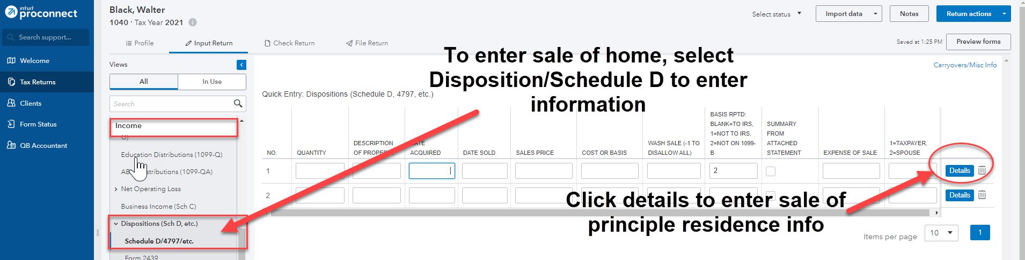
If you are already on the Details page, use the Schedule D tab at the top and enter 2=form other than Form 1099-B (Form 8949). Depending on the width of the screen, select either Sale of Home tab at the top or click on the 3 vertical dots on the right of the Schedule D tab or # more on the right of the tabs to find and select Sale of Home. Check the boxes for Sale of home and 2 year use test met (full exclusion).
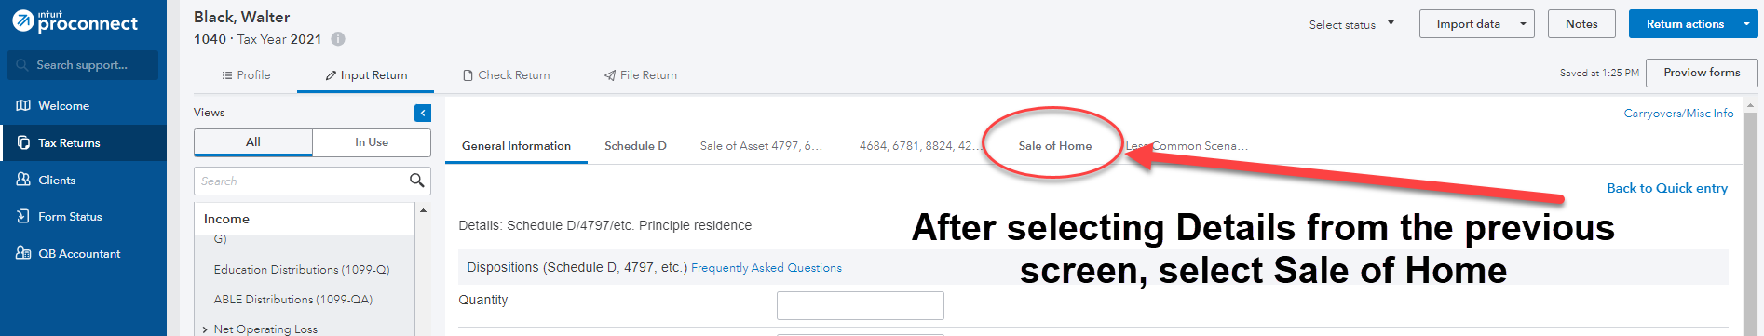
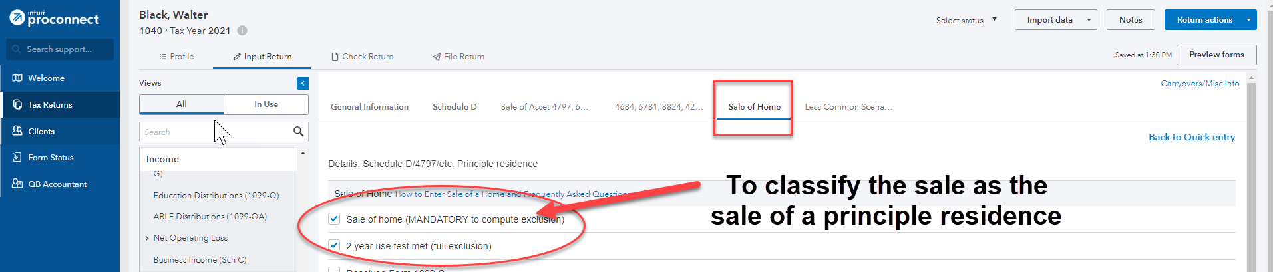
To enter the dividend income, from the menu at the left, select Income (1099-DIV), landing you on the Quick Entry: Dividend Income screen. Enter the name of the payer and enter the appropriate amounts for Total Ordinary Dividends, Qualified Dividends, and Capital Gain Distributions.
For the Black’s ski condo rental, from the menu at the left, select Income; Rental and Royalty Income (Sch E), landing you on the Details: Rental and Royalty Income (Sch E) screen.
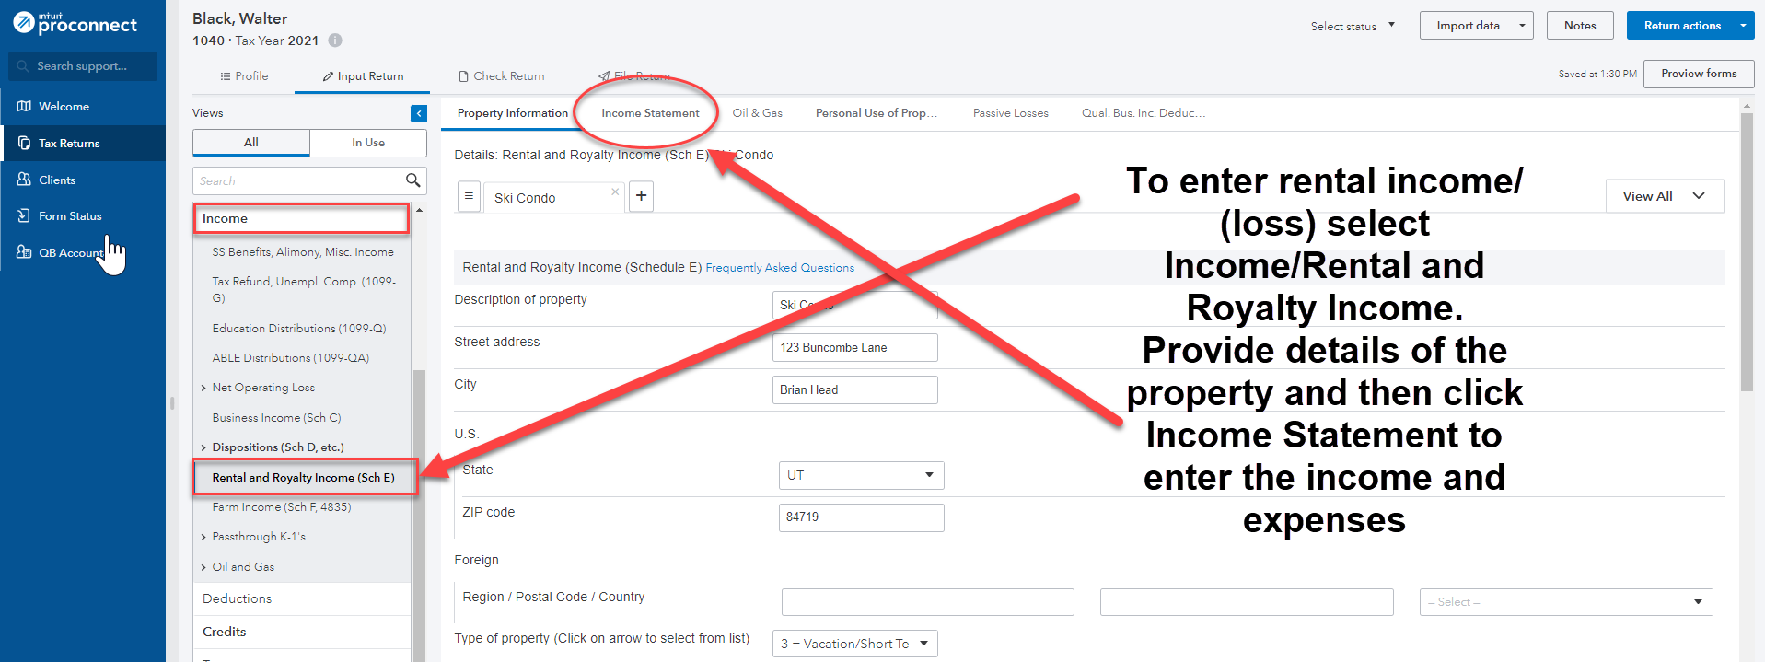
Enter the Description of property and address, and for Type of property, use the dropdown arrow to select 3 for Vacation/Short Term Rental. Enter 184 for the Number of days rented. From the tabs at the top, select Income Statement.
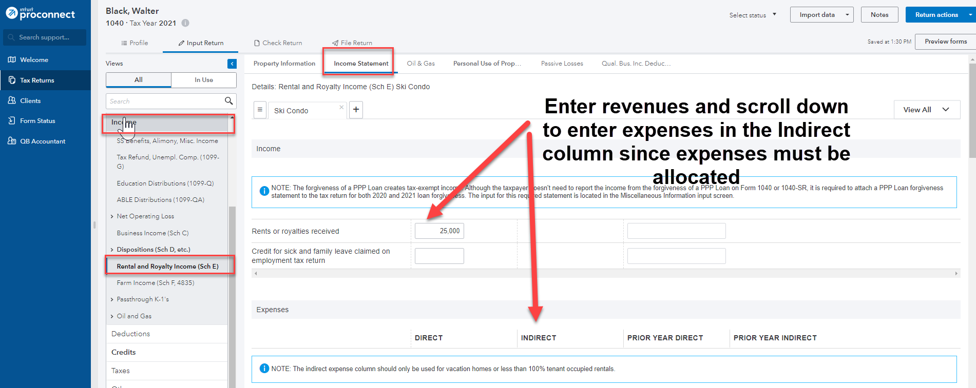
Enter the amount for Rents or royalties received. Scroll down to Expenses, and in the Indirect column, enter the expense amounts. The Indirect column is used when an allocation of expenses to personal use is required (e.g., less than 365 rental days). Click on the Personal Use of Property tab at the top and enter the Number of days personal use as 16.
Under the Credits menu at the left, scroll down to Recovery Rebate, EIC, Residential Energy, Oth Credits. The tabs across the top are used to input the different types of credits. Select the Recovery Rebate Credit tab (the first tab and the default) and enter the appropriate amount of the EIP received by the taxpayer in the Economic impact payment 3 box under the Taxpayer column and the appropriate amount of the EIP received by the spouse under the Spouse column.
From the menu at the top, select File Return. From the menu at the left, under Print, select View/Print Return PDF. Click the blue Create PDF button which will result in a Download Return PDF blue button that you should click on. The return should open in a new tab. Review the return and if corrections are needed, close out of the tab and you can go back into the return and make the necessary corrections. Once complete, follow the File Return instructions again and then download the return by clicking on the download icon in the upper right corner, to the left of the print icon. Remember where you save the tax return. Close the PDF.
Group 4, Problem 2A: Lariat, Theodore
Sign into your ProConnect Tax account and from the Welcome screen, select Tax Returns in the left margin. You will land on the Tax Returns 2021 page. Select Create tax return in the upper right corner.
From the Create tax return screen, click the [+] for Add new and select the Individual (1040, 709) button (it is selected as the default). Fill out the information for Theodore. Email and phone numbers are not required but you may enter assumed data if you wish. Click on Save at the lower right. On the next screen Client, you may review the information you input, make any corrections necessary through the Edit button on the upper right, and once satisfied, click on Save at the lower right.
You have now landed on Theodore’s 1040 Profile page. You may unselect the Select for E-file for the Federal line under General since you will not actually be filing the tax return, but it is not required to do so. From the tabs near the top, select Input Return. You will now see Details: Client Information. Scroll down this page and enter the Occupation for Theodore. Continue to scroll down through this page and toward the bottom, under Miscellaneous Info, find Prepared by and select 3 = Self-Prepared.
From the menu at the left, select Income; Wages, Salaries, Tips (W-2). See the New Tab to the right and click on the icon that looks like a sheet of paper, to the left of New Tab. This action takes you to the Quick Entry: Wages, Salaries, Tips screen. Enter the amounts for Theodore’s wages and federal income tax withheld. To enter the detail from Boxes 12a and 13 of the Form W-2, click the blue Details button on the right-hand side and scroll down the page to enter the amount in Box 12a by using the dropdown box to select Code DD. Check the Retirement plan box in the Box 13 section.
For the rental house, from the menu at the left, select Income; Rental and Royalty Income (Sch E); Rental and Royalty Income (Schedule E). Enter the Description of property and address, and for Type of property, select 1 = Single Family Residence. Enter 365 for the Number of days rented. From the tabs at the top, select Income Statement. Enter the amount for Rents or royalties received. Scroll down to Expenses, and in the Direct column, enter the expense amounts. The Direct column is used when no allocation of expenses to personal use is required (e.g., 365 rental days)
To enter the sale of the personal residence, from the menu at the left, select Income; Dispositions (Sch D, etc.); Schedule D/ 4797/ etc. Enter the Description of Property, the Date Acquired, the Date Sold, and the Sales Price. For the Cost or Basis, enter the original cost plus any improvements. If you are in Quick Entry mode, select the blue Details box on the right. If you are already on the Details page, use the Schedule D tab at the top and enter 2=form other than Form 1099-B (Form 8949). Depending on the width of the screen, select either Sale of Home tab at the top or click on the 3 vertical dots on the right of the Schedule D tab or # more on the right of the tabs to find and select Sale of Home. Check the boxes for Sale of home and 2 year use test met (full exclusion).
From the menu at the top, select File Return. From the menu at the left, under Print, select View/Print Return PDF. Click the blue Create PDF button which will result in a Download Return PDF blue button that you should click on. The return should open in a new tab. Review the return and if corrections are needed, close out of the tab and you can go back into the return and make the necessary corrections. Once complete, follow the File Return instructions again and then download the return by clicking on the download icon in the upper right corner, to the left of the print icon. Remember where you save the tax return. Close the PDF.
Group 4, Problem 2B: Pate, Patricia
Sign into your ProConnect Tax account and from the Welcome screen, select Tax Returns in the left margin. You will land on the Tax Returns 2020 page. Select Create tax return in the upper right corner.
From the Create tax return screen, click the [+] for Add new and select the Individual (1040, 709) button (it is selected as the default). Fill out the information for Patricia. You will need to create a birthdate that makes Patty 62 years old. Email and phone numbers are not required but you may enter assumed data if you wish. Click on Save at the lower right. On the next screen Client, you may review the information you input, make any corrections necessary through the Edit button on the upper right, and once satisfied, click on Save at the lower right.
You have now landed on Patty’s 1040 Profile page. You may unselect the Select for E-file for the Federal line under General since you will not actually be filing the tax return, but it is not required to do so. From the tabs near the top, select Input Return. From the menu at the left, select General; Client Information. Scroll down this page and enter the Occupation for Patty. Continue to scroll down through this page and toward the bottom, under Miscellaneous Info, find Prepared by and select 3 = Self-Prepared.
From the menu at the left, select Income; Wages, Salaries, Tips (W-2). See the New Tab to the right and click on the icon that looks like a sheet of paper, to the left of New Tab. This action takes you to the Quick Entry: Wages, Salaries, Tips screen. Enter the amounts for Patty’s wages and federal income tax withheld. You will need to create employer information.
For the rental condo, from the menu at the left, select Income; Rental and Royalty Income (Sch E), landing you on the Details: Rental and Royalty Income (Sch E) screen. Enter the Description of property and address, and for Type of property, use the dropdown arrow to select 1 for Single Family Residence. Enter 365 for the Number of days rented. Although Patty was only able to rent the condo for two months due to the mold issues, she attempted to rent the property for the remainder of the year but was unable to. These days do not count as rental days or personal days. From the tabs at the top, select Income Statement. Enter the amount for Rents or royalties received. Scroll down to Expenses, and in the Direct column, enter the expense amounts. The Direct column is used when no allocation of expenses to personal use is required.
To enter the sale of the personal residence, from the menu at the left, select Income; Dispositions (Sch D, etc.); Schedule D/ 4797/ etc. Enter the Description of Property, the Date Acquired, the Date Sold, and the Sales Price. For the Cost or Basis, enter the original cost plus any improvements. If you are in Quick Entry mode, select the blue Details box on the right. If you are already on the Details page, use the Schedule D tab at the top and enter 2=form other than Form 1099-B (Form 8949). Depending on the width of the screen, select either Sale of Home tab at the top or click on the 3 vertical dots on the right of the Schedule D tab or # more on the right of the tabs to find and select Sale of Home. Check the boxes for Sale of home and 2 year use test met (full exclusion).
Under the Credits menu at the left, scroll down to Recovery Rebate, EIC, Residential Energy, Oth Credits. The tabs across the top are used to input the different types of credits. Select the Recovery Rebate Credit tab (the first tab and the default) and enter the appropriate amount of the EIP received by the taxpayer in the Economic impact payment 3 box under the Taxpayer column.
From the menu at the top, select File Return. From the menu at the left, under Print, select View/Print Return PDF. Click the blue Create PDF button which will result in a Download Return PDF blue button that you should click on. The return should open in a new tab. Review the return and if corrections are needed, close out of the tab and you can go back into the return and make the necessary corrections. Once complete, follow the File Return instructions again and then download the return by clicking on the download icon in the upper right corner, to the left of the print icon. Remember where you save the tax return. Close the PDF.

