Tax Year 2021 ProConnect Tax Preparation Guide, Whittenburg, Gill
Chapter 5
You will be using Intuit’s ProConnect Tax online software to prepare federal income tax returns. You will not be e-filing the tax returns though! To create an Intuit ProConnect Tax account, go to:
https://taxeducation.intuit.com
Note: do not use the typical ProConnect commercial site (proconnect.intuit.com) as that site will require payment to print or download the returns.
Google Chrome and Mozilla Firefox browsers best support ProConnect Tax. At the bottom of the educational site, click on Create an account. Enter your email address and create a password. Enter your first and last names, your phone number, and for Firm name, enter a company name of your choosing. Each time you log into the software, you will receive a Welcome screen with various information that you may browse to learn more about ProConnect Tax. When you are ready to begin completing the federal tax returns for the Group 4 and 5 comprehensive problems in the textbook, select Tax Returns in the left margin. Please note that the information you enter into the ProConnect Tax software is saved automatically as you go but is also easily edited as needed.
Group 4, Problem 1: Dangell, James
Sign into your ProConnect Tax account and from the Welcome screen, select Tax Returns in the left margin. You will land on the Tax Returns 2021 page. Select Create tax return in the upper right corner.
From the Create tax return screen, click the [+] for Add new and select the Individual (1040, 709) button (it is selected as the default). Fill out the information for James. Email and phone numbers are not required but you may enter assumed data if you wish. Click on Save at the lower right. On the next screen Client, you may review the information you input, make any corrections necessary through the Edit button on the upper right, and once satisfied, click on Save at the lower right.
You have now landed on James’ 1040 Profile page. You may unselect the Select for E-file for the Federal line under General since you will not actually be filing the tax return, but it is not required to do so. From the tabs near the top, select Input Return. You will now see Details: Client Information. Scroll down this page and enter the Occupation for James. Continue to scroll down through this page and toward the bottom, under Miscellaneous Info, find Prepared by and select 3 = Self-Prepared.
From the menu at the left, select Income; Wages, Salaries, Tips (W-2). See the New Tab to the right and click on the icon that looks like a sheet of paper, to the left of New Tab. This action takes you to the Quick Entry: Wages, Salaries, Tips screen. Enter the amounts for James’ wages and federal income tax withheld. You will need to override the auto-calculated Medicare Wages amount to agree to Box 5 of the Form W-2 found in the textbook problem (Note: at the time we prepared the tax preparation guides, ProConnect defaulted to $137,700 as the maximum Social Security wage base, which was the 2020 maximum. We expect Intuit will have corrected in early 2022).
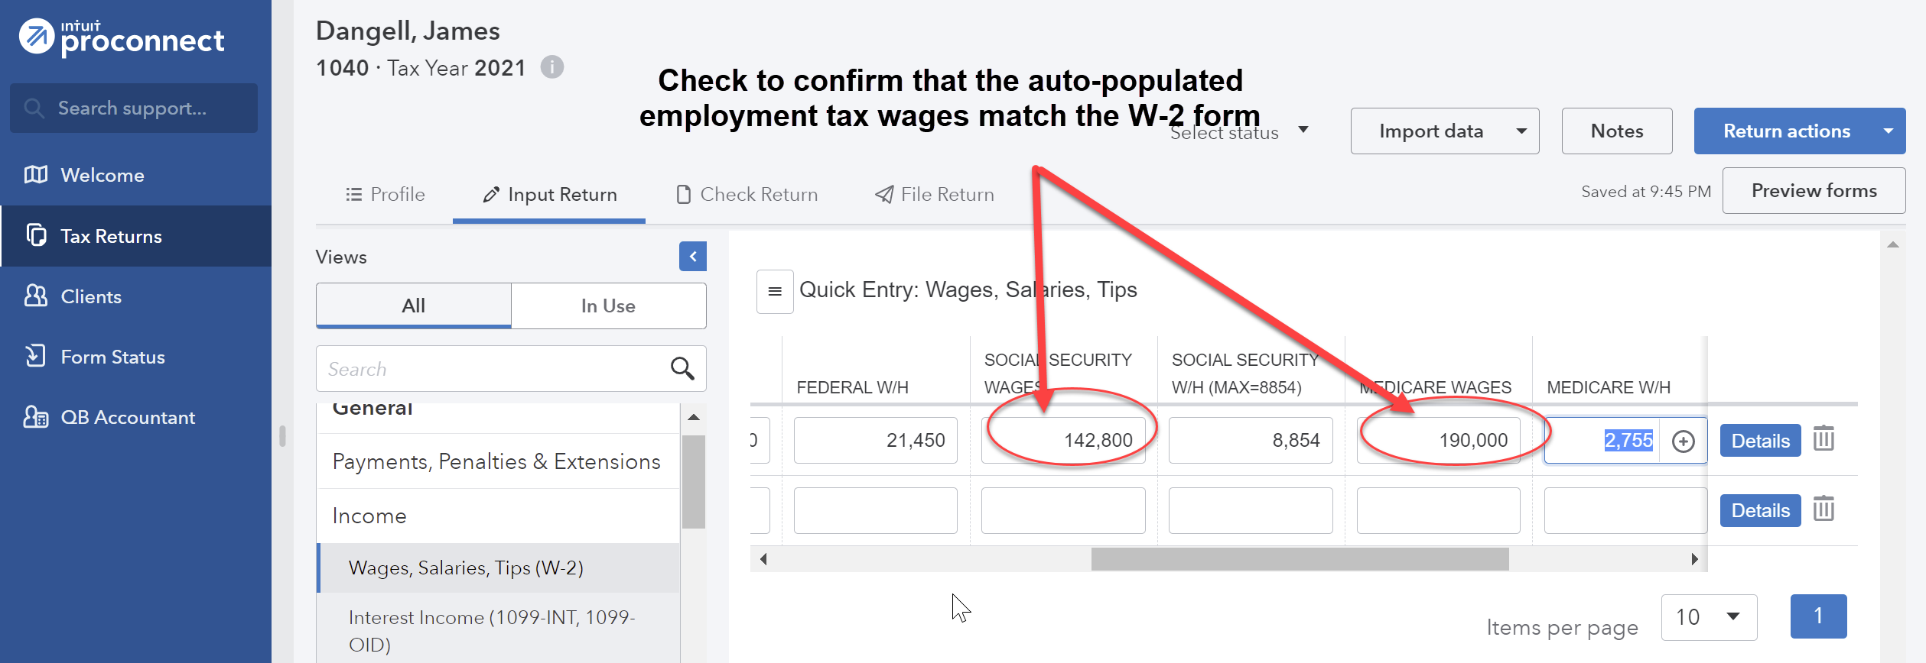
To enter the detail from Boxes 12a, 12b, and 13 of the Form W-2, click the blue Details button on the right-hand side and scroll down the page to enter the amount in Box 12a by using the dropdown box to select Code D=D-Elective deferrals to 401(k) plan. For Box 12b, use the dropdown box to select Code W=W-Employer Contributions to HSA and enter the amount. Check the Retirement plan box in the Box 13 section.
To enter the interest income, from the menu at the left, select Income; Interest Income (1099-INT, 1099-OID). From the Quick Entry: Interest Income screen, enter the name of payer and enter the amount for Banks, S&L, etc.
To enter the alimony paid, from the menu at the left, select Deductions; Adjustments to Income. Then select the Less Common Scena…tab near the top center of the screen. Click on the Alimony Paid box under Taxpayer which will expand and enter the ex-spouse’s information and amount paid for the year. Once finished, click on the OK box at the bottom. Because the divorce agreement is dated after December 31, 2018, the alimony paid is not deductible and input may also be omitted without changing the result.
To enter the contributions James made to the HSA, from the menu at the left, select Deductions; HSA/MSA/LTC Contracts (1099-SA, 5498-SA); Health Savings Accounts (8889).
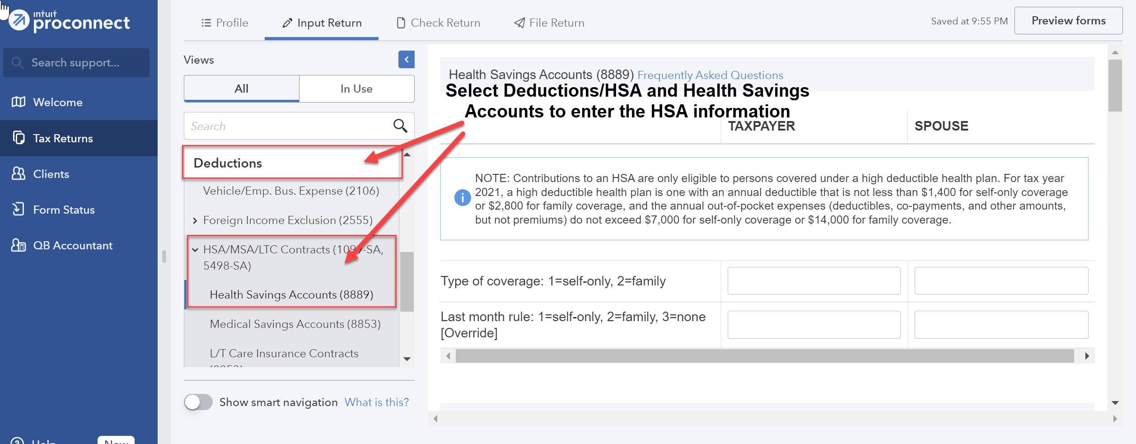
For Type of Coverage enter 1=self only. Scroll down and enter the HSA contributions that you made (1=maximum) in the Taxpayer column.
To enter James’ deductible expenses to be itemized, from the menu at the left, select Deductions; Itemized Deductions (Sch A). Select the appropriate tab across the top and enter the itemized deduction amount for each type (e.g., sales and local taxes and real estate taxes under the Taxes tab).
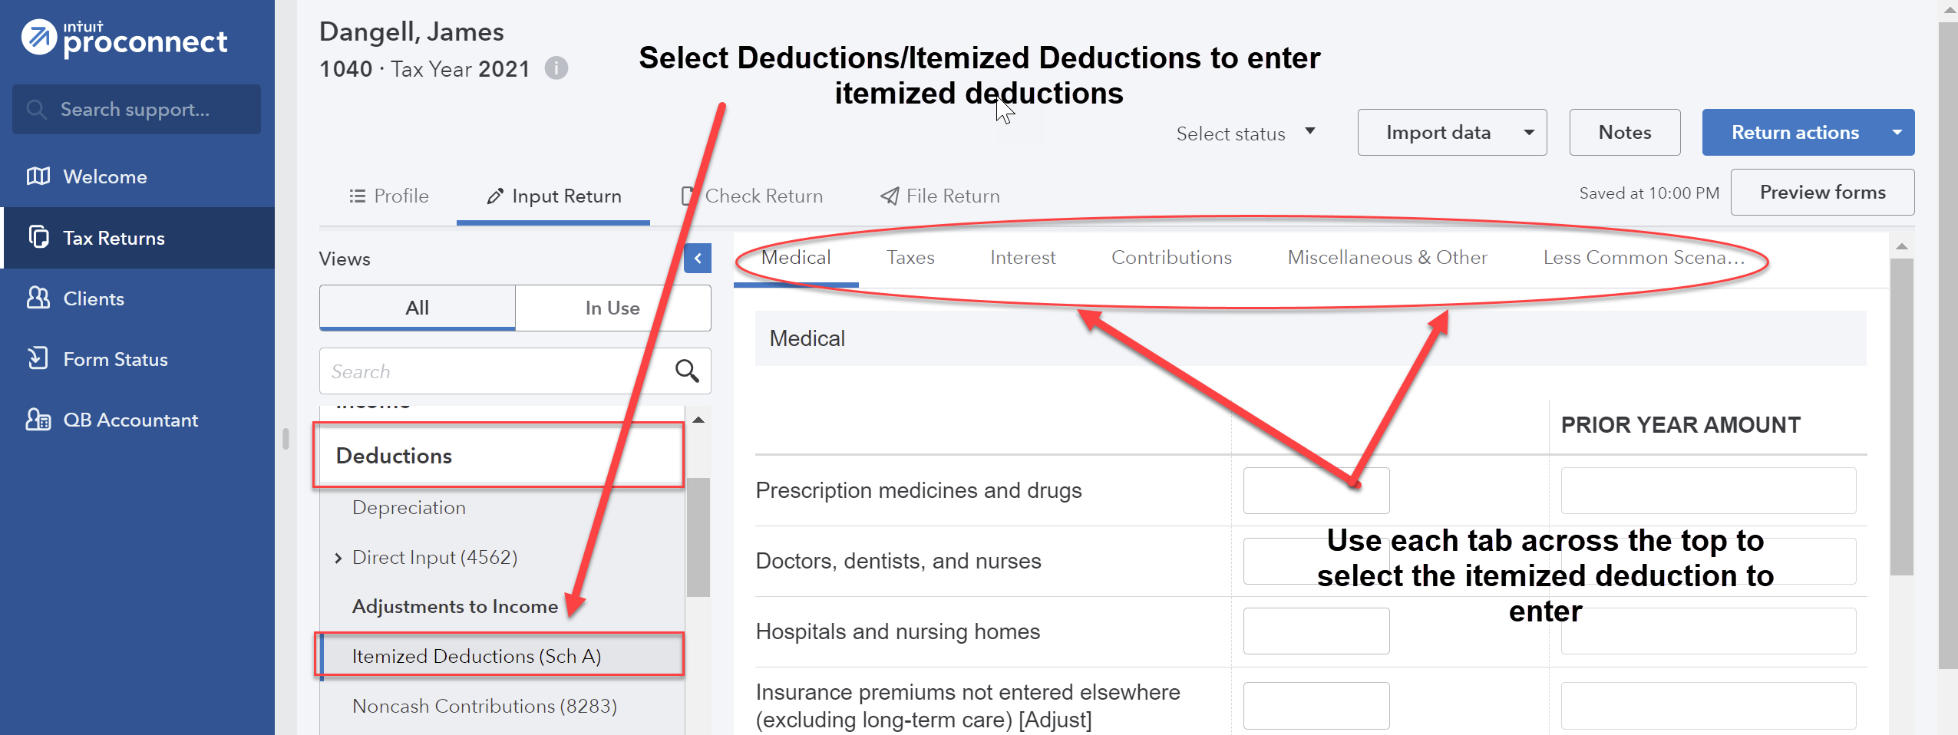
To enter the actual sales tax paid on the new car, input the amount under the Sales and Use Taxes; Actual Taxes Paid; State and local sales taxes (except autos and special items). Use information from the Form 1098 to enter in the Interest tab.
Note when entering charitable deductions, if an amount is paid to a charity and the taxpayer receives something of value in exchange, the deduction is limited to the amount that the contribution EXCEEDS the fair market value of the benefit received. Ask your instructor if you have questions about this. Also, check out the ebook regarding what types of contributions are NOT tax deductible.

James is not eligible for a 2021 Economic Impact Payment (EIP) due to the income limitation.
From the menu at the top, select File Return. From the menu at the left, under Print, select View/Print Return PDF. Click the blue Create PDF button which will result in a Download Return PDF blue button that you should click on. The return should open in a new tab. Review the return and if corrections are needed, close out of the tab and you can go back into the return and make the necessary corrections. Once complete, follow the File Return instructions again and then download the return by clicking on the download icon in the upper right corner, to the left of the print icon. Remember where you save the tax return. Close the PDF.
Group 4, Problem 2A: Jones, Bea
Sign into your ProConnect Tax account and from the Welcome screen, select Tax Returns in the left margin. You will land on the Tax Returns 2021 page. Select Create tax return in the upper right corner.
From the Create tax return screen, click the [+] for Add new and select the Individual (1040, 709) button (it is selected as the default). Fill out the information for Bea. Email and phone numbers are not required but you may enter assumed data if you wish. Click on Save at the lower right. On the next screen Client, you may review the information you input, make any corrections necessary through the Edit button on the upper right, and once satisfied, click on Save at the lower right.
You have now landed on Bea’s 1040 Profile page. You may unselect the Select for E-file for the Federal line under General since you will not actually be filing the tax return, but it is not required to do so. From the tabs near the top, select Input Return. You will now see Details: Client Information. The Filing Status will appear in the main window. Change filing status to 4 = Head of household. Scroll down this page and enter the Occupation for Bea. Continue to scroll down through this page and toward the bottom, under Miscellaneous Info, find Prepared by and select 3 = Self-Prepared.
From the menu at the left, select General; Dependents. You will now see the General Information tab on the right. Enter the information you have for Dee. You may leave Earned Income Credit and Child Tax Credit at 1=When applicable.
From the menu at the left, select Income; Wages, Salaries, Tips (W-2). See the New Tab to the right and click on the icon that looks like a sheet of paper, to the left of New Tab. This action takes you to the Quick Entry: Wages, Salaries, Tips screen. Enter the amounts for Bea’s wages and federal income tax withheld. The detail from Box 13 of the Form W-2, can be entered on the Quick Entry screen by checking the Retirement Plan box since Bea is eligible (but does not participate).
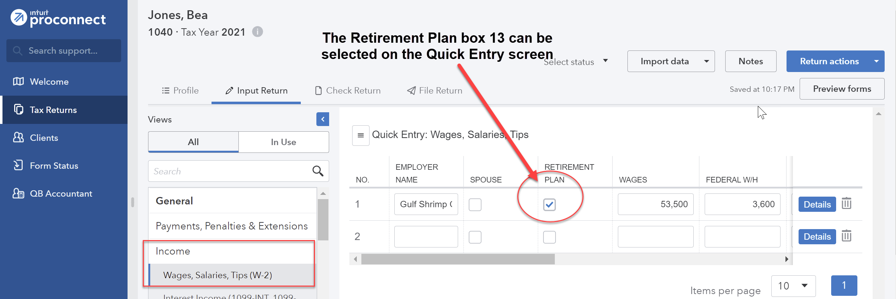
To enter the interest income, from the menu at the left, select Income; Interest Income (1099-INT, 1099-OID). From the Quick Entry: Interest Income screen, enter the name of payer and enter the amount for Banks, S&L, etc.
To record the alimony income, from the menu at the left, select Income; SS Benefits, Alimony, Misc. Income. Scroll down to the Alimony and Other Income section and enter the Alimony Received. Because the divorce agreement is dated after December 31, 2018, the alimony received is not taxable and need not be entered at all. Once finished, click on the OK box at the bottom.
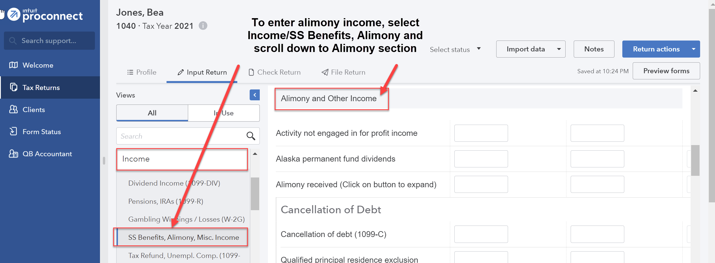
The $750 of student loan interest paid by Bea’s employer ($5,250 - $4,500) is excluded from income and is therefore not deductible. However, the $450 student loan interest that Bea paid herself is a deductible adjustment to income and can be entered from the menu at the left and selecting Deductions; Adjustments to Income. You have now landed on the Retirement tab. Select the Education tab at the top center and enter the amount of qualified student loan interest paid.
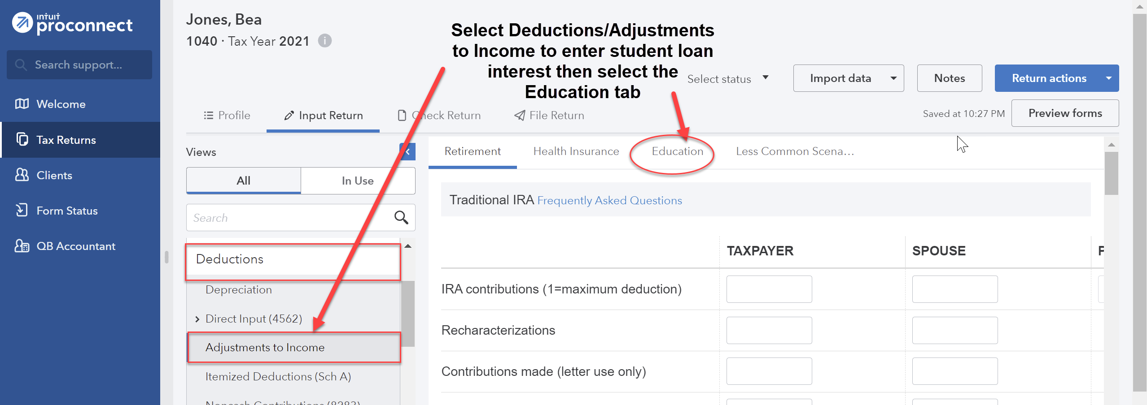
Under the Credits menu at the left, scroll down to Recovery Rebate, EIC, Residential Energy, Oth Credits. The tabs across the top are used to input the different types of credits. Select the Recovery Rebate Credit tab (the first tab and the default) and enter the appropriate amount of the Economic Impact Payment (EIP) received by the taxpayer in the Economic impact payment 3 box under the Taxpayer column.
Because Bea is not a member of the Armed Forces, she may not deduct her moving costs.
The distribution from the 529 Plan as shown on Form 1099-Q is excluded from income since it was used to pay for K-12 tuition.
To enter Bea’s deductible expenses to be itemized, from the menu at the left, select Deductions; Itemized Deductions (Sch A). Select the appropriate tab across the top and enter the itemized deduction amount for each type (e.g., sales and local taxes and real estate taxes under the Taxes tab and home mortgage interest on the Interest tab). To enter the actual sales tax paid on the new car, input the amount under the Sales and Use Taxes; Actual Taxes Paid; State and local sales taxes (except autos and special items).
Note when entering charitable deductions, check out the ebook regarding what types of contributions are NOT tax deductible.
To enter the IRA contribution, from the menu at the left, select Deductions; Adjustments to Income, landing you on the Retirement tab. Enter the IRA contribution under IRA contributions.
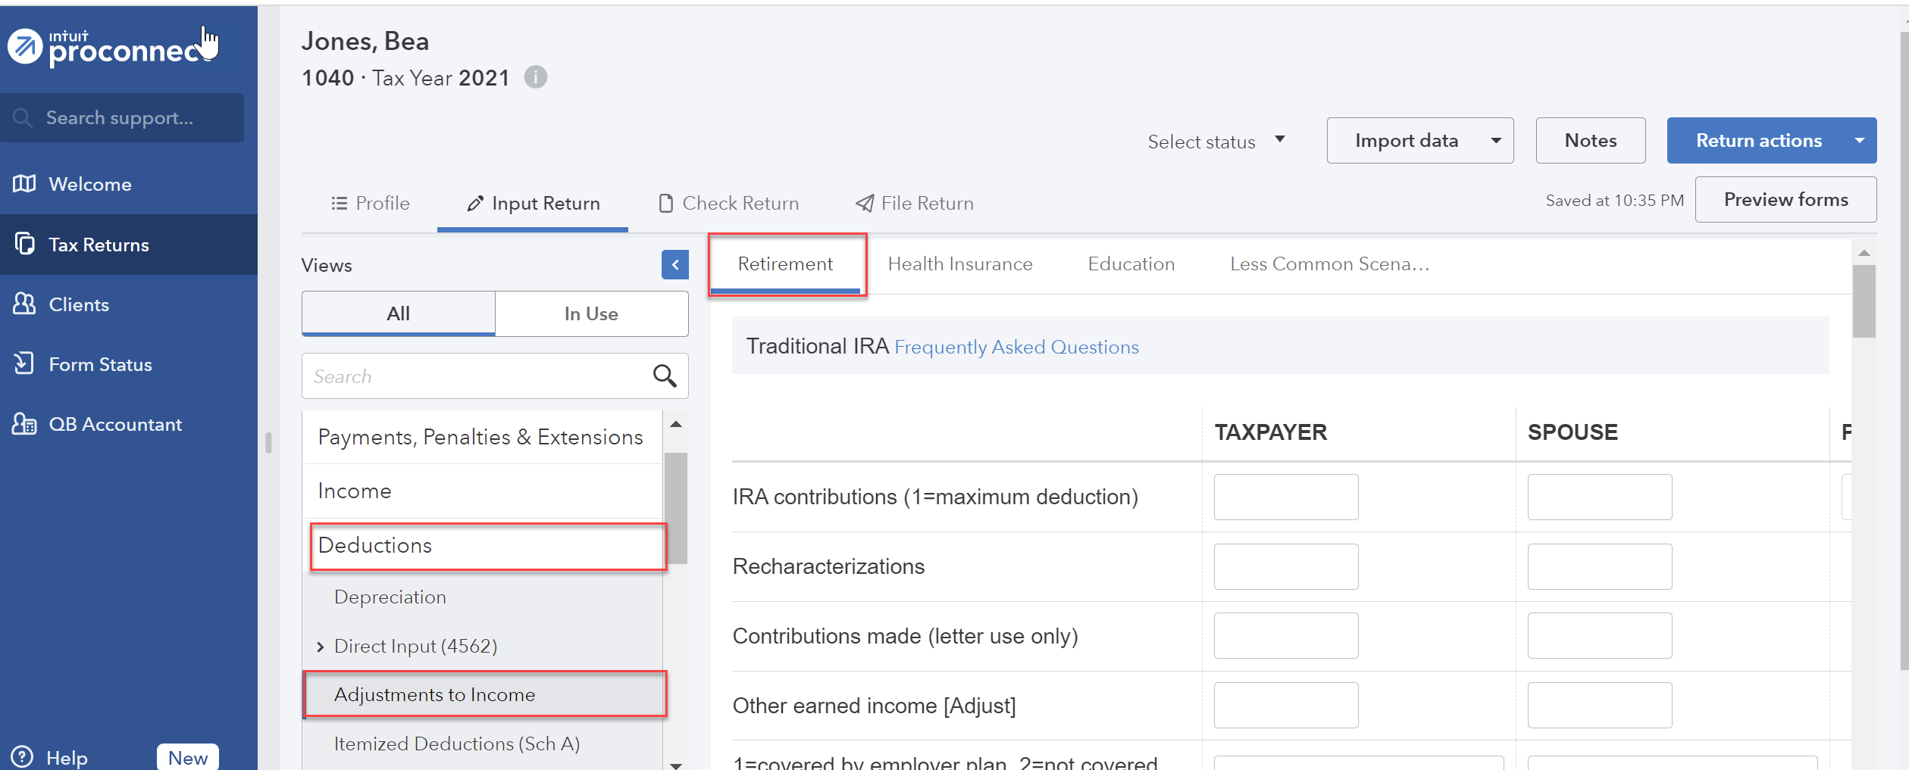
To record the casualty loss, from the menu at the left, select Income; Dispositions (Sch D, etc.); Schedule D/4797/etc. For the Description of Property, enter Residence, and enter the Date Acquired, and the Cost or other basis as $112,000. If in the Quick Entry screen, select the blue Details button at the right. At the top of the Details page, select the 4684, 6781, 8824, 42… tab. For Description enter Tropical storm. Enter 1=personal. For Disaster loss, select 7 from the drop-down list. Choose a FEMA Disaster Declaration Code for Georgia since there is not one on the list for FL despite there being a code given in the test. For the Fair market value before casualty or theft enter 112,000 and enter 100,000 for the Fair market value after casualty or theft. Enter the Insurance reimbursement and the Street Address, City, State, and Zip Code.
From the menu at the top, select File Return. From the menu at the left, under Print, select View/Print Return PDF. Click the blue Create PDF button which will result in a Download Return PDF blue button that you should click on. The return should open in a new tab. Review the return and if corrections are needed, close out of the tab and you can go back into the return and make the necessary corrections. Once complete, follow the File Return instructions again and then download the return by clicking on the download icon in the upper right corner, to the left of the print icon. Remember where you save the tax return. Close the PDF.
Group 4, Problem 2B: Fuji, John
Sign into your ProConnect Tax account and from the Welcome screen, select Tax Returns in the left margin. You will land on the Tax Returns 2021 page. Select Create tax return in the upper right corner.
From the Create tax return screen, click the [+] for Add new and select the Individual (1040, 709) button (it is selected as the default). Fill out the information for John. Email and phone numbers are not required but you may enter assumed data if you wish. Click on Save at the lower right. On the next screen Client, you may review the information you input, make any corrections necessary through the Edit button on the upper right, and once satisfied, click on Save at the lower right.
You have now landed on John’s 1040 Profile page. You may unselect the Select for E-file for the Federal line under General since you will not actually be filing the tax return, but it is not required to do so. From the tabs near the top, select Input Return. You will now see Details: Client Information. Scroll down this page and enter the Occupation for John. Continue to scroll down through this page and toward the bottom, under Miscellaneous Info, find Prepared by and select 3 = Self-Prepared.
From the menu at the left, select Income; Wages, Salaries, Tips (W-2). See the New Tab to the right and click on the icon that looks like a sheet of paper, to the left of New Tab. This action takes you to the Quick Entry: Wages, Salaries, Tips screen. Enter the amounts for John’s wages and federal income tax withheld. The detail from Box 13 of the Form W-2, can be entered on the Quick Entry screen by checking the Retirement Plan box since John is eligible (but does not participate).
To enter the interest income, from the menu at the left, select Income; Interest Income (1099-INT, 1099-OID). From the Quick Entry: Interest Income screen, enter the name of payer and enter the amount for Banks, S&L, etc.
To enter the alimony paid, from the menu at the left, select Deductions; Adjustments to Income. Then select the Less Common Scena…tab near the top center of the screen. Click on the Alimony Paid box under Taxpayer which will expand and enter the ex-spouse’s information and amount paid for the year. Because the divorce agreement is dated before December 31, 2018, the alimony paid is deductible. Once finished, click on the OK box at the bottom.
To enter the trade summary activity from the substitute Form 1099-B, from the menu at the left, select Income; Dispositions (Sch D, etc.); Schedule D/ 4797/ etc. Because the necessary information was provided to the IRS by the broker, the detail of each trade need not be entered. Instead, the aggregate data can be entered. Enter the Description of Property, the Date Acquired (use the first purchase date), the Date Sold (use the last sale date), and the total Sales Price. For the Cost or Basis, enter the total original cost basis.
To enter the Roth IRA contribution, from the menu at the left, select Deductions; Adjustments to Income, landing you on the Retirement tab. Enter the Roth IRA contribution under Roth IRA contributions.
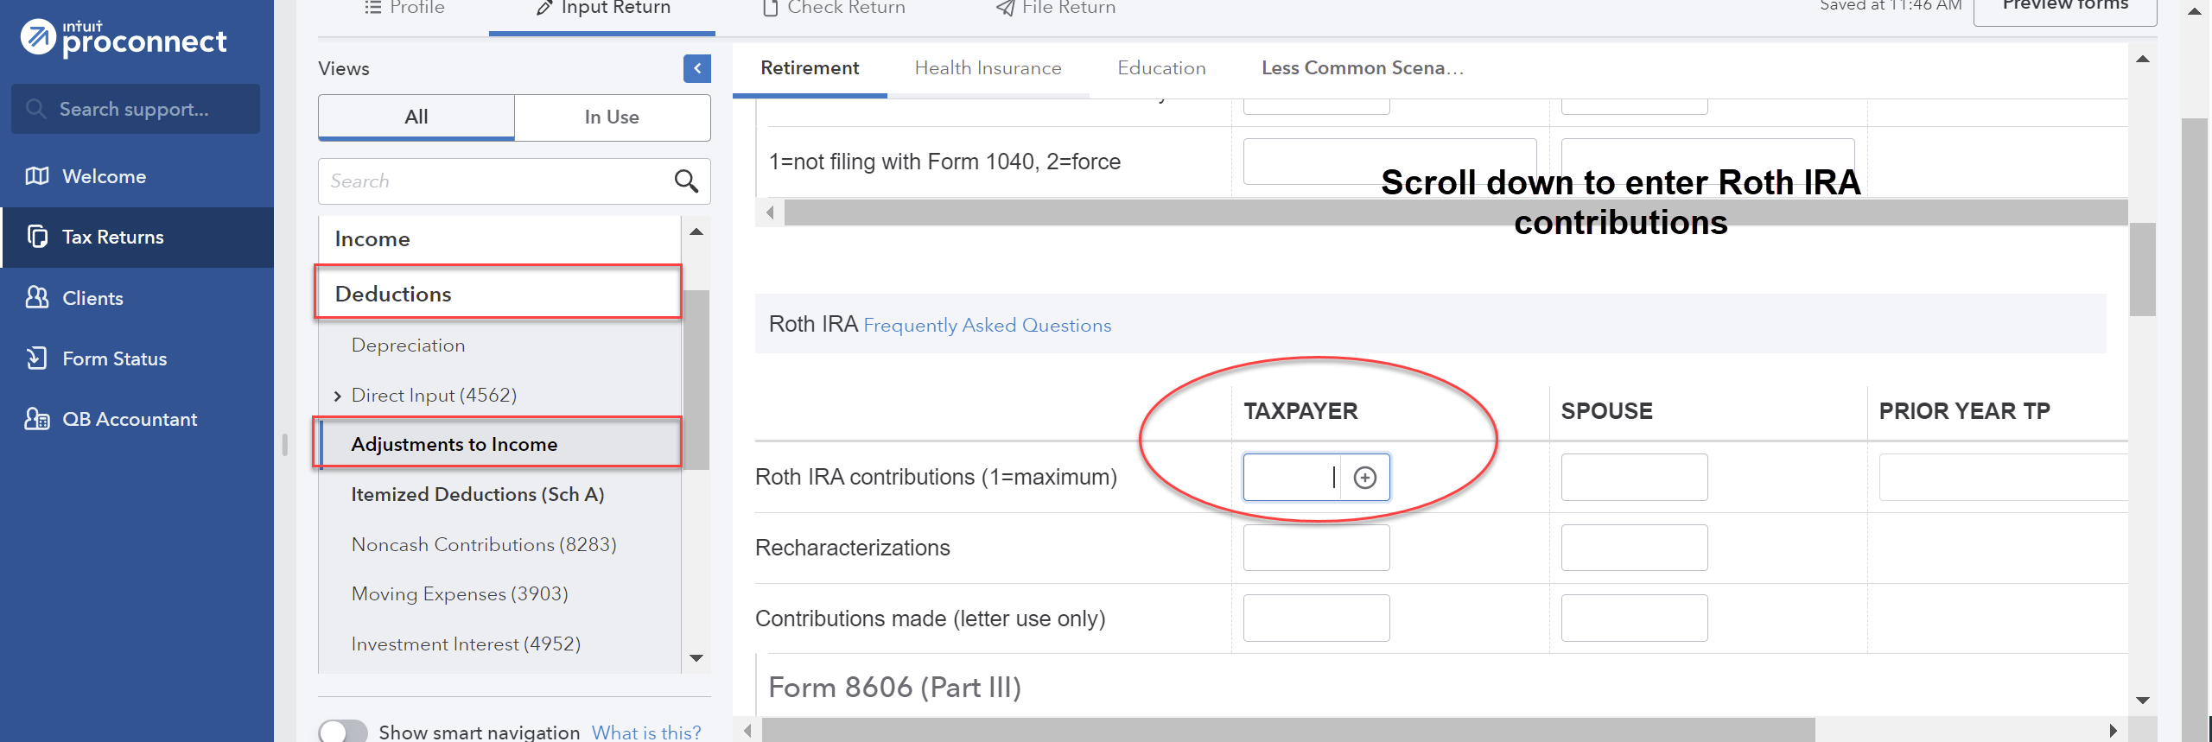
To enter John’s deductible expenses to be itemized, from the menu at the left, select Deductions; Itemized Deductions (Sch A). Select the appropriate tab across the top and enter the itemized deduction amount for each type (e.g., sales and local taxes and real estate taxes reported on the Form 1098, under the Taxes tab and home mortgage interest also reported on the Form 1098 on the Interest tab). To enter the state sales tax, input the amount under the Sales and Use Taxes; Actual Taxes Paid; State and local sales taxes (except autos and special items). After entering in the information, you shall see that the itemized deductions of $12,369 are less than the $12,550 standard deduction and thus John will take the standard deduction instead of itemizing. ProConnect Tax will automatically generate the maximum $300 charitable contribution deduction on Line 12b of the Form 1040 since John’s charitable contributions exceeded $300 and he is taking the standard deduction. The total itemized deductions can be found on the Federal Tax Summary produced by ProConnect when the return is printed in the final step.
Under the Credits menu at the left, scroll down to Recovery Rebate, EIC, Residential Energy, Oth Credits. The tabs across the top are used to input the different types of credits. Select the Recovery Rebate Credit tab (the first tab and the default) and enter the appropriate amount of the Economic Impact Payment (EIP) received by the taxpayer in the Economic impact payment 3 box under the Taxpayer column.
From the menu at the top, select File Return. From the menu at the left, under Print, select View/Print Return PDF. Click the blue Create PDF button which will result in a Download Return PDF blue button that you should click on. The return should open in a new tab. Review the return and if corrections are needed, close out of the tab and you can go back into the return and make the necessary corrections. Once complete, follow the File Return instructions again and then download the return by clicking on the download icon in the upper right corner, to the left of the print icon. Remember where you save the tax return. Close the PDF.

