Course Tools – Accessibility – Blackboard Ally Instructor Report (Adding)

This handout will walk through the steps to add the Ally Instructor Report to a course.

Adding the Instructor Report to a Course

- Navigate to a course.
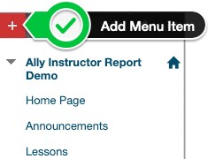
- Select the Add Menu Item button (the plus sign at the top left of the course menu).

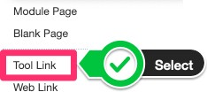
- Select Tool Link from the list of options.

- In the Add Tool Link pop-up box enter the following information:
  - Name → Accessibility Report
  - Type → Accessibility Report
  - Do not check the box Available to Users.

NOTE: Do not change the name – use the value provided above exactly as it is shown.
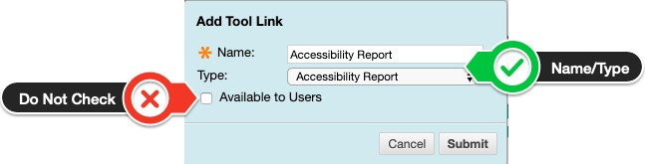
- Select the Submit button. The link is now available on the course menu.
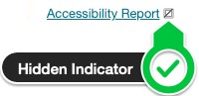
- Click the menu link. The final result will show the Hidden Indicator to the right of the text.
NOTE: If the hidden indicator is not shown select the chevron next to the text and choose Hide Link.

Revision Date: 08/13/19 Page 1 of 1

