STC Basic Blackboard Instructions

For Help: Please check the L: _How to Documents – Instructor folders.
You should set up your master course first and then copy to the crn#.

Ensure only 1 Grade Schema
- Go to Grade Center
- Click Full Grade Center
- Click Manage, Grading Schemas
- Click the drop-down arrow next to the Letter (Rounding) and rename to only Letter.
- Click the drop-down arrow next to any other schema and click delete.
- Click Ok

Create a Category (These need to come from your Syllabus Grading Policy)
- Go to Grade Center
- Click Full Grade Center
- Click Manage, Categories
- Click Create Category
- Type Name
- Type Description (optional)
- Click Submit, Click Ok

Change items already created to match your Grading Policy categories
- Go to Grade Center
- Click Full Grade Center
- Click Manage, Column Organization
- Scroll down and check the assignments you want to move to a different category
- Click change category button, select the category
- Click Submit

Set Weight Percentages for Categories
(Ensure that you only have 1 Overall Average/Final Grade column)
- Go to Grade Center
- Click Full Grade Center
- Click the drop-down arrow to right of Weighted Total column, choose edit column information
- Rename the Weighted Total column to Overall Average.
- Scroll down and choose the category (Assignments, Tests, Final) in the Categories to Select box
- Click to move it to the Selected Columns section
- Type % for each category
- Scroll down and click submit
- Click the drop-down arrow to right of Weighted Total column, set this column to your External Grade.

Ensure all gradebook is in the correct category and with the appropriate points/percentage.
- Go to Grade Center
- Click Full Grade Center
- Click Manage, Column Organization
- You can click the four-point arrows on the left to move up or down to sort them.
- Make sure the category is correct for each column and that it is out of 100 points .
- The Overall average should be totaled to 100 points.
- All columns should be a percentage type column or all points. You cannot mix points and percentages.

If you don’t have a Weighted Total/Overall Average column
- Click Create Calculated Column, Weighted Column
- Fill in Column Name as Overall Average.
- Follow steps to set weight percentages for categories to assign weights to categories
- Click the drop-down arrow t right of the Overall Average column, Set this column to the external grade.

If you are manually entering your grades into the column.
- Create a column and Name it Final Grade.
- Click the drop-down arrow t right of the Final Grade column, Set this column to the external grade.
- You will click in the grade box to manually enter the student grade.

Setting up your Table of Contents Menu in Blackboard for Masters on the L: Drive

No SHOW Policy for marking No Shows on the L: Drive

Pushing Grades at the end of the semester on the L: Drive.

Copy Course from the Master to the crn#
- Go to the master course
- Click Packages and Utilities in the Control Panel section
- Click Course Copy
- Click Browse to select destination course. Ensure it has the crn# of the course you want to copy to.
- Click Select All to copy entire course
- Click Submit

Discussion Boards (2 step process)

Step 1 – Create Discussion and options
- Click Course Tools in Control Panel
- Click Discussion Board
- Click title of your course forum
- Click Create Forum to make a discussion Board
- Give it a name
- Click in Description and give your instructions (Copy all of the description for step 2-#4 below.)
- Click to select Participants must create a thread if you do not want students to see each other’s post before they type their own.
- Click Grade Discussion and give it 100 points possible.
- Change the needs grading after to 2 or 3 posts.
- Optional: Add rubric
- Enter Due Date required.
- Optional: Allow member to rate posts
- Click Submit

Step 2 – Deploy/Give to Students
- Go to location such as lessons to give to students.
- Click Tools, Discussion Board
- Click Select a Discussion Board, select your discussion and click next.
- Enter the description again from when you created/copied above.
- Click Submit.

Tests, Surveys, and Pools (2 step process)

Step 1 – Create Test by importing, creating, or from a third-party such as Examview/Respondus

Import a Test Pool to Blackboard
- Download zip file for test pool from Cengage or publisher website
- Click Course Tools in Control Panel
- Click Tests, Surveys, and Pools
- Click Pools
- Click Import Pool
- Browse to select zip file
- Click Submit

Create a Test from a Pool
- Click Course Tools in Control Panel
- Click Tests, Surveys, and Pools
- Click Tests
- Click Build Test, fill in name, description, etc… (Cannot have dashes, slashes, etc in the names)
- Click Submit
- Click Reuse Questions, Find question to select questions from pool to create test

Import a Test from ExamView to Blackboard
- Create and save test in ExamView Test Builder
- Click File, Export, Blackboard 7.1+
- Type file name and choose location to save – I create a folder named Test Exports so all the tests will be together, which makes it easier for test upload into Blackboard.
- Click Save
- Type Name, Description, and Directory Name for test package
- Click OK – this creates a zip file that can be uploaded to Blackboard
- Follow steps 1-6 until all tests have been created and exported
- Log into Blackboard and go into the class
- Go to Control Panel, Course Tools, Tests, Surveys, and Pools
- Click Tests
- Click Import Test
- Click Browse My Computer to navigate to the test package
- Select the test package zip file, click open
- Click Submit – the test has now been imported and is ready to be deployed

Step 2 – Deploy/Give to Students

- Go to Lessons and go to the location where you would like to deploy the test
- Click Assessments, Test, Select the test to be deployed, Click Submit
- Set the Test options, Click Submit

Accessibility

How to Make Items Accessible on the L: drive

Last Resort to Make a PDF Accessible on the L: drive.

Making a KMS Standard Accessible on the L: drive.

Blackboard Building Content Tips
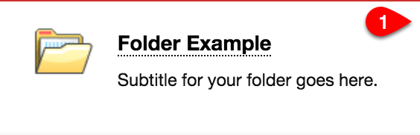
The following are quick tips for identifying various Content Items inside of Blackboard Learn. Additional resources, videos and handouts can be found at http://www.gvtc.org/bblearn under the guides and tutorials area.

Folder
A course area that contains content items. Folders allow content to be structured with a hierarchy or categories.

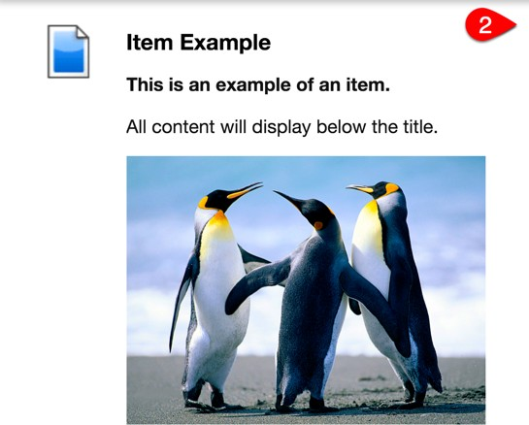
Item
An item can contain text, audio, movies, files, images, and mashups. If you add text, you can format it using the content editor functions. Items display all of the content placed inside of the Content Editor directly below the title.

Blank Page
The blank page tool allows you to include files, images, and text as a link in a course area. Blank pages present content in a different way than items do. There is no description that appears below the title of the page. Users see your content only after clicking the link.

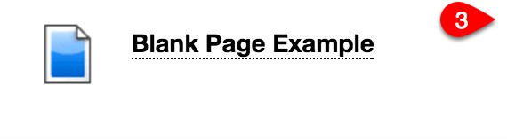
File
An HTML file that you can use in your course. These files can be viewed as a page within your course or as a separate piece of content in a separate browser window.

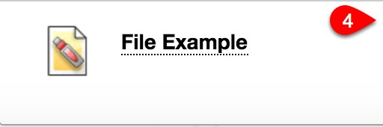
Web Link
Link to an outside website or resource. It is always recommended to open web links in a new tab/window.
Note: Web Link URLs should NEVER be in all CAPS. This will cause an error locking you out of the content area.
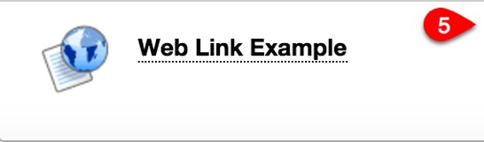

Mashups
Mashups allow you to include content in a course that is from an external website. Three types of mashups are available:
  - Flickr Photo®: Link to a site for viewing and sharing photographic images.
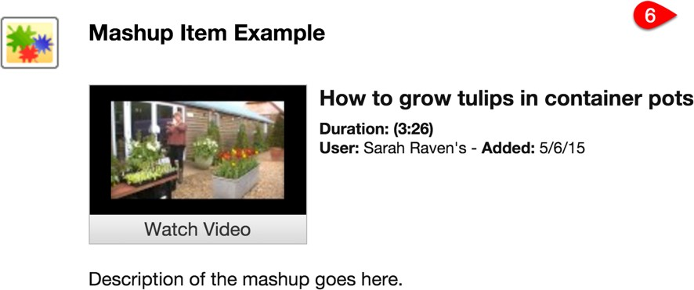
  - SlideShare: Link to a site for viewing and sharing PowerPoint presentations, Word documents, or Adobe PDF Portfolios.
  - YouTube™: Link to a site for viewing and sharing online videos.

Learning Module
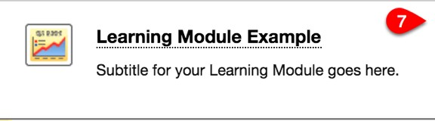
A set of content that includes a structured path for progressing through the items. Learning Modules can hold the same content as folders, however, they are not stackable. You cannot put a Learning Module inside of another Learning Module as you can a folder.
- Sequential Viewing – The option to force sequential viewing is available for Learning Modules, however, items will always have to be viewed sequentially even if a student has already viewed the materials.
- First Page of Learning Modules – NEVER place a Web Link or File as your first page of the Learning Module as this will cause your students to exit the module before they are on the first page. An Item or Blank Page as an introduction to your Learning Module is a great way to give students basic information about the content inside of the Learning Module.
- Item Availability – Though each individual item can have its own availability dates, it is recommended to keep content simplified by using one over-­‐arching Availability Date for the Learning Module as a whole.
- Module Page – This is NOT to be used with Learning Modules. Though terminology is similar, a Module Page is a page of modules similar to most courses’ Home Page. (See #8 Below).
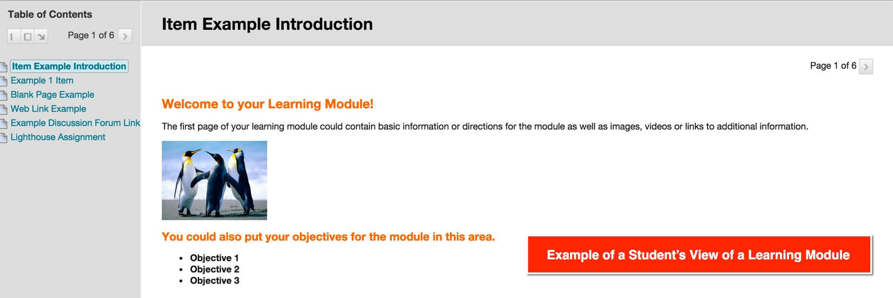

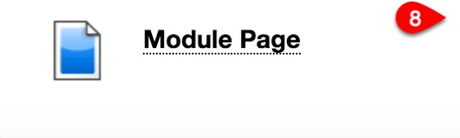
Module Pages
Module Pages are specialized content pages that present content in discrete boxes. The modules that appear on this page can be arranged in any order. Most courses have a Home Page that is classified as a Module Page.
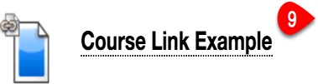
Note: Module Pages are NOT used in Learning Modules.

Course Link
A shortcut to an item, tool, or area in a course. The Course Link will have the same icon as the linked content plus a small link symbol in the upper left corner.

Assignment Tips
The following are quick tips for managing Assignments inside of Blackboard Learn. Additional resources, videos and handouts can be found at http://www.gvtc.org/bblearn under the guides and tutorials area.

- Editing an Assignment – Click the Options Menu to the right of the assignment title. This will allow you to edit the assignment settings including the following: Assignment Information, Assignment Files, Due Date, Grading, & Availability.
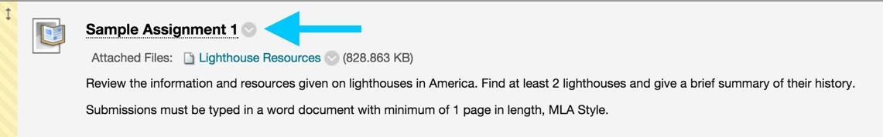

- Assignment Availability – The Make the Assignment Available option must be checked in order for students to have access to the assignment. If a future date is chosen, the Make the Assignment Available option still must be checked.
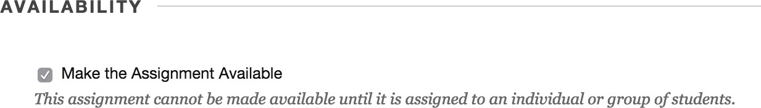

- Due Dates: The Due Date feature for assignments is only a suggestion, but instructors will see a Late Flag on assignments in the Needs Grading area as well as in the Grade Details page of the student’s assignment in the Gradecenter. Using the Due Date feature will auto-­‐populate the item to the Calendar as long as the item is currently available. It will not populate items until they are available for students if a future availability date is chosen.

- Assignment Files – To attach files to an assignment this may be done in the content editor area OR single or multiple files can be added to the Assignment Files area below the content editor. Instructors can Browse My Computer or Browse Course (Content Collection) to add files.
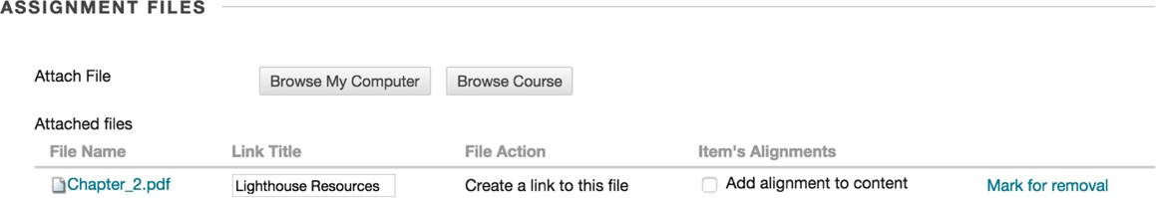

- Rubrics – If no Add Rubric button is available in the Grading section of the assignment, instructors can go to the Course Management area, Click Customization > Tool Availability. Scroll down until you find Rubrics to be sure the item is checked.
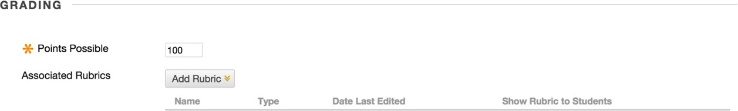

- Submitting Attempts – When students submit an attempt, instructors can use the inline grader to grade some documents with the option to markup the document within the browser. Those file types are: PowerPoints, Word Documents, Excel files and .PDF files.
  - Note that instructors will not be able to see the formulas for the individual cells in Excel files unless the file is downloaded and opened in Excel.
  - Students should always use the Attach File option for submitting these files for instructors to grade with inline grader.
  - If a student uses the Write Submission option for submitting the assignment, instructors will not be able to utilize full features of the inline grader.
  - If a student submits a file other than the 4 types listed above, instructors will be given the option to download the file for viewing.
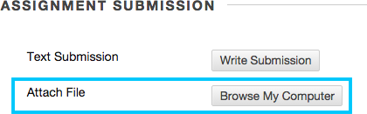
- Ignoring, Clearing, & Exempting Attempts:
  - Ignore Attempt — [Under View Grade Details for a specific grade cell] Allows the instructor to allow an additional submission and retain the original submission. Before the attempt is ignored view the attempt and provide a note in the feedback area documenting why the attempt is being ignored.
  - Clear Attempt — Deletes the actual attempt and its details. See Ignore Attempt option.
  - Exempt Grade — Grade is ignored in calculations. Document with a quick comment.
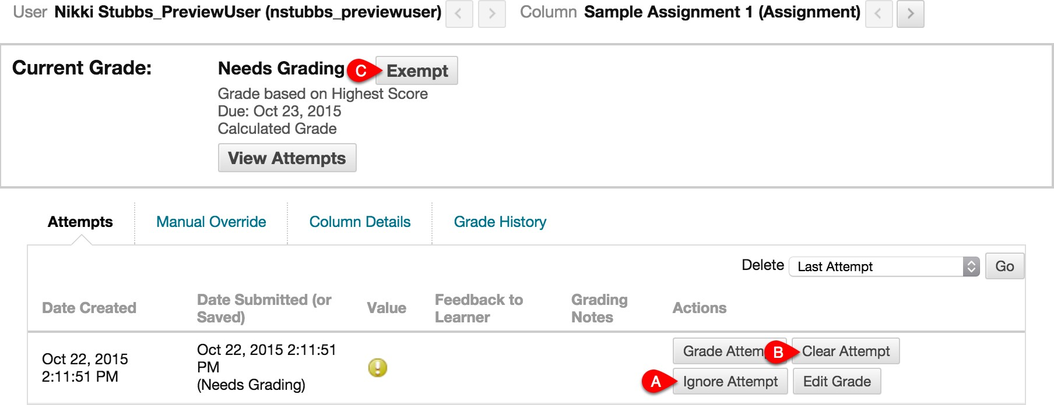

End of the Semester Duties

Reminders
- Ensure that zeros are entered for all assignments that students do not complete by the due dates.
- Calculate at least 3 students to ensure gradebook is calculating correctly.
- Delete any extra columns from the copy such as Weighted Total, Total. You should only have 1 column for the Overall Average (if blackboard is calculating your grades) or Final Grade (if you manually enter the grade). Delete any extra. This column should be checked green in order to push your grade.
- Double check the LDA Column in BB for accuracy. Check your Gradebook for accuracy.
- Students that do not complete a proctored event on the schedule date and do not give a valid documented excuse within the 3 business days of the event are given a ZERO for the proctored event grade.
- For F2F Proctored Exams: Save the required sign-in sheet. (This is on the Intranet.)
- Save a printed or electronic copy of the Banner Grade Sheets for each of your courses. Please note LDAs associated with withdrawals and F grades and make sure you have proof of each LDA.

Backup the Grades
- Go to Grade Center
- Click Work Offline
- Click Download
- Click Submit
- Click Download
- Save to your machine, one drive or location of your safe keeping.
- Open and print to keep printed version. Save the paper gradebook with your records including any third-party grade books and/or reports.

Create a Grade Report of all students
- Go to Grade Center
- Click Reports
- Click Create Report
- Name Grade Report for Course (Example: CIST1100 Grade Report for all students)
- Select Date, Course Information
- Select the check box to include hidden users.
- Click Submit
- Right click and print. Or use the Browser printer options.
- You can save by changing the printer to a print to pdf or save to pdf.
- Save to your machine, one drive or location of your safe keeping.

Create a Grade History Report of all students (Has Grades and Comments)
- Go to Grade Center
- Click Reports
- Click View Grade History
- Change the total entries on the right to: All and click GO
- Scroll to the bottom and select SHOW ALL.
- Scroll back up to the top. Click the column named USER column twice to sort them by user.
- You can copy and paste to Word for a specific student.
- Click the download (top left). Save the document to keep for records. (This is often long)
- You can save by changing the printer to a print to pdf or save to pdf.
- Save to your machine, one drive or location of your safe keeping. Example: CIST1100 Grade History for all students

Create the Student Last Access and Submission Date report of all students
- Go to Course Tools
- Click My Reports
- Click Student Last Access and Submission Dates
- Change the Course ID to your current course
- Change the Output Selection to pdf.
- Click Run Report
- Give the file a name with date such as “CIST1220 CRN60053 Student Last Access and Submission Dates 07252022”.
- Save to your machine, one drive or location of your safe keeping.

Archive Videos from Collaborate/WebEx/Zoom… at the End of the Semester
- Go to course that you want to copy (source)
- Click Virtual Room - Collaborate
- Click the three lines. Click recordings
- Click Filter by: Change to Recordings in a Range. Change the date to the course begin date, click ok.
- Click the three dots on the session recording line. Click download
- Save to a location of your choosing (NOT the STC drives), your PC, a flash drive, external storage.
- All videos are saved for 2-3 semesters and then are deleted by TCSG office.

Completing an LDA
- For an LDA resulting from a withdrawal or F grade, save the proof of the LDA in a location where you can find it in case there is an audit years later! Save all LDA proof with your grades.
- Use the LDA column in Blackboard to help you document each LDA as it occurs. Click the LDA column drop arrow, Enter a short description of the last assignment with date in the box. Example: Hmw1072522 (This is short for Homework 1 on July 25, 2022 – add this in next step)
- Click the LDA column drop arrow, add a comment with more detail of the LDA information. Such as LDA Homework 1 on July 25, 2022.

Examples of information to use for LDA.
- Face to Face: Sign-in sheets / Attendance proof; Hybrid: Sign-in sheets / Attendance Proof or Online Work Proof; Online: Online Work Proof (The last graded online activity such as third-party work, quiz, test, discussion board, essay, etc.…) If a student is withdrawn using the date from the registrar, save that email as the proof of the LDA used.
- Save registrar emails that tell you the LDA for students who withdrew themselves. Use the LDA given by the registrar and document in the LDA Column something like 11/20/21_per reg email.
- Save attendance Records
- Save documentation of any administrative withdrawals – cheating, etc.…
- Save Blackboard grade & date records that correlate with the LDA
- Save a hard copy or electronic copy of the assignment, discussion board, and/or test record that correlate with the LDA
- Save reports/evidence from your third-party resources – student grade records or activity records, class record, etc.…
- Save proctored exam sign-in sheets. (These are found on the intranet.)

TCSG office archives all courses. Archives are not good methods of retrieval due to the systems updating therefore it is not a valid way to save this information and should not be done.

