Sending Reminders
Blackboard allows instructors to send automated reminders to students who have not attempted a graded item in Blackboard. This guide will demonstrate how to send reminders to students from the Grade Center

Sending a Reminder, Part 1
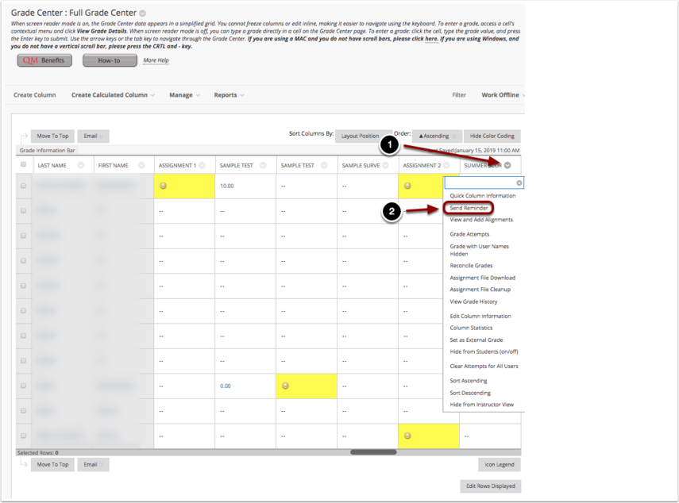

To send a reminder to students:
- In the Full Grade Center, Click on the contextual menu button for the assignment you wish to send a reminder for.
- Select Send Reminder from the menu that appears.

Sending a Reminder, Part 2
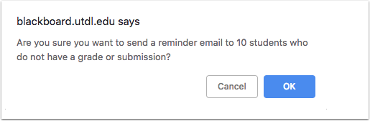
A dialog box will appear asking you to confirm sending a reminder to students. You will be able to see the number of students who have not submitted. Click OK to confirm sending a reminder.

