Course Content – Content Editor – Adding Media to Content Editor (SAAS)

How to Add Media to the Content Editor
Adding media content to the content editor can be completed by selecting the Add Content icon. Media may include images, files, embedding YouTube videos, Flickr photos, Slideshare presentations, or a variety of other tools depending on your college’s configuration.
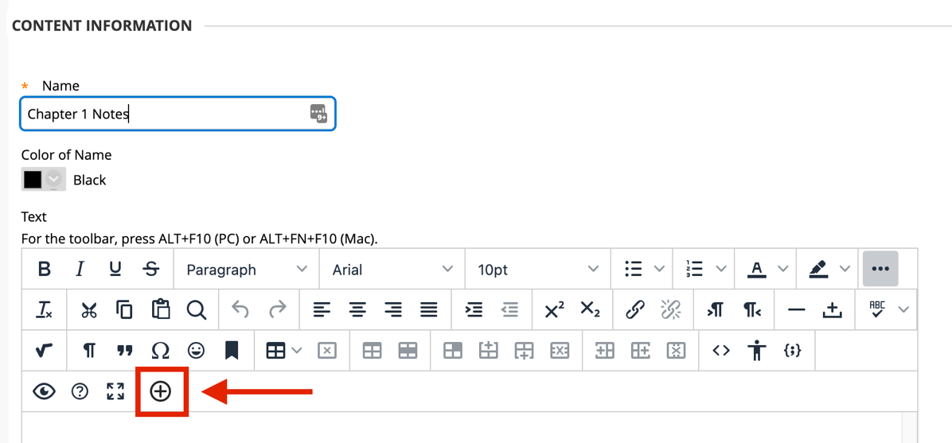

In the new window, choose one of the Common Tools (local or course files). Additional Tools are available according to the content type you are creating and are listed in alphabetical order. The available tools in this window may vary slightly according to your college’s third party configurations.

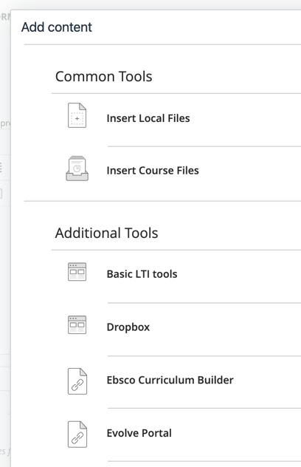

Revision Date: 11/3/2021 Page 1 of 1

