Create a Sign-Up Form in Blackboard using Wiki Tool

https://youtu.be/akKuGLYv4ow (Video)

Go to Lessons - Tools – Wiki
To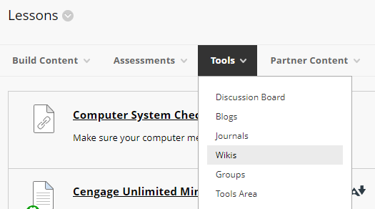

Create a New Wiki. Click Next
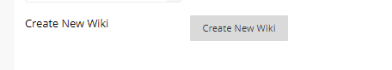

Name it and add directions. Example below. You can set availability dates/time to display. Leave “Open to Editing”, click “Closed to Commenting”. Click Submit
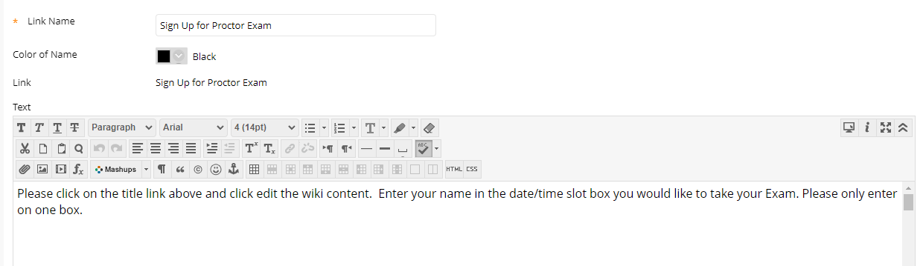
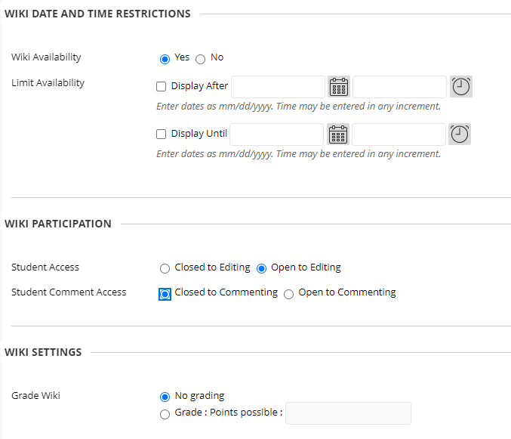

Click Submit. Click Next, Click Submit. This is just the placeholder for the Wiki.
Click the actual Sign up Wiki Assignment link
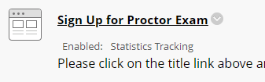
You will need to rename it, one more time. Use the same name. Enter the same as instructions as before. Add your table of Dates and Time. You can copy my information below and change for your preferences of information/dates/times. Just copy and CTRL-V to paste into your box.
You can click in the box to edit the date and information. Right click on the table, select row, and add/delete rows as needed.
Example for you to copy below and paste:
Please click on the title link above, click "EDIT THE WIKI CONTENT". Enter your name in the ONE date/time slot box you would like to take your exam.
Date | Time | Student Name
10/21/2021 | 9:00 a.m.
10/21/2021 | 9:00 a.m.
10/21/21 | 9:30 a.m.
10/21/21 | 9:30 a.m.
10/22/21 | 9:00 a.m.
10/22/21 | 9:30 a.m.

Once a student enters their name in the box, all will see the name. You can click the title again and on the right side, under Wiki Details. click the arrow next to the title, click History. You can see the history of when they add or change the form.
