Course Tools – Groups – Sign-up Lists

When creating groups, instructors have the option to create sign-up lists. Blackboard’s sign-up lists takes the place of paper sign-up sheets. They are used to allow students to sign-up for opportunities or activities that may be available. Sign-up Lists are only available when using the Self-Enroll group options. Follow the steps below to create sign-up lists via a single group. The steps are the same for both a single group and group set.

1. Navigate to *Groups* by selecting the **Users and Groups** section in the Control Panel.
2. Select **Groups**.

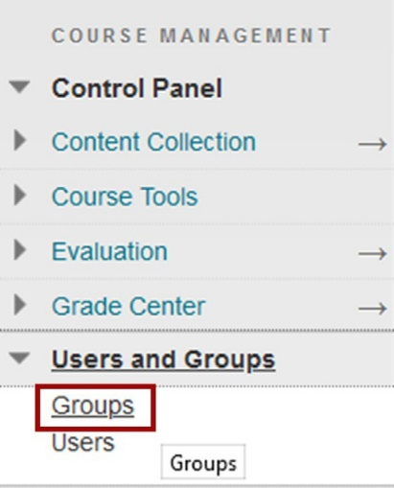

1. From the *Groups* page, select **Create**.

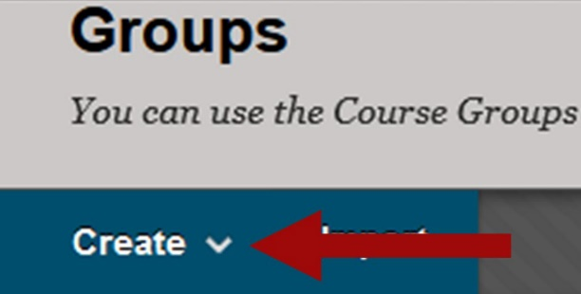

1. In the *Single Group* section, select **Self-Enroll**.

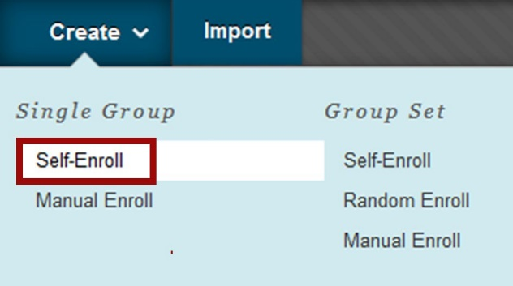

1. Enter a **Name**. *A description is optional*.

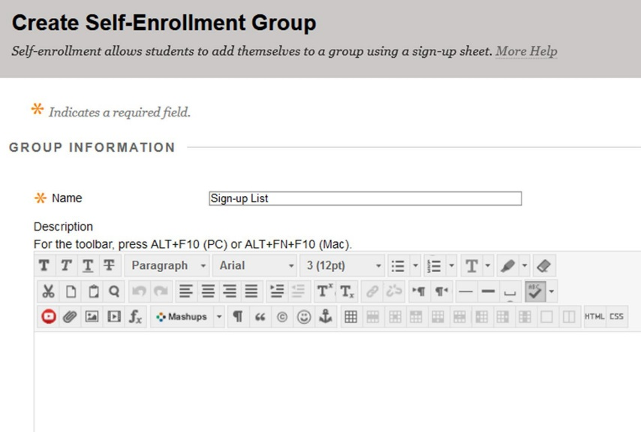

1. Underneath the description, determine if the group should be visible to students or if only the sign-up sheet should be visible.

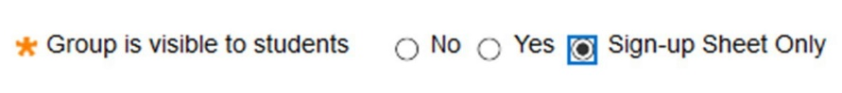

1. Enter the settings for the group. Refer to the GVTC handout [Course Tools – Groups – Creating and Using](https://gvtc.tcsg.edu/Portals/0/Documents/CourseToolsGroupsCreatingandUsing.pdf?ver=dmQWSemN9Qr_q5kz5N5mIg%3d%3d) for instructions on creating groups and descriptions for the settings.

A. Determine what tools will be available to the group.

group tool availability menu

* + Uncheck all the tools if the group is for your management view only. (Such as monitoring Move on When Ready students or Sign-Up sheets for Proctoring).
* If the group is for coursework determine which tools will be needed for the students to complete their assessments/projects.
* Recommend uncheck Allow Personalization (this keeps a consistent look and feel for students).
* Define how many groups are to be created at once. Do not enter an amount for maximum if you do not have a size limit.
* Check “Create smart view” for this group for projects. For sign-up sheets, leave blank.

1. In the *Sign-Up Options* section, enter a **name** for the sign-up sheet.
2. Enter the *Sign-up Sheet Instructions*.
3. Enter the *Maximum Number of Members* allowed to sign up.
4. Select the *Show Members* checkbox if students will be allowed to see names of other members in a group before they sign up.
5. Select the *Allow students to sign-up from the groups listing page* checkbox for the sign-up list to appear on the groups listing page.

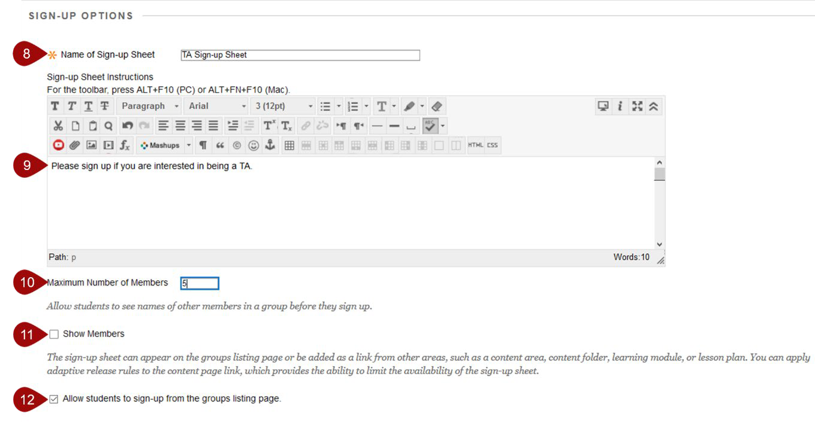

1. Select **Submit**.

# Add the Sign-Up List to your Content Area

1. Navigate to a content area.
2. From the *Tools* menu, select **Groups**.

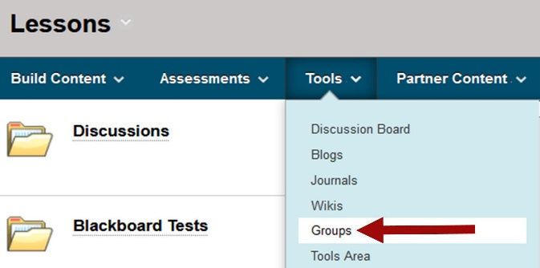

1. Select **Link to a Group or Group set**, then choose the Group that includes the sign-up list.

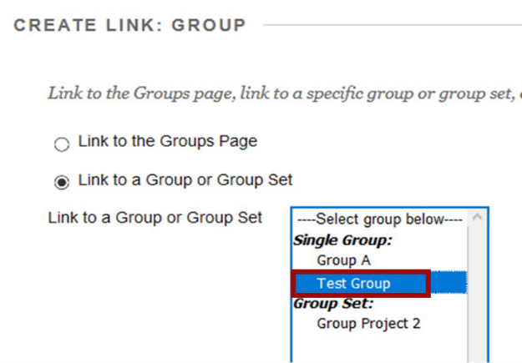

1. Select **Next**.
2. Enter a **Link Name** and **Text** to describe the link.

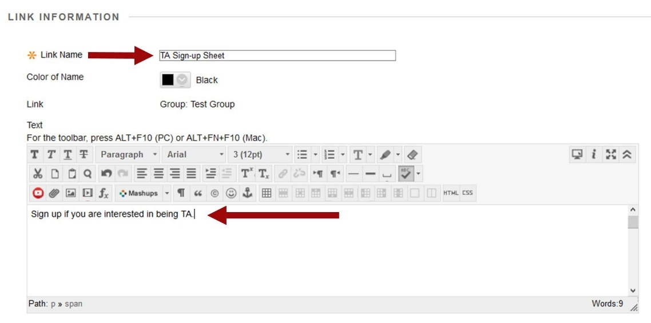

1. Select **Submit**.
2. When students access the link, they will see the Signup sheet information, the maximum numbers of members allowed, and a Sign Up button.

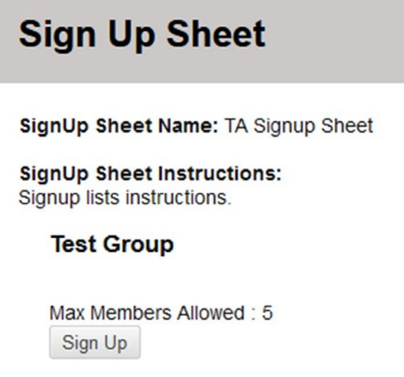

Make Sign-up Lists Available to students in your Table of Contents (Left Menu)

Sign-up lists can be made available to students via the course menu or a content area.

# Course Menu

1. Select the **Add Menu Item** button.
2. Select **Tool Link**.

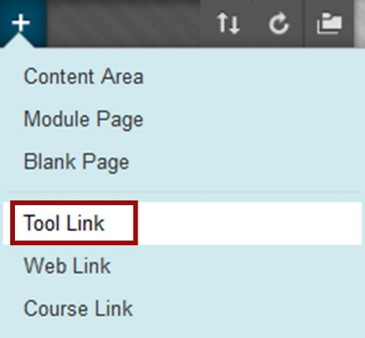

1. Enter a **Name**.
2. From the *Type* menu, choose **Groups**.
3. Select the *Available to Users* checkbox.
4. Select **Submit**.

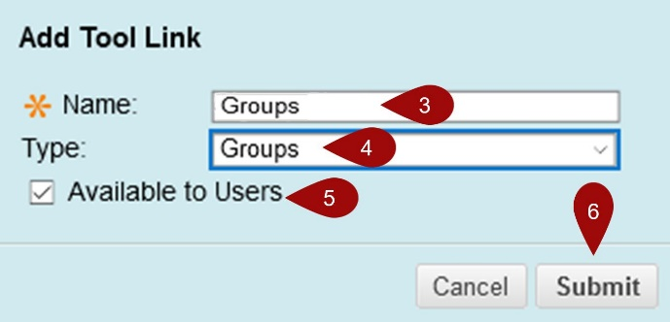

1. The *Groups* link will appear on the course menu. When students access this link they will see the group and an option to *Sign Up* as shown below.

