Creating SignUp Lists for Proctored Events
You can create signup lists to place in your Blackboard courses for students to choose the date/time/location they plan to attend.
Inside your Blackboard course go to Lessons – Build Content drop arrow – Choose Sign Up List
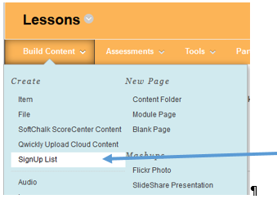

Select BATCH CREATE so you can create the multiple date/time/locations at one time.
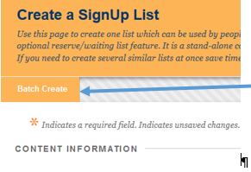

SignUp Names and Instructions
Enter the dates/times/locations for each proctored event along with the instructions you would like them to know. (Sample below) You will need to advise them to only sign up for one date. The student can removed themselves from one list and add to another if they wish. They can also signup for both dates so you will need to monitor for this.
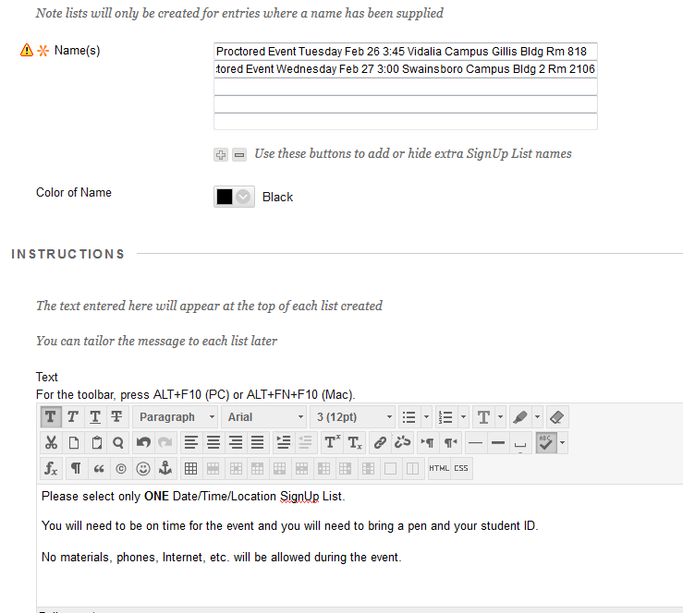

Sign UP Period Dates and Number of Seats Available.
Enter the dates you would like the Sign Up to Open and Close. These will display to the students.
Enter the Number of Places (this is the number of seats you have in the classroom that you can accommodate). You will be edit them individually after setup if one room has more/less seats available.
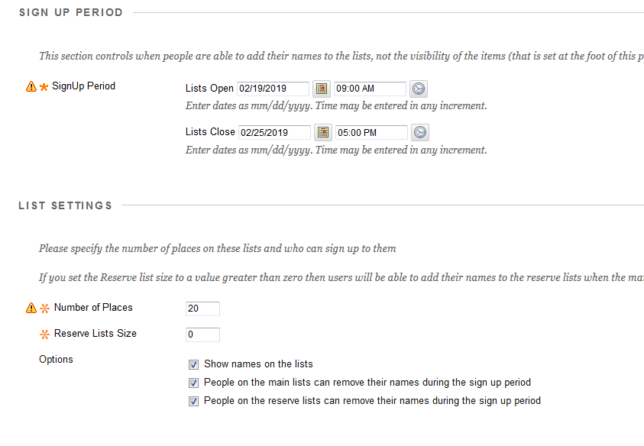
Scroll Down to bottom and then click Submit.

Group Names and Group Information
On the next screen click NO on Group Available and click Submit.

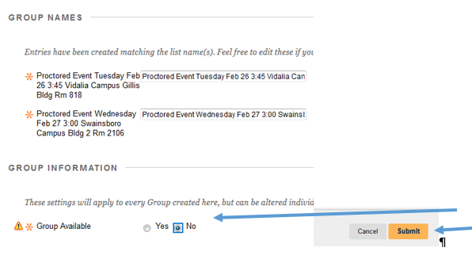

SignUp Listing Displays
You will now have a signup for each of the names you listed.
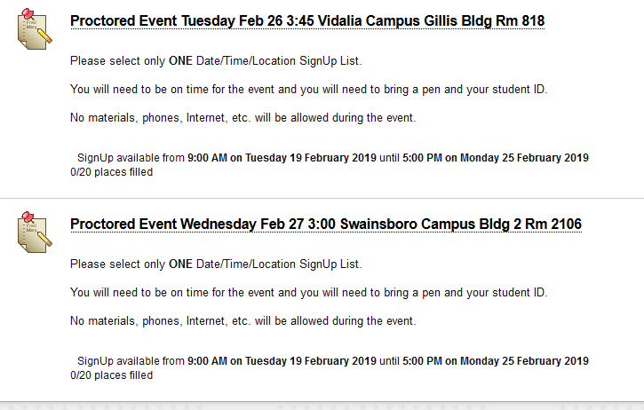

Edit your SignUp List
You can edit each one with the drop arrow by the title if you need to.
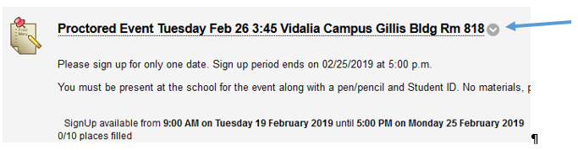

View your SignUp List
The student will click the date they prefer and it will add them to a list.
To retrieve the list you will click the Title of the Event and then click Batch View
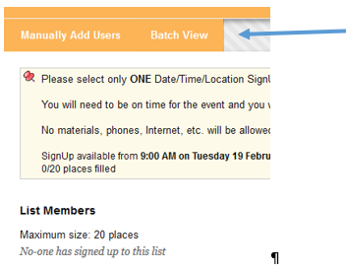
The Batch View list will display all your student names and which date they chose for the exam. You can then print the page from your browser.

