Setting up your Table of Contents Menu in Blackboard for Masters
Below is the standard menu I have marked the items in red that you will need to create within your MASTER course before you copy to the crn. All other items will be coming in with the Template for the crn course. Instructions are below.
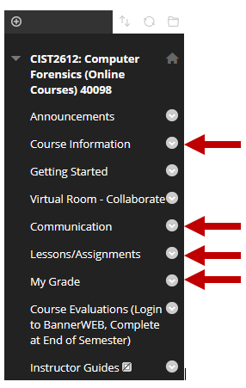
Remove the HOME menu. Click the chevron arrow to the right of the name. Click Delete, Click Delete this menu item, click delete.
Remove the divider lines. Click the chevron arrow to the right of the name. Click Delete, Click Delete this menu item, click delete

Create a Course Information Menu
To create: click the +, click Content Area, Name as Course Information, check to be Available to Users, Submit.

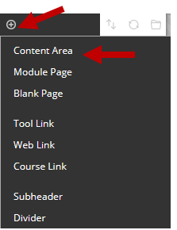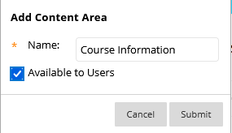

Anything that is course related other than assignments should be in this folder. Instructor, Syllabus, Standards, Handbooks, etc.
Move the Course Information menu to be place under the Announcements. Click to the left of the name. You will see a 4-sided arrow. Click and hold, drag up to the location.

Add items within a Menu
To add Instructor Information within the Course Information. Click the Course Information menu, click Build Content, Click item. Add your Instructor Contact information. Submit.
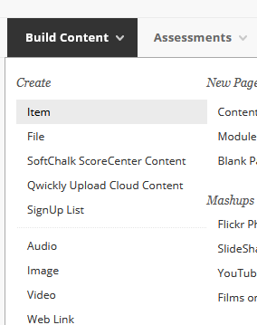
To add Syllabus Lesson Plan, click Build Content, Click File. Add your Syllabus Lesson Plan. Submit. (Preferably in pdf format so all students can open without Word or a needed program)
To add Standards and Objectives, click Build Content, Click File. Add your Standards and Objectives. Submit. (Preferably in pdf format so all students can open without Word or a needed program)
To add other Course Information type materials such as Handbooks, Proctor Information, etc. Click Build Content, choose your format, add and submit.

To move items from a menu into the folder
If you already have these within your course, you can click the chevron next to the title, click the move, and choose the location as your Course Information, click Submit.
If the item does not give the option to move, you will have to create it in the correct location and then delete the old one.

Create a Lessons/Assignments Menu
Your classwork that you give to students should be organized within this folder. Place them in folders by Chapters, Modules, Weeks, etc. Students have less confusing of what to accomplish if their assignments are in order of how they will need to complete and turn in the work.
To create: click the +, click Content Area, Name as Lessons/Assignments, check to be Available to Users, Submit.
Use the same instructions to Add items within a Menu above. To create a folder, items, files, links, discussions, tests, etc.

Create a Communications Menu
To create: click the +, click Content Area, Name as Communication, check to be Available to Users, Submit.
To create the Send Email
Click inside the Communications Menu. Click Tools – More Tools – Email – Make sure it has Send Email has the title. Submit.
To create the Check Email
Click Build Content – Web Link. – Name it Check Email – Office 365. Enter https://southeasterntech.okta.com/ in the URL, in the description add the text - Use this link to sign-in and check your Office 365 school email.

