Downloading and importing publisher Test Banks into Blackboard

- Go to the publisher’s web site and log in. (we are going to use Cengage as an example)
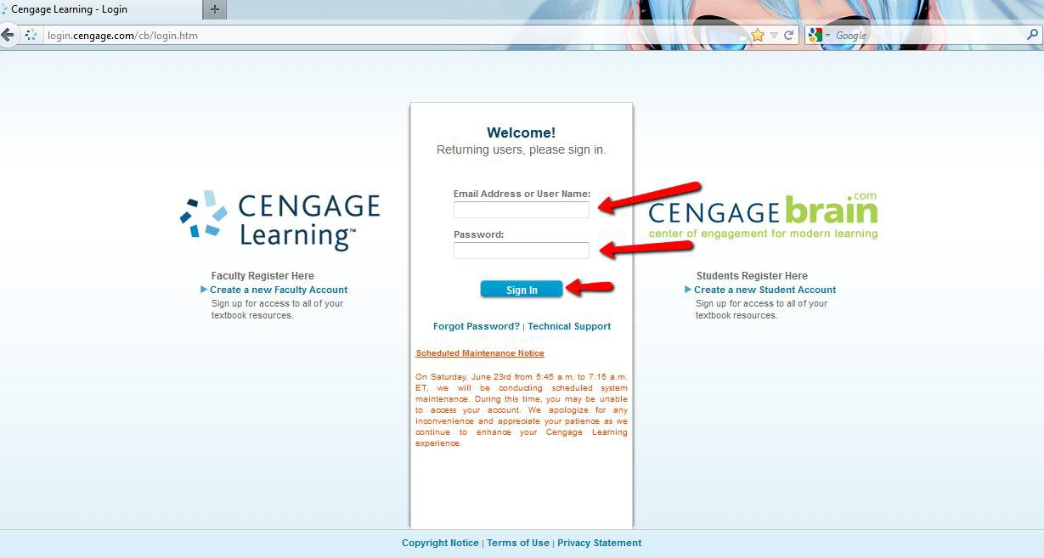

- Enter the Author, Title, or ISBN in the form box and select “Search.”
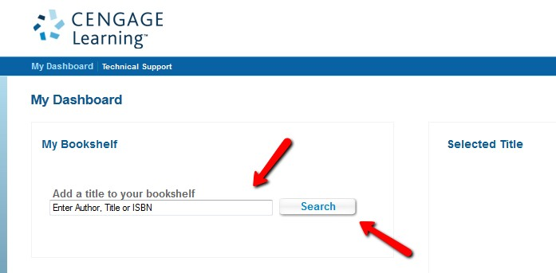
- Select the learning materials that you are using and then select “Continue”.

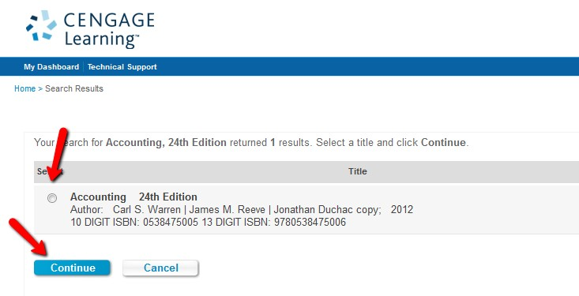
Slide down to the bottom of the page and select the check box next to “Add only the complimentary student resources and all instructor companion site resources,” then “Add to my Bookshelf.”
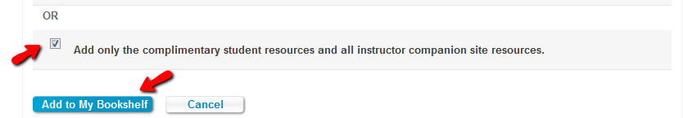

- Once the learning material has been added to your “Bookshelf” then select “Instructor Companion Site.”
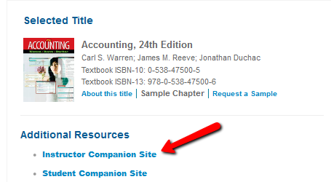

- Then select “Blackboard 6/7/8/9 test bank”
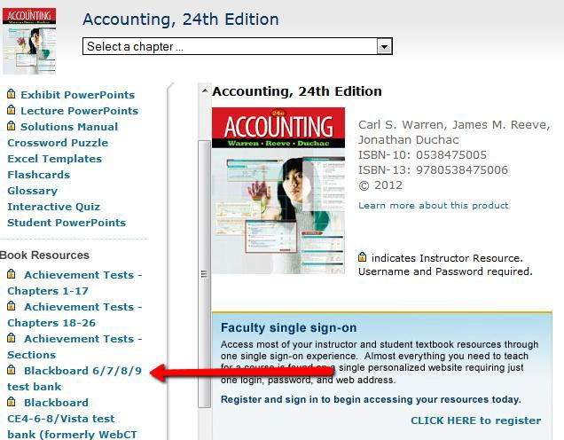
- At this point, there is typically a “Terms of Agreement” or “License Agreement” statement that you have to review. READ and agree with the statement to download the test bank.
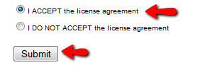

- You will then click on the zip file to download the test bank. The zip file will be downloaded to your computer.
Make sure to keep the following in mind:
  - That you know where the file saved to so that you can upload to Blackboard
  - The zip file is what Blackboard needs to upload the test bank. You do not need to unzip the file. Additionally, do not select “Open” on the download prompt. Select “Save File or “Save as” depending on your browser.
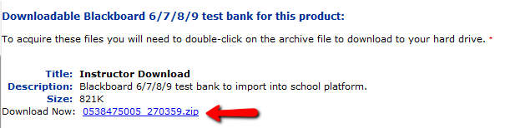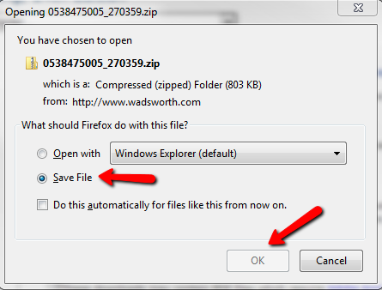

- Log on to Blackboard and access the course in which you want to upload the test. Expand “Course Tools” under the “Course Management” section and select “Tests, Surveys, and Pools.” Select the “Pools” section.
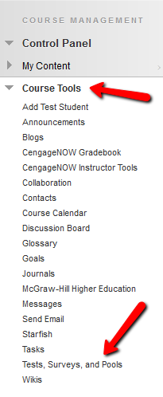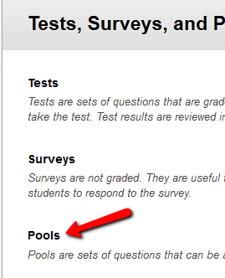
- Select “Import Pool”,
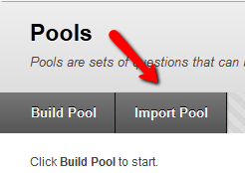
- Click “Browse My Computer” then select the zip file that you downloaded in step 8 followed by clicking “Submit”
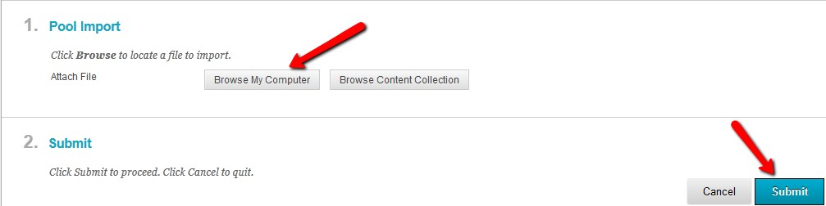

- You should then see a message stating that the import is complete. 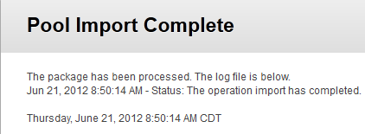

- After clicking “Ok” you should then see the test pools that you have just imported. 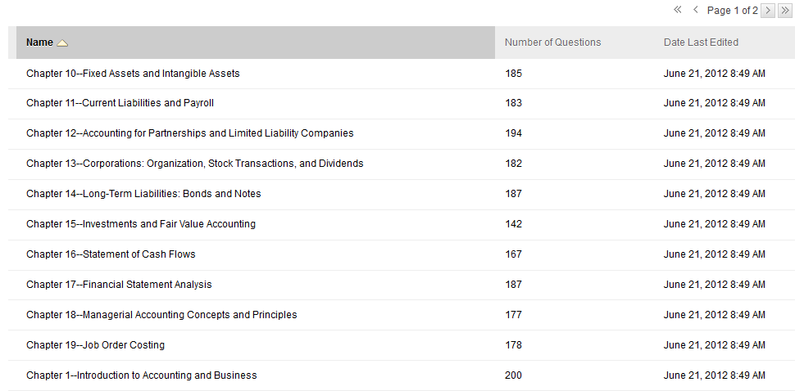

If for some reason the import failed, repeat steps 6-13 to ensure that the file downloaded from the publisher and uploaded to Blackboard properly.

