Remote Lab (Citrix) Instructions

PRINT THIS DOCUMENT AND KEEP WITH YOU AT ALL TIMES FOR THE CLASS.
All Students will have access to use the Information Delivery System, better known as IDS or Remote Lab. Read the information below so you will be ready to start the semester.
What will the IDS Remote lab do for me? You can use our software (Microsoft Word, Excel, PowerPoint, Access, Publisher, etc,) from the comfort of your own home without having to purchase it. Plus you can save your files to your own personal folder on our server, which means you will not need a disk. These files are backed up several times a week, so they'll be safe and secure. Your instructor will have access to them when you are ready for them to be graded, so you won't have to email them as an attachment or use the digital drop box. If you have the software, such as Word, PowerPoint, Publisher, etc. loaded on a personal computer, you do not have to use IDS. It is only used if you do not have the software, or if you are trying to save your work to the P drive while not on a campus of Southeastern Technical College.

You will also have to disable Pop Up Blockers before using IDS, SAM, or BLACKBOARD as well. Open Internet Explorer, Click Tools, Click Pop Up Blockers, Click Turn Off Pop Up Blockers. You may also have Firewall issues as well. Turn off any Norton Security, Avg Security or any Firewall security programs when using course items. You may also need to add the citrix web address (https://citrix.southeasterntech.edu and http://sam2010.course.com) to your trusted sites.
Tools – Internet options – security tab, click trusted sites, type in address and add to box. Note—For the Information Delivery System, your student id will be your username and your school PIN in six digit format will be your password.

To ACCESS the IDS Remote Lab
See the link and instructions below the Information Delivery System (IDS – Remote Lab Access)
You will log in to the IDS using this link or click the icon in MySTC: citrix.southeasterntech.edu/
This screen should pop up. Make sure pop-up blockers are turned off:

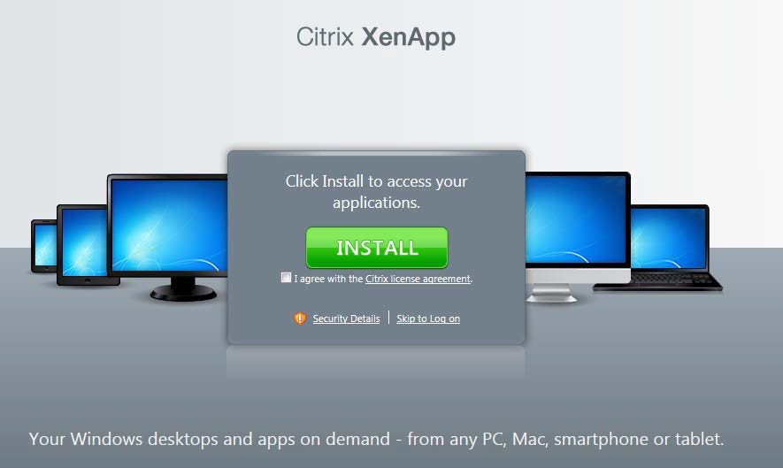
Before you can access our software, you must click the CHECK BOX, click INSTALL, and then click RUN on the link to install the software. See picture below CLICK RUN ONCE.
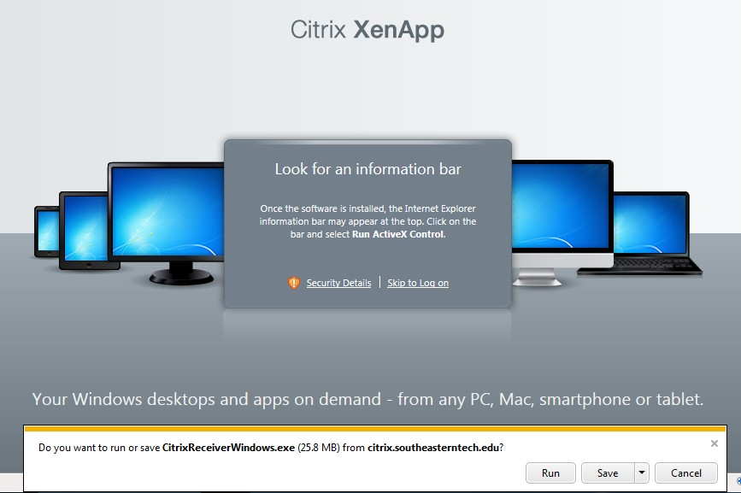
If the yellow bar pops up at the top of the screen, click and choose run ActiveX Control. See picture above. Let the program install.
You only have to do this one time on your computer. If you work on another computer, say a friend’s house, you will have to go through this process again. But if you always use the same computer, your home computer for example, you will only have to go through this process one time. It may take a few minutes--my home computer took a little while to load. Please contact the IT Dept if you have any problems installing the software. For technical issues with IDS system at any time, please email help@southeasterntech.edu. If using a Windows 7 or 8 operating systems, you may have to enter your User Access Control and give yourself permissions.Once you have loaded the software, you are ready to begin working!!!

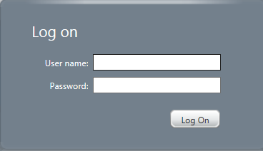

LOGGING IN: Use your student id as your username and your school six digit PIN as your password.

Once you’ve logged in, you’ll see the following screen:
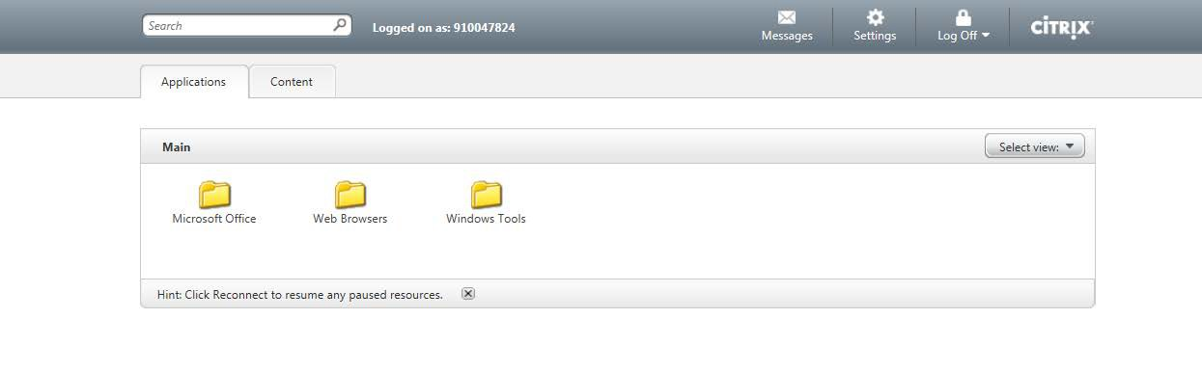

When you begin working on an assignment, make sure you are logged in to the IDS.
To begin working with BLACKBOARD using the Remote Lab…..
Please follow the directions below to access BLACKBOARD through Citrix:
Log on to Citrix using your Username and Password; choose the folder titled Web Browsers; choose one of the Internet choices (Blackboard prefers Chrome or Firefox); CLICK OPEN. A new Web Browser window will open up. Go to www.southeasterntech.edu then click Current Students. Click BLACKBOARD: Log in to BLACKBOARD.
If this is what your screen looks like after you click on BLACKBOARD, then click ok.
Once you click Ok. Go to the Tools Bar. If the Tools Bar isn’t there, you have to right click at the top where the tabs are, and click on Menu Bar.

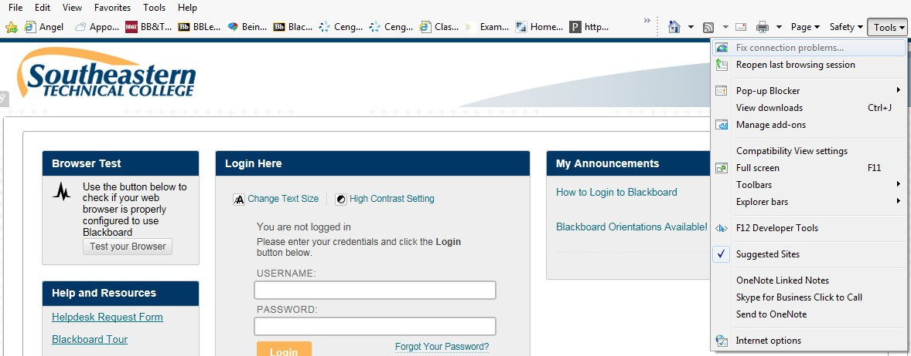

Go and click on TOOLS on the menu bar. Go to the bottom and click on INTERNET OPTIONS.
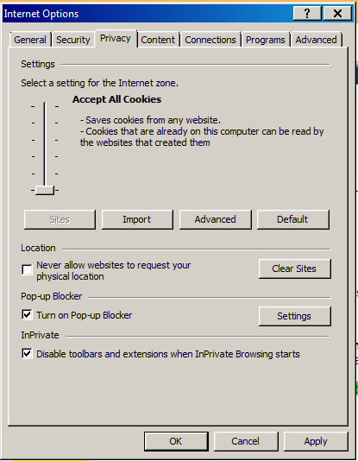

When the INTERNET OPTIONS dialogue box appears, click the PRIVACY tab. Select the Settings scale tab and lower it to the bottom to where it reads ACCEPT ALL COOKIES. Then click APPLY at the bottom and then OK.

Then put in your Username and Password to
continue on to Blackboard (using 43_9100…. As username. By using our connection, you should be able to work a little faster, although IDS is still rather slow using dial-up.
To begin using our products (Word, PowerPoint, Publisher, etc.,) for your assignments follow the instructions below:To Begin Working in Word using the IDS………

In the "Your Applications" box, you will choose Microsoft Office.

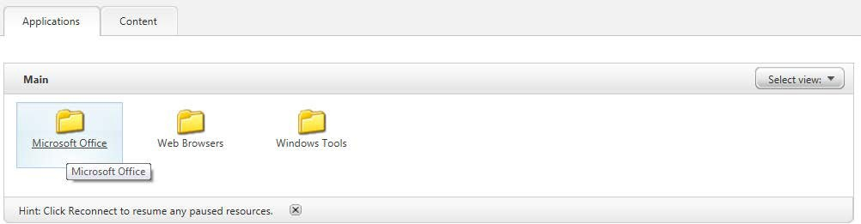

In the next box, click Microsoft Word.

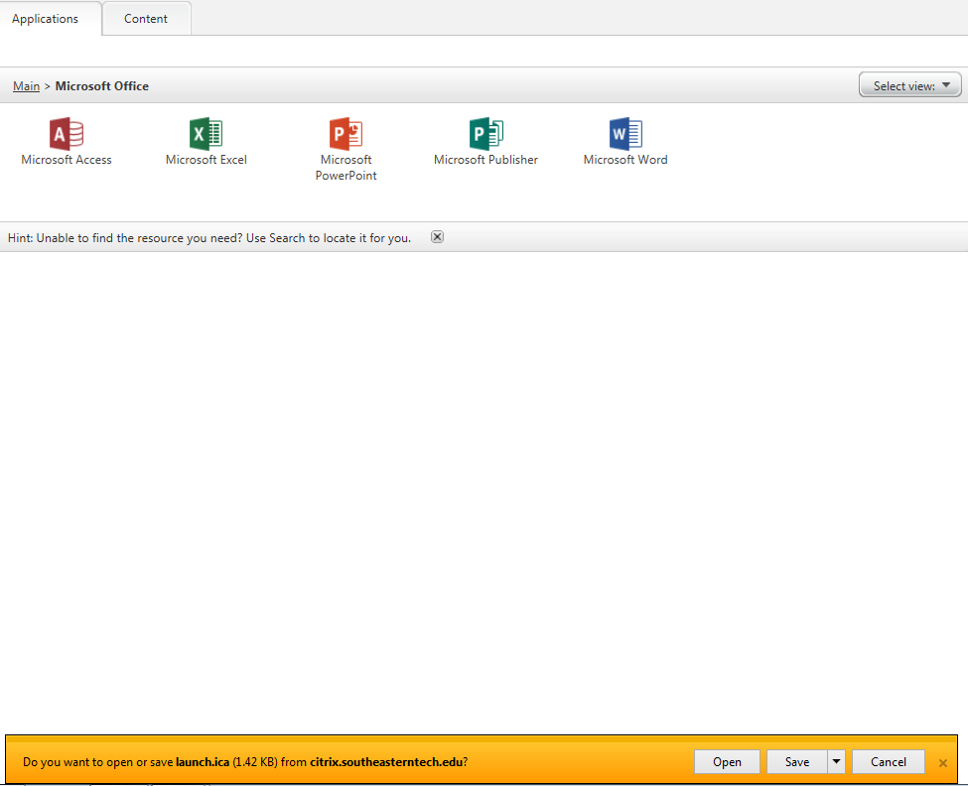

The first time you click on an application a permission/security screen will open. Click Full Access and Never Ask Again. If you have already clicked on this and it told you not to ask again but did not give Full Access.
Click the application (Word). Click OPEN on the link that pops up to open Word. It will take a few minutes to open.
A blank Word screen will open. Complete the assignment as directed in the textbook or to complete your assignment(s). Some files will be created from scratch and others may require the use of the templates. These files can be accessed using the Course Materials (M :), which can only be accessed through the IDS. (Note: The files that are mentioned in your textbook are the same files that we have loaded in Course Materials (M :).

Before you save your work, you will have to create a folder in (P :) folder. See below:

While in Word, click File, Save As, select Computer, then click Browse.

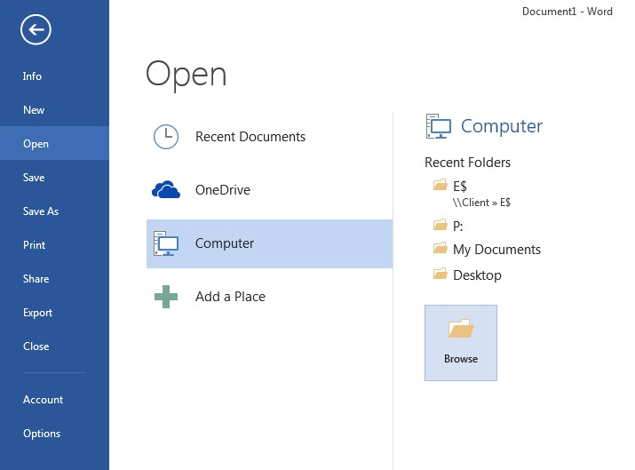

Go to your P folder. Click the New Folder button on the Save As Toolbar. (See where Arrow is pointing below). Create a folder and name it according to the work you will be saving.

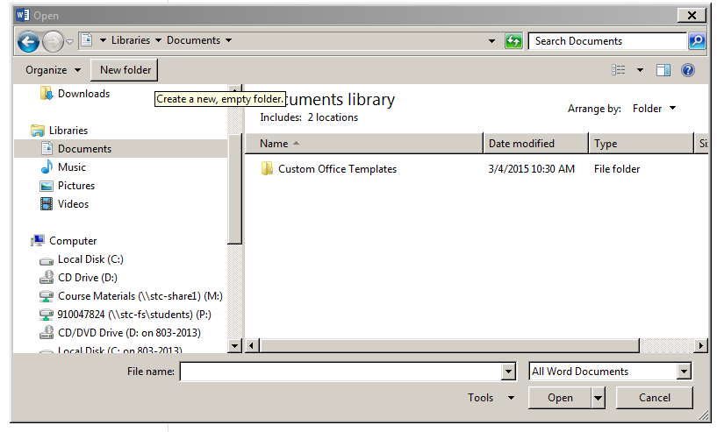
P Folder
(Drive)
The New Folder Button. Name the folder whatever class you are enrolled in. (i.e., CIS105)

Now you are ready to save the assignment. After completing chapter 1 assignments, for example, click File, Save As, and double click the class folder (ie COMP1000, CIST 2127, CIST2128, CIST2129, BUSN1400 or BUSN 1430). At the Filename box, key the filename for the assignment (Example, Chapter 1, In the Lab 1 or as directed from the assignment.)

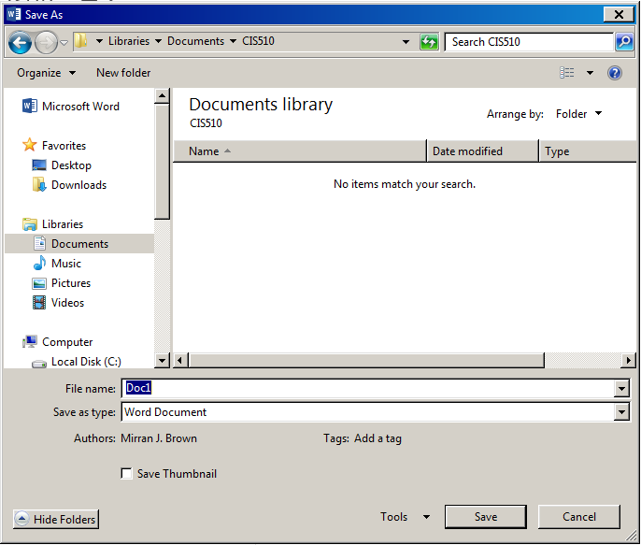
Key filename here.

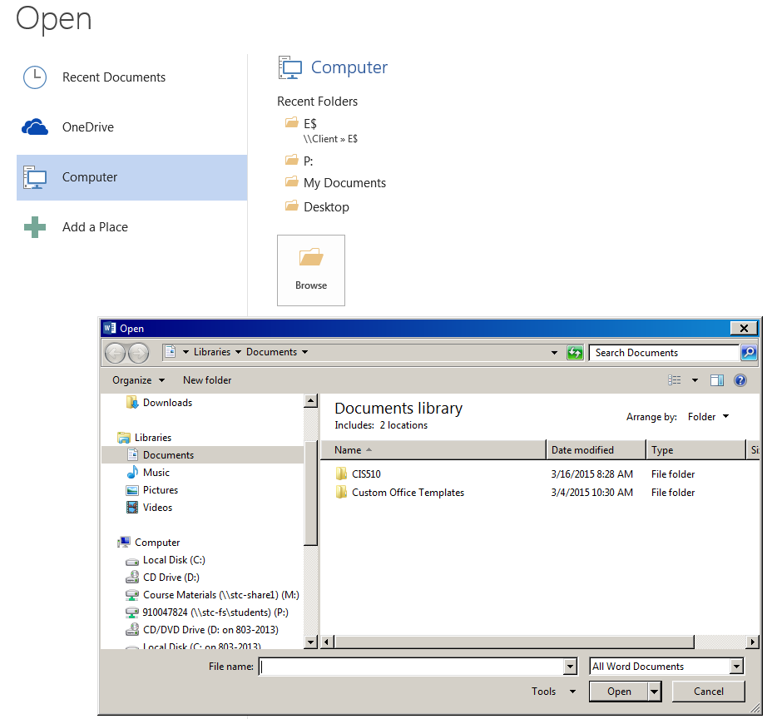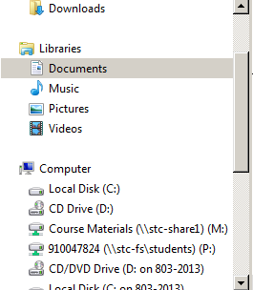
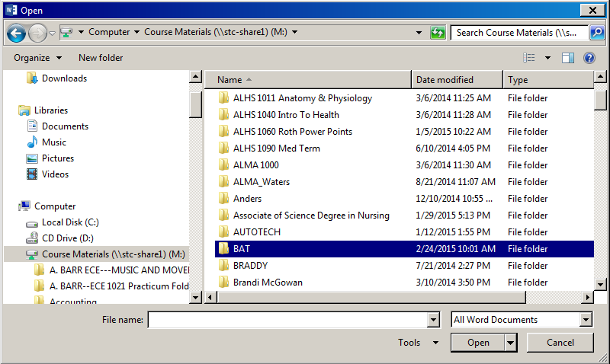
To open a file as directed in the text (i.e., Data file), just go to File, Open, and click Computer then the Browse box (then scroll up or down until you get the following choices) and double-click on: M:\Course Material

The following choices will appear: Double-click the desired program/class

These choices will appear: Double click on the class you are enrolled in.
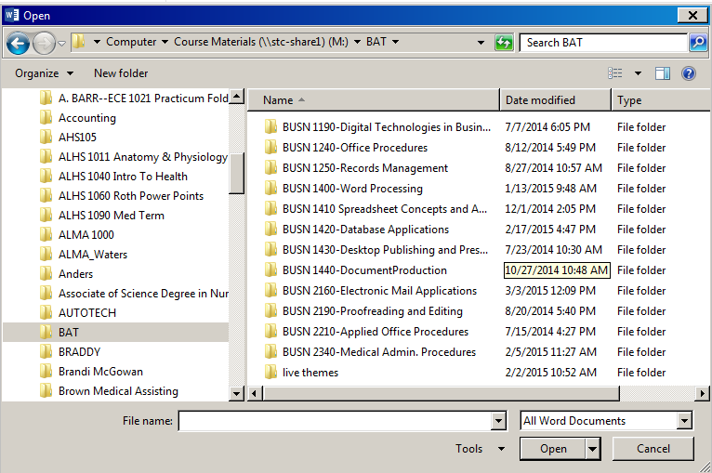
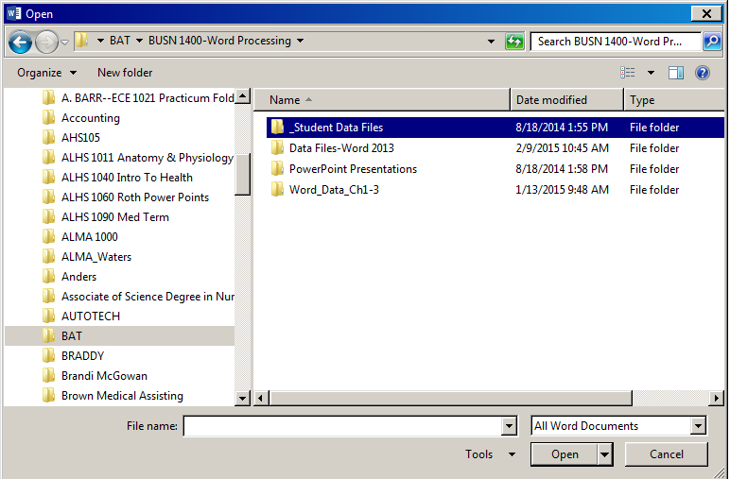
Then double click the data file folder or whatever folder you need depending on what class you are enrolled in.

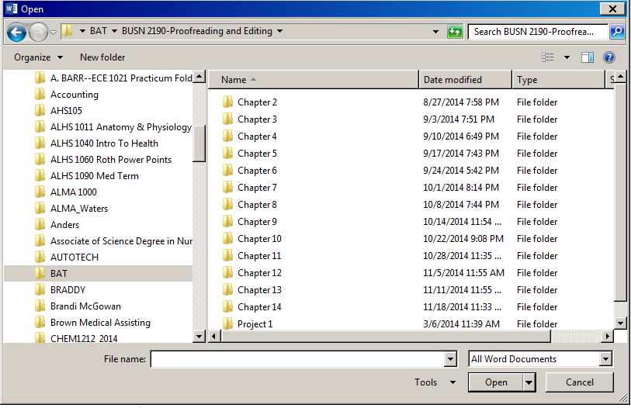

The chapter folders as shown below will appear: Double click on the chapter you need and then double click the file you need.

Note that the files in Course Material (M :) are read-only and you cannot make changes to them WITHOUT SAVING THEM TO A DIFFERENT LOCATION. So, after opening the file, click File, Save As, and click the drop-down box (or the up arrow) and choose P: and double click on the folder for which you are working and key the filename in the file name box, for example, CD Assignment 7-1 Page 173.
See picture below.
Key filename here.

WHEN YOU NEED CLIP ART PICTURES TO ADD INTO YOUR DOCUMENTS. FOLLOW THE STEPS BELOW.

Open the document (Word, Excel, etc). Click Insert – Picture - FROM file.

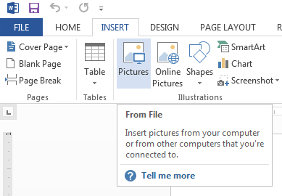

Change the drive to M: Course Documents and then choose your COURSES folder.
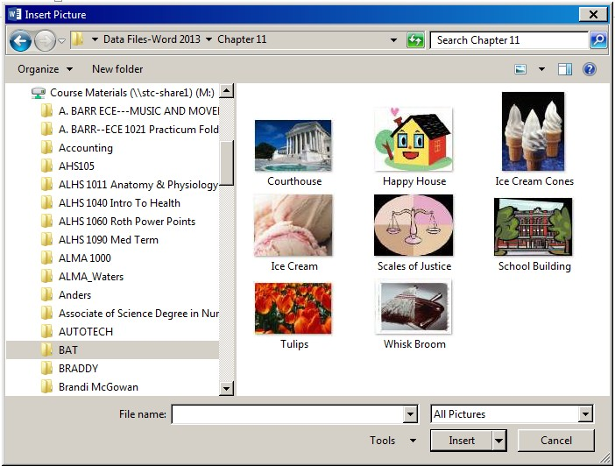

Then choose Clip Art folder. Select your Picture and Insert.

You can also open files without accessing Word first.
You will log in to the CITRIX in the same manner as explained earlier. After you log into CITRIX,
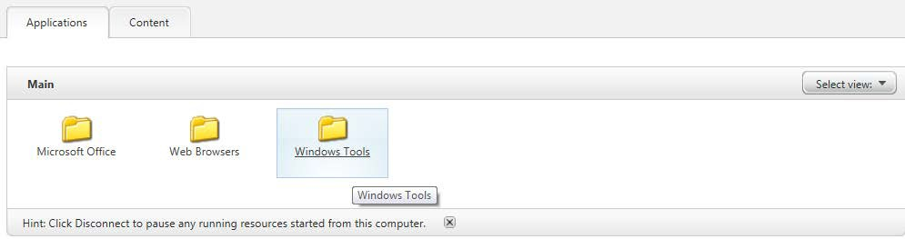

In the "MAIN Applications" box you can choose WINDOWS TOOLS folder.
When the window comes up you will see all the network drives you have access to:
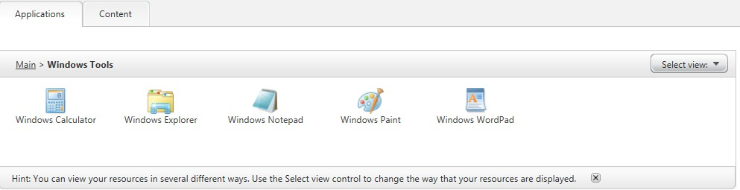

Next choose Windows Explorer.
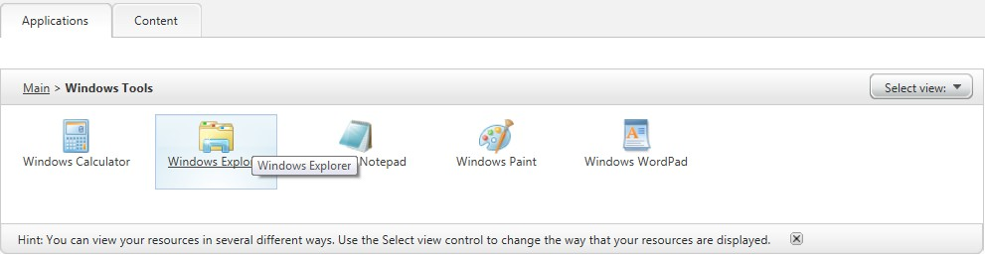

Clink OPEN on the link when it comes up. Then when the window comes up you will see all the network drives you have access to on the left:
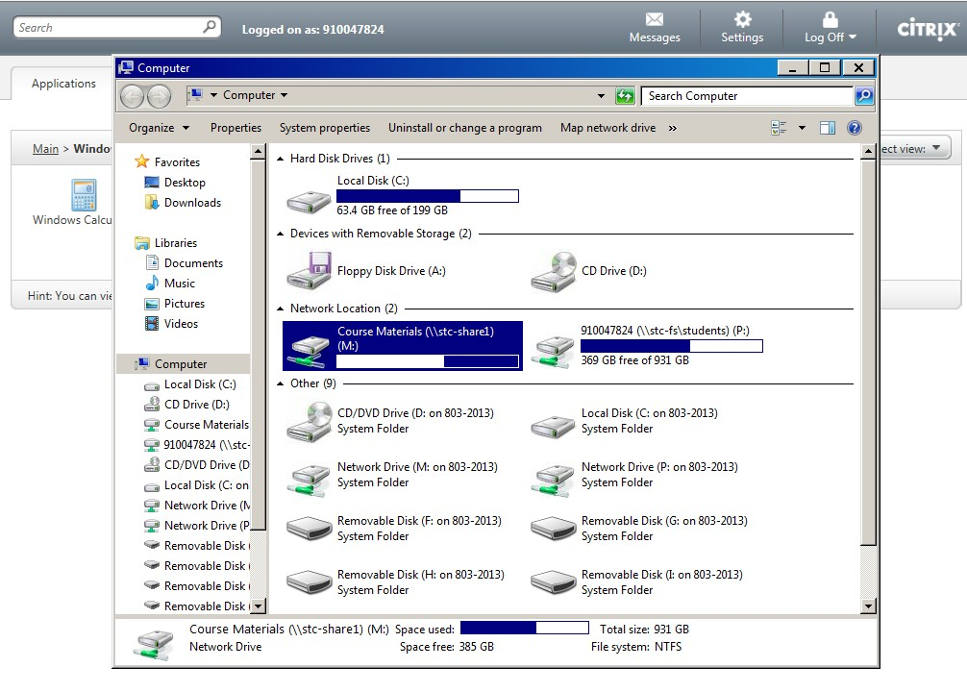

Once opened, click COMPUTER folder. You will see a drive M: that is for Course Materials. This includes the read-only student data files need for pictures, data files, etc. Your P: drive is your files you have previously saved from assignments. Your machine in front of you will be the C$Client drive (This is your machine). Copy the file to your machine.

**ONLINE STUDENTS…….Even though you may have Word loaded on your computer, please don’t use the Start button or an icon on your desktop to access Word. If you do so, you will be able to work, but when you get ready to save your work, it isn't going to give you the option of saving to the P: drive—which is where I need you to save your work. When you access Word from the Start menu or an icon on your desktop, you are using the Word program loaded on the hard drive and not on CITRIX.
*Note that if you have a project on your thumb drive (flash drive) you must have it plugged in to your computer before you log in to CITRIX.
Use the CONTENT tab to access SAM within CITRIX. This should only be done when uploading projects to SAM.
Remember, if you have questions, please email me. I can't help if I don't know you're having trouble. Be specific on emails about what is happening and when.*Note that if you are working from campus you do have access to your folder without having to log into the CITRIX. Just login to the machine and click on Word, Excel, etc. But you will need to save your work to your P: drive.
Do not worry--no one can access your files but me. No one can see your files; no one can change your files. Even though it appears that each of you are saving to P: it is saving your work in a folder on our server with your student id number (that you logged in with) uniquely identifying you. :-)
MAKE SURE YOU CLICK THE LOG OFF ICON WHEN YOU’RE FINISHED.

