To download go to gvtc.tcsg.edu/download
Username: gvtc
Password: downloads
Click on link need like the picture below.
You will need this screen for the Institution Name, Contacts, and Password info.
https://gvtc.tcsg.edu/Downloads/Downloads.html
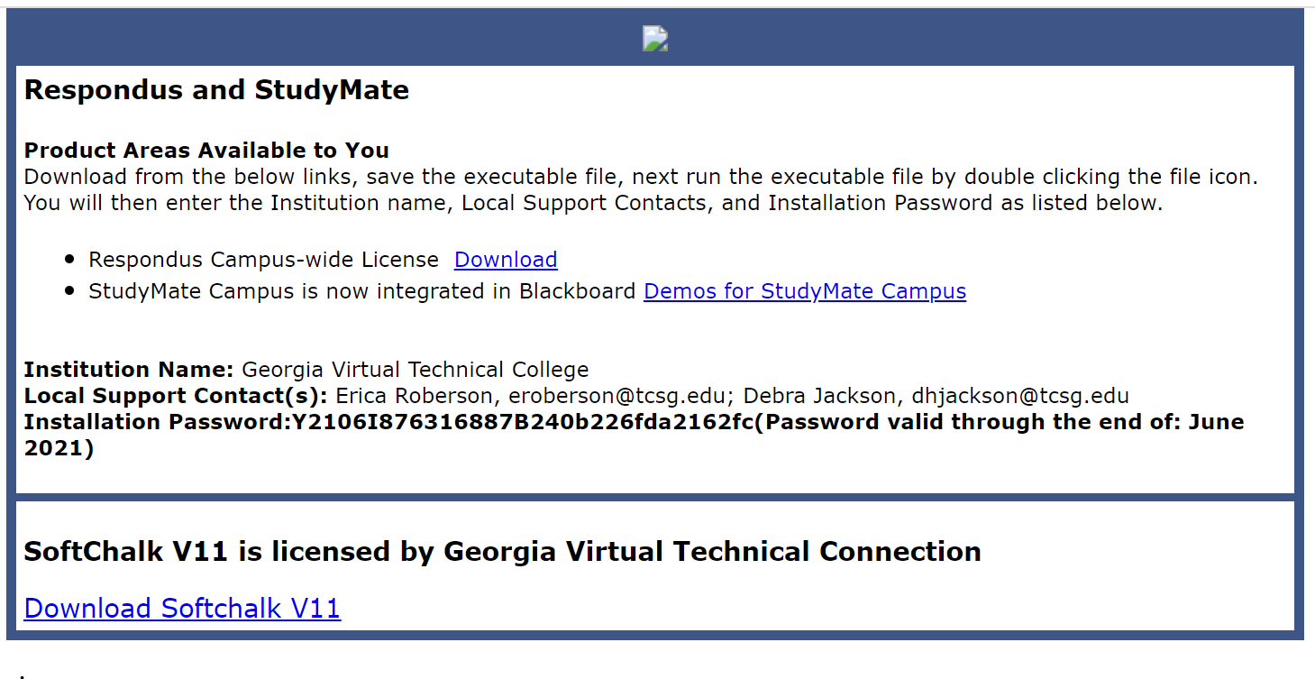
This screen updates, so you need to be sure to go to the link and get each time.

