**How to Create/Export a Test from Examview to Blackboard**

1. Launch *Examview Test Generator*:

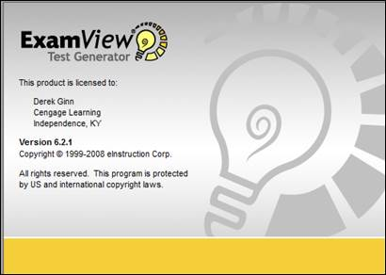

1. Click **Open an existing test**:

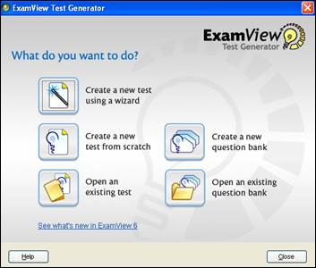

1. Choose the test you want to export:

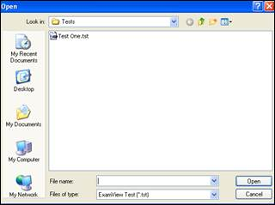

1. Click **File** then **Export:**

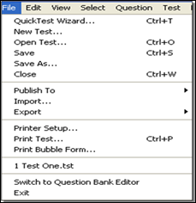

1. Choose the **version of Blackboard 7.1+** you want to export to:

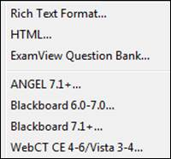

1. Enter a file name then click **Save**:

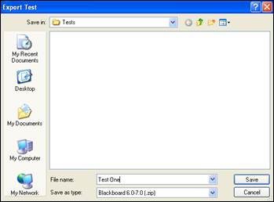

**Please Note**:  Make sure the correct version of Blackboard is listed next to *Save as type*.

1. **Enter a name for the question pool** you want to link this file to.  **Please Note**:  This is **how the file will display under Blackboard’s Pool Manager**.

1. Enter a **description** for the question pool.

1. **Leave *Formatting* set to HTML**.

1. Enter the Dictionary Name for where the graphics are embedded in the test areas to be saved on your Blackboard server.  **If there are no graphics, enter a period (.)** in the field.

1. Click **OK**:

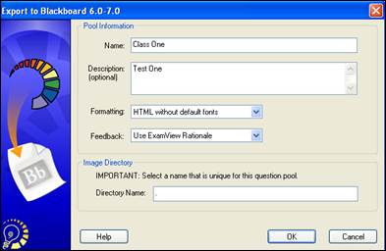

Step 1:

From the **Control Panel**

**select Course Tools and then**

**select Tests, Surveys and Pools**

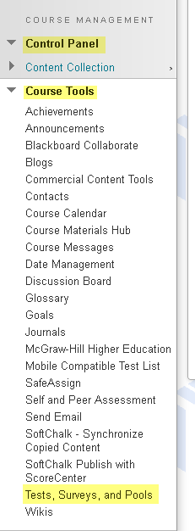

.

2.  Select **Tests**

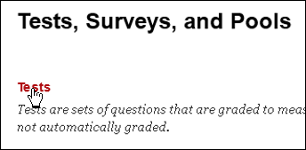

3. Click on **Import Test** to locate the test zip file:

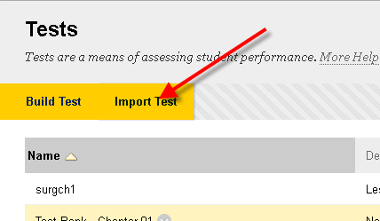

4. Click on **Browse**:

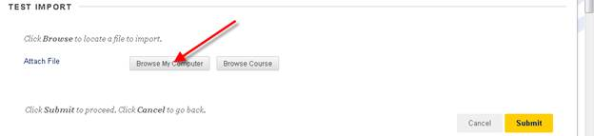

5. Locate your C drive then click on the **Examview** folder: (**depending on where you save the export in zip format**)

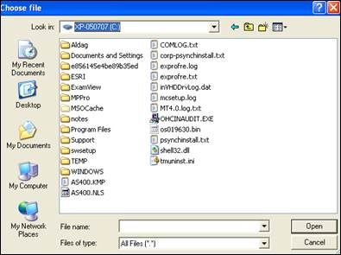

6. Click on the **Tests** folder:

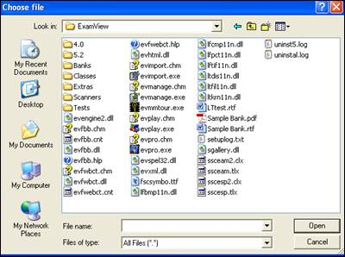

7. Click on the appropriate zip file:

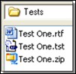

8. Click on **Submit** to import the test:

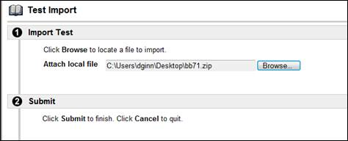

9. If the **import package is successful**, then you get the following message.

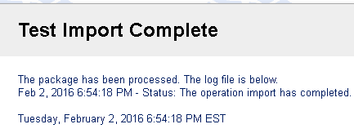

**How to Deploy a Test in Blackboard 9.1**

**Step 1: Select the Content Area** (Assignments, Course Documents, Course Information) where you want to add a test and select the appropriate option from drop-down arrow next to the menu item and select **Test**.

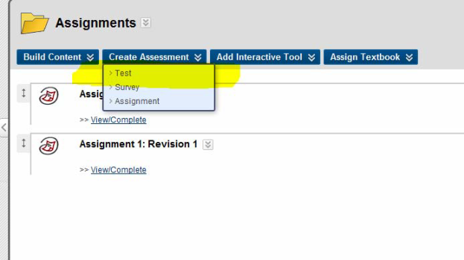

**Step 2: Select the appropriate test from your list of existing tests.**

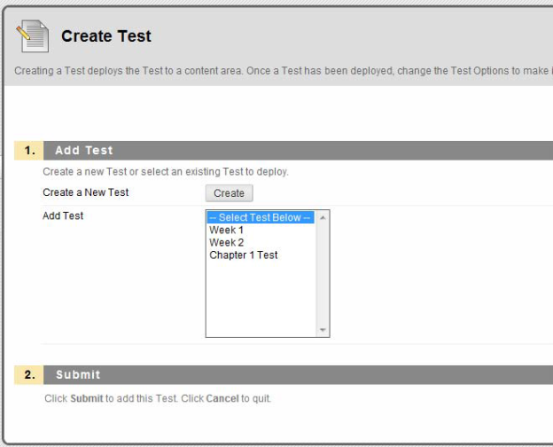

**Step 3: Choose the options that you want applied to this test or survey**

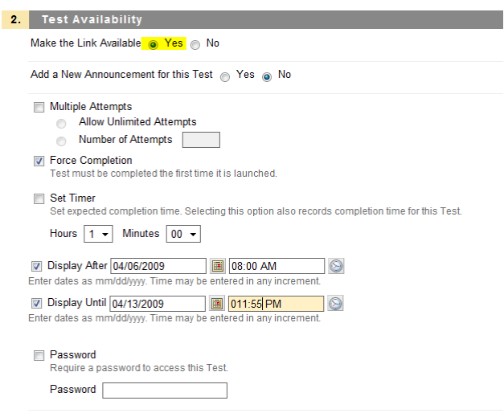

*Note: Make sure that you select* ***“yes”*** *to* ***Make the Link Available*** *or your students will not have the ability to see the survey or test.*

**Step 4:** Choose the self-assessment options, feedback and presentation options that you want applied to the test/survey and then click **Submit** when finished. **Results of your test/survey** will be found in the **Grade Center**.