IMPORT A TEST TYPED IN WORD INTO EXAMVIEW

- The test you type using Word must be formatted exactly.
PRESS AND HOLD THE CTRL KEY. THEN CLICK HERE!
- The test you type using Word must be saved as a RTF (rich text format) file
  - Click on FILE (top, left corner)
  - Select SAVE AS from the pop-up menu
  - Change the SAVE AS TYPE to RICH TEXT FORMAT
  - Be aware of the FILE NAME and SAVE IN location
- Open ExamView Import software
  - TEACHER PROGRAMS folder
  - EXAMVIEW folder
  - Double click on the EXAMVIEW IMPORT icon
- Click NEXT
- Locate the test you typed in Word (top frame)
- Highlight the test you typed in Word (top frame)
- Click on SELECT (top frame)
- You may modify where the ExamView file will be saved (bottom frame)
  - The EXAMVIEW software currently uses W:\Examview\Banks as the default. This location is available to all building teachers. I would suggest your H drive.
- Click NEXT
- Click NEXT
- Click NEXT
- Click NEXT
- Click FINISH
- The software will convert the RTF Word file to ExamView
- Read the import screen and edit any questions containing errors. Repeat steps 1-15 if needed.
- The new ExamView file (test bank) is automatically saved to the location selected in step 8
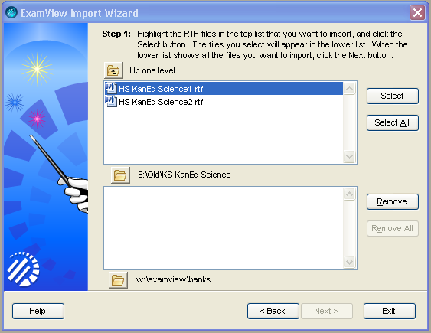
Step 8
Step 7
Step 6
Step 5
Step 7 and 8

Notice the selected file moves down.
