FLU PRECAUTIONS!
IF YOU HAVE NOT HAD THE FLU SHOT, IT IS NOT TOO LATE!
PLEASE SEE A LOCAL PHARMACY OR HEALTH DEPARTMENT FOR A SHOT!
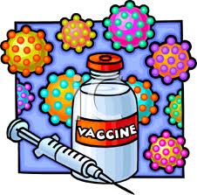
DOCTORS RECOMMEND “If you are sick, stay home from school or work. Before returning to school or work, you should be naturally free of fever (without having to use anti-fever medications) for at least 24 hours.”
“Flu symptoms and their severity can vary from person to person, and can include fever, coughing, sore throat, runny or stuffy nose, body aches, headaches, chills and fatigue. If you think you have the flu, call or visit your doctor.”
TO PREVENT SPREADING:
- Wash your hands frequently with soap and warm water. If you do not have access to soap and water, alcohol-based disinfectant gels are the next best thing.
- Cover your nose and mouth when coughing and sneezing to help prevent the spread of the flu. Use a tissue if one is at hand, or cough or sneeze into the crook of your elbow or arm.
- Avoid touching your face, as flu germs can get into the body through mucus membranes of the nose, mouth and eyes.

Please try to stay well and protect others as we get through this year’s horrible flu season!

