NEW ILP NO SHOW Process

You will be entering No Shows through Blackboard similar to pushing your grades at the end of the semester.

Enter your Blackboard course
- click “COURSE TOOLS”
- click “ILP INTEGRATION”
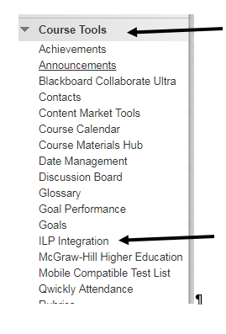
- click “Midterm Grades” in the center of the screen. This will be just the name of the column we are using. This will not tie to any grade in your grade center.
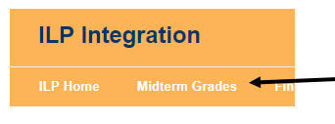
- For each student’s name. Click in the Midterm 1 column and enter: PR (Present) or NS (No Show) into the box. For Learning Support: enter PR* (Present) or NS* (No Show).

L****
L****
- Click Submit Grades. Look for the Green box at the top indicating it was completed successfully.
