Video:
https://www.youtube.com/watch?v=AlHOyTg2L6Q

ILP – Grades – Submitting

When submitting grades via Blackboard it is important to complete all three steps listed below in each course section to help ensure the accuracy of the grades being pushed to Banner.

Step One: Configure/Verify Grading Schema

ILP integration looks for a specifically named grading schema when translating grades in step three (below) so the first step is to make sure that this grading schema exists in the course. The grading schema must be named Letter.
- Locate the Control Panel.
- Navigate to the Grade Center.
- Select Manage.
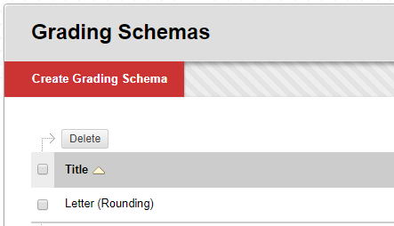
- Select Grading Schemas.
- Locate the grading schema that is to be used for this course (if more than one grading schema exists). If the grading schema is named Letter move on to the next section, Step Two: Configure/Verify External Grade (inner document link; jumps to the correct section). If the grading schema is not named Letter, use the steps below to update the name:
  - Select the contextual menu chevron to the right of the grading schema title and choose Edit.
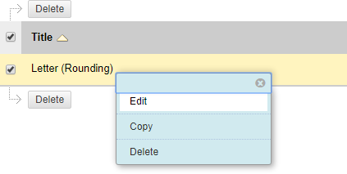

  - At the top of the Edit Grading Schema screen edit the Name value to Letter.
  - Verify the schema mapping is accurate.
  - Select Submit to finalize the changes.

IMPORTANT NOTE FOR SCHEMA MAPPING: This mapping should reflect college policy for the course.

- If college policy supports rounding the schema should be mapped as such.
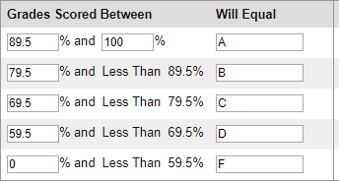
  - Example: 89.5 to 100 is an A
- If the college policy does not support rounding the schema should be mapped as such.
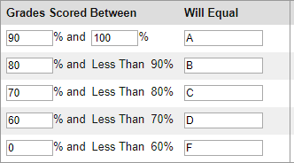
  - Example: 90 to 100 is an A

TIME SAVING TIP: If the college utilizes a master shell process make this change in the master for the course so that each term this step only needs to be verified rather than configured in the term course section shells.

Step Two: Configure/Verify External Grade

It is important to verify that the correct column in the grade center is marked as the external grade. This indicator tells ILP to use the specific column when populating the course final grade in the last step.
- Locate the Control Panel.
- Navigate to the Grade Center.
- Locate the column with the green checkmark icon to the left of the column name. This icon indicates that the column is the external grade.
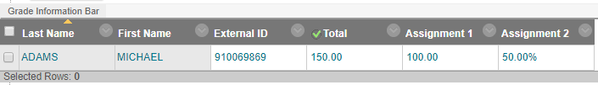
- Verify that the external grade indicator icon is on the correct column. If the correct column is marked move on to the next section, Step Three: Use ILP Integration to Push Grades to Banner (inner document link; jumps to the correct section). If the marked column is not the correct one, use the steps below to update the external grade:
  - Locate the column that should be the external grade.
  - Select the contextual menu chevron to the right of the column title and choose Set as External Grade.
  - Verify that the external grade indicator icon (green checkmark) is now on the desired column.

IMPORTANT NOTE FOR SECONDARY DISPLAYS: If the external grade column is using both the primary and secondary display settings the secondary display must be Letter for the grades to populate correctly in the last step. If a secondary display schema other than Letter is being used the instructor will need to temporarily change the secondary display to Letter. After grades are submitted the secondary display value can be set back to the schema originally being used.
MATHMATICAL REMINDER: Prior to pushing grades to Banner instructors should always verify that the calculations for the external grade column are configured correctly and are accurate.

Step Three: Use ILP Integration to Push Grades to Banner

This course tool can be used to push grades to Banner as often as needed until the deadline date defined by the college.
- Locate the Control Panel.
- Navigate to ILP Integration under the Course Tools section.
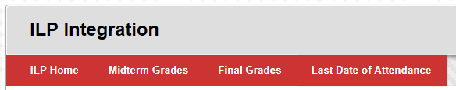
- Select Final Grades.

- In the Populate final grade from current grade drop-down select Final Grade (this is mapped to the column set as the external grade). The students’ letter grades will be populated in the Final Grade column.
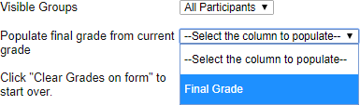
- Work Ethics (skip this step if the college does not require a work ethics grade to be submitted with the letter grade).
  - If a work ethics grade is required, add it to the final grade cell for each student.
  - Spacing is important here so check with the college to determine the correct format.
  - Example: A2 or A 2 where a space is used between the letter grade and the work ethics numerical value.
- Verify that the grades are accurate and that any grades requiring a last date of attendance (LDA) have the required date.
- Select Submit to push the grades to Banner.
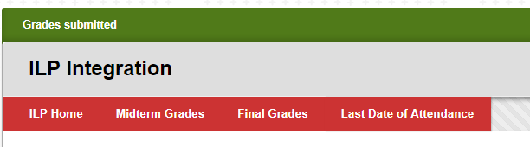
- A green Grades submitted message bar will appear at the top of the screen.
NOTE: Once grades are pushed for the first time when the instructor returns to the final grade screen the final grade column will be populated with the last values submitted.
IMPORTANT NOTE FOR LAST DATE OF ATTENDANCE (LDA): If a grade requires a last day of attendance to be submitted it must be entered for the student record in the appropriate column in the following format: MM/DD/YYYY. (Example: 05/15/2017)
IMPORTANT NOTE FOR INCOMPLETES: Each college will define if the grade I is acceptable via this process. If a grade of I is allowed the Extension date value should be left blank; Banner will automatically use the date as defined by the college.
IMPORTANT NOTE FOR WITHDRAWALS: Each college will define if the grade W, WP, or WF are acceptable via this process. If the grade(s) are allowed a Last Date of Attendance (LDA) will be required.

