Creating an Accessible Table in Blackboard
Note: It is always better to make lists in Blackboard whenever possible instead of Tables.

Making the Table
- In the Blackboard content edit box. Choose the Insert/Edit Table.
- Enter the number of columns and rows. You would like for your table. If you want a border line, enter a 1.
- Be sure to check the Table Caption to include a Title for the Table.
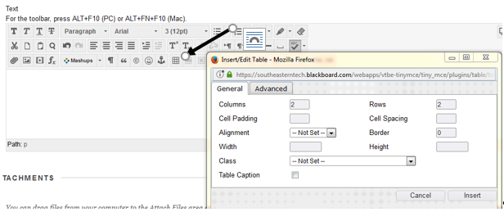

Setting a Table ID & Summary
- Click the Advanced Tab or Right click anywhere in the table and click Table Properties.
- Enter an ID and Summary.
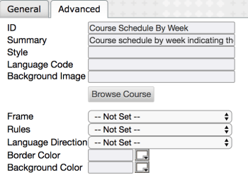

Setting the Row Header
- Highlight the row that will serve as the header.
- Click the Table Row Properties Icon.
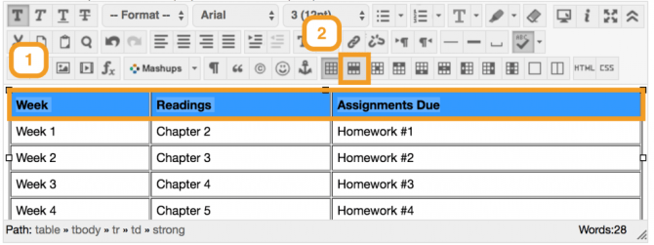
- Select Header from the Row Type Drop Down Box and click Update.
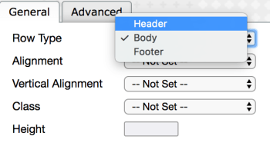

Setting a Column Header (If you want a column on the left to be a Header)
- Click anywhere in the cell that you would like to make a column header.
- Click the Table Cell Properties Icon.
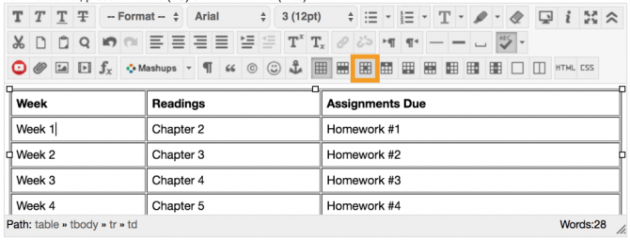
- Select Header from the Cell Type Drop Down Box and click Update.
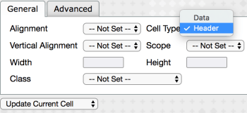
NOTE: You must repeat these steps for each cell that will serve as a column header.

