On Windows 11, Microsoft Edge now has an option to generate alternative text labels for images on the web that do not include them. The "alternative text" or "alt text" is a helpful label part of website code that screen readers use to describe the contents of an image to people with vision impediments.

How to enable automatic image labels on Edge
To allow Edge to auto-generate image labels, use these steps:
- Open Microsoft Edge.
- Click the Settings and more (three-dotted) button in the top-right corner and select the Settings option.
- Click on Accessibility.
- Under the "Make Microsoft Edge easier to use" section, turn on the Get image description from Microsoft for screen readers toggle switch.
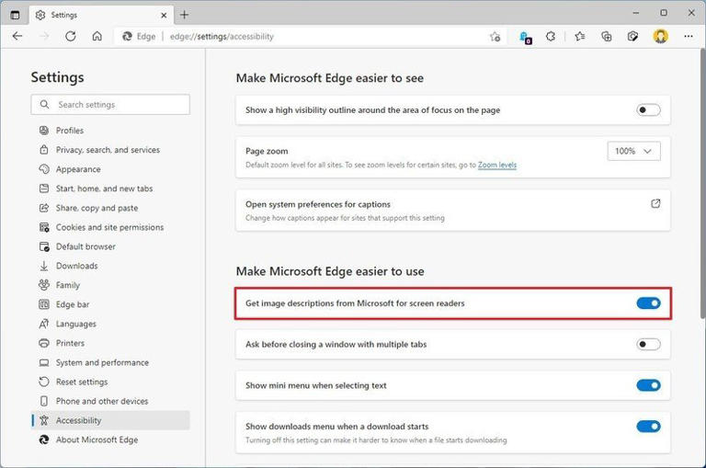
© Provided by Windows CentralMicrosoft Edge can generate image labels — here's how to enable the feature
- Click the Yes, I'm in button.
Once you complete the steps, as you browse the web, if an image doesn't have a useful label, the browser will generate an alternative text label automatically.

Enable auto-generation labels from Accessibility
To enable screen reader support through the Accessibility settings, use these steps:
- Open Microsoft Edge.
- Copy and paste the following path in the address bar and press Enter:
edge://accessibility/
- Under the "Accessibility modes" section, check the Web accessibility option.
- Check the Screen reader support option.
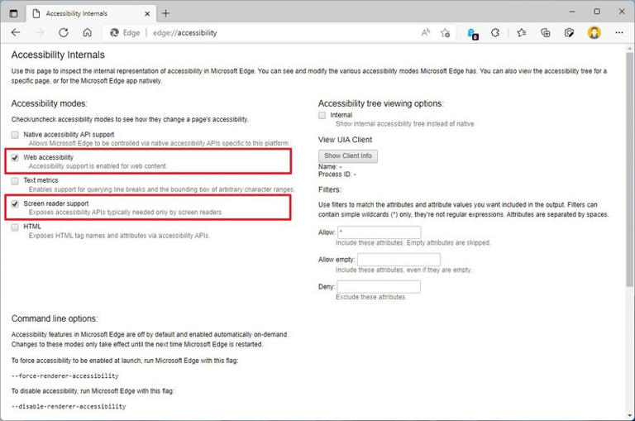
© Provided by Windows CentralMicrosoft Edge can generate image labels — here's how to enable the feature
After you complete the steps, the browser will use ML to generate labels for missing "alternative text" on the image across the internet.
We are focusing this guide on Windows 11, but the instructions will work on Windows 10 and on any platform that supports the Chromium version of the browser, except Android and iOS.

