We have received reports that recent Microsoft updates may have changed the document themes available in your Microsoft Office applications.
To recover the missing themes, take the following steps:
- Open Microsoft Word (or Microsoft PowerPoint).
- Click FILE.
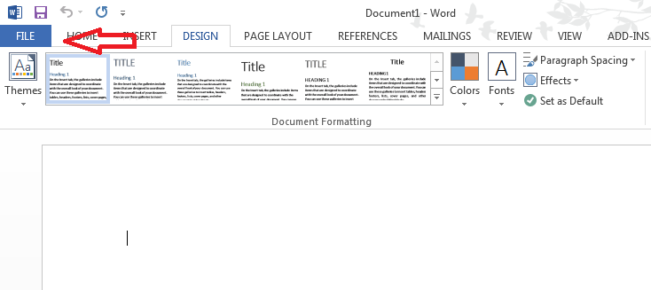
- Click Options.
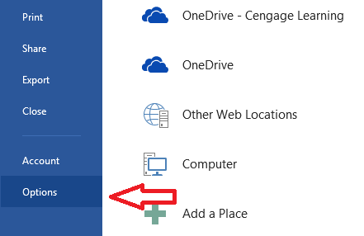
- Click Trust Center.
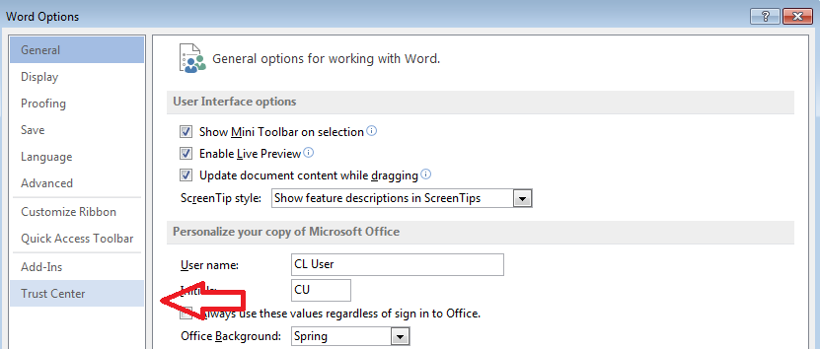
- Click Trust Center Settings.
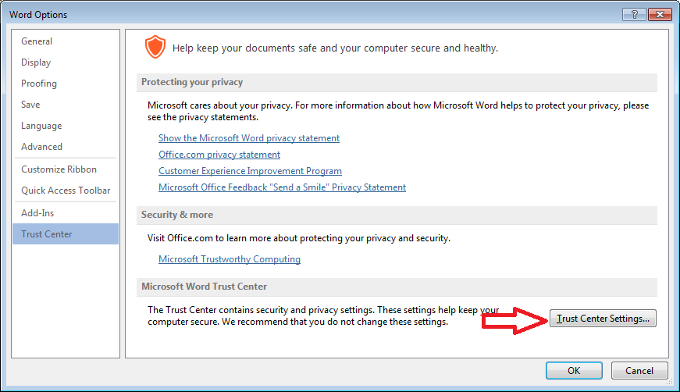

- Click Privacy Options.
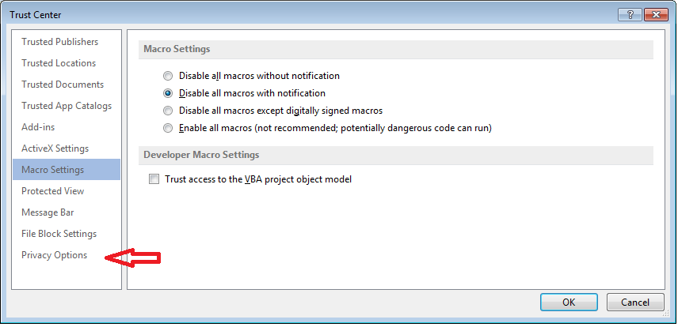
- Uncheck Allow Office to connect to the Internet and click OK. Click OK.
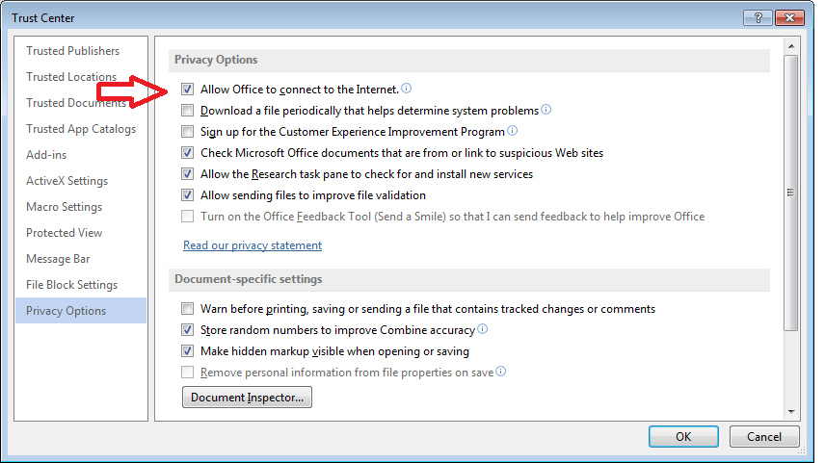
- From the Ribbon, select DESIGN, open the Themes dropdown and click “Enable Content Updates from Office.com.” A window will open asking if you want to allow Office to connect to the Internet. Click OK.
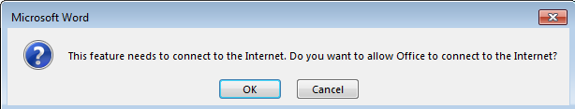
- Exit the application and then reopen your application. All required document themes should now be available under DESIGN > Themes. (It may take several minutes for all of the themes to download.)

If the above method does not work, or if you prefer to apply a theme from a file on your local machine, Cengage Learning provides all Microsoft themes necessary to complete the SAM 2013 Projects. Refer to the tab for your specific textbook series in the SAM Project Information spreadsheet (column G, “Release Notes”), available from the SAM homepage, to download specific themes.

To apply a specific theme in Microsoft Word 2013:
- From the Ribbon, select DESIGN.
- Click the Themes button.
- Click Browse for Themes.
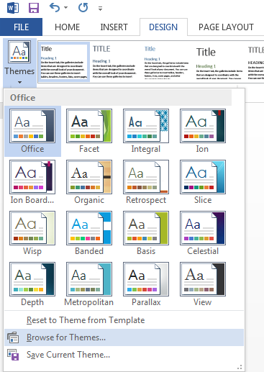
- Navigate to the saved theme and click Open. The theme is now applied to the document.

To apply a specific theme in Microsoft PowerPoint 2013:
- From the Ribbon, select DESIGN.
- In the Themes group, click the arrow at the bottom right to expand the themes options.
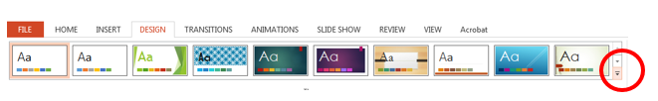
- Click Browse for Themes.
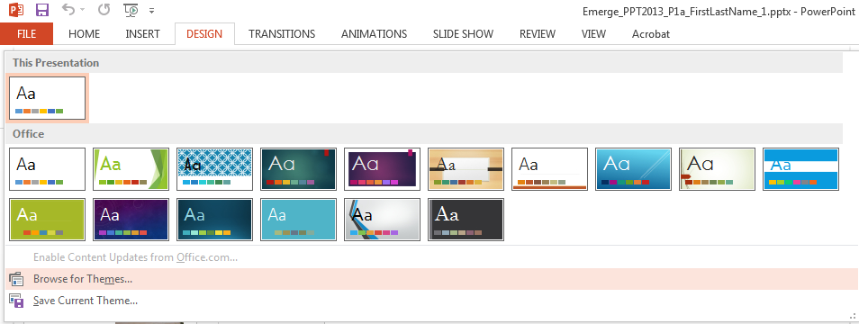
- Navigate to the saved theme and click Open. The theme is now applied to the presentation.

