Moving Publisher Content to LTI 1.3
We have been migrating course content links to LTI 1.3 since our move to SaaS and encouraging you to have your faculty update all their publisher content to the new process. Thanks to all of you who have been diligently working on this. It’s now time to make sure everyone has updated to the new processes.
At the end of summer Term – the Publisher Building Blocks (Pearson, McGraw Hill, etc.) will be turned off so that any remaining courses who have not migrated can be identified before these building blocks are removed from the system by Anthology on 12.31.2023. Masters need to be updated with the new links during summer term and older content links need to be removed from the course.
I am going through each environment and will be sending an email with any other publishers/content providers that you have specific to your college that need to be migrated to LTI 1.3 over the next few months.
Please be sure your faculty are using the links under Build Content to pair their courses and not the links under Partner Content (your instance may have more listed in this location depending on adoption)
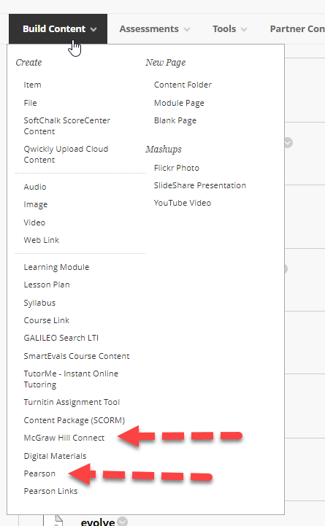

Pearson
https://help.pearsoncmg.com/integration/cg/instructor/content/get_started-bb_original-13.htm

McGraw Hill
https://www.mheducation.com/highered/support/connect/course-setup/upgrade-your-blackboard-course.html?page=13
As we have been actively moving toward this, Sherry has written several reports to help.
The following list is ready for use on each of your environments to help identify courses using older technologies to pair the content.
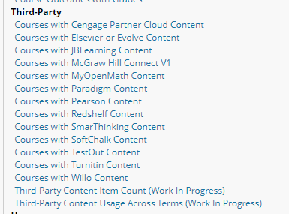
I would also encourage you to have your faculty reach out to their publisher reps to make sure they are on the latest version for their course content.

