Click the little Windows Circle in the ower left hand corner of screen and in the serach box type: Internet Options
Then Click on the item highlighted below.
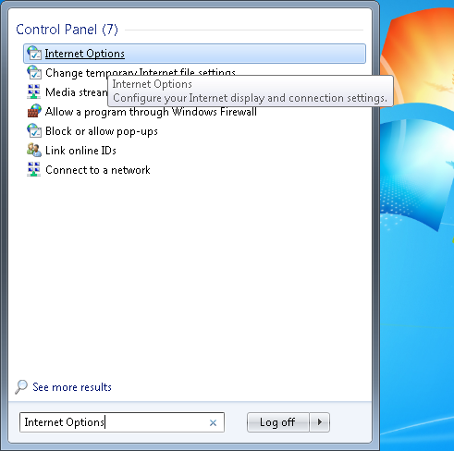

Then Click on the Advance Tab and scroll close to the bottom and put a check mark beside all the SSL and TSL options as shown below then click OK
