Qwickly – Adding Qwickly Tools to a Course

Adding Qwickly Tools to the Course Menu

- Access a course.
- From the course menu, select Add Menu Item.
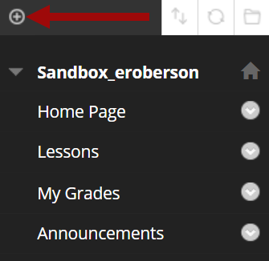
- Select Tool Link.
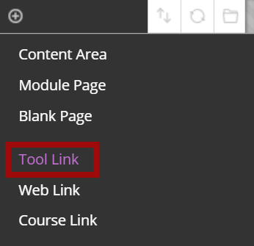
- Enter a name in the Name field.
- Select the Type menu and choose Qwickly Tools from the list.
- Leave the Available to Users checkbox blank if the link should NOT be visible to students.
- Select Submit.
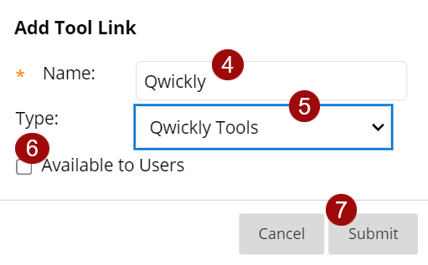
- The tool link will appear in the course menu.
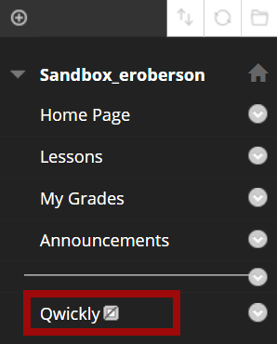
NOTE: Repeat these steps to add Qwickly Attendance to the course menu.

Adding Qwickly Tools to a Content Area

- Navigate to a content area.
- Select Tools.
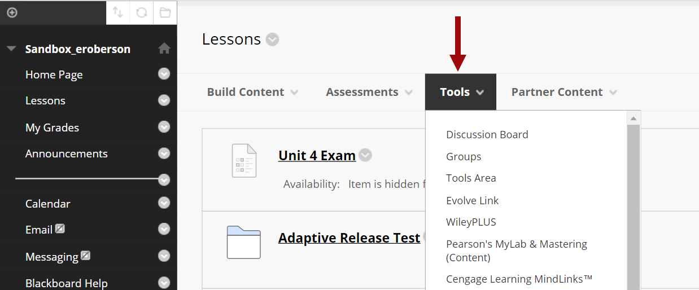
- Select More Tools.
`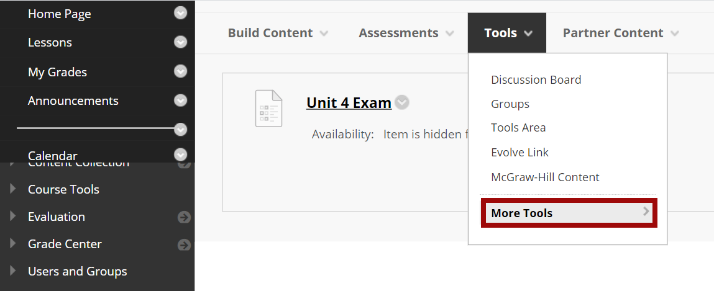
- Choose either Qwickly Tools or Qwickly Attendance.
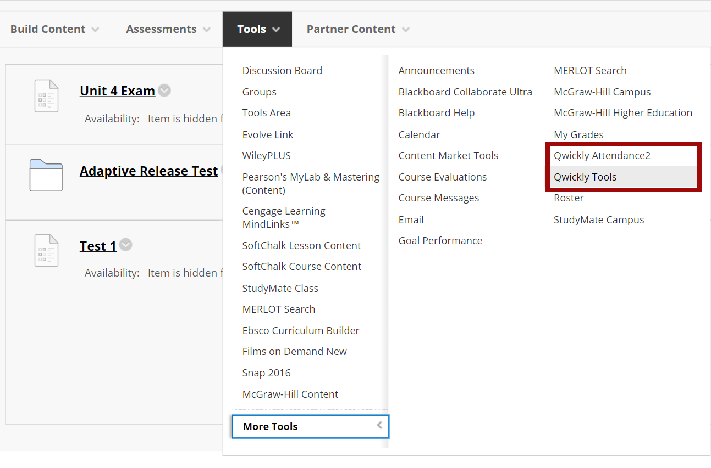
- On the Create Link page, enter a Link Name.
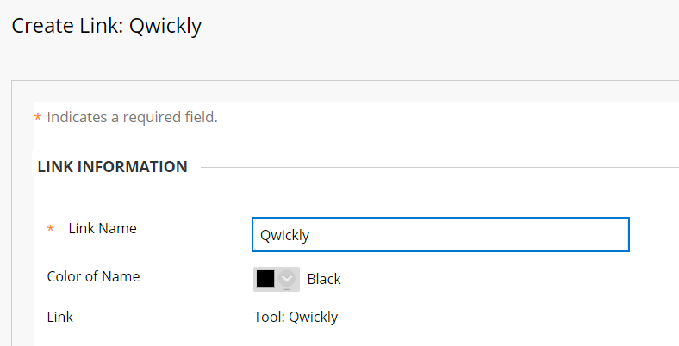
- In the Options section at the bottom, determine if the tool will be available to students.
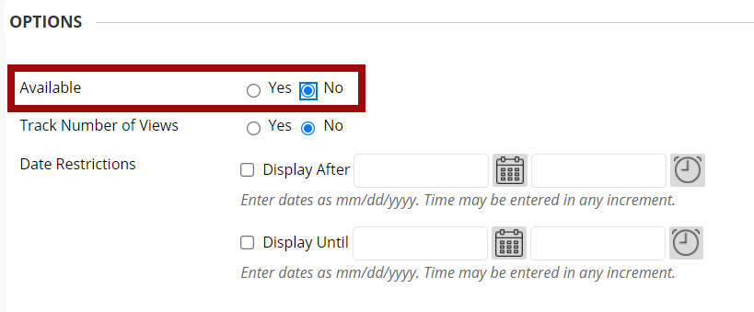
- Select Submit.
- The tool will appear in the content area.
