RESPONDUS LOCKDOWN BROWSER & RESPONDUS MONITOR – Faculty Instructions
Respondus Lockdown Browser is a customized browser that increases the security of test delivery in Blackboard. When students use Respondus LockDown Browser to access an exam, they are unable to print, copy, go to another URL, or access other applications. Once an assessment is started, students are locked into it until it is submitted. Tests created for use with LockDown Browser cannot be accessed with standard browsers nor taken using the mobile app, Bb Student.
Southeastern Technical College (STC) has additionally licensed Respondus Monitor, a webcam feature for LockDown Browser that records students during online, non-proctored exams. When this feature is enabled for a test, students are required to use a webcam and a microphone with the LockDown Browser. After the exam is complete, an instructor can review details of the assessment, even the recorded videos. Additional settings for Respondus Monitor will appear in the LockDown Browser Dashboard.

Respondus LockDown Browser Features
- Assessments are displayed full-screen and cannot be minimized.
- Screen capture, messaging, screen-sharing, virtual machine, and network monitoring applications are blocked from running.
- Right-click menu options and function keys are disabled.
- Browser menu and toolbar options are disabled, except for Back, Forward, Refresh and Stop.
- The browser automatically starts at the login page for Blackboard.
- External links in exam questions do not compromise the locked testing environment.
- Pages from the assessment are not stored on the computer after exiting.

What Does Respondus LockDown Browser NOT Do?
Respondus LockDown Browser does NOT prevent cheating unless the student is in a proctored environment. Students can still use another computer, another device, or course materials while taking the exam in a non-proctored environment.

Blackboard Support Recommendations
After enabling Respondus protections on a test, DO NOT MODIFY Test Options settings:
- Test Name
- Open Test in New Window option
- Require a password checkbox and password field
Respondus uses these options to protect your test. If these settings are modified, the test’s protections will break and an “Error” message will appear in your Respondus LockDown Browser Dashboard.
SUGGESTION: Prior to the first test, have students complete a practice test that uses Respondus LockDown Browser to make sure they can access it correctly.

NOTE: If students indicate that they are unable to access a test because they are being prompted for a password (or that the password provided to them doesn’t work), it usually indicates that they are trying to access the test with a standard browser instead of Respondus LockDown Browser.

Setup an Exam
Make sure that the test has been deployed in the appropriate Blackboard content area.
- Under Control Panel, click Course Tools
- Click Respondus LockDown Browser.
- If needed, view the Video Tutorials, Getting Started, or Resources links
- Click the Continue to LockDown Browser button

In the Respondus LockDown Browser Dashboard, a list of deployed tests will be displayed.
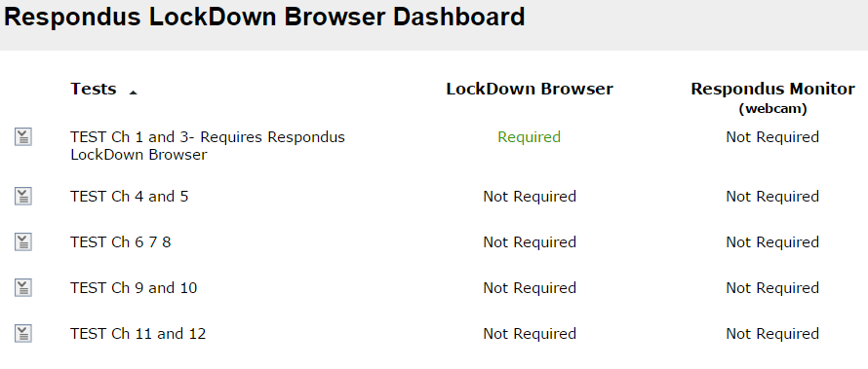
- To change the settings for a test, click the drop down arrow to the left of the test title and select Settings.
- For LockDown Browser Settings, select Require Respondus LockDown Browser for this exam.
- Include a password (optional) that students will use to access the exam. See the Password Feature Explained section of this document for information about the password created by Respondus.
- Choose optional Advanced Settings (click the plus + sign). Explanations of these settings can also be located on the Respondus Dashboard.
  - Lock students into the browser until exam is completed. Select this option to prevent students from exiting LockDown Browser before an exam is submitted for grading. Optionally, a password can be entered to enable a proctor to close the browser during an exam. Respondus does not recommend selecting this setting outside of a proctored environment. When this option is NOT selected, a student is able to exit the browser if their Internet connection fails or there is an emergency. A student will be warned twice before being able to close the browser. Students will also be prompted to enter their reason for exiting the exam early. The student’s response will be available to the instructor from the Lockdown Browser Dashboard.
  - Allow students to take this exam with an iPad (using the “Lockdown Browser” app from iTunes). Note: the Blackboard administrator nor the IT department provides support for the iTunes app. Instructors and students choosing to use the browser with an iPad can find instructions by clicking this link: Instructions for Students .
  - Allow students to take this exam with a Chromebook (using the “Lockdown Browser Chromebook extension”). Students must install the Chromebook extension to their browser. See the instructions for students on Chromebook.
  - Allow access to specific external web domains. Normally, if an exam contains a link to an external web domain, students can view the page but all links and navigations from that page are blocked. The setting here changes thereby allowing a student to access any page or link within the specified domain. This is useful, for example, to provide access to an e-book during an exam. Multiple domains can be entered, separated by commas.
  - Enable Calculator on the toolbar. A standard or scientific calculator can be enabled on the Lockdown Browser toolbar.
  - Enable Printing from the toolbar. A print button can be enabled on the LockDown Browser toolbar, allowing the exam screen to be printed. By default, the student is not capable of printing when testing in the LockDown Browser. Use this feature in the rare case a printed copy of the exam is required.
- Click Save and Close.

The words “Requires Respondus LockDown Browser” will be appended to the exam title in the content area.

The “Password” Feature Explained
The “password” feature for a Blackboard assessment is the underlying technology used for the integration with Respondus LockDown Browser. LockDown Browser uses the test password functionality to ensure that students are using the LockDown Browser to access the test. When a test is configured to use LockDown Browser, a random password is added under the Blackboard test settings. This internal password is not something the students will need to enter, but rather is used by LockDown Browser to force the LockDown Browser requirement for the exam.

The instructor should NOT delete this password once the test has been designated as a LockDown Browser test. If they do, the student will receive a warning message and the test will display a "Fix It" indicator on the Respondus Dashboard. Clicking "fix it" will restore the password in the Blackboard quiz settings. The instructor should also never provide this password to students.

DO NOT uncheck, remove, or change the password or you will break the settings for the Lockdown Browser and compromise the exam. Students do not need this password to enter the exam—this password is only needed to set up the LockDown Browser.
When a student accesses the test with LockDown Browser, the password is automatically entered. If the student cannot navigate past the password screen, and the password field is blank, it is a good indication that they are trying to access the test with a standard browser instead of LockDown Browser, or that they are using a notification shortcut to go straight to the test instead of navigating to the course and starting the test from the normal location.
If the instructor would like to require students to enter a password to access an exam, this can be set in the LockDown Browser DashboardSettingsPassword Settings.

Additional Resources
- Student Overview Video: RESPONDUS LOCKDOWN BROWSER STUDENT VIDEO
- Respondus, Inc. offers free instructor trainings throughout the year, with each webinar lasting about 45 minutes. An up-to-date webinar schedule can always be found at RESPONDUS WEBINARS.

LockDown Browser for Chromebook details for Blackboard

Students
Installing LockDown Browser to a Chromebook is easy.

- Log into the Chromebook and start Google Chrome
- Go to the download Respondus icon install link for LockDown Browser on the MySTC website (https://www.southeasterntech.edu/mystc/). You will automatically be redirected to the Chrome Web Store.
- From the Chrome Web Store, select “Add to Chrome” to install the LockDown Browser Extension.
- Log into Blackboard Learn and navigate to the exam that requires LockDown Browser
- The LockDown Browser extension will be started automatically when an assessment requires it
- Note: this extension will only work with assessments an instructor has enabled for use with LockDown Browser for Chromebook. Please check with your instructor before using a Chromebook to ensure this has been enabled.

