RESPONDUS LOCKDOWN BROWSER – Student Instructions

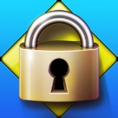

Accessing the LockDown Browser Using Southeastern Technical College (STC) Computers
- Login to the STC computer.
- Double click the Respondus LockDown Browser icon (see picture above for example) on the desktop. (This icon appears on the student side only.) The lockdown browser will automatically connect to Blackboard.
- Key Blackboard username and password as usual.
- Access course as usual.
- Access exam from content area as usual.
  - Students can then take the exam as usual but with the Respondus LockDown Browser security enabled.
- To resume operations using a standard browser (Chrome, Firefox, etc.), students should click the X on the Respondus LockDown Browser tab.

Accessing the LockDown Browser Using non-STC Computers
Students using laptops or not on campus who are taking an online exam using the Respondus LockDown Browser can still access the browser icon on the desktop if they log in to mySTC. Follow these steps to access mySTC:
- Access the STC website.
- Click mySTC at the top of the screen.
- Double click the Respondus LockDown Browser icon to download the product to their pc/laptop. Once downloaded, double click to install the Respondus LockDown Browser and following the onscreen prompts: Note: this link is unique to STC and should be used to access the lockdown browser install screen.
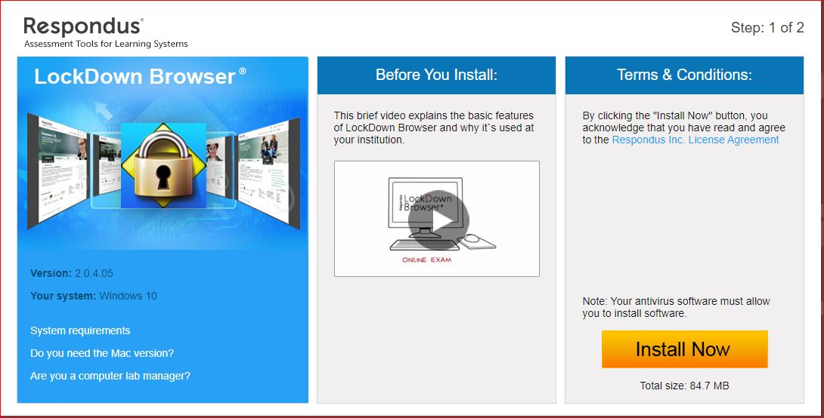
- On the install screen, click the Do you need the Mac version? link if you are using a Mac computer.
- Click the Install Now button and follow the onscreen prompts.
- Once installed, double click the Lockdown browser icon on the desktop of your PC/laptop to begin the test in Blackboard.
- Key Blackboard username and password as usual.
- Access course as usual.
- Access exam from content area as usual.
  - Students can then take the exam as usual but with the Respondus LockDown Browser security enabled.
- To resume operations using a standard browser (Chrome, Firefox, etc.), students should click the X on the Respondus LockDown Browser tab.

LockDown Browser for Chromebook BETA details for Blackboard

Students
- Installing LockDown Browser to a Chromebook is easy.
- Log into the Chromebook and start Google Chrome
- Go to the download Respondus icon install link for LockDown Browser on the MySTC website (https://www.southeasterntech.edu/mystc/). You will automatically be redirected to the Chrome Web Store.
- From the Chrome Web Store, select “Add to Chrome” to install the LockDown Browser Extension.
- Log into Blackboard Learn and navigate to the exam that requires LockDown Browser
- The LockDown Browser extension will be started automatically when an assessment requires it
- Note: this extension will only work with assessments an instructor has enabled for use with LockDown Browser for Chromebook. Please check with your instructor before using a Chromebook to ensure this has been enabled.

