Using Respondus with ANGEL and Blackboard

Install Respondus

This program should be downloaded from www.gvtc.org/download

*Do not download the version from Respondus.com

NOTE* Some colleges do not allow the “Respondus Projects” folder to be created on the C drive by the install process – Please check to make sure that you can create the following folder on your computer: C:\Respondus Projects.

If you are not able to create this folder then you will need to get with your IT department and have them assist you in creating this folder and then install the program.
If you have already installed the program and this file was not created – you will need to get with your IT department to create this folder and then uninstall and reinstall the program again.

Once you have installed the program you will be prompted to add the following information to register your program.

Institution Name: Georgia Virtual Technical College
Local Support Contact(s): Robert Keown, rkeown@tcsg.edu; Debra Rogers, drogers@tcsg.edu
Installation Password: (changed annually and stored on the website where you downloaded the software)
This information is stored on the GVTC Download page and the license key is updated annually. There is a new activation process that does not require you to enter a new code every year as long as you continue to use the program. So if you use Respondus frequently you should not have to enter the code again.

If you have not used Respondus recently – you may be asked to enter the current installation password again and/or you may be asked to check for updates. Please run this if asked to do so.

Once you have installed/updated Respondus you are ready to connect to ANGEL

Equation Editor – The installation process will ask you if you want to install this – recommended if you are going to be writing questions using math equations, but for this process it is not needed.

Using Respondus with ANGEL
Make sure you are on the Start Tab – and that your currently personality shows ANGEL 6.3-8x
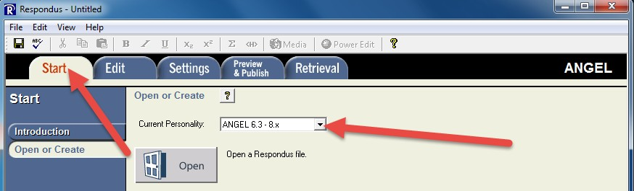

Next you are going to connect Respondus with your ANGEL account Click on the Retrieval Tab
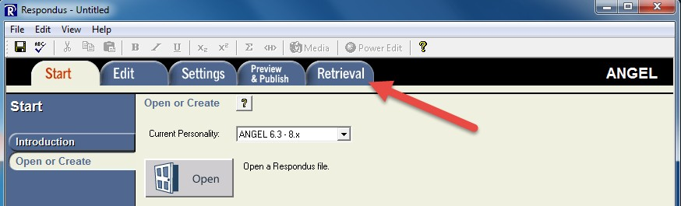

Then Retrieve Questions
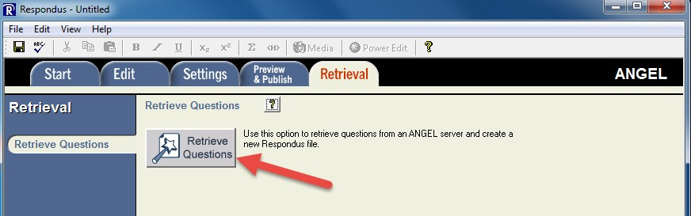

This will open the following screen where you can “add new server” on the dropdown list

*NOTE – you only have to do this once for ANGEL and then once again for Blackboard – your settings will be saved and you won’t have to do this again on the same computer.
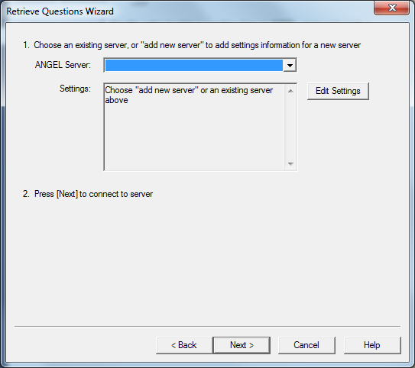

Once you have selected “add new server” on the drop down the next window will open

Please make sure that ”Yes, check for preconfigured server setting” is checked and then click “Next”
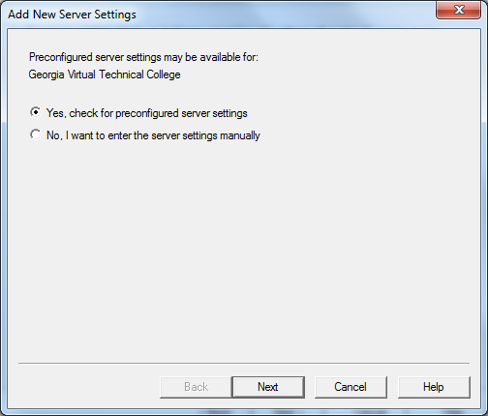

Choose your college name from the dropdown list and then click “OK”

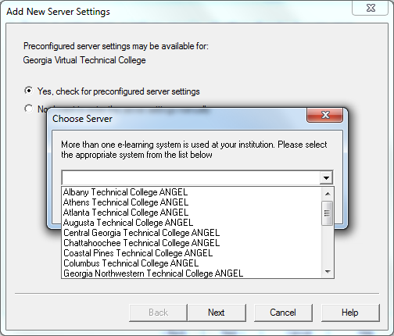
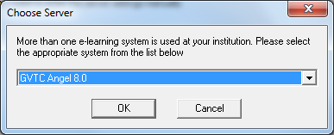

Once you click “OK” you will be taken to the next screen where you will enter your information in the appropriate boxes.

NOTE* you can save your username and password on your local machine but it is not recommended that you save this info on a lab or shared computer.

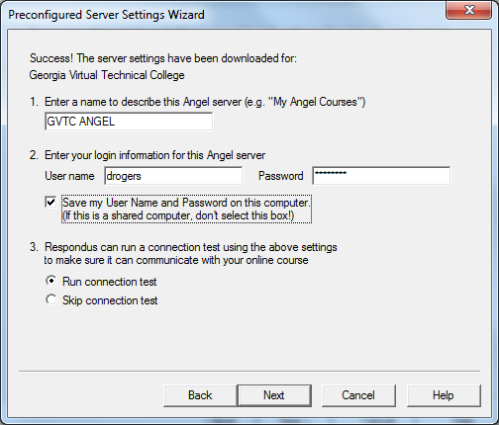

Click “Next” to run the connection test and you should receive the following success message
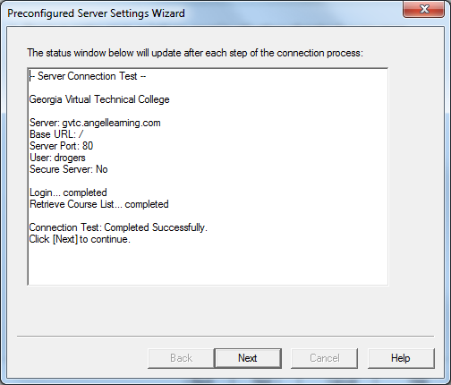

Click “Next” then Finish to start the retrieval process

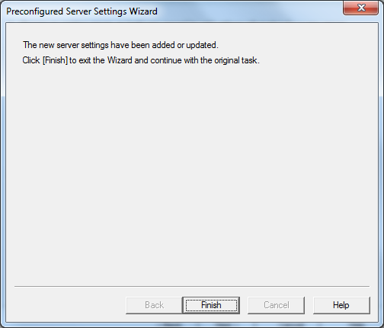

NOTE* If you get the following message that the connection test has failed – then you do not have the C:\Respondus Projects folder on your computer system and you will need to follow those steps from the first page of this tutorial to get that worked out before continuing.
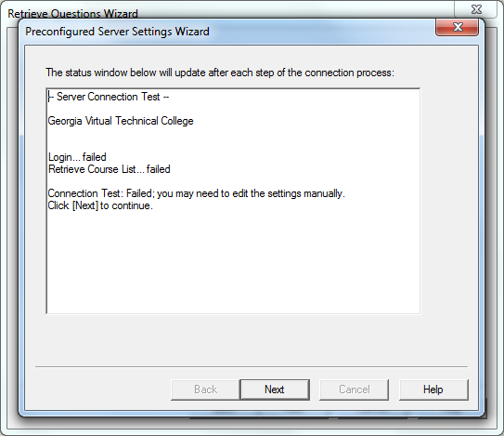

The Retrieval Process

Now that you have successfully completed the “Add New Server” process you will see this information when you use Respondus – unless something changes you will not need to “Edit Settings” just click “Next” when you get to this screen.
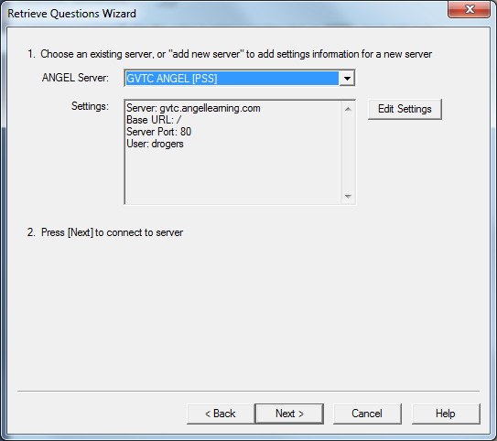

Then you are ready to choose the course where the test you want to download is located Expand the + signs if you have multiple levels and choose the test
You should give the test a new name that needs to be specific to the course so you can identify it later – also you can’t have duplicates so there won’t be a lot of chapter 1 quiz, chapter 2 quiz, etc.

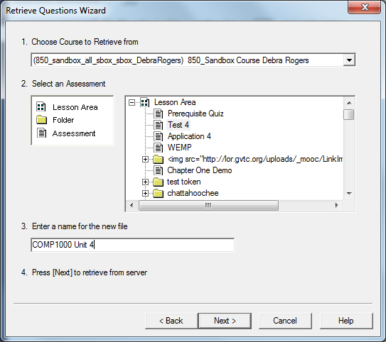

Once you select the “Next” button you should get the following screen that the process has complete successfully.
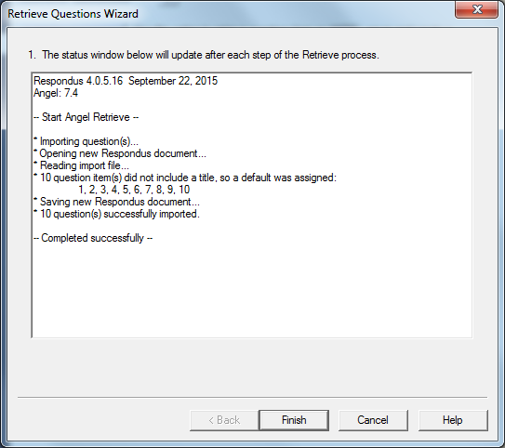

Click Finish!

You now have the option of retrieving all your tests at one time – with unique names so you can find them later under File Open in Respondus – or you can do them one at a time and then publish to Blackboard.

Publish to Blackboard
After you have retrieved the test(s) from ANGEL, you are ready to start the publish to Bb process You will need to go back to the Start Tab and change to the Blackboard personality
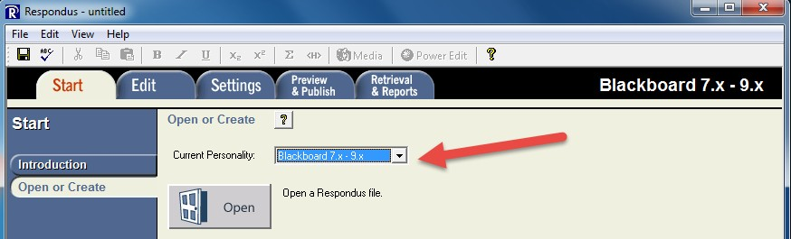

You will see this message for each of your tests as you open them since they were created in ANGEL and now you are moving them to Blackboard. If you are doing this at different times you will need to use File Open in Respondus to choose your tests. (that is why it is so critical to name them appropriately)
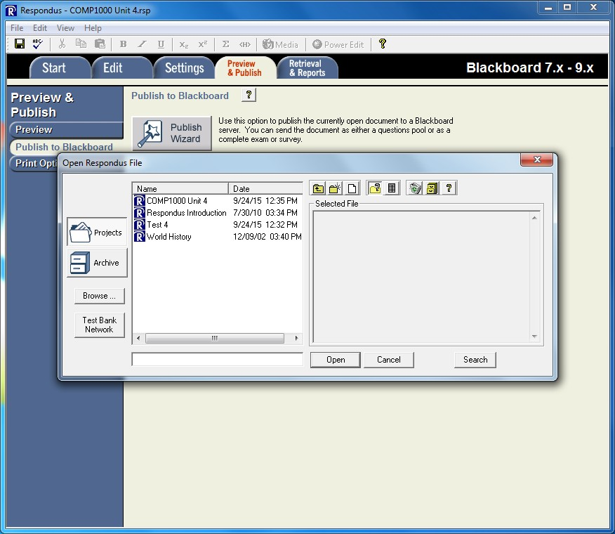

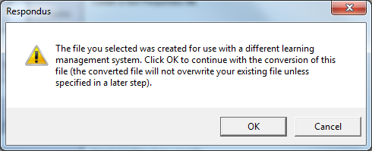

You may also get this message if you are using feedback
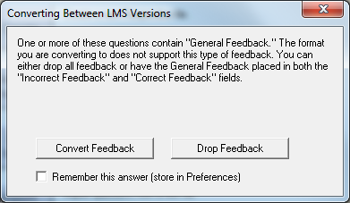

Depending on your choice – your message in the following screen will read different if you kept your feedback or dropped your feedback

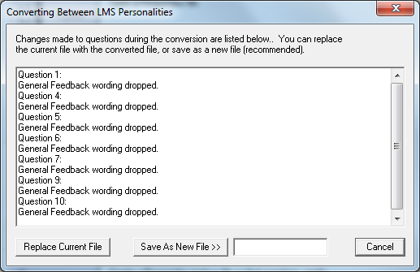

The following message will appear if you kept your feedback
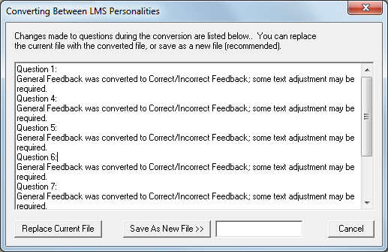

You can choose to Replace Current File – if you need the file in the ANGEL format you can simply retrieve it again.
This will take you to the next screen where you can view the questions if necessary, but since you have been using them in ANGEL – they should all have correct answers, etc.

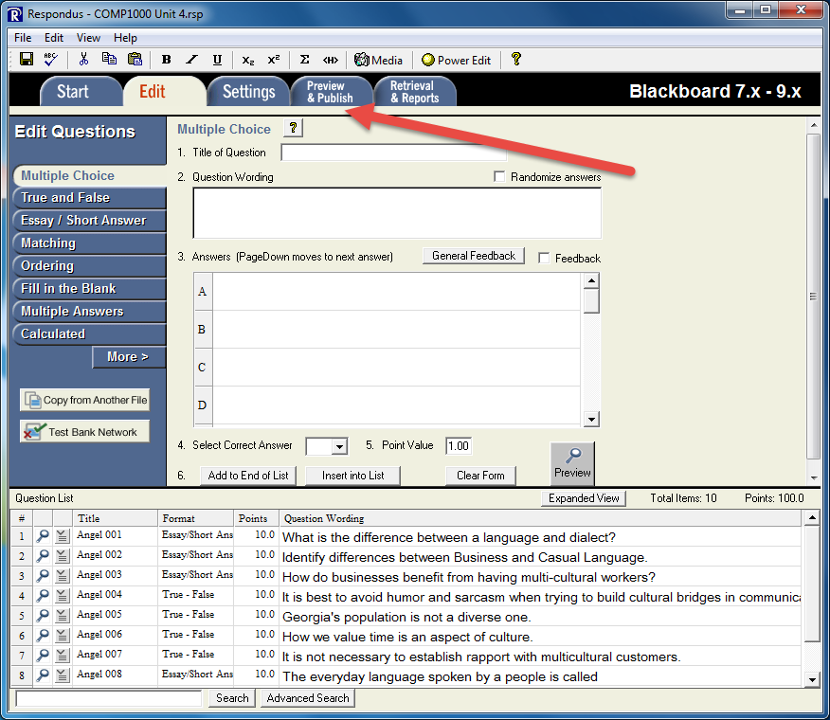

Choose the Preview and Publish Tab – here you can view each question one at a time if you do want to verify that each question has the correct answer or there is one that you have been wanting to rewrite.

Then choose Publish to Blackboard

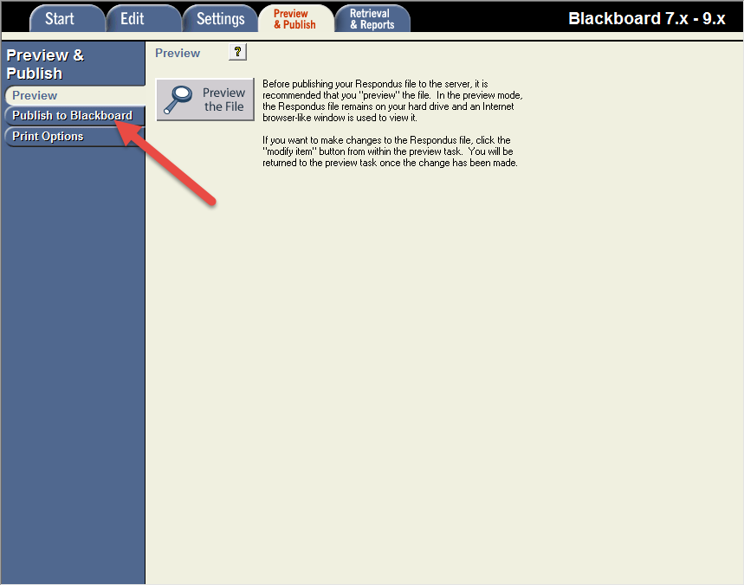

Then choose the Publish Wizard Button

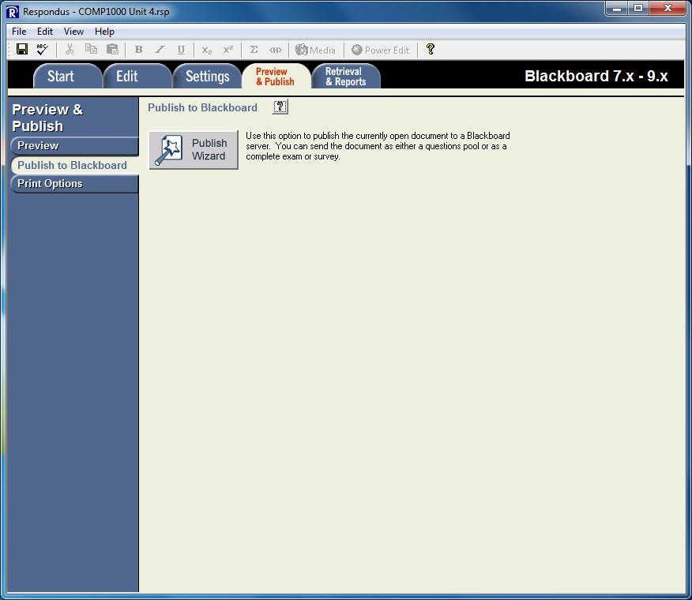

Here you will need to go through the “Add New Server” Steps again – only this time you will choose your College Blackboard preconfigured settings and add your Blackboard login and password.

The following screenshot shows that Bb is configured properly – Click “Next”

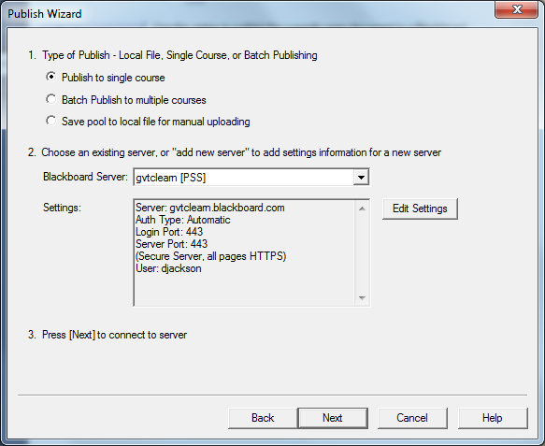

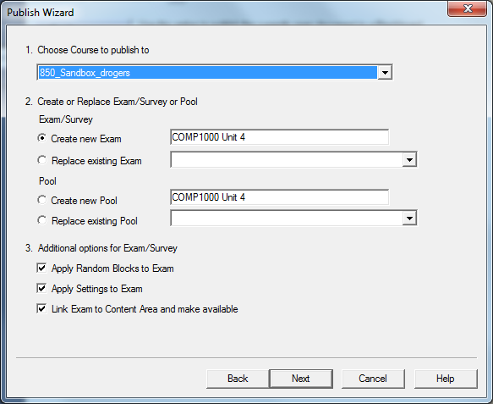
Complete the following settings and click next

You have the option to create a test or create a pool

If you choose to create a test it will also deploy the test for you – the next screen asks you where you want to place the test

If you choose to create a pool then you will need to create a test and then deploy it later

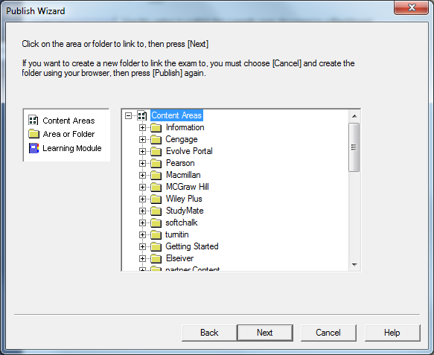

Once you have chosen the content area where you want to place the test – choose “Next”

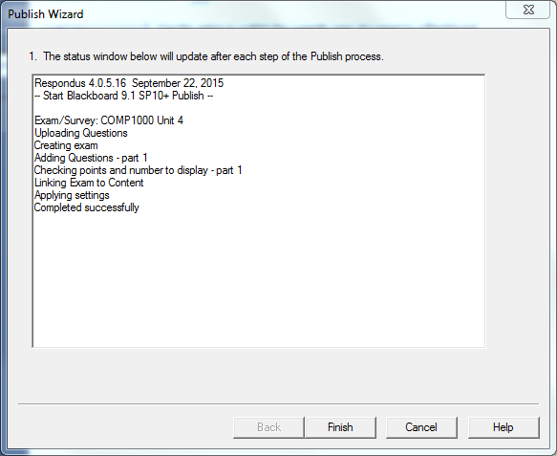

You can now click the Finish button

If you have more tests/pools that need to be published to Bb then you will need to use File > Open and choose the next test

You will be asked if you want to save the changes to the test you just published before opening the next one
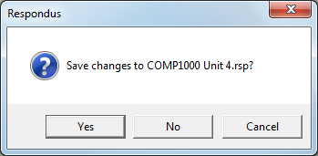

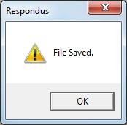

And you will be back at this step in the process
