SoftChalk Cloud – Account – Requesting

To use SoftChalk Cloud, instructors must have an account. The steps below explain how to submit a request for a SoftChalk Cloud account.

Request SoftChalk Cloud Account

- Navigate to https://gvtc.tcsg.edu/SoftChalkUserRequest.
- Complete the form. All fields are required. NOTE: A College email address must be entered for the account to be created.
- In the Security Code field, enter the code shown in the box.
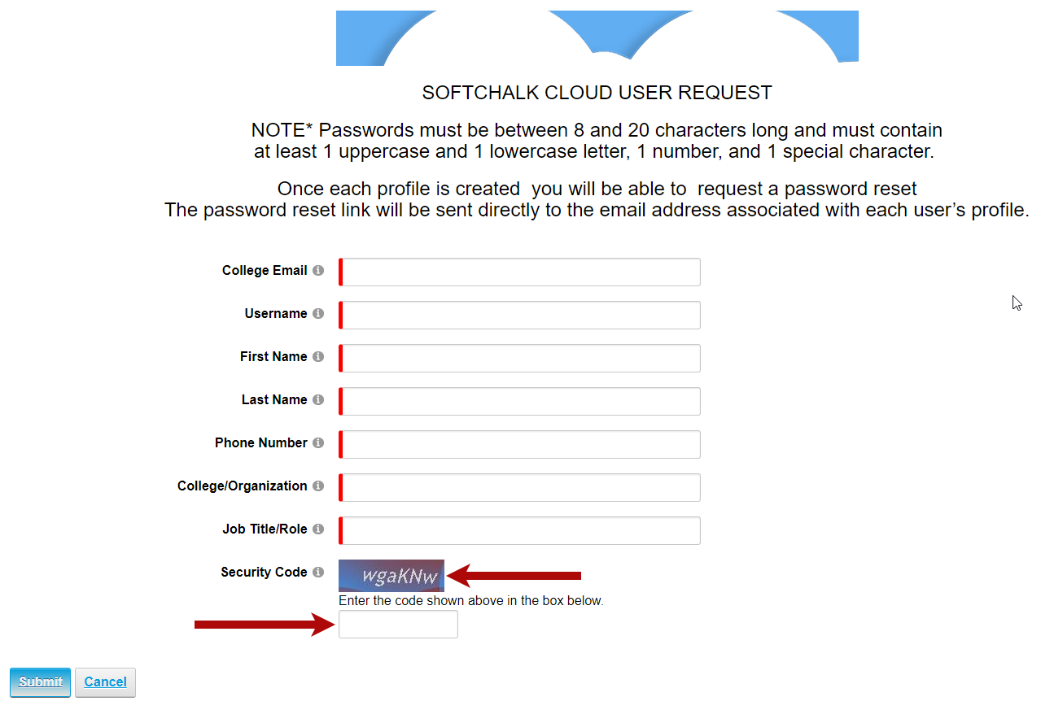
- When done, select Submit. You will be notified once the account has been created. 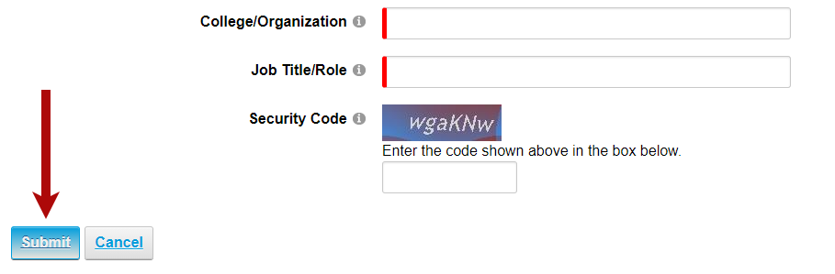
NOTE: Once the account is created, you can request a password reset. The password reset link will be sent to the email address associated with the account. Passwords Requirements:
- Must be between 8 and 20 characters long
- At least 1 uppercase and 1 lowercase letter
- At least 1 number
- At least 1 special character

