Creating Recordings and Closed Captioning Tips
Those signed into Coastal Pines Office 365 accounts have access to the live captions that are available in Microsoft Teams. Captions are also available in Microsoft Stream. This feature improves the accessibility of Microsoft products.
Live captions give participants another way to follow a conversation. They can make your meeting or video more inclusive to participants who are deaf or hard of hearing, participants with different levels of language proficiency, and participants in loud places. There are many options for making videos, streaming videos, and applying captions to increase accessibility. Below, a few of these options are mentioned. These or other methods can be applied as you create instructional content. With all instructional videos, care must be taken with video searchability, copyright compliance, and privacy settings.

Microsoft Stream and Microsoft Teams tools available in Office365
As an instructor, you could use Microsoft Teams (separate handout) to record a lecture. Once the recording is ended, it goes into Microsoft Stream.
Setting a language (such as English) enables automatic closed captioning for your video. You can also have Stream Autogenerate a caption file that students can see while viewing and that can be downloaded. The screenshot below highlights the options that can be applied in your video settings when you have video content in Microsoft Stream for which you wish to apply captions. Note that Microsoft Stream would require the student to use their singe sign on.
Using Microsoft Stream would be a good option for creating custom videos for use inside or outside of Blackboard. The perks of using O365 would include: you already have the software on your work computer or can download it easily, you only need a headset or webcam, you have the option to share a screen, the recordings are easy to make and automatically close caption with the right settings on, you have 1TB (a lot) of storage available in your O365 account.
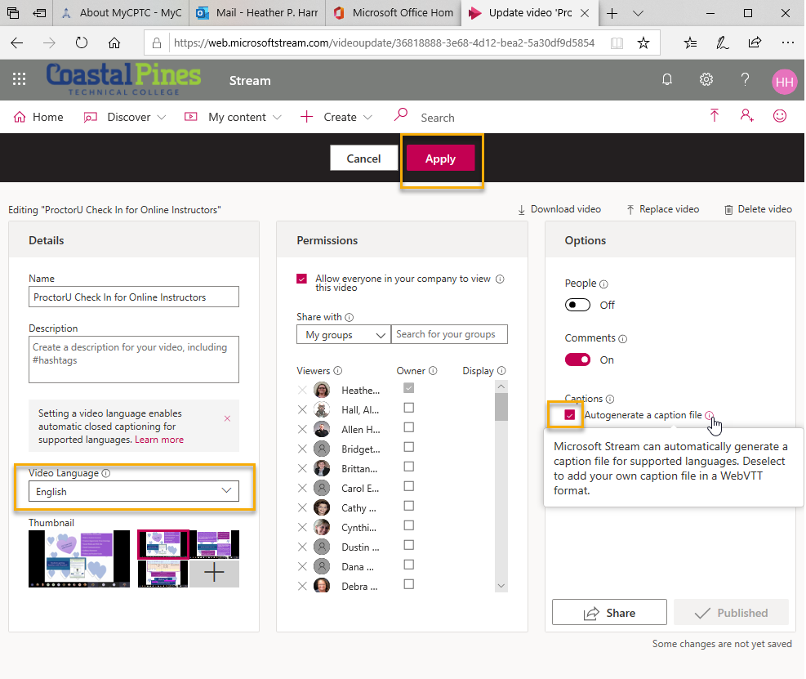

Some Other Video Options (outside of single sign on)
Another free video tool would be Screencastomatic. This would be a good place to start as well if you would like to try something free and relatively easy to use. If you use significant bandwidth, you may have to upgrade to keep going. This video software allows you to record your screen while recording audio and video. The free version of this does not include closed captions but a paid account does have that option.
TechSmith, the same company that operates Camtasia and Snagit, has a free version of Screencast for video streaming. Again, if your videos get a lot of views, bandwidth could be an issue. Paid accounts are more expensive. This streaming service does allow easy video captioning that can be added after the video is made. Simply click on the CC button and type in your captions or copy paste them in if you followed a script.
YouTube offers automatic closed captions that can be edited. The WebVTT files mentioned below can also be loaded. Again, bandwidth and storage limits would be a concern if you have a lot of usage. And, given the public nature, as mentioned above for all videos: care would have to be taken with video searchability, settings, copyright, privacy, etc.
A free and open source software for video recording and live streaming is OBS studio. It does not have a built in closed captioning tool, but you can use web captioner for the captioning (only works in Chrome). You can also use web captioner if you are looking to record audio only files (lectures without video) and provide captions.

Customizing the Closed Captions in Microsoft Stream (Advanced File Formatting)
For those new to captioning, simply turning on the language and autogenerate will allow the automatic captioning to be available in Microsoft Stream. If you wish to edit what the captions say, here are some more advanced steps.
Once the automatically generated caption file has had time to generate in Microsoft Stream, it can be downloaded and opened in Notepad. The file will be in what is known as a WebVTT format. This is the file type used by subtitles and captions. If you wish to edit the Closed Captioning, you could download this file, edit it in Notepad, copy and paste your new content into a format checker to make sure that you got it right. Once your file is formatted correctly, you can copy and paste your captions into a file converter. Finally, you would upload the edited version for the subtitles. WebVTT files must be formatted in a very specific way.
Distance Education is glad to help you bring your recording ideas to life if you have a goal in mind and need assistance.

