Meetings in Microsoft Teams
If you already have Microsoft Teams and Microsoft Outlook installed from the Office 365 package, it is easiest to schedule or attend a Teams Meeting through the Outlook calendar.
- To schedule a Teams Meeting: You will have the Teams icon next to the Skype Icon when setting up a meeting from your calendar.
- To join a Teams Meeting: You can also join a meeting using the same icon or by clicking “Join Microsoft Teams Meeting”
  - When the new window pops out select “Open in Microsoft Teams” or “Join on the Web Instead”.
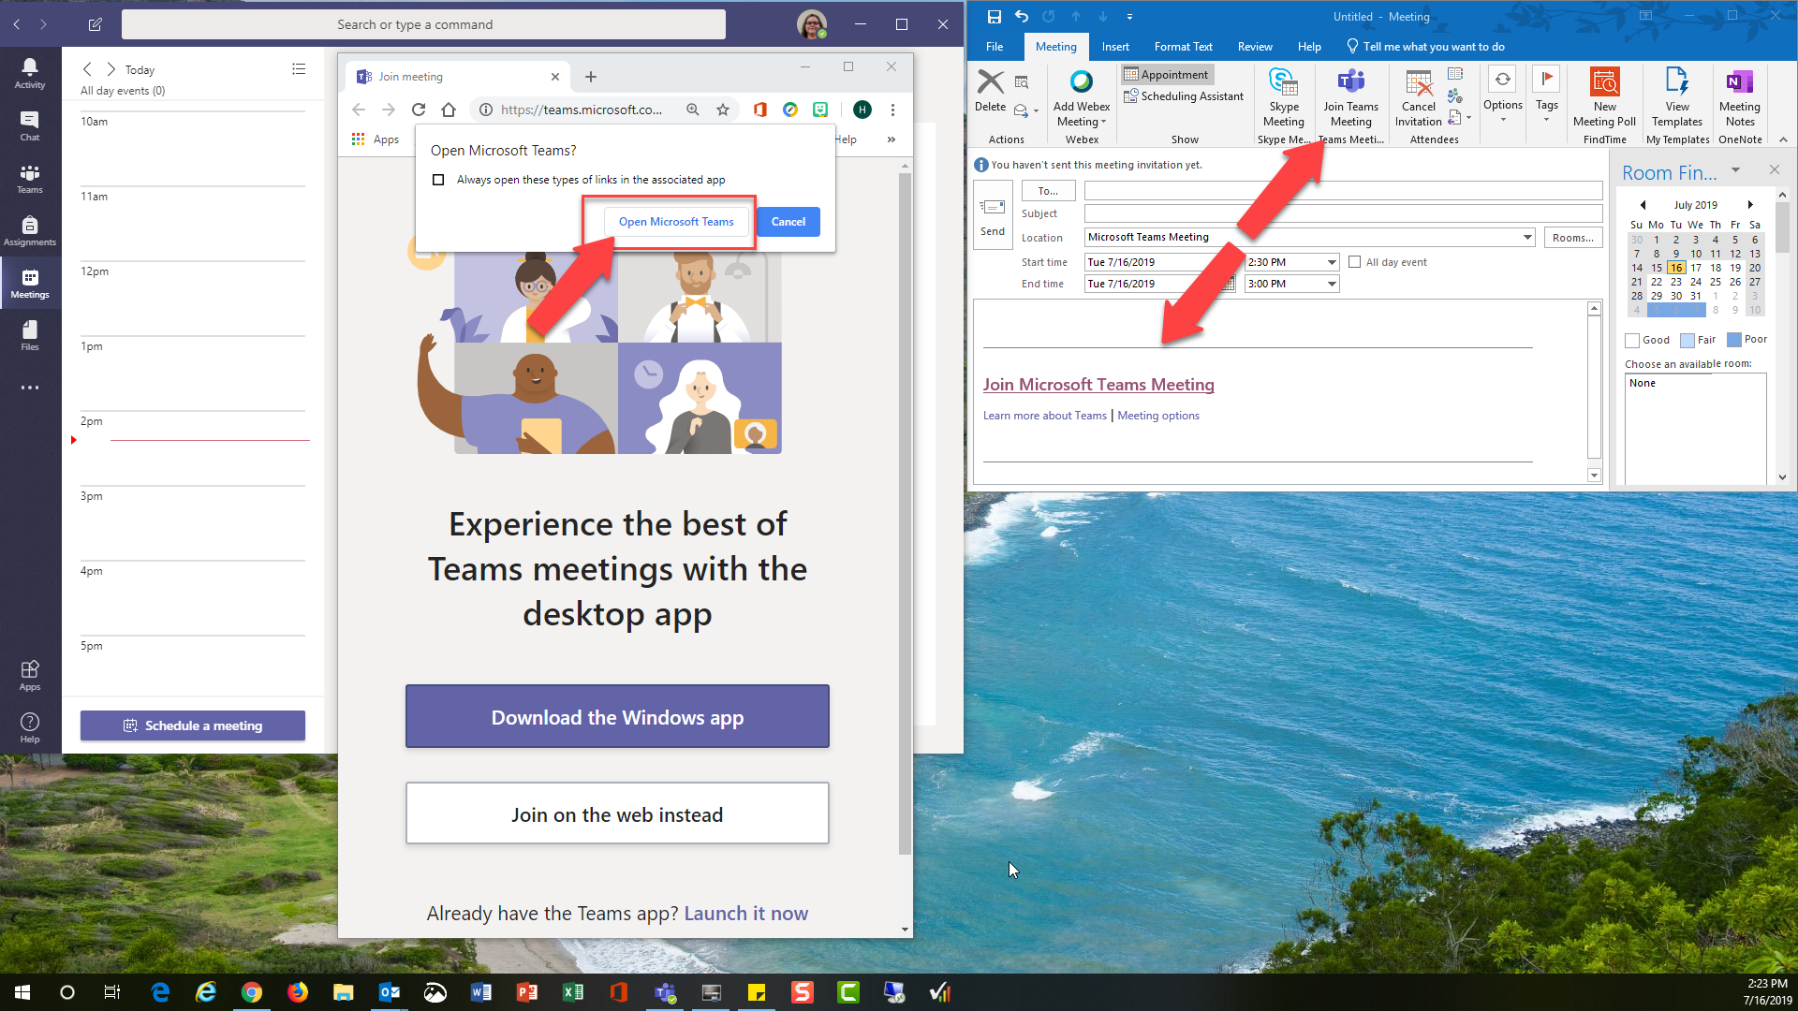
Check your camera and microphone settings before clicking "Join now".
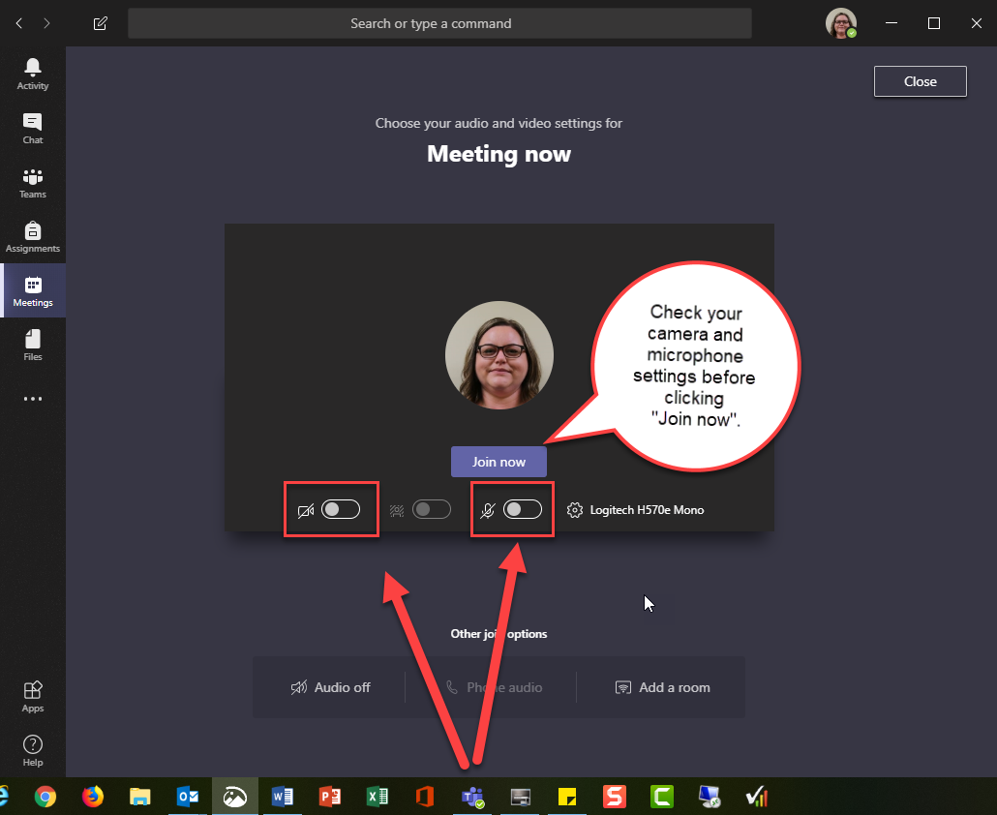
While in the meeting, you can
- Share your screen or an application.
- Chat with others.
- Start or stop a recording from the … ellipse button.
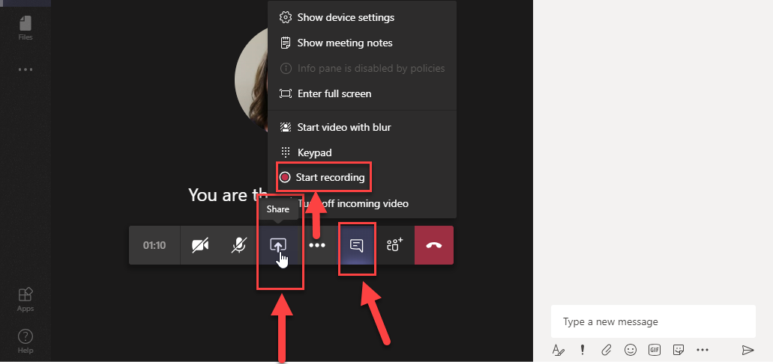
As a meeting organizer, when starting or stopping a recording from the … ellipse button, you will receive the prompt that your recording will be available in the chat or in Microsoft Stream.
Once the recording is stopped, the easiest way to get the link is to use the menu beside the chat item to choose “Get Link” and copy/paste the link into your calendar invite or send an email with the update.
If you forgot to grab the link or want to grab it later. You can find a complete list of any recorded sessions in Microsoft Stream https://web.microsoftstream.com/studio/videos and use the ... Ellipse button on the far right of the meeting to share or download the recording.
