Microsoft Teams from Student Office 365 Account-

Can be used Online (without download) or Downloaded Free
- Logon to student mail at My CPTC web page:
https://outlook.office365.com/student.coastalpines.edu
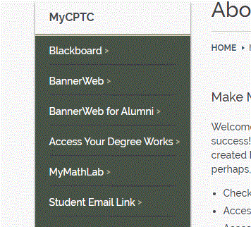

- In the Upper Left Corner, click App Launcher
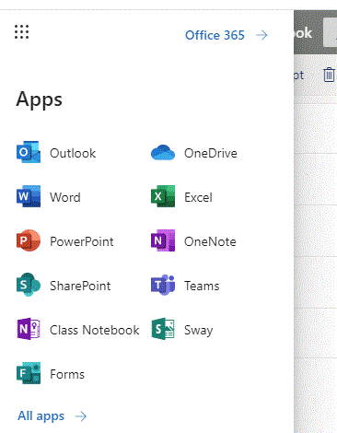
- Teams App is in right column 4th from top
If your instructor has set up a calendar invite- you will just go to the calendar from your webmail and click join meeting.
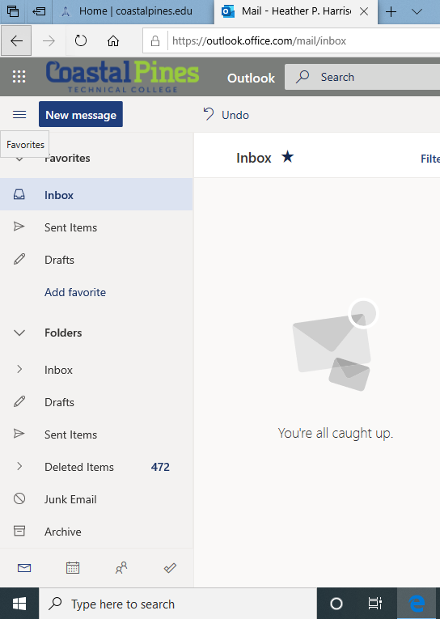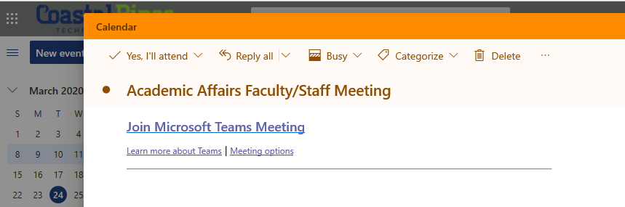
You will be able to join online just using your web browser or with the app. You also have access to your calendar from within Microsoft Teams.
