Turnitin – Assignments – Creating

Creating an Assignment

- Within a course, navigate to a content area.
- Select Build Content, then choose Turnitin Assignment Tool.
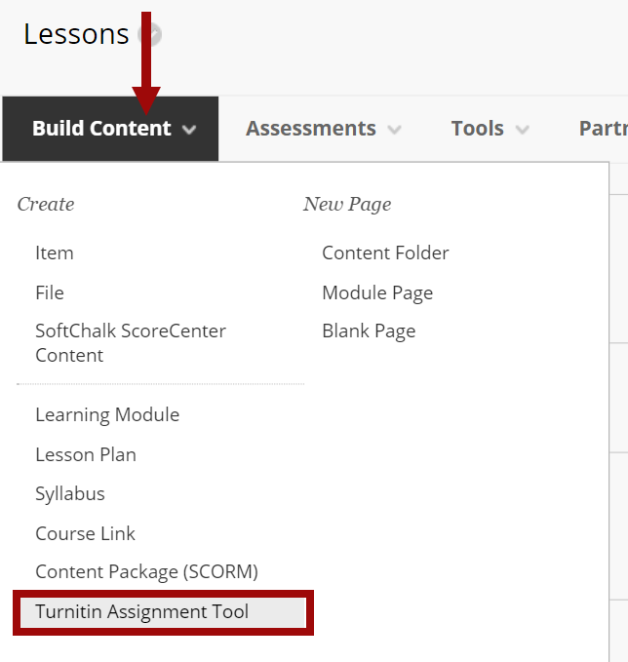
- On the next page, enter the following:
  - Title – The assignment title.
  - Instructions – The assignment instructions.
  - Max Grade – The point value for the assignment. A grade column will be created in the grade center.
  - Start Date – The date and time students can begin submitting the assignment.
  - Due Date – The date and time student papers are due.
  - Feedback Release Date – The date and time students can begin viewing the comments and grades instructors have left on their papers in GradeMark.
  - Enable PeerMark – Enable this option to add PeerMark assignments to the assignment.
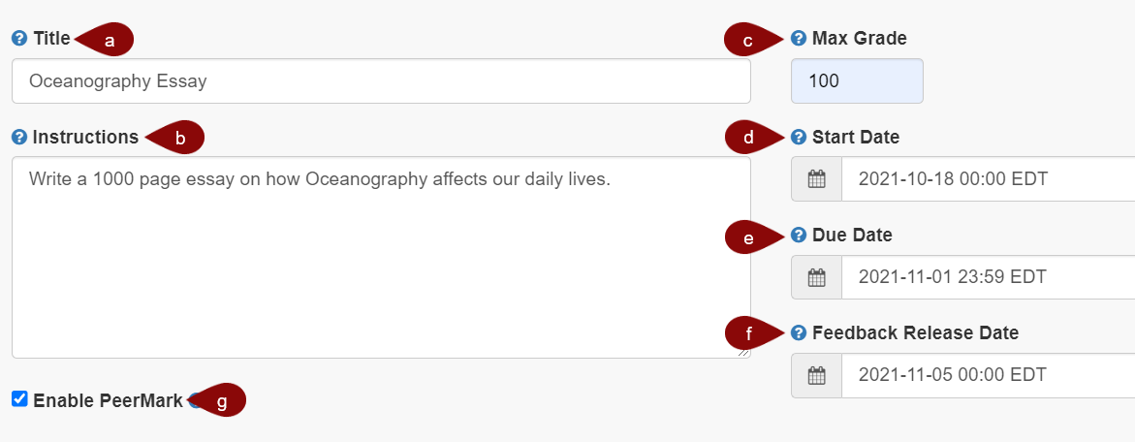

Enabling the Turnitin Settings

NOTE: Select the blue checkmark next to a title for help on the topic.
- Select the Optional Settings link.
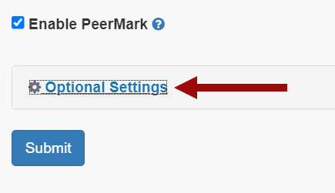
- Review and enable the Turnitin settings for the assignment.
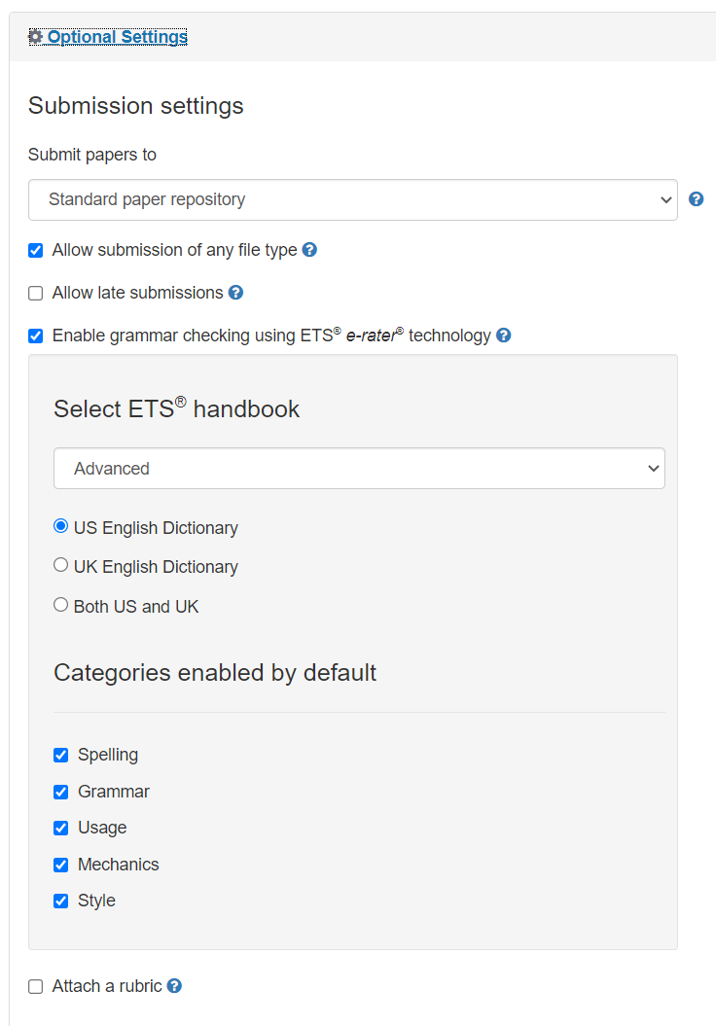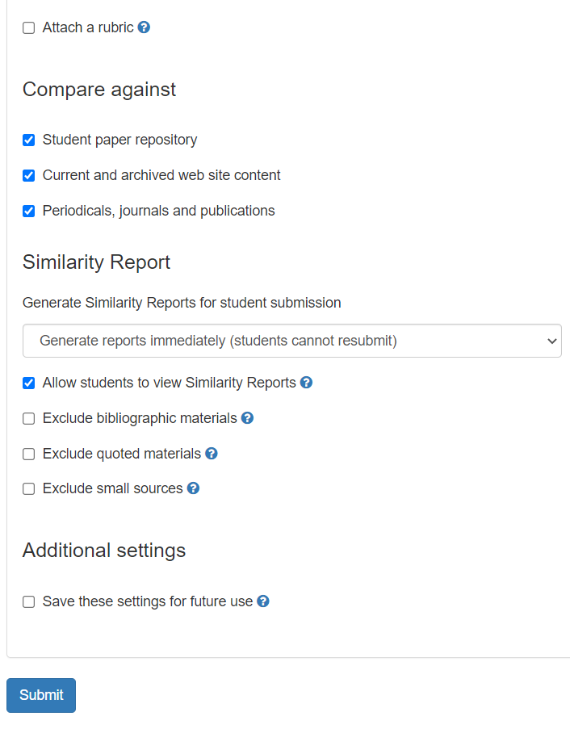
- When done, select Submit.
- The settings will be saved and the assignment will appear in the content area. NOTE: Adaptive Release will be enabled on the assignment. A date criteria is applied based on the Start Date entered for the assignment.
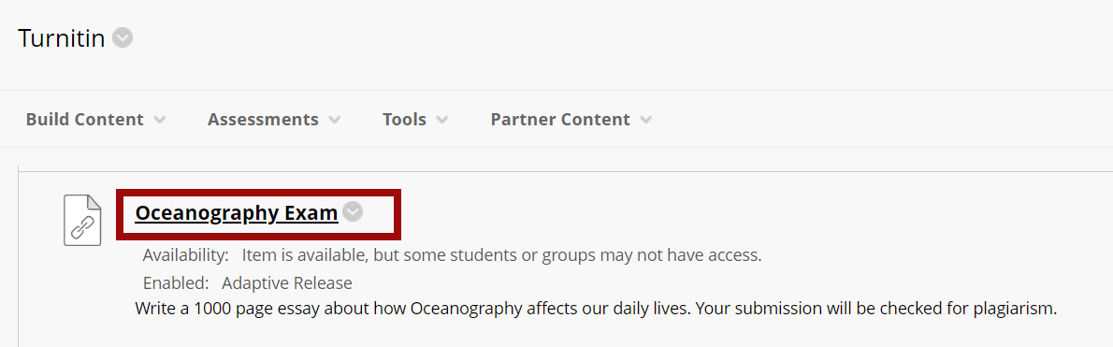

Viewing Submissions

- To view student submissions, from the content area, select the assignment link. The Assignment Inbox will appear.
- There are three tabs, Assignment Inbox, Analytics and Peermark.
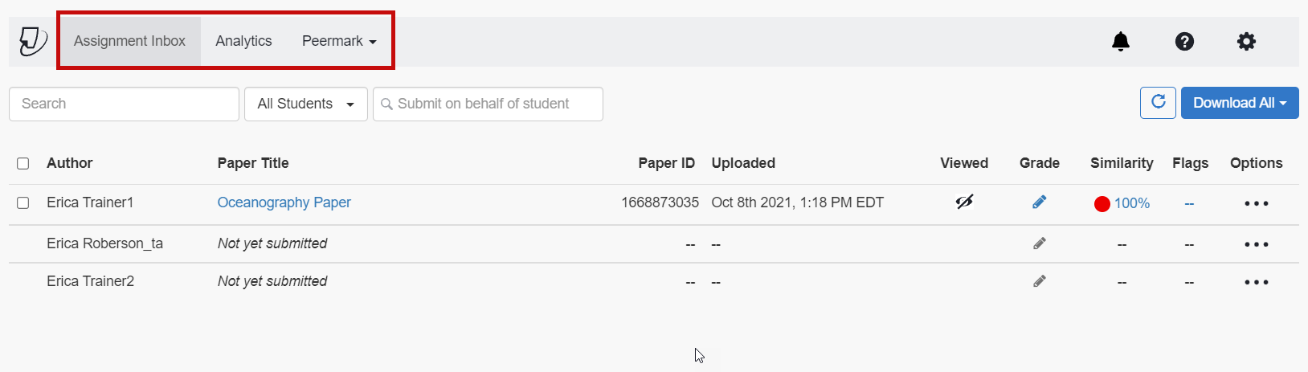
- On the right, there are three icons, Notifications, Helpdesk and Settings.
  - Notifications – View new messages or announcements.
  - Helpdesk – View Turnitin’s help page.
  - Settings – View/modify the Turnitin settings for the assignment.
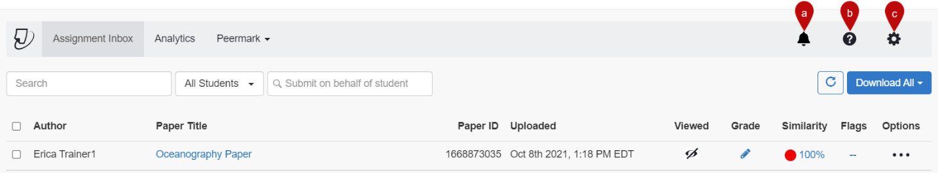
- Underneath the icons on the right, is the Refresh button and the Download All button. Select the Download All button and choose an item to download. The item will be downloaded for all students.
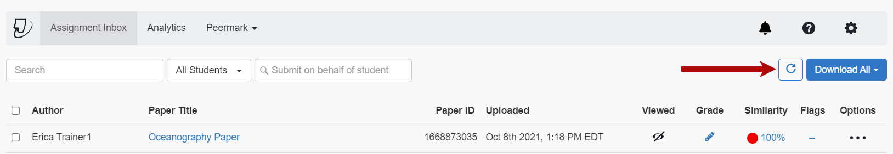
- The Assignment Inbox shows:
  - Class Roster – Lists all students enrolled in the course, regardless of submission status.
  - Paper Title – Displays if the paper has been submitted. If the paper has been submitted, the title of the assignment entered by the student upon submission will appear.
  - Paper ID – Each submission is assigned an ID number.
  - Uploaded – Shows the date and time the paper was submitted.
  - Viewed – Shows if the student has viewed the feedback.
  - Grade – View the Instructor Feedback in Turnitin and enter a grade.
  - Similarity – Shows the percentage of similarity matches found in the paper. Select the percentage to open the Feedback Studio and view similarities.
  - Flags – Shows flags Turnitin has applied in the paper for review.
  - Options – Choose the three dots to either upload a new document for the student, download the submission, or delete the submission.
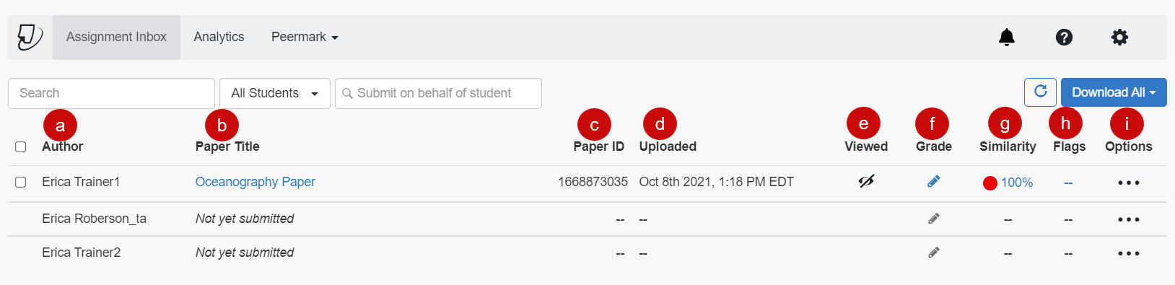
- The Analytics tab shows the statistics for a variety of areas.
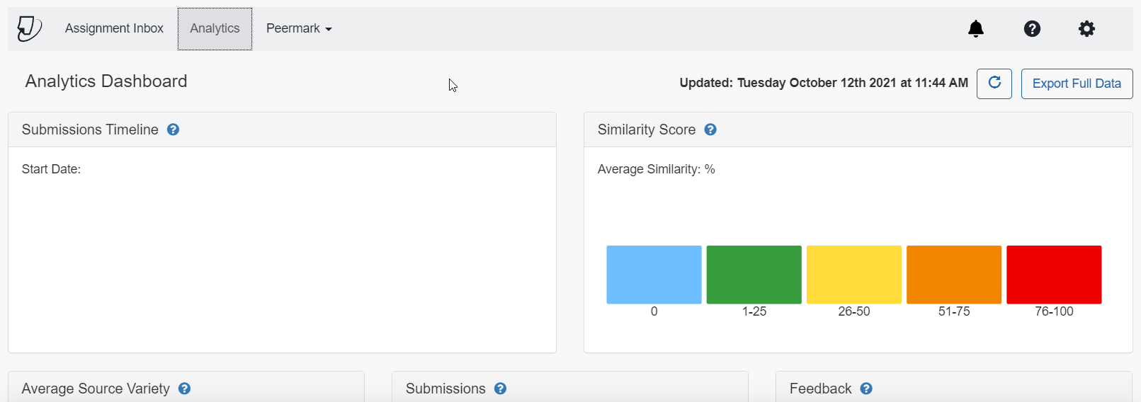
- Select the PeerMark tab to setup PeerMark assignments and to view PeerMark Reviews.
