DEGREE WORKS
Logging into DegreeWorks

Navigate to your My STC/OKTA Dashboard and select Degree Works:
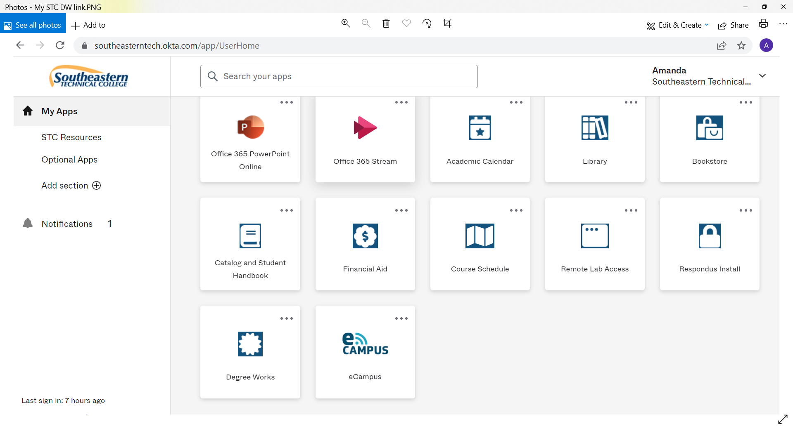

You can also log into Bannerweb and Select Degree Works from the Faculty Services menu.

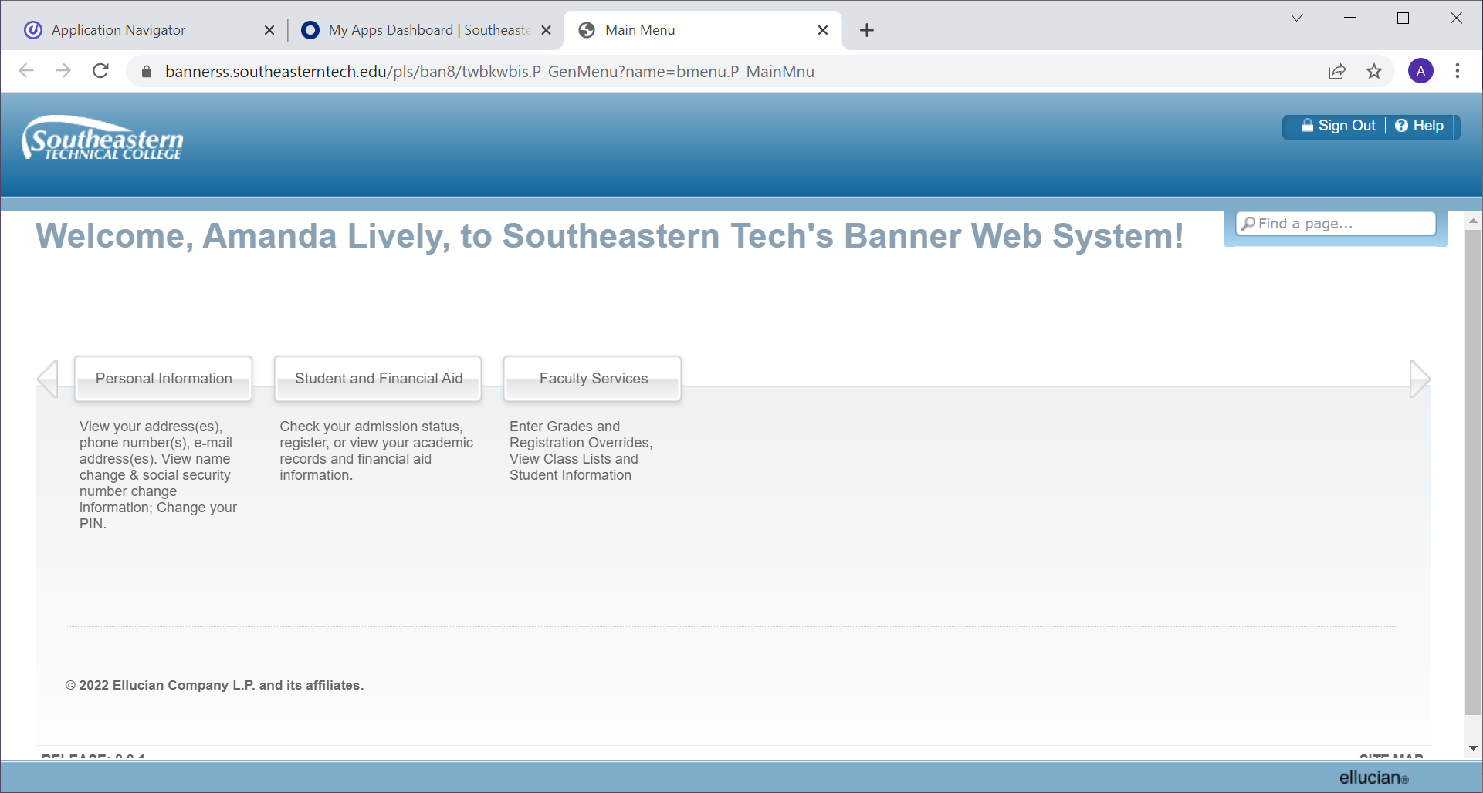

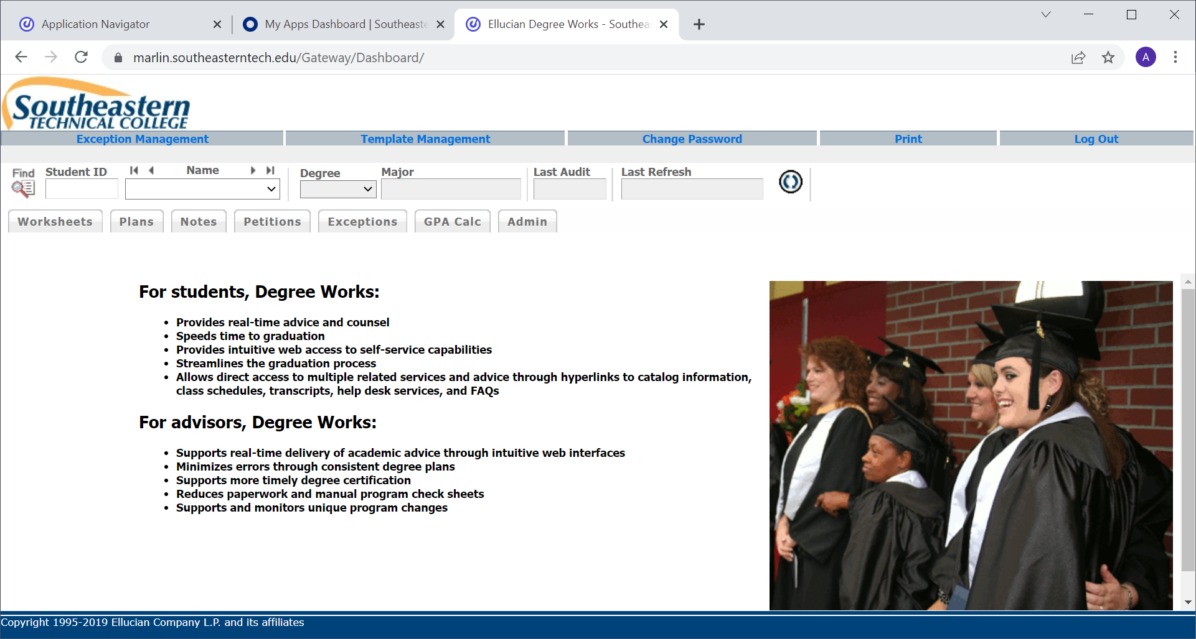
Enter in the Student ID number and press the Enter key to bring up the Student Audit Worksheet.
You may also select the and enter in the Student ID number.
The next screen will be the full Student Audit Worksheet.
To ensure that you are viewing the most current information for each student it is important that you click the “Process New” button to refresh that student’s information.

Student Audit Worksheet

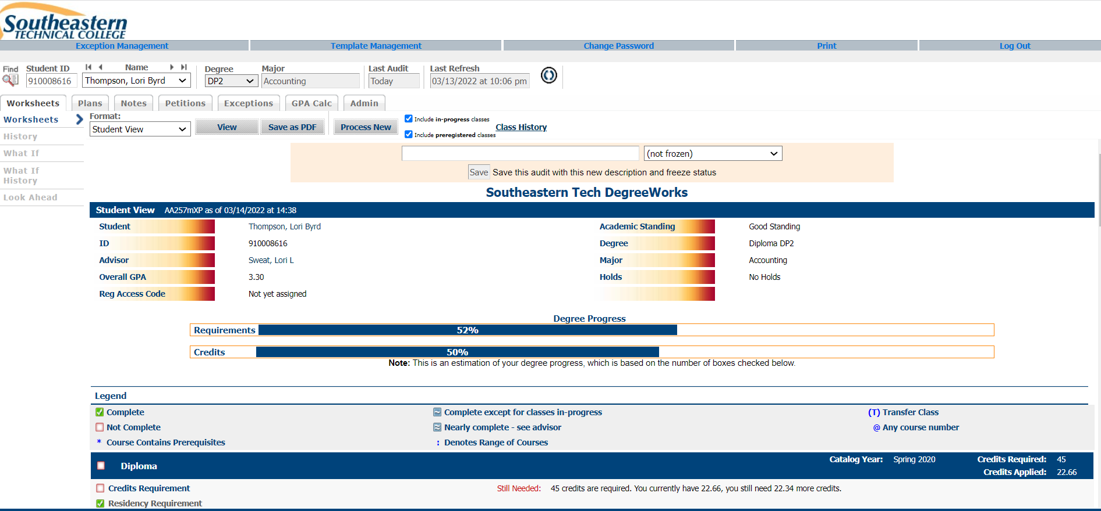

Audit Overview

Student Header
The first section of the audit, the Student Header, contains key elements of the student record.
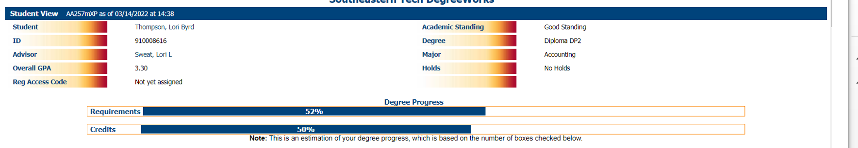

** Please note the Registration Access Code is listed and can be provided to a student so they may register on Bannerweb – this is a unique number that changes each semester and is used for registration purposes only.

Legend
The legend contains all of the unique symbols that are important for interpreting the DegreeWorks audit.

Legend

 | Complete |  | Complete except for classes in-progress | (T) | Transfer Class
 | Not Complete |  | Nearly complete - see advisor | @ | Any course number
* | Course Contains Prerequisites | : | Denotes Range of Courses

- Complete - This symbol will appear beside all requirements that have been completed within the audit. The row will be highlighted light yellow and will display the course(s) that fulfilled the requirement along with the grade and the term in which the course was taken.
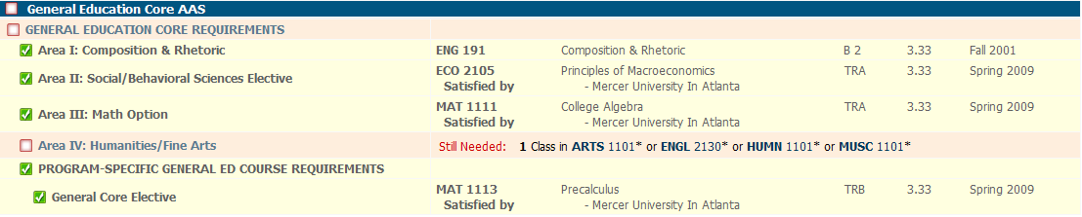

- Not Completed – This symbol will appear beside all requirements that have not yet been completed. The row will be highlighted in red and will also indicate the course(s) that will be required to complete the requirement.
- In-Progress – This symbol will appear for requirements where the classes needed to
fulfill the requirement are currently being taken or are registered to be taken for a future term. The row will be highlighted light blue and the grade section for the course will display (NA).
Any Course Number (@) – The symbol “@” in Degree Works is a wildcard. This means that it represents all classes when used as a prefix. When a course prefix is followed by the @ symbol (Ex: BUSN @), this means any course number for that prefix can be used to fulfill the requirement.

Non-Program Courses – This block will display all completed courses that are not currently being used to fulfill a requirement within the audit.

Courses with Insufficient Completion – This block will display all the courses that do not meet the minimum required grade for the program. This includes grades of “D”, “F”,“W”,”WP” and “WF”.

Test Scores – This block lists all test scores on the student’s record. The list will include the description, date taken, score as well as notations of whether the test was successfully completed or a learning support class was exited.

Notes from Banner: This block will indicate any notes made in Banner by the Registrar’s office – such as expiration of transfer course.
Notes from Banner

BIOL 2113/2113L transfer classes expire Fall 2025.
Completed evaluation 8/25/21 - kv

Blocks
Each section in a DegreeWorks audit is called a “Block”. Each block header will contain a title for the block and will also display specific course information for that block such as credits applied and classes applied for that block. Like individual requirements, the block header will also contain a symbol stating the status of all requirements within this block.
Program Requirements – This is the main block that houses all of the global rules that apply to all other blocks within the audit. This block will never have the “Complete” symbol until all other blocks have been completed. Within this block you will also find “Unmet Conditions” which are requirements that must be met in order to graduate.
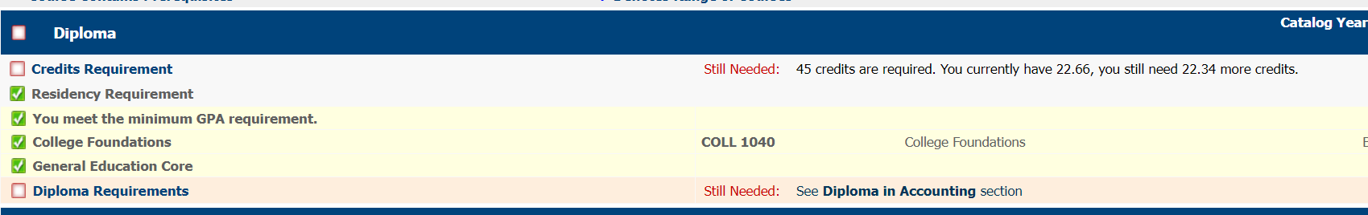
General Education Core – In this block you will find all the core classes that are required for your program.
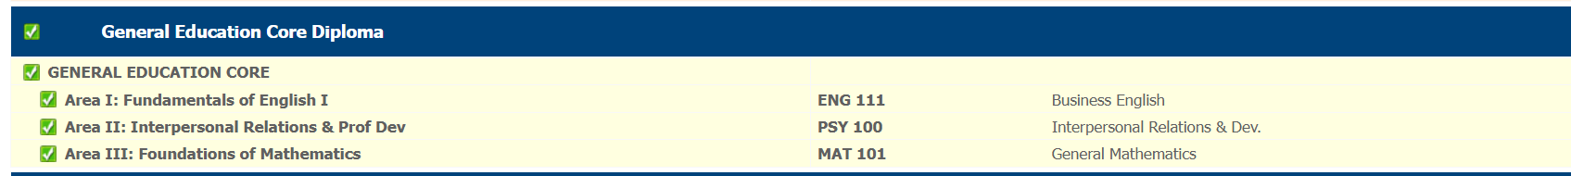
Program Requirements – This block will house all of the major requirements for your program.
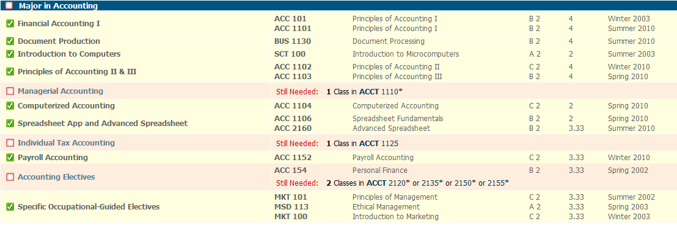

Embedded Certificates – this lists the embedded certificates in your program and allows you to see if the student has the classes needed to award the embedded certificate.

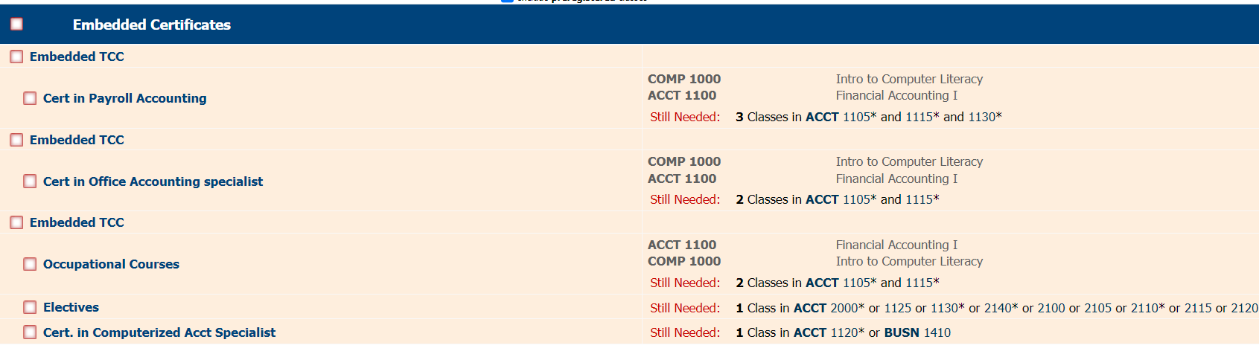

Performing a What If Scenario

If a student is thinking of changing his/her major, DegreeWorks has provided the What If tool to enable you/student to apply his/her course history to a sample audit with any of these changes. This tool will allow you to enter a different program and see which courses already taken can be used in a new program.

To access the What If option, click on the “What If” link on the left-side of the audit screen under the “Worksheets” tab. Once at the What If screen, you will be able to use the drop-down boxes to select the Academic Term and Major.

Your selection will be added to the list box on the right hand side. If you would like to remove your choice, select it from the list and click on the “Remove” button located below the list box. After selecting the desired criteria, click on the “Process What-If” button. Degree Works will then take your entire course history and apply it to an audit with the newly selected changes.

