Embed a YouTube Video into Blackboard
These instructions cover how to embed YouTube videos into a Content Area. If your video is not able to be embedded because there is no embed code you can simply link to it by grabbing the url and create a Web Link to the video's address online.
- Locate the video on YouTube.
- Click the Share button below the video. This will open a sharing menu.
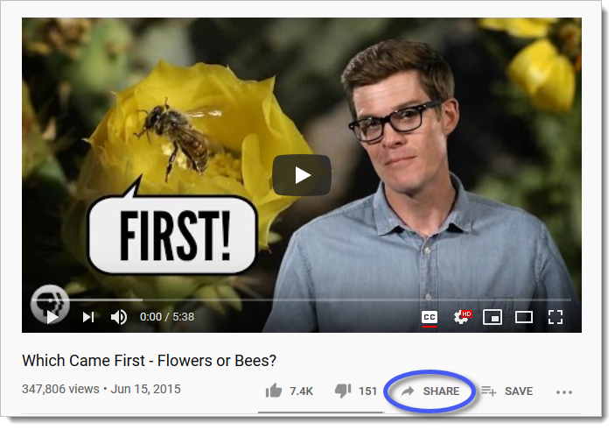
- Click the Embed button on the sharing menu.
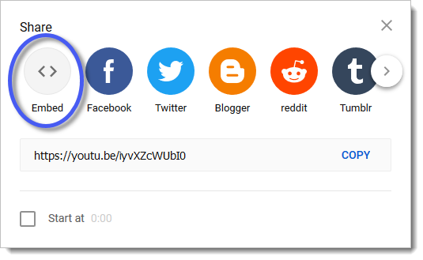
- Copy the embed video code by clicking the COPY button in the lower right of the window.
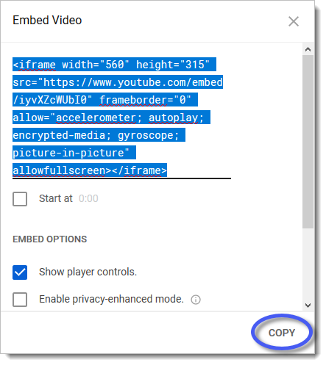
- Log into your course and navigate to the course area where you'd like to embed the video. Click the Build Content button in the upper-left to open a drop-down menu.
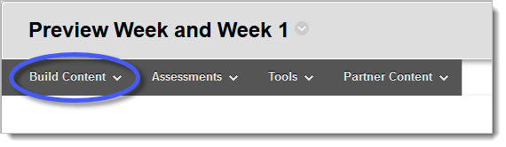
- Click on Item (from the Build Content menu).
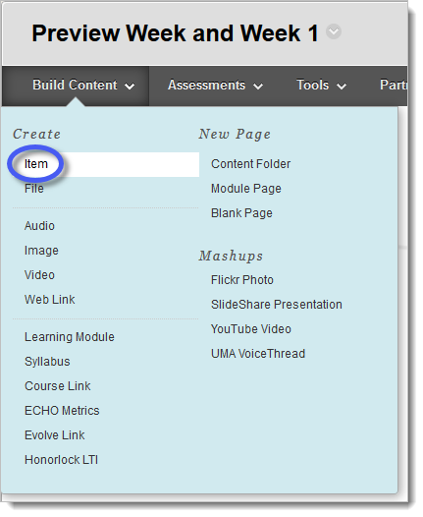
- Enter a name for the video in the name textbox.
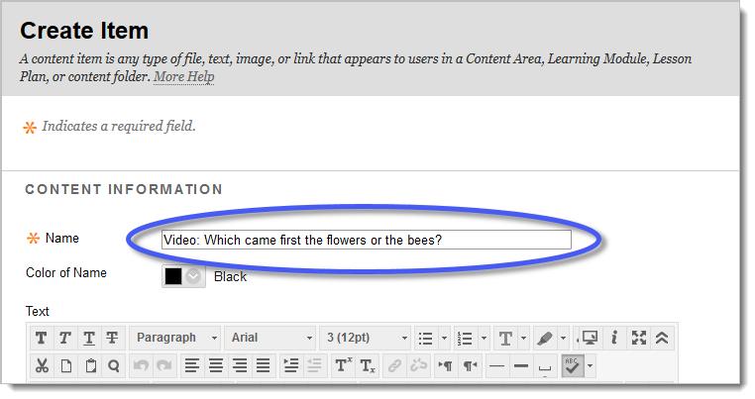
- Click on the HTML Code Button in the Text editor. This will open the HTML code window.
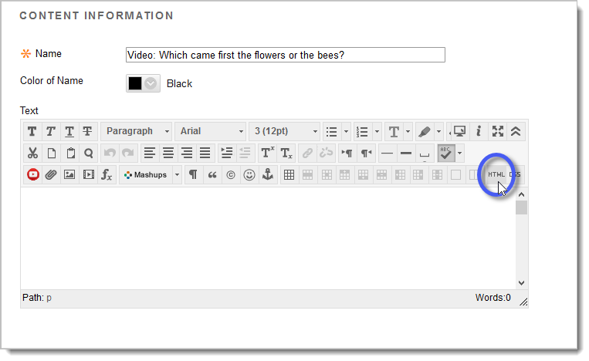
- Paste the embed code you copied from YouTube into the HTML Code Window box.
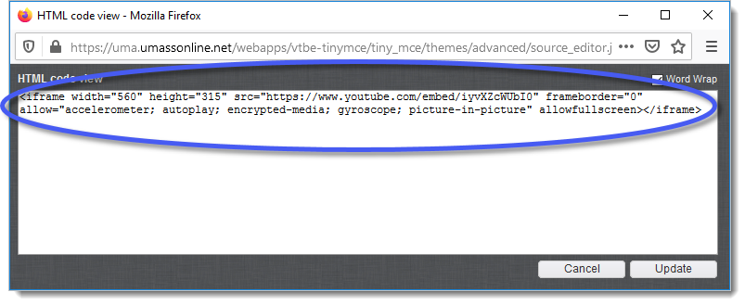
- Click the Update button in the lower right.
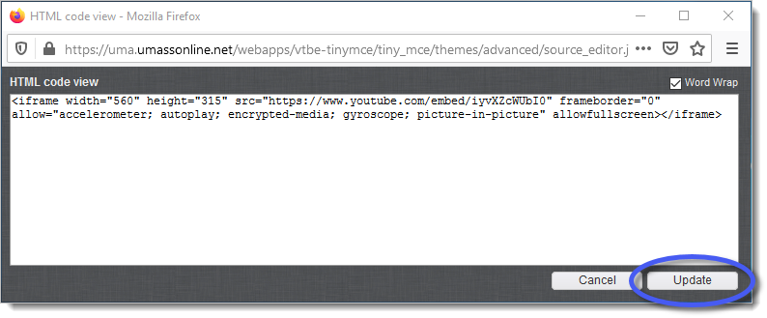
- Click the Submit button to add the video to your course.
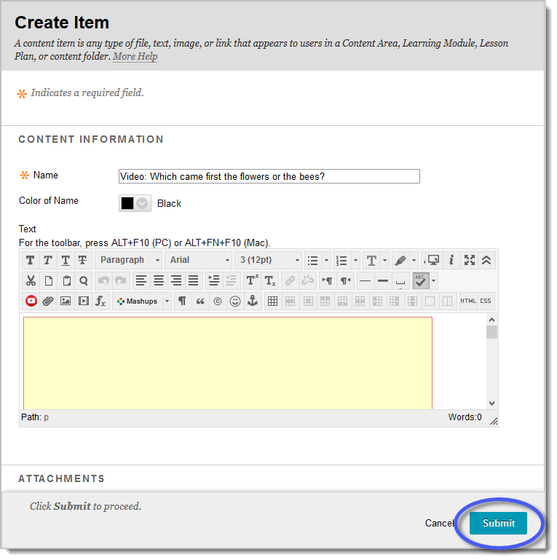
- Press the Play button to view the video.
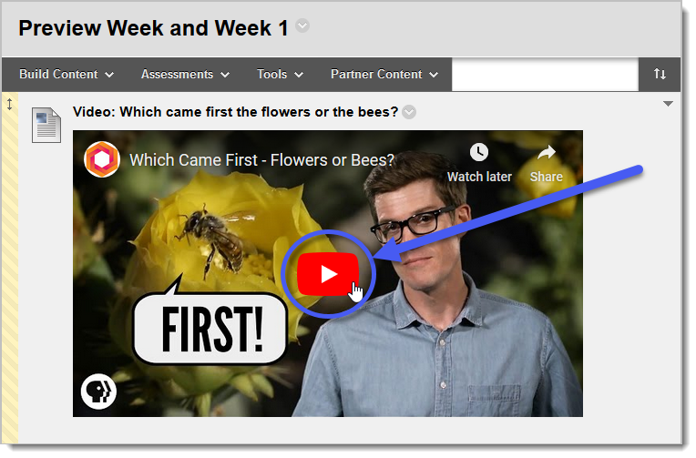

Adding a Video Link into Blackboard

Creating an Item, Part 1
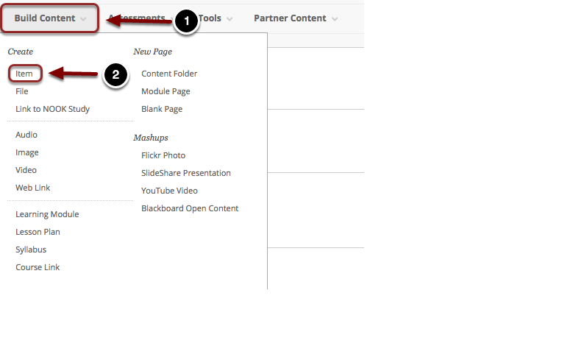
Log into Blackboard and access the content area in which you would like to upload your content item to. Please refer to the guide titled Creating a Content Area for more information on how to create a content area. To upload your document:
- Click on Build Content at the top of the page.
- Choose Item from the menu that appears.

Creating an Item, Part 2
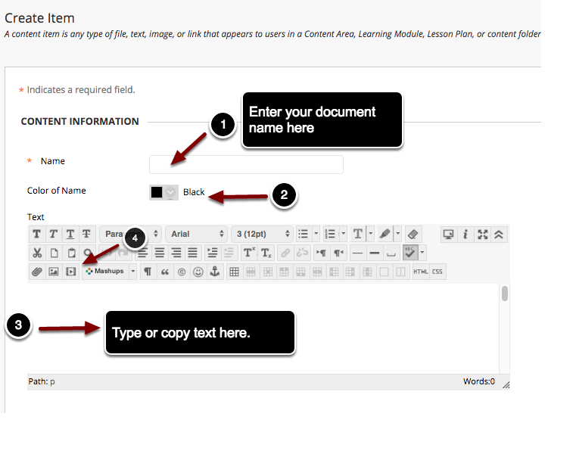
- Name: Enter the name of the document in the space marked Name.
- Color of Name: Select a color to use for the item name.
- Text: Type or paste your text into Blackboard's Text editor. You can then use the formatting toolbars to format the text
- To insert a video into the content item, click on the Insert/Edit Embedded Media button

Uploading a Media File
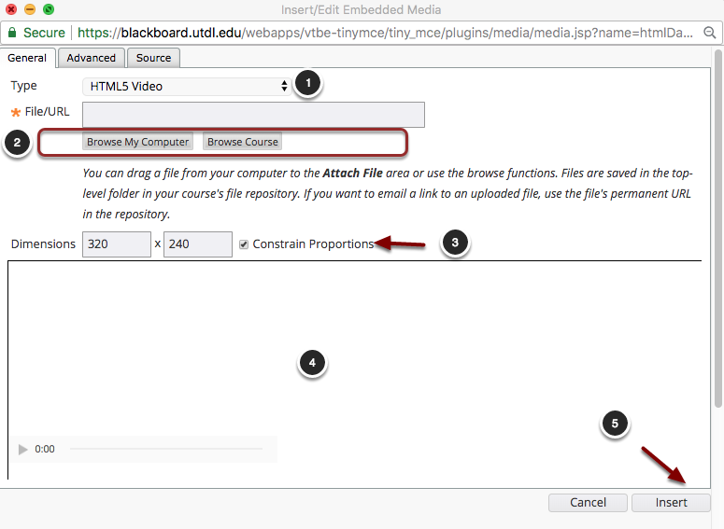
You will see a screen similar to the one above appear on screen. To upload an audio or video file:
- Type: Select HTML5 Video for video files or HTML5 Audio for audio files. HTML5 offers the most optimal playback across different browsers and devices and HTML5 content can be played without using external plugins.
- File/URL: Click Browse My Computer or Browse Course to upload a media file.
- Dimensions: Enter the dimensions of the media file here. Check the checkbox for Constrain Proportions to maintain the original proportions of the media when resizing.
- A preview of the media item will appear here.
- When finished, click the Insert button to insert the media item in the content editor.

