HOW TO USE THE WORD 2016 ACCESSIBILITY CHECKER

You may think nothing of reviewing your Word 2016 document when your vision is good and you can ably use a mouse or keyboard. Not everyone is so blessed. To ensure that you do not unintentionally create a trap for someone who may not have your same abilities, you can run the Accessibility Checker.

- Save your document.
- Click the File tab.
The Info screen appears.
- Click the Check for Issues button and choose Check Accessibility.
The Accessibility Checker pane, shown here, appears on the right side of the document window. It lists any parts of the document that need addressing with regard to accessibility.
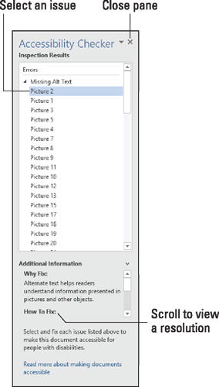
The Accessibility Checker pane.
- Click to select an individual item.
Word highlights the item in your document and displays the reasons why they need addressing.
- Scroll the Additional Information item in the Accessibility Checker pane to review the fix.
In the case of the Picture issue selected in the figure, the item lacks alternative text. The solution is to add a text description to the image.
- Continue to review the document; repeat Steps 4 and 5.
- Close the Accessibility Checker pane when you are done.
Click the X (Close) button.

