Online Course Orientation
Student Policies and Procedures
A member of:
Georgia Virtual Technical Connection
https://gvtc.tcsg.edu
March 2019

Table of Contents
Georgia Virtual Technical Connection (GVTC) 4
Getting Started With Your Online Class 5
Student Email Access 7
BLACKBOARD 9
Office 365 11
Installing Office 365 Applications to Your Personal Computer 12
For PC 12
For Mac 18
Accessing Office 365 24
Method 1 (mySTC): 24
Method 2 (direct website): 24
Method 3 (QUICKLINKS): 24
BannerWeb 25
Weekly Student Engagement 25
Proctored Event Requirement 25
Approved Methods 26
On-Campus 26
On-Campus Proctored Event Registration Form 26
Off-Campus 26
Proctor Scheduling and Approval Form 26
Proctoring Fees 26
Off-Campus Proctor and Site Qualifications 27
Approved Proctor List 27
Proctoring Instructions 27
Off-Campus Proctored Event Registration Form 27
Proctored Event Scheduling/Makeup 28
Students Failing to Complete the Proctored Event 28
Access to Proctored Event Materials 28
Adjunct Instructor Information 28
Statement for Syllabus 28
Student Policy 29
No Show Policy for Online Courses 29
Dropping Online Courses Before the Class Has Begun 29
Withdrawing from an Online Course 29
Academic Dishonesty 30
Academic Misconduct 30
Procedure for Academic Misconduct 30
Work Ethics 31
Instructor Response 32
PROCEDURE CONCERNING INSTRUCTOR RESPONSE TIME 32
Privacy Procedure for Distance Education 33
PROCEDURE 33
Secure Logins/Pass Codes 33
Proctored Events 34
Protecting the Privacy of Student Data in the Student Information System 34
Protecting the Privacy of Student Email 34
Important Contact Information and Links 35
Important Contacts: 35
Important Links: 35
STC Policies and Procedures 37
List of Policies and Procedures 38
Student Affairs Information 39
Academic Assistance 39
Career Services 39
Student Organizations 39
Special Programs 39
Admissions 40
Registrar 40
Financial Aid 40
Other Questions? 40
TECHNOLOGY ACCESS 41

Georgia Virtual Technical Connection (GVTC)
The Georgia Virtual Technical Connection (GVTC) is a consortium of independent technical colleges providing occupational courses and programs, using a standardized curriculum delivered over the Internet and through local centers. The mission of the Georgia Virtual Technical Connection is to provide support, guidance, and assistance to the state’s Technical Colleges in the design, development, and delivery of distance education and technology based learning initiatives, manage the state level online student application portal, and serve as a conduit for distance and technology enhanced education.
GVTC provides the central point of contact for the student applying online by providing an online course catalog, an online orientation, answers to questions concerning the online process and facilitation of the online application to the requested college. GVTC acts as a facilitator rather than a full functioning admissions department. Application files, assessment testing, advisement and registration, financial aid, textbook orders, and awarding credentials are managed at the local colleges. GVTC's function is to assist the student in locating the course(s) needed and direct the application to the requested college. The same policies and procedures that apply to the traditional student services apply to the Georgia Virtual Technical Connection (GVTC) process. Each application is processed in a nondiscriminatory way for admission to any technical college with the Technical College System of Georgia. GVTC acts as a facilitator in assisting the colleges' Student Affairs divisions in processing the online student.

Getting Started With Your Online Class
To get the most out of the online class experience, a little planning on your part will go a long way. It is important to make contact with your instructor as soon as possible by sending the instructor an email on the first day of class letting him/her know that you are registered for online course(s). This helps establish your intent to complete the online course. Each online instructor will have No Show requirements that students must complete to secure a seat in the course(s). Those requirements will include, but are not limited to, completion of the Pledge Acknowledgement Quiz located within the Getting Started/Start Here item of Blackboard and at least one academic activity by the third day of the semester. The No Show requirements will be documented in the Day 1 Announcement for each online course. Note: The No Show requirements may vary for each instructor and/or for each course, so it is very important to read all instructions carefully.

Students may access the course syllabus from the course schedule located at STC website homepage (www.southeasterntech.edu) to view course requirements and textbook information. Students should check with the instructor to ensure the posted syllabus is the most up-to-date version. If you decide to order your textbooks as opposed to purchasing them on campus, order them from the bookstore at least two weeks before classes start. A student may order books by emailing the bookstore with a list of courses. Southeastern Tech’s Vidalia campus bookstore (bookstore@southeasterntech.edu) may be reached by email, by phone at 912-538-3129, or by fax at 912-538-3156. Southeastern Tech’s Swainsboro campus bookstore may be reached at 478-289-2217. If you intend to use your financial aid to purchase your course materials, you must email the bookstore using your Student Email account. Please include your student ID number, a mailing address, and the classes in which you are registered. A student may include a credit card number in the email, or call the Vidalia Campus Bookstore and give the VISA, Master Card, or Discover credit card number and payment information over the phone. Students should contact the bookstore for any questions about books. Books mailed will have a shipping and handling fee added. Students may email their instructor in advance of the semester to obtain the book’s International Standard Book Number (ISBN) if they plan to purchase their books from an outside vendor. However, all students are encouraged to use the STC bookstore for their books and other supplies and are expected to obtain all required materials by the first day of the semester.

It is the student's responsibility to ensure that they have access to a computer that meets the minimum hardware/software requirements to participate in an online course. Those requirements are listed at Blackboard’s Help Website. https://help.blackboard.com/Learn/Student/Getting_Started/Browser_Support Although students can use their smart phones and tablets to access their online course(s), exams, discussions, assignments, and other graded activities, these items should be performed on a personal computer. Neither STC, Blackboard, nor GVTC provide technical support for issues relating to the use of a smart phone or tablet. Students are advised not to rely on these devices to take an online course.

Finally, a transient student must request that his/her grades be transferred back at the end of the semester to the home college.

Over the next few pages, you will find information that will make your online learning experience a good one.

Direct access to websites can be found by using QUICKLINKS.

Go to STC website homepage (www.southeasterntech.edu).

Near the top right of the screen, click the down pointing arrow next to QUICKLINKS.

Student Email Access

Every student at Southeastern Tech has a Student Email account through Office 365. Student Email is a web-based email program that you can use to check your college email account from campus, home, or anywhere that offers access to the Internet. As an online student, it is very important that you check your email on a daily basis. Email is the main source of communication between you and your online instructor. Any emails that your instructor creates and sends to you will be sent to your Student Email account. There are four different ways to access Student Email. Each method is shown below.

Method 1 (mySTC):

Click on mySTC via the STC website homepage (www.southeasterntech.edu). Enter your 9XXXXXXXX student ID as the username and your usual six-digit BannerWeb Pin for the password.

Click the Office 365 icon.

Enter your email username using the following format 9XXXXXXXX@students.southeasterntech.edu and your usual six-digit BannerWeb Pin for the password.

Click the Mail icon on the Office 365 screen.

Method 2 (portal.office.com):

Go to Office 365 website (https://portal.office.com).

Enter your email username 9XXXXXXXX@students.southeasterntech.edu and your usual six-digit BannerWeb Pin for the password.

Click the Mail icon on the Office 365 screen.

Method 3 (QUICKLINKS):

Go to STC website homepage (www.southeasterntech.edu).

Click the down pointing arrow next to QUICKLINKS.

Click Student Email.

Enter your email username 9XXXXXXXX@students.southeasterntech.edu and your usual six-digit BannerWeb Pin for the password.

Click the Mail icon on the Office 365 screen.

Method 4 (Blackboard):

Students may also access their Student Email account by clicking on the mySTC tab at the top of the screen while logged into their Blackboard course. To send an email only, click on the email option on the course menu located on the left side of the screen.

You can locate your email address by using the following steps:

Click on mySTC via the STC website homepage (www.southeasterntech.edu). Enter your 9XXXXXXXX student ID as the username and your usual six-digit BannerWeb Pin for the password.

Click the Office 365 icon.

On your first attempt, you may have to enter your email username using the following format 9XXXXXXXX@students.southeasterntech.edu and enter your usual six-digit BannerWeb Pin for the password.
- From the top right of the menu, click the person pictured icon next to the student name.
- Click View Account.
- Click Personal info.
- The Student Email address will be listed under “Contact Details” with the student name as part of the email address. Example: flastname22@students.southeasterntech.edu. This is your third-party-id address.
- To return to your Inbox, simply click the Office 365 words at the top of the screen.
9. To logout of Office 365, simply click the person pictured icon next to the student name at the top right, and click Sign Out.

Student Email can also be used by required software vendors such as SAM, Mathxl, MindTap, etc. The format of the email address you use with those programs is your named third-party-id address such as flastname22@students.southeasterntech.edu.

BLACKBOARD

Blackboard is a web-based course management system used by faculty and students in colleges and universities. You will use Blackboard to locate all information for your online classes, take tests, check your grades on assignments, etc. There are three different ways to access Blackboard. Each method is shown below.

Method 1 (mySTC):

Click on mySTC via the STC website homepage (www.southeasterntech.edu).

Click on the Blackboard Icon.

Click the “Click Here” Logo to access a login screen.

Enter your Student ID# as your username and your usual six-digit BannerWeb PIN as your password to login. Blackboard should immediately open.

You will see the current courses you are registered for listed, but you will not be able to access them until the first day of class.

Click on the course you want to enter.

Method 2 (QUICKLINKS):

Go to STC website homepage (www.southeasterntech.edu).

Click the down pointing arrow next to QUICKLINKS.

Click Blackboard icon.

Click the “Click Here” Logo to access a login screen.

Enter your Student ID# as your username and your usual six-digit BannerWeb PIN as your password to login.

Method 3 (Access Blackboard Directly):
- Go to STC Blackboard Website (https://southeasterntech.blackboard.com).
- Click the “Click Here” Logo to access a login screen.

Enter your Student ID# as your username and your usual six-digit BannerWeb PIN as your password to login.

It is very important that you explore each Blackboard course by clicking the course menu items to learn where everything is located (announcements, syllabus, grades, etc.). Along with your email, check the announcements in Blackboard daily. Your instructor may frequently post important information in the announcement section of Blackboard.

If you have any problems logging in or experience technical difficulties, contact your course instructor FIRST for assistance. In the event that your course instructor is unable to provide appropriate assistance, contact the appropriate Blackboard point of contact.

Sonya Wilson, Swainsboro Campus

(478) 289-2298

(swilson@southeasterntech.edu)

(onlinelearning@southeasterntech.edu)

Stephanie Moye, Vidalia Campus

(912) 538-3161

(smoye@southeasterntech.edu)

(onlinelearning@southeasterntech.edu)

Gina Robison, Vidalia Campus

(912) 538-3122

(grobison@southeasterntech.edu)

(onlinelearning@southeasterntech.edu)

Office 365
Microsoft Office 365 includes the latest version of Office and gives you the full Microsoft Office experience. With access to the latest Office applications as well as other cloud-based productivity services, Office 365 will meet your needs.

With our Office 365 subscription plan you can install the 2016 versions of Word, Excel, PowerPoint, Outlook, and OneNote (Access and Publisher are also included for PC users). When a new version of Microsoft Office is released, you will get instant access to it so your applications are always up-to-date. Because Office 365 is optimized across your devices, it is easy to get “anywhere access” to your files on your laptop, phone, tablet and more.

Along with the latest software, you will also get 1TB of OneDrive cloud storage, which lets you keep documents in one place, and access them anywhere on any device -- making it easier than ever to create, edit, and share your documents on the go. In addition, Office 365 subscribers will get 60 minutes of Skype calling per month, so you can stay in touch with friends and colleagues around the globe. Best of all, you can get tech support from the Microsoft Answer Desk experts, by phone or chat—at no extra charge.

Office 365 Home lets you install Office on up to 5 PCs or Macs, as well as 5 Windows, Android, or iPad tablets—an ideal solution for homes with more than one user.

Installing Office 365 Applications to Your Personal Computer

For PC
- Sign in with your work or school account at Office 365 Weblink https://portal.office.com/OLS/MySoftware.aspx.
Note: If you are unable to sign in, you may be signing in to the wrong Office 365 service. See where to sign in to Office 365.
If you do not see Office listed, your plan probably does not include Office applications. If you know your plan includes Office, you may not have a license assigned. See what Office 365 product or license do I have? If Office is not listed, ask your Office 365 administrator to assign a license to you.
- On the Office page, go to the version of Office you want to install. For example, your admin may have given you the option to install either Office 2016 or Office 2013.

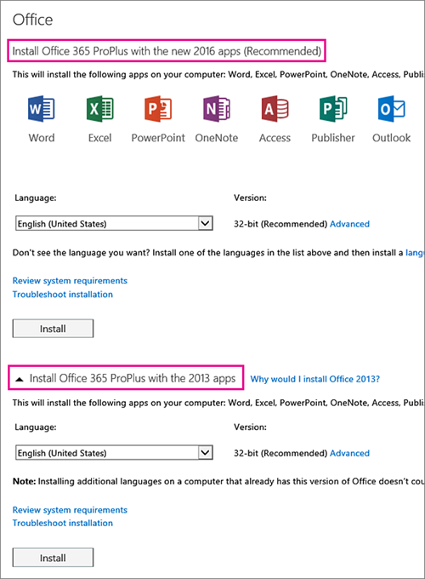
Important: The process that installs Office 2016 also uninstalls all Office 2013 products. See "Stop, you should wait to install Office 2016" error or How do I reinstall Office 2013 after an Office 2016 upgrade.
- Select a Language, and accept the default to install 32-bit, or select Advanced and choose 64-bit from the drop-down list. If you are not sure which version to install, see Choose the 64-bit or 32-bit version of Office 2016.
Important: If you currently have the 32-bit version of Office installed on your PC, you will need to uninstall that version before you can proceed with installing the 64-bit version and vice versa.

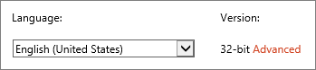

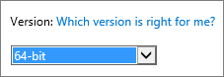

- Select Install.
- Depending on your browser, go to the install pop-up that appears and click Save (in Edge), Run (in Internet Explorer) Setup (in Chrome), or Save File (in Firefox).

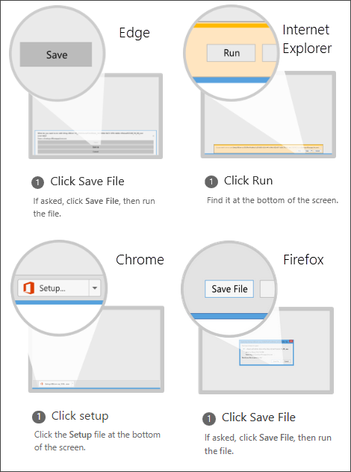

If you see the User Account Control prompt that says, Do you want to allow this app to make changes to your device? Click Yes.
- The install begins.

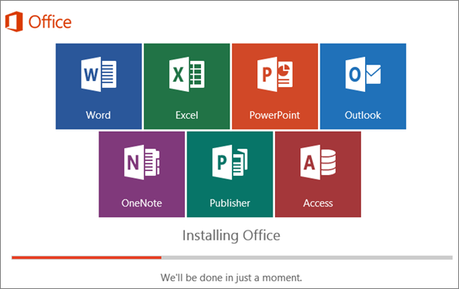

- Your install of Office 2016 is finished when you see the phrase, You're all set! Office is installed now and an animation plays to show you where to find Office applications on your computer. Follow the instructions in the window, for example Click Start > All Apps to see where your apps are, and select Close.

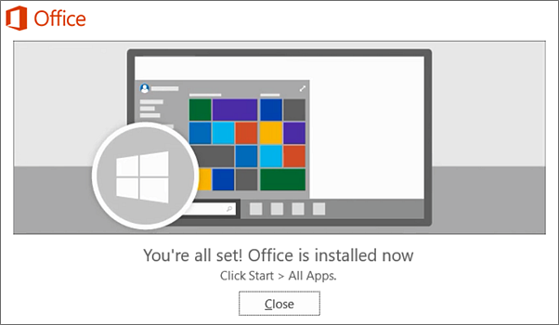

- Start using an Office application right away by opening any app such as Word or Excel. In most cases, Office is activated once you start an application and after you agree to the License terms by clicking Accept.

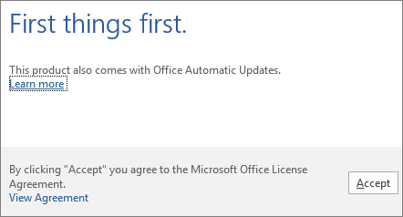

For Mac
- Sign in with your work or school account at https://portal.office.com/OLS/MySoftware.aspx.
- On the Office page, under Install Office 2016 for Mac, select Install to begin downloading the installer package.
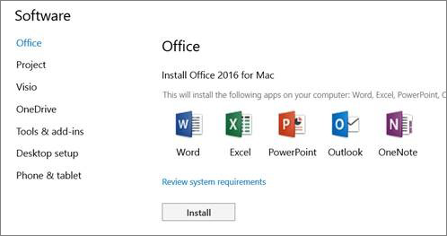
- Once the download has completed, open Finder, go to Downloads, and double-click Microsoft_Office_2016_Installer.pkg. (The name might vary slightly.)
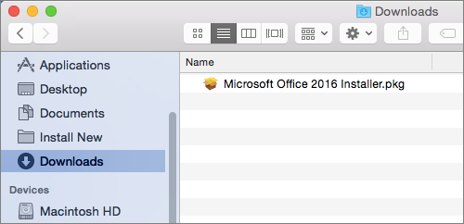

Tip: If you see an error that says the Microsoft_Office_2016_Installer.pkg can't be opened because it
is from an unidentified developer, wait 10 seconds and then try double-clicking the installer package again. If you are stuck at the Verifying…. progress bar, close or cancel the progress bar and try again.
- On the first installation screen, select Continue to begin the installation process.
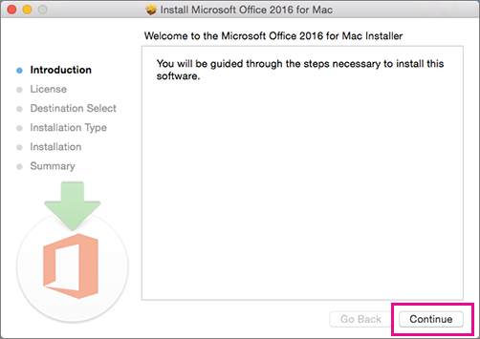
- Review the software license agreement, and then click Continue.
- Select Agree to agree to the terms of the software license agreement.
- Choose how you want to install Office and click Continue.
- Review the disk space requirements or change your install location, and then click Install.
Note: If you want to only install specific Office apps and not the entire suite, click the Customize button and uncheck the programs you do not want.
- Enter your Mac login password, if prompted, and then click Install Software. (This is the password that you use to log in to your Mac.)
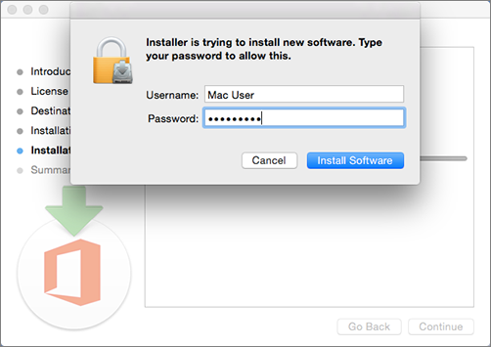
- The software begins to install. Click Close when the installation is finished. If Office installation fails, see What to try if you can't install or activate Office 2016 for Mac using Office 365 for business.
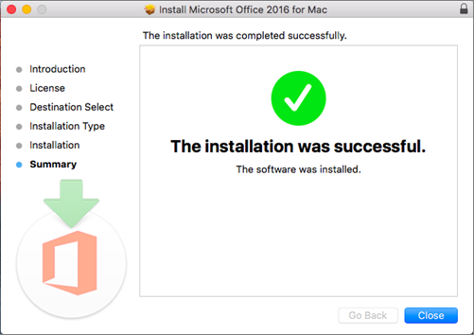
Step 2: Launch an Office for Mac app and start the activation process
- Click the Launchpad icon in the Dock to display all of your apps.
- Click the Microsoft Word icon in the Launchpad.
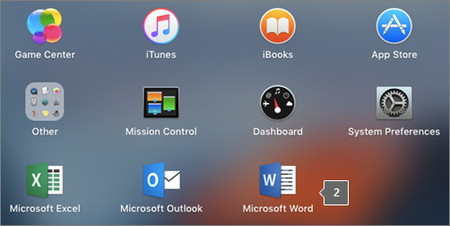
- The What's New window opens automatically when you launch Word. Click Get Started to start activating. If you need help activating Office, see Activate Office 2016 for Mac. If Office activation fails, see What to try if you can't install or activate Office 2016 for Mac using Office 365 for business.
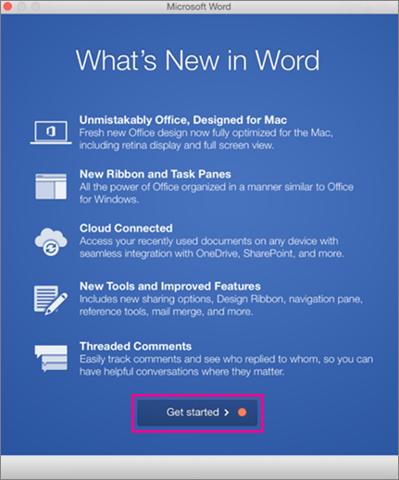
Were these steps helpful? Please leave a comment.
Installation notes
Keep in mind:
- You may need to check in with your organization's technical support team before installing apps.
- If you are not sure you have a license to install Office 2016 for Mac, see What Office 365 business product or license do I have?
Can I install Office 2016 for Mac and Office for Mac 2011 on the same computer?
Yes, you can install and use Office 2016 for Mac and Office for Mac 2011 at the same time. However, we recommend that you uninstall Office for Mac 2011 before you install the new version just to prevent any confusion.
To uninstall Office for Mac 2011, follow the steps in Uninstall Office 2011 for Mac.
How do I pin the Office app icons to the dock?
- Go to Finder > Applications and open the Office app you want.
- In the Dock, Control+click or right-click the app icon and choose Options > Keep in Dock.
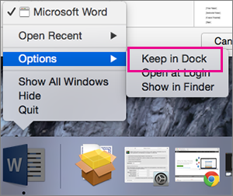

Accessing Office 365

There are three different methods to access Office 365. Each method is shown below.

Method 1 (mySTC):

Click on mySTC via the STC website homepage (www.southeasterntech.edu).

Click the Office 365 icon.

Enter your email username using the following format 9XXXXXXXX@students.southeasterntech.edu and your usual six-digit BannerWeb Pin for the password.

Click the icon needed on the Office 365 screen.

Method 2 (direct website):

Go to Office 365 website (https://portal.office.com).

Enter your email username 9XXXXXXXX@students.southeasterntech.edu and your usual six-digit BannerWeb Pin for the password.

Click the icon needed on the Office 365 screen.

Method 3 (QUICKLINKS):

Follow the directions below to access Office 365 via QUICKLINKS.

Go to STC website homepage (www.southeasterntech.edu).

Click the down pointing arrow next to QUICKLINKS.

Click Student Email.

Enter your email username 9XXXXXXXX@students.southeasterntech.edu and your usual six-digit BannerWeb Pin for the password.

Click the icon needed on the Office 365 screen.

BannerWeb

BannerWeb is where you access your final grades, registration, financial aid, and other important information. Follow the steps listed below to access BannerWeb:

From the STC website homepage (www.southeasterntech.edu).:

Click on mySTC via the STC website homepage

Click on the BannerWeb Icon.

You will receive a login screen.

Enter your Student ID# as your username and your usual six-digit BannerWeb PIN as your password to login.

Follow menus to find information such as financial aid or final grades, etc.

From QUICKLINKS on STC website homepage (www.southeasterntech.edu).:

Click the down pointing arrow next to QUICKLINKS.

Click BannerWeb.

You will receive a login screen.

Enter your student ID# as the username and your usual six-digit BannerWeb Pin for the password.

Follow menus to find information such as financial aid or final grades.

Weekly Student Engagement
Online courses require students to be academically engaged each week doing course related activities. The completion dates of these activities will be used to determine a student’s last date of attendance in the event a student withdraws or receives an F in a course. A student’s last date of attendance can have a negative effect on his/her financial aid and academic progress.

Proctored Event Requirement
In order to validate student identity for all online courses, students enrolled in online courses are required to complete one proctored event (a major exam, assignment, or presentation, etc.). The event will count a minimum of 20% of the course grade, and will be reflected as such on the course syllabus. Proctored events should be completed after the 65% point of the semester.

The proctored event will be administered on separate days—once on the Vidalia campus and once on the Swainsboro campus. Students must attend one of the proctored sessions as scheduled on the Lesson Plan/Course Calendar. The event will be monitored by the instructor or by an approved proctor.

Approved Methods

On-Campus

The proctored event will be administered on separate days—once on the Vidalia campus and once on the Swainsboro campus. Students must attend one of the proctored sessions as scheduled on the Lesson Plan/Course Calendar. The event will be monitored by the instructor or an approved proctor. The instructor will be responsible for scheduling of date(s), time(s), lab, etc. On-campus proctors will administer the On-Campus Proctored Event Registration Form.

On-Campus Proctored Event Registration Form

Instructors, mentor instructors, and on-campus proctors will be required to administer the On-Campus Proctored Event Registration Form at the time of the proctored event. If the event is proctored by anyone other than the instructor, the form will be filled out in its entirety and returned (if appropriate) with the hard copy test, note sheets, or any other paperwork outlined by the instructor. If the instructor administers the form, the instructor will simply save the completed form.

Off-Campus

Students living farther than 75 miles from either campus who cannot come to Southeastern Tech for the event must secure an approved proctoring site. The site and the proctor must meet Southeastern Technical College's requirements as outlined on the Proctor Scheduling and Approval Form. Students arranging off-campus proctoring will take the event on the same day(s) it is originally scheduled. Proctors must follow the Proctoring Instructions, which includes administering the Off-Campus Proctored Event Registration Form.

Proctor Scheduling and Approval Form

Students taking proctored events off campus will utilize the Proctor Scheduling and Approval Form found under the Getting Started section in Blackboard and submit the completed form to their instructor for approval a minimum of two weeks prior to the proctored event. If approved, the instructor will notify the proctor.

Proctoring Fees
Students are not charged a proctoring fee when taking a proctored event at Southeastern Technical College or any other TCSG college. Students who choose to use an off-campus proctor may be assessed a proctoring fee by the proctoring site. In this instance, the student is responsible for payment.

Off-Campus Proctor and Site Qualifications

Students choosing to utilize an alternative proctoring solution are responsible for finding a qualified proctor to administer each event and for submitting the required approval form for each event. The proctor must meet the following criteria:
- be a teacher, professor, librarian (or full-time library staff member), or administrator in a nearby public secondary school, college, university, library, or testing center;
- be a commissioned officer whose rank is higher than the student's own (for students in the military only).
Proctors cannot be family members, friends, or co-workers.
Students must confirm that their proctor and/or the event site have the following:
- a business e-mail address (Exam materials are not sent to proctors who do not have a business e-mail address.);
- a quiet, appropriately lit, and furnished location in which to complete the exam or assignment;
- an available computer with reliable access to the Internet;
- the ability to download files (some exams may require downloaded components);
- a printer with the ability to print PDF documents;
- and access to a fax machine or scanner (for returning completed documents to STC)
Approved Proctor List

Proctors who have been approved by a Southeastern Technical College instructor will have their name placed on the Approved Proctor Form that will be maintained by the Academic Affairs Secretary and kept on the S Drive.

Proctoring Instructions
Proctors will follow the guidelines as outlined in the Proctoring Instructions form. The instructor will send this form and any test materials or instructions to the proctor.

Off-Campus Proctored Event Registration Form
Approved proctors will be required to administer the Off-Campus Proctored Event Registration Form at the time of the proctored event. The form will be filled out in its entirety and returned (if appropriate) with the hard copy test, note sheets, or any other paperwork outlined by the instructor.

Proctored Event Scheduling/Makeup
Students who do not complete the proctored event as scheduled must submit a valid documented excuse within three business days after the scheduled event. If the excuse is approved by the instructor of the course, students must make arrangements with the instructor to makeup/reschedule the missed event. The penalty and makeup instructions will be at the instructor's discretion.

Students Failing to Complete the Proctored Event

Students who do not complete the proctored event on the scheduled date and do not present a valid documented excuse within three business days of the scheduled event will be withdrawn from the course with a “WF” (Withdrawn Failing) and will be disabled in Blackboard. The last date of attendance will be the last day an academic activity is completed. If the proctored event is scheduled during final exams, any student who misses the proctored event will be issued an “F” (Failing) for the course.

Access to Proctored Event Materials
In order to facilitate proper access to proctored event materials (exams and/or assignment documents and instructions), and to limit potential misuse of the materials, they will not be made available to the student prior to the scheduled proctored event. Such materials will either be sent directly to the approved proctor, or if provided via the online Learning Management System (LMS) will be password protected. Access to the materials will be provided to the approved proctor via e-mail by noon on the business-day prior to the scheduled event.

Adjunct Instructor Information
Adjunct instructors who are unable to come to campus will coordinate their proctored event with their on-campus mentor(s).
Adjunct instructors will contact the Academic Affairs Secretary to reserve a lab for the event.

Statement for Syllabus
All online course syllabi will include a statement outlining proctoring requirements. The required statement is located on the online course syllabus template that is saved on the S Drive.

Student Policy

For a complete student policy guide, see the school’s website STC Catalog and Handbook (http://www.southeasterntech.edu/student-affairs/catalog-handbook.php).

No Show Policy for Online Courses

Each online instructor will have No Show requirements that students must complete to secure a seat in the course(s). Those requirements will include, but are not limited to, completion of the Pledge Acknowledgement Quiz located within the Getting Started/Start Here item of Blackboard and at least one academic activity by the third day of the semester. The No Show requirements will be documented in the Day 1 Announcement for each online course. Note: the No Show requirements may vary for each instructor and/or for each course, so it is very important to read all instructions carefully.

Any no show student whose registration is voided and who seeks reinstatement must obtain approval from the class instructor (who will seek approval from Student Affairs if necessary).
NOTE: Some classes have waiting lists. When a no show student’s registration is canceled, students on the waiting list are given the opportunity to register. This means that no show students may lose their place in class.

Dropping Online Courses Before the Class Has Begun

Students wishing to withdraw from one or all courses prior to the first day of class need to go to BannerWeb and drop their classes. Please note that a registration access number will be needed as well as a student’s ID number and PIN. If the registration access number is unknown, the student will need to contact the registrar.

Withdrawing from an Online Course

Students wishing to officially withdraw from course(s) after the drop/add period and prior to the 65% portion of the semester (date will be posted on the school calendar) must speak with a Career Counselor in Student Affairs and complete a Student Withdrawal Form. A grade of “W” is assigned when the student completes the withdrawal form from the course(s). After the 65% portion of the semester, the student has earned the right to a letter grade and will receive a grade for the course. Abandoning a course(s) instead of following official withdrawal procedures may result in a grade of “F” being assigned.

Academic Dishonesty

Academic Misconduct
Academic misconduct is any act that does or could improperly distort student's grades or other student academic records. A student enrolls at Southeastern Tech to gain technical skills to lead to greater employability. Academic misconduct is not only "cheating" the student of learning the needed skills, it is an offense to the academic integrity of the learning environment. All forms of academic dishonesty will call for discipline.

Procedure for Academic Misconduct
The procedure for dealing with academic misconduct and dishonesty is as follows:

--First Offense--
Student will be assigned a grade of "0" for the test or assignment. Instructor keeps a record in course/program files and notes as first offense. The instructor will notify the student's program advisor, academic dean, and the Registrar at the student's home campus. The Registrar will input the incident into Banner for tracking purposes.

--Second Offense--
Student is given a grade of "WF" (Withdrawn Failing) for the course in which offense occurs. The instructor will notify the student's program advisor, academic dean, and the Registrar at the student's home campus indicating a "WF" has been issued as a result of second offense. The Registrar will input the incident into Banner for tracking purposes.

--Third Offense--
Student is given a grade of "WF" for the course in which the offense occurs. The instructor will notify the student's program advisor, academic dean, and the Registrar at the student's home campus indicating a "WF" has been issued as a result of third offense. The Vice President for Student Affairs, or designee, will notify the student of suspension from college for a specified period of time. The Registrar will input the incident into Banner for tracking purposes.

Work Ethics
Southeastern Technical College instructs and evaluates students on work ethics in all programs of study. Ten work ethics traits are defined as essential for student success. The definitions for these traits have been integrated into the program standards of each program curriculum thereby allowing each program to make work ethics a relevant and meaningful part of the program curriculum. The traits are assessed before the student graduates from the program in a designated course. If your online course is this designated course, it will be indicated on your Syllabus as well as under the appropriate menu item on the left side of your screen in Blackboard. These assessments have been developed using questions unique to each program area. The assessment will make up 5% of a student’s grade for the designated course. A student must make a grade of 70 or above on the assessment in order to successfully pass the work ethics module and receive a work ethics seal on his/her transcript.

The following statement will appear in every course syllabus which assesses the Work Ethics traits:

The Technical College System of Georgia instructs and evaluates students on work ethics in all programs of study. Ten work ethics traits have been identified and defined as essential for student success: appearance, attendance, attitude, character, communication, cooperation, organizational skills, productivity, respect, and teamwork.

Instructor Response

PROCEDURE CONCERNING INSTRUCTOR RESPONSE TIME
The instructor will do his or her best to immediately respond to all Student Email and phone messages. STC and its instructors realize that when an online student has a question, he or she may not be able to continue class work until that question is answered. Email is the best method for an online student to contact his or her instructor. Instructors will reply to all email that requires an answer by the following business day. Additionally, online instructors are required to check email at least once over the three day weekend (Friday, Saturday, and Sunday) and daily if tests or assignments are due on Monday. Students should refer to the course syllabus section of Blackboard which provides online students with times and dates they can expect their instructor to be available for personal contact. Also, the Faculty Information Section of your Blackboard course provides you with the times and dates that you can expect your instructor to be available for personal contact (phone calls or on campus visits).

If you have not received a reply from your instructor within 72 hours after submittal, contact Gina Robison (grobison@southeasterntech.edu) for Business Technology and Human Services, Dana Roessler (droessler@southeasterntech.edu) for Health Sciences, Cheryl West (cwest@southeasterntech.edu) for General Education and Learning Support, Jessie Garrett (jgarrett@southeasterntech.edu) for Environmental and Industrial Technologies, Sonya Wilson (swilson@southeasterntech.edu ), Math Instructor/GVTC Coordinator, Swainsboro Campus, or Stephanie Moye (smoye@southeasterntech.edu) CIS Instructor/Blackboard Point of Contact (POC), Vidalia Campus.

Privacy Procedure for Distance Education
Southeastern Technical College (STC) has a procedure for protecting the privacy of students enrolled in distance education courses or programs. Southeastern Tech also adheres to written procedures of the Georgia Virtual Technical Connection (GVTC) to protect the privacy of students who participate in distance learning activities.
Southeastern Technical College uses Blackboard Learn as its Learning Management System (LMS). Blackboard Learn provides students a secure logon environment into their virtual classroom. Students should not share their login credentials with others and are instructed to periodically change their password to maintain privacy.
According to the Technical College System of Georgia (TCSG) and Industry Standards, STC develops policies and guidelines to meet all security requirements. Information Technology (IT) systems have built in processes to enforce as many of these policies and guidelines as possible. It is the responsibility of system users to understand and follow all policies and guidelines. If anyone is found in violation of any of these polices and guidelines, they are processed according to our current disciplinary action procedures.

PROCEDURE
Southeastern Technical College utilizes (1) secure logins/pass codes and (2) proctored events to verify the identity of students enrolled in distance education courses. Additionally, all students enrolled at Southeastern Technical College, regardless of the mode of instructional delivery (traditional, web-enhanced, hybrid, or online), are protected by the Family Educational Rights and Privacy Act of 1974 (FERPA). Students are notified of their FERPA rights during orientation. Information about this act is published on STC’s Website and in STC’s Catalog and Handbook. To ensure that faculty and staff understand and carry out the commitments to confidentiality, integrity, and security of student academic records, Southeastern Technical College requires annual FERPA training.

Secure Logins/Pass Codes
When students are enrolled in a course in Banner, they are automatically enrolled in Blackboard and a secure login is created. Students enrolled in distance education courses must use their secure login to access courses in Blackboard. The secure login information identifies students to the system on each course visit. Students use Blackboard to submit assignments, complete assessments, access course materials, and view grades. When students login to Blackboard for the first time, they must change their pass code to maintain privacy. Students are instructed not to share their login credentials with anyone and to change passwords periodically to maintain security. From the time of the first student logon to Blackboard, STC faculty and staff do not have access to students’ Blackboard pass codes.

Reliability, privacy, safety, and security for Blackboard courses are provided by the Georgia Virtual Technical Connection (GVTC). All courses are loaded onto a server that Blackboard maintains. GVTC is the contact for any server level administrative changes.

Proctored Events
In addition to using secure logins/pass codes, Southeastern Technical College also requires that every online student complete a proctored event as a means of verifying identity. Students must present photo identification, such as a STC Student ID, driver’s license, passport, etc. All Off-Campus Proctored Event Registration Forms and On-Campus Proctored Event Registration Forms must be completed in the presence of the proctor. Proctors are to check the information and signature against the identification presented to ensure that the student who is present for the proctored event is the correct student to be completing the event for the scheduled course. Completed proctored event registration forms and all proctored event materials are kept in a secure location by the instructor of the course.

Protecting the Privacy of Student Data in the Student Information System
Banner is the software front-end for the Oracle database housing student data. This data includes all student institutional history, as well as some biographical information. It is the shared responsibility of the Banner system administrator and all departments accessing student data in Banner to guard against it being compromised and the student's privacy violated. At the physical level, this data is transmitted in encrypted fashion to prevent electronic interception or manipulation. Further security is added by disallowing direct access to the Oracle database or its host server from outside the school network. Students in the Banner system are provided a web portal (BannerWeb) to access most of their own student information such as grades, awards, bills, etc. This information is protected at the physical level by encryption and at the user level by a user id and pin number combination login. A student's user ID is comprised of a non-associative, sequentially generated number and the pin is a completely randomized number. It is the responsibility primarily of the student to guard their ID and pin from disclosure. All information in Banner, including student identification numbers, is protected in compliance with the Family Educational Records and Privacy Act (FERPA) and is not shared.

Protecting the Privacy of Student Email
Student Email is a secure logon environment. The identity of all students is verified through the use of a secure and unique nine digit student identification number. This identification number is utilized as part of the student’s username when accessing the student email. Additionally, STC utilizes Secure Sockets Layer (SSL) certificates to establish an encrypted link between the web server and the client’s browser. This link ensures that all data passed between the web server and web browser remain private and integral. SSL is an industry standard and is used by millions of websites in the protection of online transactions with users.

Students are responsible for using their STC Student Email address when registering third party products.

Important Contact Information and Links
BTHS stands for Business Technology and Human Services

Important Contacts:

Ms. Gina Robison, Dean BTHS/Blackboard POC – Vidalia Campus (912) 538-3122
Ms. Sonya Wilson, GVTC Coordinator – Swainsboro Campus (478) 289-2298
Ms. Stephanie Moye, Blackboard POC – Vidalia Campus (912) 538-3161
Southeastern Technical College Customer Service (912) 538-3100
Southeastern Technical College Fax number, Vidalia Campus (912) 538-3156
Southeastern Technical College Fax number, Swainsboro Campus (478) 289-2263
Southeastern Technical College Financial Aid, Vidalia Campus (912) 538-3107
Southeastern Technical College Financial Aid, Swainsboro Campus (478) 289-2272
Southeastern Technical College Bookstore, Vidalia Campus (912) 538-3129
Southeastern Technical College Bookstore, Swainsboro Campus (478) 289-2217
Southeastern Technical College Registrar, Vidalia Campus (912) 538-3160 (912) 538-3213
Southeastern Technical College Registrar, Swainsboro Campus (478) 289-2271
Southeastern Technical College Career Services, Vidalia/Swainsboro Campuses
(912) 538-3207

Important Links:

http://www.southeasterntech.edu
(Southeastern Technical College Home Page)
This is our college homepage. If you have any questions, start at the homepage and look at the list of contacts in the Directory.

http://www.southeasterntech.edu/student-affairs/catalog-handbook.php
(Southeastern Technical College Catalog)

https://gvtc.tcsg.edu
(Georgia Virtual Technical Connection)

https://gvtcapp.tcsg.edu/GVTC/General/Courses.aspx
(GVTC Online Courses)

http://www.gsfc.org
(Georgia Student Finance Commission)

http://www.fafsa.ed.gov
(Federal Financial Aid Application (Pell)

http://www.southeasterntech.edu/student-affairs/how-to-apply-types-of-aid.php
(Types of Financial Aid – Application Procedures)

STC Policies and Procedures
Read all policies and procedures listed on the next page of this manual. When you have read and understand each of these policies, follow your online instructor’s directions for issuing a statement of acknowledgement. Most instructors ask that you post your statement of acknowledgement in the discussion forum of Blackboard. This is typically located in the Getting Started/Start Here menu item located on the left side of the screen in Blackboard. Your instructor will likely also ask you to introduce yourself to the class as a part of this process.

List of Policies and Procedures
By issuing a statement of acknowledgement in your Blackboard course, you agree that you are responsible for all policies and procedures listed on this page and in the STC Catalog and Handbook (http://www.southeasterntech.edu/student-affairs/catalog-handbook.php).

______ Student Affairs Information
______ Attendance Policy
______ Academic Dishonesty Procedure
______ Instructor Response Time
______ Withdrawal Procedures
______ Weapons Policy
______ Dress Code
______ Drug-Free Campus Policy
______ Tobacco Use
______ Academic Misconduct
______ Non-Academic Misconduct
______ Privacy Procedure for Distance Education
______ Proctoring Requirements

Student Affairs Information
The Student Affairs office is excited you are seeking to augment your life with education through Southeastern Technical College, and we are committed to assist you any way we can. Provided here is resource and contact information to enhance your experience as an online learner.

Academic Assistance

Georgia Virtual Technical Connection https://gvtc.tcsg.edu has excellent information on their website. The site includes assistance areas including library resources, course orientation, tutorials and support information.

The Southeastern Technical College library (http://library.southeasterntech.edu) is an excellent resource:

Southeastern Technical College also has a Student Success Center (http://www.southeasterntech.edu/student-affairs/student-success-center.php) where a variety of resources and tools are available:

Career Services

The Career Services Office provides a variety of resources and personal assistance to graduates seeking employment. Services include job search assistance, resume writing and interview preparation. All resources may be accessed by contacting the Career Services Office (lhelms@southeasterntech.edu) or at 912/538-3207.
Additional job opportunities and career planning tools may be accessed through one of the following links:
STC Career Center (http://www.southeasterntech.edu/student-affairs/career-center.php)
STC JobLink (http://www.southeasterntech.edu/student-affairs/STC-JobLink.php).

Student Organizations
The benefits of joining a student organization include, but are not limited to, learning more about the College, meeting other students with similar interests, and gaining leadership skills. The Student Organization webpage (http://www.southeasterntech.edu/student-affairs/student-organizations.php) has contact information for clubs and organizational events.

Special Programs
Southeastern Tech has a variety of special support services programs designed to ease the transition into higher education and maximize the potential for student success. Our Special Needs Program will assist with reasonable accommodations to qualified students with disabilities. The Student Success Center (http://www.southeasterntech.edu/student-affairs/student-success-center.php) and Learning Support (http://www.southeasterntech.edu/academics/learning-support.php) pages are valuable resources for providing students with tutoring assistance. STC provides Special Support Services (http://www.southeasterntech.edu/student-affairs/special-services.php).

Admissions
Questions regarding admission status, changing your program, or transcripts? For admissions questions on the Vidalia campus, email Melissa Rowell (mrowell@southeasterntech.edu). For admissions questions on the Swainsboro campus, contact Agatha McRae (amcrae@southeasterntech.edu).

Registrar
Our Registrar can assist you with BannerWeb questions, having a transcript sent to another school, your grades, and GPA. Vidalia campus students can email Amanda Lively (alively@southeasterntech.edu). Swainsboro students should contact Karen Vereen (kvereen@southeasterntech.edu).

Financial Aid
On the Vidalia campus, Brandy Kennedy (bkennedy@southeasterntech.edu) can assist you with financial aid matters. Swainsboro students can email Mitchell Fagler (mfagler@southeasterntech.edu).

Other Questions?
If you have any problem or are in need of assistance not listed above, contact the Director of Enrollment Services, Brad Hart (brhart@southeasterntech.edu).

TECHNOLOGY ACCESS
For information on how to login to resources, reset passwords, set up security questions, and troubleshooting tips, please see the Technology Access link.

